Mark Zuckerburg Lost $16 Billion in One Year. What Will His Employees Lose?
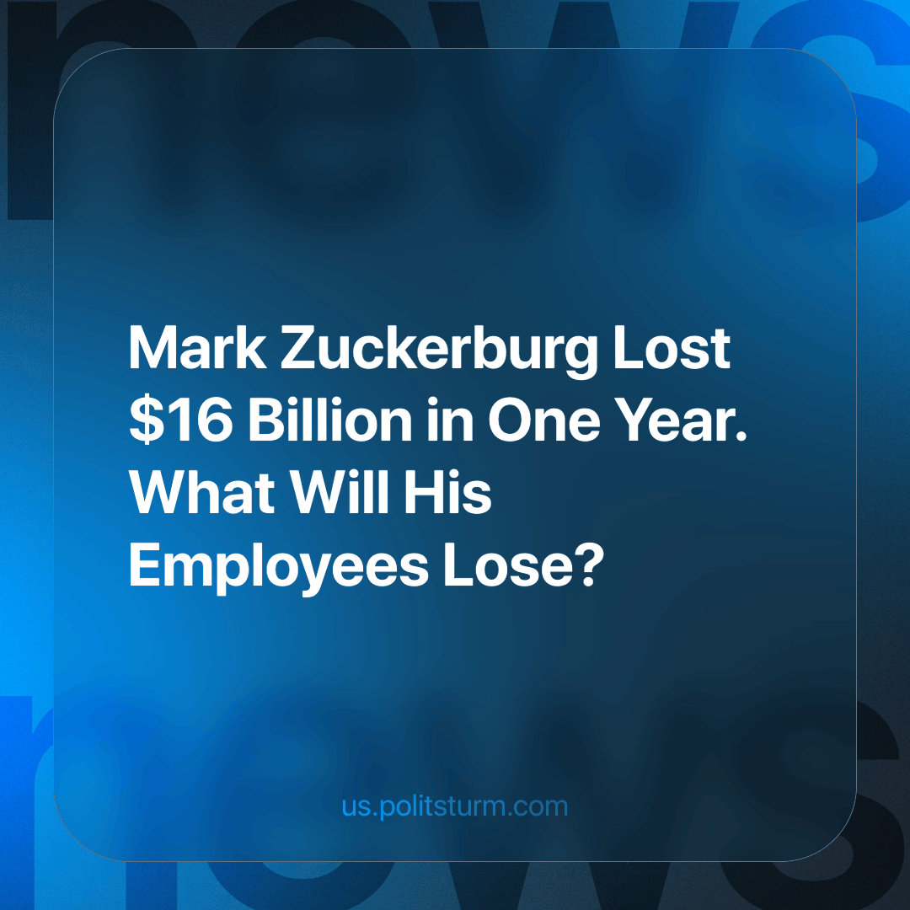

Original article
2024-03-06
1 min read

In the last quarter of 2023, Meta's division responsible for developing software and hardware for VR, made a loss of $4.6bn. But despite the projected increase in costs, Zuckerberg isn't about to give up on his inventions.
Despite the projected colossal losses, the company's shares have risen 12% on the back of investment bonuses and a frenzy of demand for shares. Its market capitalization has more than doubled in the last year to $1 trillion. Mark Zuckerberg will receive $700 million from the company's profits.
So what helps a successful businessman stay afloat? The secret is simple - reduction of labour. About 21 thousand people lost their jobs in the company last year. Additionally, 5 thousand vacancies were closed. This practice has been used in this billionaire's companies for several years.
A world in which thousands suffer for the whim of one person is not only unjust, it is inevitably doomed to self-destruction. Every year millions of workers are thrown out onto the streets, left to face hunger, cold and poverty. All this happens because the authorities protect the interests of private owners at various levels, from billionaires to small businessmen, and do not care at all about ordinary people, only profits.
Only the workers themselves have the revolutionary potential to change this. The study of Marxist-Leninist will teach us how.
Source: Business Insider - "Meta spent billions closing offices and laying off people. Now we know why"

Original article

