Zohran Begins to Break Campaign Promises
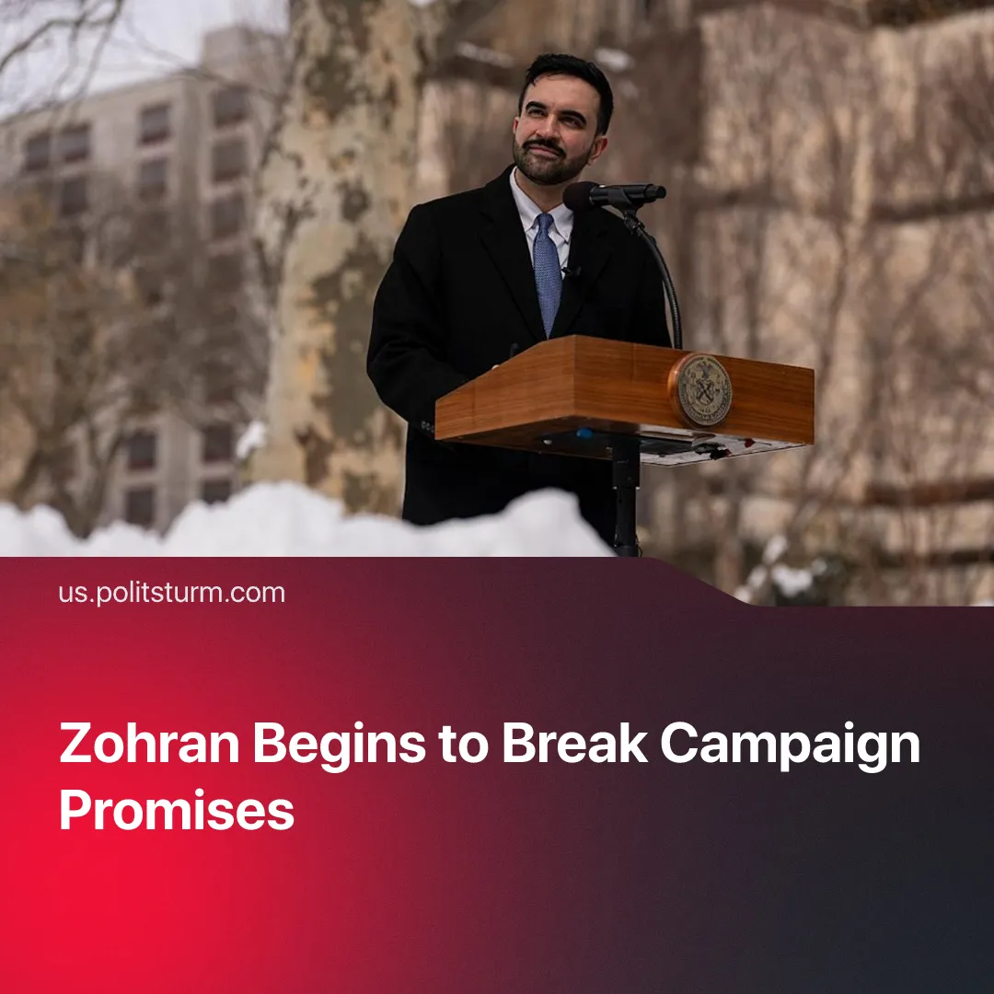

Original article
2026-02-28
1 min read

New York’s “socialist” mayor retains police funding, whilst cutting funding for libraries and parks below campaign promises.
Details. Zohran Mamdani’s preliminary spending plan falls short of his campaign pledges to allocate 0.5% of the city budget to libraries and 1% to parks. His budget allocates only 0.39% to libraries – a $20–30 million cut – and 0.57% to parks. Typical of any capitalist politician, Mamdani claimed this was due to a budget shortfall and blamed the previous mayor.
► The Governor, Kathy Hochul, and state lawmakers have so far refused to raise taxes on the rich, depriving Mamdani of one of his planned sources of funding. In response to this, instead of reallocating funding from other sources such as the NYPD budget, he is considering property tax hikes. He admits this will put “this crisis on the backs of working- and middle-class New Yorkers.”
Context. Zohran Mamdani is a Democratic Party politician and member of the Democratic Socialists of America who won the New York City mayoralty on a social-democratic platform focused on “affordability,” including rent freezes, free buses and expanded public services. Upon election, he stated, “I was elected as a democratic socialist, I will govern as a democratic socialist.”
► Shortly before Mamdani’s election, he and Trump held a meeting. Despite past animosity between them, the meeting was very friendly. Trump withdrew his former threat to cut New York’s funding and said he would be “cheering for him.” On 26 February, they met again to discuss housing construction; this second meeting was likewise described as friendly and “productive.”
► Mamdani currently endorses Governor Kathy Hochul for reelection despite Hochul’s opposition to taxing the wealthy. He also has retained NYPD Commissioner Jessica Tisch, maintaining continuity with the existing policing leadership despite having previously called in 2020 for defunding the NYPD.

Original article

