Zelenskyy Declined to Sign US Mineral Agreement
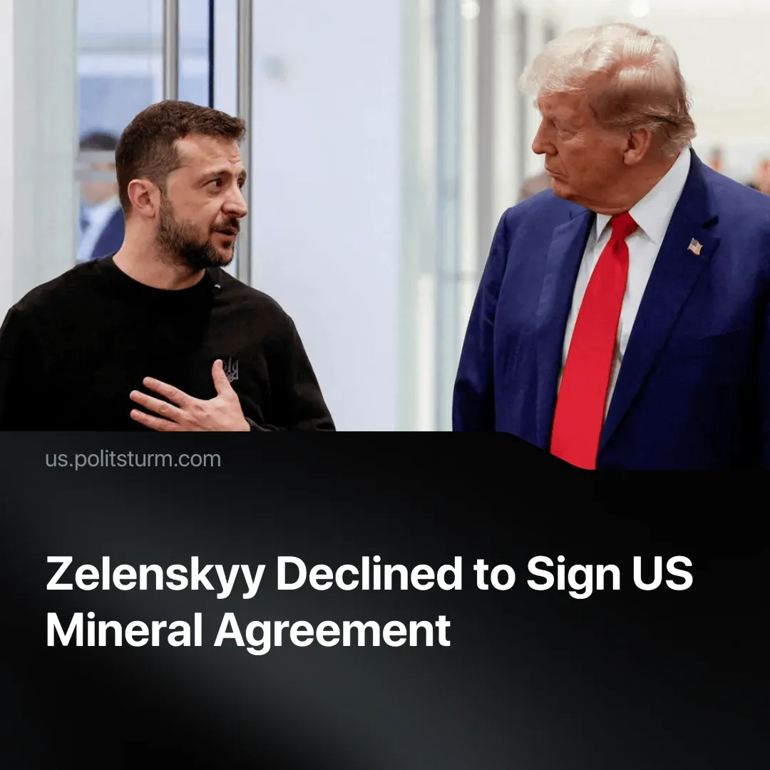

Original article
2025-02-21
2 min read

Ukrainian President Zelenskyy refused to sign the US proposal for agreements on rare earth minerals.
Details: During a conference in Munich, Germany, on February 15, 2025, Zelenskyy told journalists that he had instructed his ministers to reject the U.S. proposal because it was too U.S.-focused.
► Zelenskyy stated, “I didn’t let the ministers sign a relevant agreement because in my view it is not ready to protect us, our interest.”
► The proposal didn’t offer any security guarantees that in return for the minerals would protect Ukraine from Russia. In this regard, The Ukrainian PM said, “For me is very important the connection between some kind of security guarantees and some kind of investment”
► The U.S. proposal was intended to “compensate” for the aid provided under the Biden administration and to serve as payment for future assistance under the Trump administration.
Context. Since the inauguration of Trump’s administration, the U.S. has adopted a hawkish foreign policy towards their supposed “allies”, using threats of tariffs to advance policies favorable to American interests.
► Donald Trump has criticized Zelenskyy for prolonging the conflict, suggesting that the Ukrainian leader should have ended it sooner, and has even referred to him as a “dictator”.
► According to the Kiev Institute of the World Economy's Aid Tracker for Ukraine, the U.S. has provided nearly $120 billion in aid. Although Europe collectively has contributed more, no single European country has matched the U.S. contribution.
Important to Know. The U.S. is leveraging Ukraine’s reliance on American military aid to negotiate favorable terms for rare earth materials, aiming to reduce its own dependence on China. The U.S. wishes to openly reassert their global dominance.
► These rare earth materials are crucial for the aerospace, defense, and nuclear industries.
► Zelenskyy is open to signing the deal if it includes proper guarantees for protection and investment. Much of the national industry has already been privatized during and before the conflict.
► As of February 5, 2025, Zelenskyy reported that more than 45,100 Ukrainian soldiers have lost their lives since the conflict began, with workers on both sides having died in service of capital interests.
Conclusion. In the end, the Ukrainian prime minister refused to sign the deal, not out of principle, but because of the lack of security guarantees and investment. Capitalist states represent the interests of capitalists and are therefore happy to keep their state entrenched in dependency as long as there are profits to be made. The common working people pay the price.

Original article

