Zelensky meets Meloni in Italy and Urges More Arms Supplies
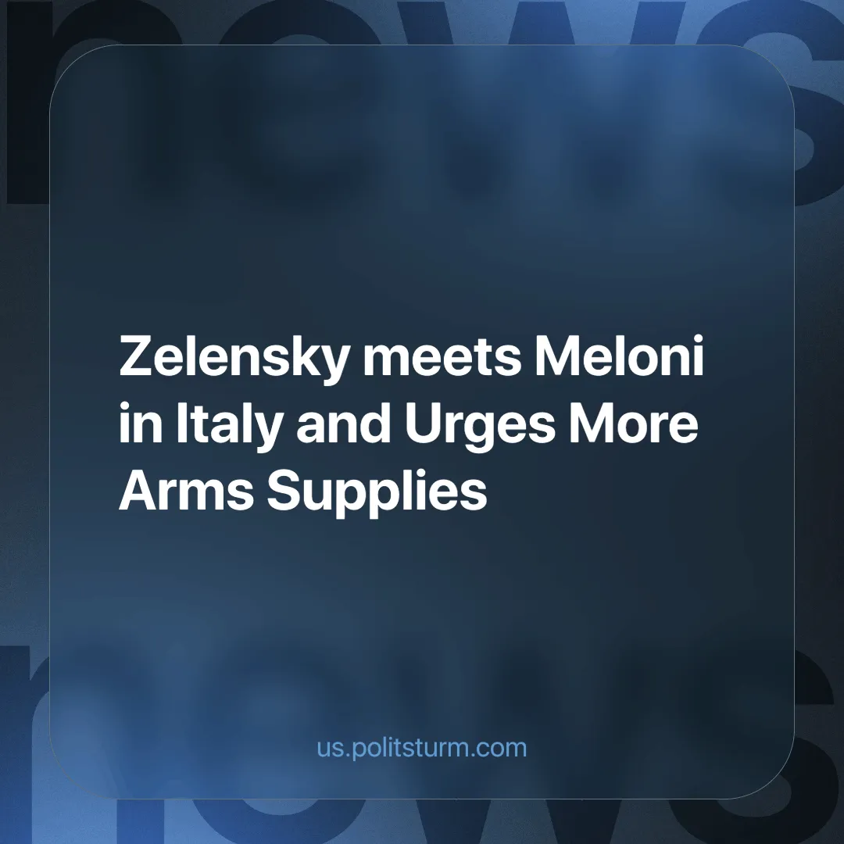

Original article
2024-09-27
5 min read

In Cernobbio, Italy, on Sept. 9, 2024, Ukrainian President Volodymyr Zelensky met with Italian Prime Minister Giorgia Meloni on the sidelines of The European House - Ambrosetti forum. This is an international meeting to discuss mainly economic issues held every year since 1975, on the first weekend of September, at Villa d'Este near Lake Como. Zelensky calls for an acceleration in the supply of armaments, particularly Samp-T air defense systems [1].
Zelensky stressed the urgency of receiving new military supplies, pointing out that the Ukrainian army is increasingly dependent on support from its Western allies. Italy has previously supplied weapons to Ukraine and reiterated its commitment to supporting the Ukrainian state's defense, but stressed that the use of such armaments must remain confined to Ukrainian territory. Zelensky, however, appears to be seeking to broaden the scope of operations, pushing for the United States and other European allies to allow the use of armaments to strike strategic targets in Russian territory.
Tensions on this front are high: according to the Reuters news agency, the Ukrainian government has reportedly already sent the United States and the United Kingdom a list of potential targets in Russia, including military command centers, weapons depots, and fuel depots. These developments increasingly raise the possibility of a sharp escalation, directly involving NATO in a broader conflict scenario [2] [3].
The meeting comes after Zelensky had already attended the summit at Ramstein Air Base, Germany, where Washington announced an additional $250 million in military aid for Kiev, Germany announced the supply of 12 more panzers, and the European Commission mobilized a new €40 million aid package [4].
Meanwhile, on the international front, Hungarian Prime Minister Viktor Orban, who was also present at the Ambrosetti forum, again called for an immediate cease-fire, a proposal that Zelensky firmly rejected, saying that Russian President Vladimir Putin has never respected previous agreements [5].
In this context, we also need to clear up some controversial or completely mistaken ideas about the EU-US alliance. A country’s membership in an alliance doesn’t guarantee smooth cooperation between all the nations in the bloc, since each country, along with its state apparatus and foreign policy, operates based on the interests of its own national bourgeoisie. It’s not that alliances are pointless for capitalists; at certain times, they defend monopolists' interests on the global political stage with a united front, and each country finds it beneficial to participate in specific areas proposed by one of the bloc’s nations (this was also discussed in the previous news material dedicated to the agreement between the Prime Minister of Italy and the leader of the PRC).
Putin, for his part, reiterated that conquering the Donbass remains his “primary objective” while the conflict continues to cause massive casualties and devastation.
Wars are nothing more than conflicts between capitalist states vying for control of resources, markets and strategic areas, with the working classes paying the highest price in terms of suffering and sacrifice. This is very clearly demonstrated by US Senator Lindsey Graham's recent statement that Ukrainian mineral resources, estimated to be worth $10-12 trillion, are a key motivation for U.S. support, makes explicit the role that capital and natural resources play in this dispute, from all sides and groups involved in the conflict [6].
The same is the case for Russia. After 2014, Russian capital was expelled from the Ukrainian market, that is, it lost its main place of application. Sanctions have also made expansion into other regions of the world more difficult. This can be traced back to the Russian Federation's direct investments in other countries. Thus, from 2013 to 2020, the presence of Russian companies in foreign economies steadily declined. This was one of the main reasons in terms of the economic and political impact of the 2022 “special military operation”. All attempts to win back Ukrainian markets through treaties and diplomatic interference had failed, and the state has decided to find a military solution:
“War is a continuation of policy by other means. All wars are inseparable from the political systems that engender them. The policy which a given state, a given class within that state, pursued for a long time before the war is inevitably continued by that same class during the war, the form of action alone being changed.” (Vladimir Lenin, “War and Revolution”)
Zelensky continues to be a puppet in the hands of Western capital, playing to the interests of the Western powers, particularly the United States and its allies in NATO, who do not supply arms to Ukraine out of solidarity or humanitarian reasons, but to pursue their own strategic goals; so much so that Ukraine and its terrain remains the chessboard of confrontation between imperialist blocs.
Italy, under the leadership of Giorgia Meloni, is following this line, militarily supporting Ukraine, not to defend the rights of the Ukrainian people, but to remain part of the capitalist Western bloc and secure its geopolitical position. Meloni, while declaring that the weapons provided should not be used to strike Russia, nonetheless accepts the logic of conflict, continuing to spend resources that could be allocated to the Italian working class, which is struggling due to austerity policies and the economic crisis.
In any case, we return to the exact same conclusion: there is no agreement between capitalists or between politicians (representatives of these same capitalists) that is not linked to the interests of national monopolies, cartels, trusts, blocs and alliances of political influence. There is no agreement that is not linked to the economic interests of the wealthy exploiting minority, and which is not, as a result, linked to the oppression and exploitation of the vast majority.
But “like every crisis in the life of individuals or in the history of nations, war oppresses and breaks some, steels and enlightens others.” (Lenin, “Reply to P. Kievsky (Y. Pyatakov)”)
Ukraine, Palestine and many other conflicts that are breaking out in the world are a time bomb: the world crisis, the next global conflict is knocking at our doors, and the workers feel it or, those who have not yet felt it, will sooner or later feel it directly on their skin. The world has already experienced two world wars caused by the interests of monopoly powers.
In order not to repeat this, let us continue to fight not for abstract slogans, but for real world peace. Capitalism has already exhausted its progressive role in the development of society. If the development of society does not follow the development of productive forces, then, human society will be doomed to perdition. Contrary to the bourgeois conservatives of the old system, hoping for the eternity of capitalism, the infinity of exploitation, and the unstoppability of wars, society must move on and continue its development in a new social system; and this system will be socialism. This system will not grow out of capitalism, as it is against the interests of the capitalists. It must be built by the workers after having overthrown capitalist power. However, to struggle against capital requires Marxist-Leninist theory, which fully lays bare our social relations and the interests that stem from them. Our organization has been working on this for many years and we call on all conscious workers to unite and join our ranks to work together to form a party that will show the workers of the world the right way.
Sources:
[1] governo.it - “Incontro Meloni - Zelensky a Cernobbio” dated September 7, 2024;
[2] europari.europa.eu - “L'Ucraina deve essere in grado di colpire obiettivi militari legittimi in Russia” dated September 19, 2024;
[3] tass.ru - “Reuters: Украина передала США список целей в РФ для ударов западным оружием” dated September 14, 2024;
[4] tg24.sky.it - “Zelensky: "Ho un piano, lo mostrerò a Harris e Trump. Grazie Meloni per sostegno"” dated September 7, 2024;
[5] avvenire.it - “La visita. Orbán “suggerisce” a Zelensky la tregua con Putin, l'ucraino lo ignora” dated July 2, 2024;
[6] cremaoggi.it - ““Ucraina miniera d’oro, ecco perché Usa devono aiutarla”: l’appello del senatore” dated June 11, 2024.

Original article

