Zelensky Falsely Claims USSR Killed Languages
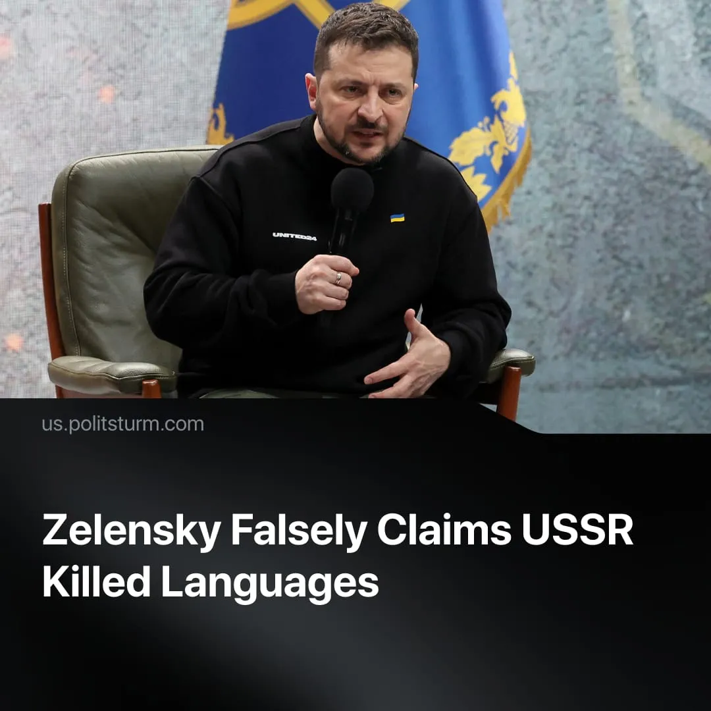

Original article
2026-07-30
2 min read

Zelensky claims the USSR killed the languages of its peoples. The Soviet Union created written alphabets for many that had never had one.
In a recent interview with far-right US commentator Laura Loomer, Ukrainian President Volodymyr Zelenskyy claimed that the USSR "killed all the languages" of its peoples.
Quote: "During 70 years plus of the Soviet Union period, they killed all the languages... They came, occupied the territories, then killed your traditions, killed churches... Killed religion. There is no religion, only the Communist Party. This is the only one religion".
Context. Zelensky made these claims while trying to win over the MAGA base after earlier pressure from Trump to end the conflict. Loomer is a MAGA influencer, openly admits she was previously anti-Ukraine, and has direct access to Trump as an informal advisor. Republican backing for military aid to Ukraine has fallen from 51% in July 2025 to 43% in February 2026.
► This follows a broader pattern of capitalist officials distorting the history of the Soviet Union to justify anti-communist politics today. In the US alone, Secretary of State Marco Rubio recently convened 60 countries to coordinate against "far-left political terrorism," describing the left as a "scourge" and "cancer". At the same time, House Speaker Johnson has defended a $350 billion increase in Pentagon spending to fight "communism on our own shores".
In reality, Communists have long upheld the right of nations to self-determination. Stalin defined this in “Marxism and the National Question”: “The right of self-determination means that only the nation itself has the right to determine its destiny, that no one has the right forcibly to interfere in the life of the nation, to destroy its schools and other institutions, to violate its habits and customs, to repress its language, or curtail its rights”.
► The USSR comprised 15 Union Republics and dozens of Autonomous Soviet Socialist Republics and regions, each operating in its own national language and with its own nationally-specific constitution.
► The early Soviet Union reversed Tsarist Russification. The soviet constitution forbade discrimination based on language. Policy adopted in 1923 actively promoted non-Russian languages in education, government, and the press. Under Soviet power, 48 nationalities acquired a written alphabet for the first time. Before the revolution, the majority of the population in the national regions was illiterate; by 1939, the overwhelming majority had become literate.
► The Communist Party was not a "religion" and religious belief was not outlawed. The 1936 constitution enshrined "freedom of conscience," separating religion from the state. Religious worship was permitted as a private affair, but so too was freedom of anti-religious propaganda; the state simply did not fund places of worship or allow religious instruction in public schools.

Original article

