Xi Jinping Writes Open Letter to Brazil Ahead of the 2024 G20 Summit
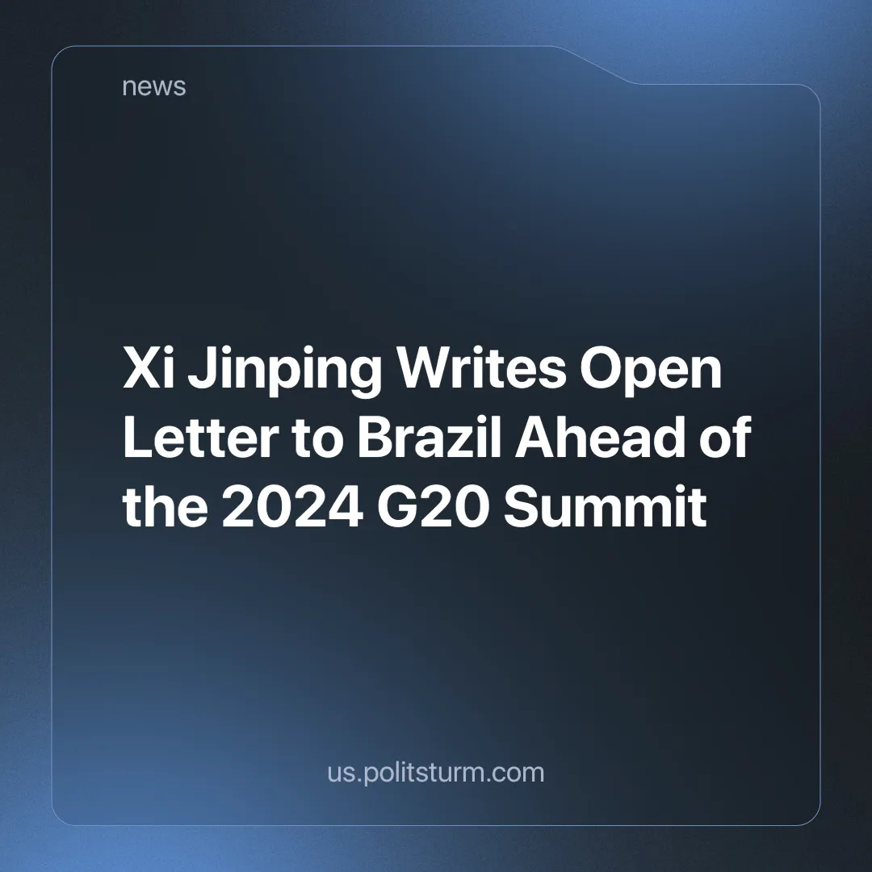

Original article
2024-12-05
3 min read

G20 summits are annual meetings of the world's largest economies. They consist of 19 countries, the African Union and the EU. G20 summits are the culmination of many other meetings that take place throughout the year, where these countries informally discuss and coordinate global policy on trade, health, climate and other issues.
Notably, the G20 conferences and their resolutions have no binding enforcement and end up being more for show and to give the citizens of the world, who are watching new wars declared, rising tensions, climate change and many economic problems, the impression that these issues are being taken seriously.
The capitalist countries, due to the individualist profit motive and competition which will contradict any national or international plan to tackle global problems (which often means sacrificing profits), cannot easily effectively mitigate these issues, let alone solve them completely and in the timely manner required.
Ahead of the 2024 summit in Rio de Janeiro, Brazil, Xi Jinping wrote an open letter to the host country to discuss the long-standing relationship between the two countries. In the letter, he talks about cooperation between the two countries and the growth and development it could bring [1].
Many non-communists, as well as many self-proclaimed communists, consider China and the CPC that governs it to be socialist; adhering to Marxist-Leninist principles adapted to new, modern conditions.
In his letter, besides touching on historical and cultural ties, Xi focuses on economic investment.
“China has been Brazil’s largest trading partner for 15 consecutive years, and is a major source of foreign investment in Brazil. According to statistics of the Chinese side, China’s annual imports from Brazil in the past three years have stayed above US$100 billion…
…We should promote synergy between China’s Belt and Road Initiative and Brazil’s development strategies, and we should keep enhancing the strategic impacts of our mutually beneficial cooperation, broaden its scope, and break new ground.”
As China's (state and private) monopolies completely dominate their national economy, they are trying to expand into new countries. The Belt and Road Initiative is an expression of this. We have previously written about how China's New Silk Road is subjugating the world.
Chinese capital seeks to subjugate developing countries. They are turned into simple sources of raw materials and cheap labour. This can be seen in the relationship between exports and imports between the two countries, with Brazil mainly exporting raw materials or simple commodities and importing industrialised products from China. We discussed this in a previous article.
As China builds factories in Brazilian territory in order to exploit the Brazilian working class at a cheaper wage than that of their own workers, these "socialist" companies are being investigated for illegal and degrading working conditions [2].
The letter also makes statements in support of developing countries. As tensions between Eastern and Western imperialism grow, China is trying to position itself as a leader of the so-called "Global South" against primarily American imperialism.
Multipolarity by itself means nothing more than capitalist competition. Different capitalist powers are growing and trying to claim more of the world for themselves. By positioning itself as the leader of the developing world and giving out huge loans, China is ensnaring countries in a system of debt traps and forcing them to align themselves with the Eastern bloc. You can read more about this here.
But more important than what the letter says is what it doesn't say. While China tries to portray itself as a socialist country, it does not once mention class struggle, the proletariat or the achievement of socialism. It attempts to maintain its socialist image to hide the real class relations within the country and its capitalist ambitions internationally.
Socialism can only be achieved through the overthrow of the capitalist system, which can only be achieved through the class struggle —a fierce battle between the working class, and the capitalists. The proletariat seeks to replace the exploitative system, which serves only the interests of the ruling capitalist class, with socialism.
Socialism is a system based on the common ownership of the means of production, which in this way does not allow the exploitation of the working class and directs the economy towards satisfying the needs of all.
A socialist country, where all the means of production are owned by society and centrally planned for the benefit of society, cannot exist alongside billionaires. Billionaires exist because of the exploitation of the working class through private ownership of the means of production; by taking a portion of the value of what the working masses produce and privately accumulating it as their own individual profit. Sources show that China has the highest (lowest estimates show second-highest) number of billionaires in the world [3] [4].
Behind the red flags and pseudo-socialist rhetoric, Chinese capital is expanding and exploiting more and more workers worldwide. The proletarians of the world must not count on one capitalist power to save them from another. The working class must liberate itself through organised struggle against the capitalist system and the capitalist class.
Genuine communist parties capable of leading this struggle are sorely needed. If you want to help work towards the formation of these parties, consider joining Politsturm.
Sources:
[1] Folha de S.Paulo — A Friendship Spanning Vast Oceans — 17/11/2024
[2] Folha de S.Paulo — Fábrica da BYD na Bahia é investigada por suspeita de trabalho degradante — 30/11/2024
[3] Forbes — The Countries With The Most Billionaires 2024 — 03/04/2024
[4] Statista — The 20 countries with the most billionaires in 2024 — 04/07/2024

Original article

