China's Xi Visits Moscow
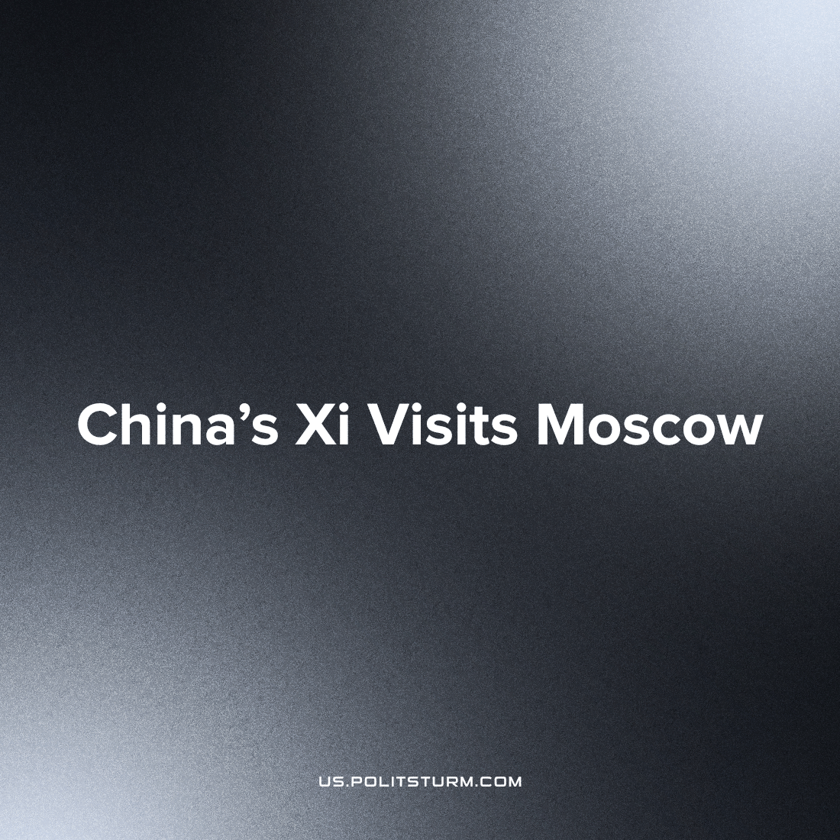

Original article
2023-04-05
3 min read

President Xi Jinping of China and Russian President Vladimir Putin met in the Kremlin to discuss the close ties and strategic vision shared by China and Russia on the first day of the state visit, framed by Beijing as a peacekeeping project, against attacks from Kiev and the West. This meeting prefaced the Chinese declaration for peace in Ukraine, and its calls for the reversal of the deployment of nuclear weapons to the front.
This is the Chinese leader's first visit to Russia since Moscow launched its military operation in Ukraine, and the visit took place only days after the International Criminal Court in The Hague accused the Russian president of committing war crimes [2] in Ukraine and issued a warrant for his arrest.
Xi Jinping and Vladimir Putin are positioning themselves as peacemakers, again advertising the proposed plan to end Russia's war in Ukraine, which in essence is a proposal to consolidate Russian strategic and territorial gains and stop military operations for a certain period of time, which is primarily beneficial to the Russian bourgeoisie, which will exploit the land, subsoil, labor resources, while the West will continue to supply Ukraine with loans, promote its defense industry, and build up Ukraine's capacity for revanchism.[3]
So, what does China get out of it?
There have been many changes in Russian-Chinese relations over the past year. Cooperation with China deepened after the sanctions came into force, while Russia actively began to urge countries to abandon the dollar in international trade. The main beneficiary of such a policy aimed at shifting the dollar as an international currency is China, since it is one of the most powerful economies in the world, which imports its goods around the world, and clearly does not have an interest in maintaining the disadvantageous formal dominance of a rival national currency - the US dollar.
The results of such relations between the two states were not long in coming - the Chinese yuan will replace the US dollar as the most traded currency in Russia. [4]
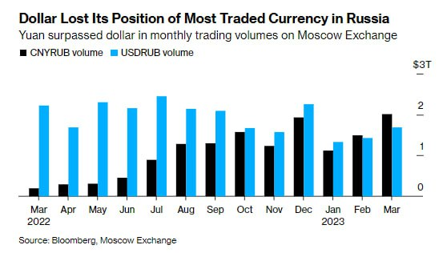
Chinese monopoly corporations own major stakes in big Russian companies, and owns rights to extensive Russian resources; therefore, Xi Jinping's defense of the Russian states' gains in Ukraine and its admonition against continued fighting is simply defending the returns on China's own investments.
A couple of days after the meeting, Putin approved a new version of the Russian Foreign Policy Concept: "Cardinal changes in international life required us to seriously adjust key strategic planning documents." [5] In this updated foreign policy outline, the United States is identified as the main conductor of the anti-Russian line, and strategic partnership with China and India is officially announced.
The Russian Federation in the Concept of Foreign Policy has otherwise clearly fixed the idea that it does not have hostile intentions towards the Anglo-Saxon countries and Europe. Russia considers 'Islamic civilization' friendly and will strengthen comprehensive mutually beneficial cooperation with it, opening up potential alignment of China and Russia with the regimes such as that of the Taliban in Afghanistan to one extreme, and also continued serious alignment with the Islamic Republic of Iran.
Russia is trying to strengthen its position, while the West opposes it. But everything goes to the fact that only two countries will remain the beneficiary of this conflict - China and the United States. China has guaranteed itself an ally with one of the largest nuclear weapons in the world - forcing a military monopoly into servitude through economic dependency. The United States guaranteed Ukraine's withdrawal from the CIS space and the transformation of the latter into a NATO military base, but which does not exclude Chinese capital which flows across the borders of the conflict.
Source: 1, 2, 3, 4, 5

Original article

