Writers Guild Accuses Streaming Services Of Monopolizing The Market
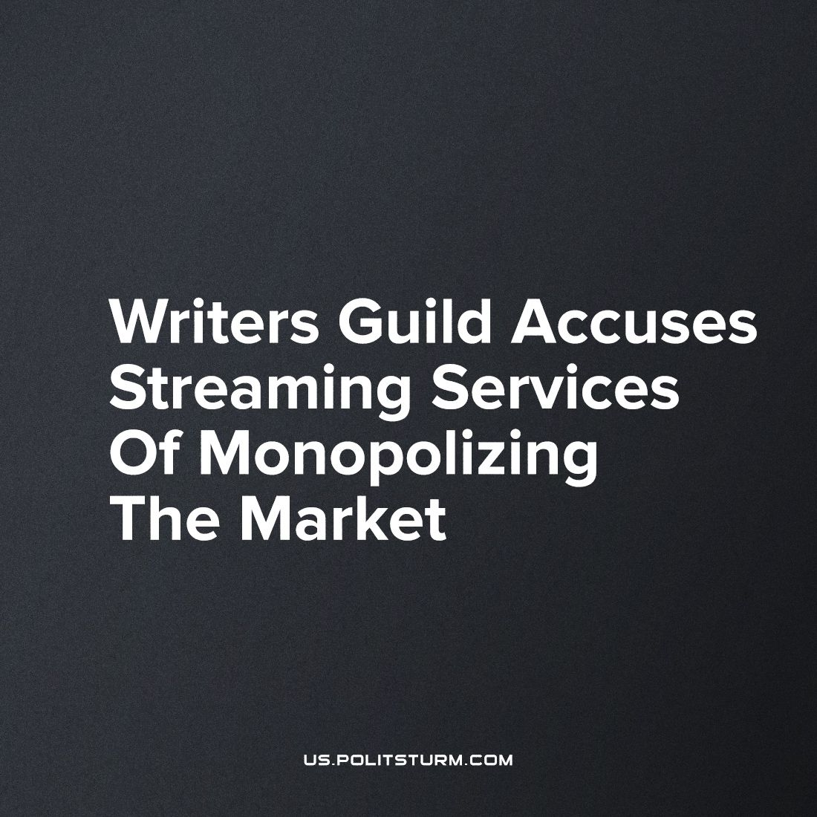

Original article
2023-10-15
1 min read

The Screenwriters Guild on their website accuses streaming platforms Netflix, Amazon and Disney of monopolizing the media market. Trade union leaders are calling on the antimonopoly US antitrust authorities to prevent consolidation in the streaming market, because in their opinion this has led to a reduction in the salaries of screenwriters.
Accusing companies of monopolization is like blaming the winter for being cold. The point of their existence is to make a profit, not to benefit customers and workers. It is in their nature to use any means necessary to increase profits. The government stands on the side of companies, so complaining to the government to break up monopolies is useless. The only thing that will protect workers from monopolies is the struggle for workers' power.
Source: Central Trade Union newspaper "Solidarnost’" - "Screenwriters Guild accuses Netflix, Amazon and Disney of monopolizing the media market" from August 21, 2023.

Original article

