The demographic problem in the Russian Federation is getting worse
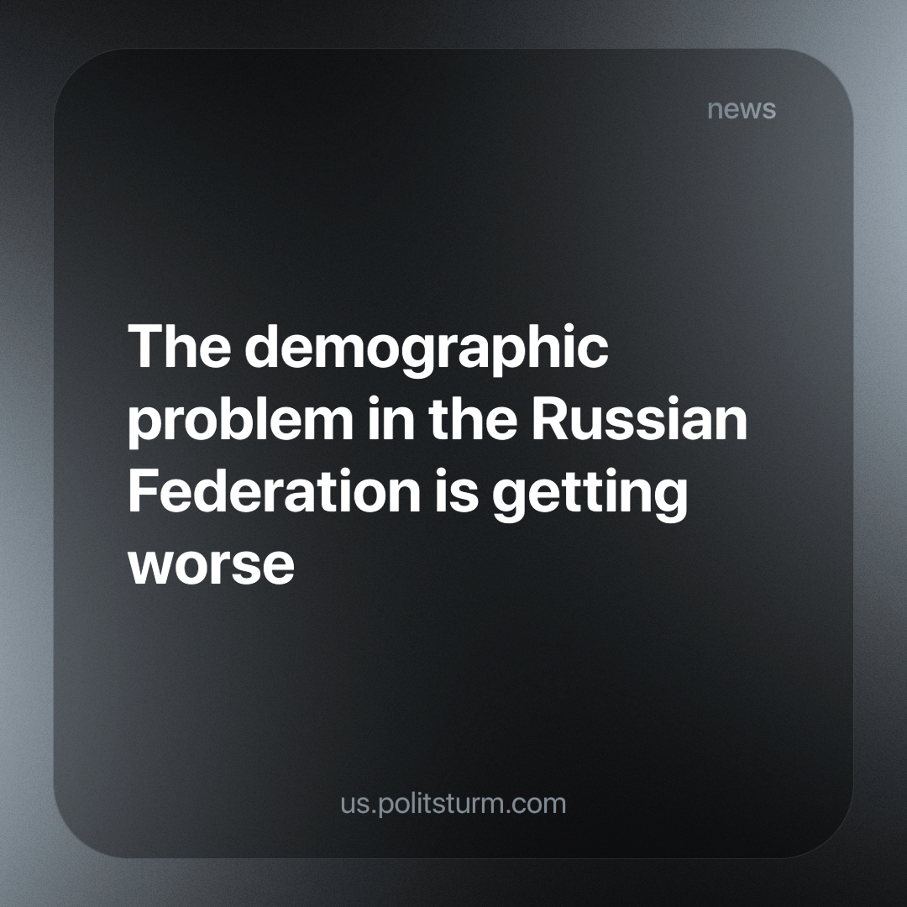

Original article
2023-12-29
2 min read

According to Rosstat's forecast, the population of Russia, excluding the newly annexed regions, may decrease by about 3.2 million people by 2030. This information was presented at a meeting of the Presidium of the State Council for the Development of the Labor Market at the end of September and was confirmed by a source familiar with the relevant data.
At the beginning of 2023, the population of Russia was slightly more than 146.44 million people. Rosstat estimates that the population will decrease in the coming years. If this forecast is correct, by 2030, the population of Russia (excluding the Donetsk and Lugansk People's Republics, Zaporozhye and Kherson regions) will fall to 143.25 million people, which would be the lowest number since 2012. This is shocking because at that time, Crimea was not yet incorporated into Russia, and the incorporation of the territory added about 1.9 million inhabitants.
This forecast has worsened compared to the previous one published in early 2020, when the COVID-19 pandemic and the special military operation in Ukraine had not yet begun. In that, the average variant assumed that by 2030 the population of Russia would be 144.27 million people (a decrease of 2.1 million compared to 2023). The average prediction of the new report indicates that the population will be 1 million less than was predicted in 2020.
Rosstat also announced that it is finalising work on a new long-term demographic forecast, which will cover the period up to 2036, and plans to publish it by the end of October. Factors such as fertility, mortality and migration are taken into account when making the forecast. Rosstat notes that the absolute number of newborns will decrease due to a decrease in the number of women of active reproductive age, but life expectancy will increase, which will lead to an ageing population. However, forecasting migration remains a difficult task due to external economic instability.
Addressing the birth rate decline in Russia remains difficult. The authorities expressed interest in additional support for families, expectant mothers and traditional values.
In recent years, the demographic problem has worsened in the Russian Federation, and the state authorities still blame the previous leaders for this. But the demographic situation has been deteriorating since the collapse of the USSR; when the socialist economic basis was replaced by a fully capitalist economy. Recently, the situation has worsened under the influence of the foreign and domestic policy of the ruling class of the Russian Federation, which generates emigration, a reduction in the welfare of the population due to sanctions, and military conflicts. Only a socialist economy will help to stabilise the demographic issues of Russia.
Source: RBC - "Rosstat estimated the dynamics of the population of Russia by 2030" dated October 11, 2023.

Original article

