World Leaders React to Maduro’s Capture
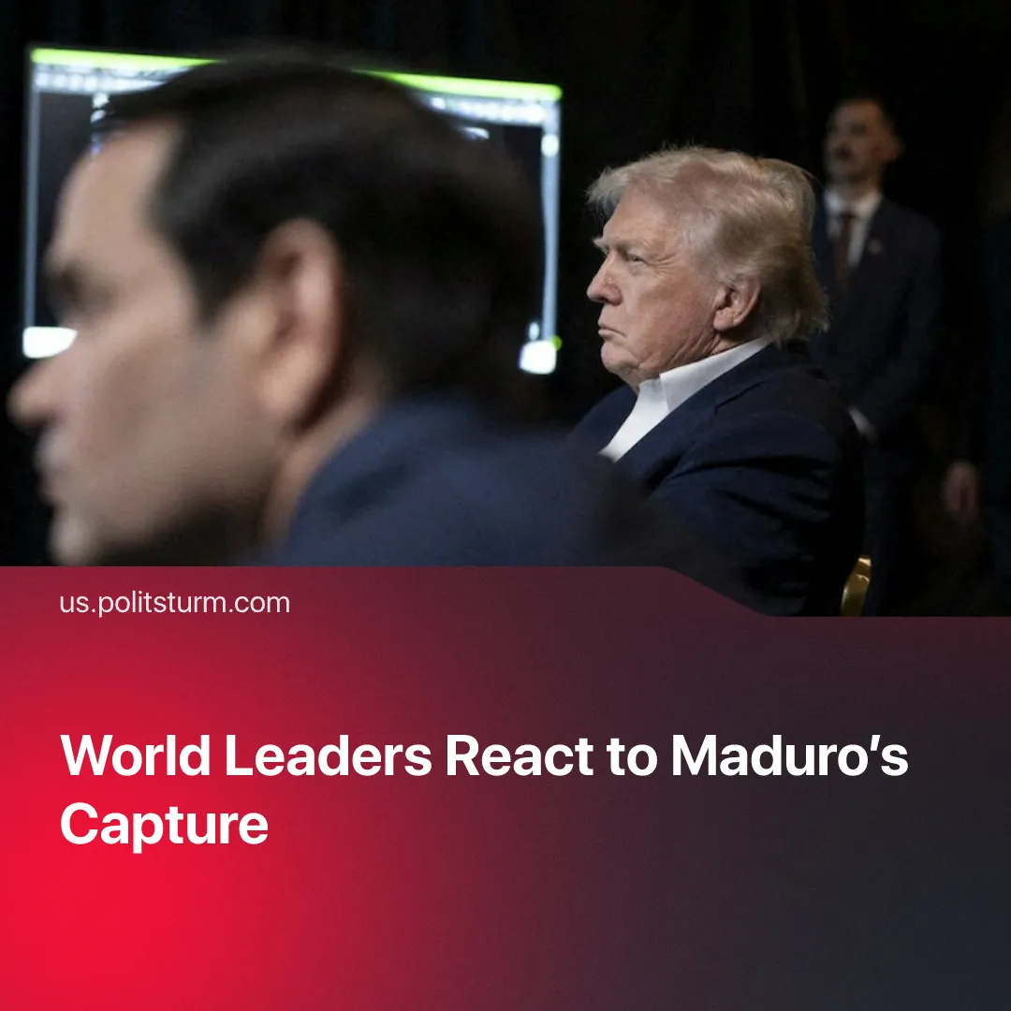

Original article
2026-01-04
2 min read

Maduro's allies from Chinese bloc limited themselves to "condemnation" of the US invasion. A similar reaction occurred during the US strikes on Iran.
Details. Amidst various US strikes on Venezuelan territory, Trump announced on Truth Social that the US had captured Maduro along with his wife, with them now being in New York. Secretary of State Marco Rubio has stated that Maduro will stand trial, whilst Trump himself has said at a press conference that the US will now “run the country” and that a second, larger attack may take place if deemed necessary.
► Venezuelan allies have condemned this action only after the event. Russia’s foreign ministry has called this an “act of armed aggression” and stated that Caracas "must be guaranteed the right to determine its own destiny". Russia reiterated its support to Venezuela and whichever course it chooses to defend its national interests and sovereignty.
► China has also strongly condemned what it calls “hegemonic behaviour”, urging that the US abide by international law. Just hours before the strike a special envoy was in Venezuela reviewing more than 600 existing agreements that strengthen the economic and political alliance between the two countries, reaffirming their “unbreakable” bond against the US blockade.
► Other allies, such as Cuba, Colombia, Brazil and Iran have also strongly condemned the attack and the violation of Venezuela’s sovereignty, with Cuba calling this an act of state terrorism. Despite these condemnations, Venezuelan allies have not yet offered any significant material support to Caracas.
► The EU has reacted more mildly stating it is closely monitoring the situation and calling for restraint, but reiterating that it considers Maduro illegitimate. Countries like the UK have denied involvement in the operation whilst in Germany, a member of the Christian Democratic Union called the attack a coup. France said that the move violates international law and called for the US to respect national sovereignty.
► Regional US allies such as Ecuador and Argentina have defended the attack, reinforcing claims that Maduro is linked to the illegal drug trade and repeating US calls that Maduro’s rule was illegitimate.
Context. The move is a culmination of the US’s attempt to remove Nicolás Maduro from power as part of its renewed focus on securing its own hemisphere, as stated in its latest Security Strategy.
► Venezuela was one of the strongest bastions of “Eastern imperialism” within the West, having strong economic and political ties to Russia, Iran and China; but partners remain preoccupied with more pressing matters, such as Russia’s Special Military Operation, renewed possibility of missile strikes on Iran as well as political unrest, and China’s huge military exercises around Taiwan.
► The invasion was preceded by lengthy negotiations, during which Maduro attempted to sell national resources to American corporations. Read more in our organization's position.

Original article

