Working Age Americans Dying at Higher Rates
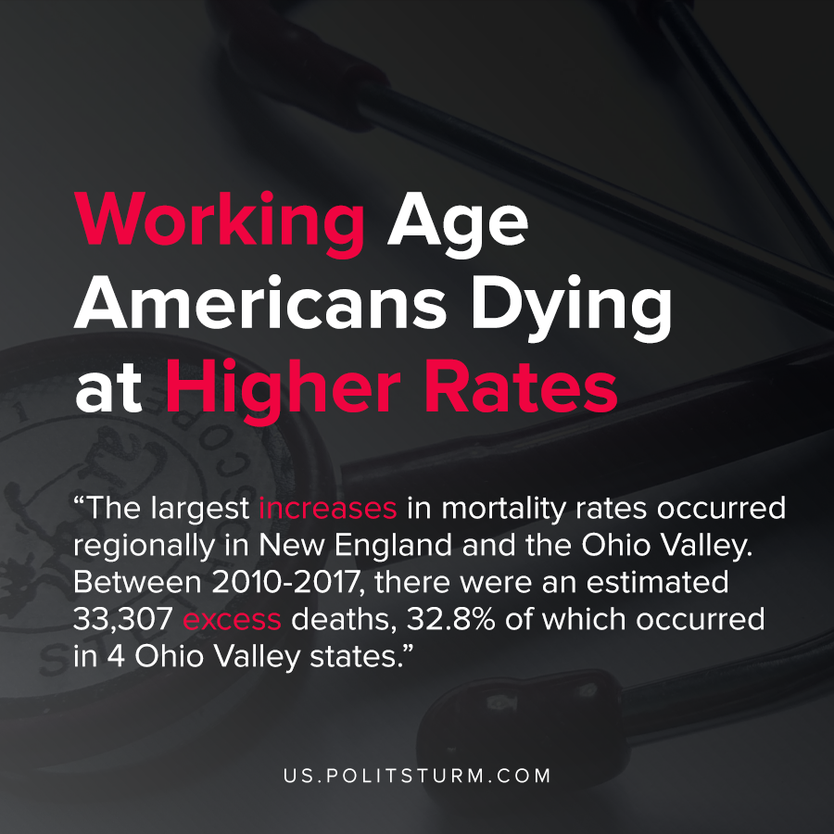

Original article
2021-02-17
1 min read

Recent research by Virginia Commonwealth University found an alarming trend about U.S. life expectancy and mortality. Midlife mortality in the United States was on the rise from 2014 with deaths caused by drug overdoses, alcohol abuse, suicides, and other organ system diseases.
The largest increases in mortality rates occurred regionally in New England and the Ohio Valley. Between 2010-2017, there were an estimated 33,307 excess deaths, 32.8% of which occurred in 4 Ohio Valley states.
The researchers note that the United States has not kept pace with other developed countries with respect to rising life expectancy, and on the contrary is declining.
The study concluded that the implications of decreased life expectancy to the economy and society were “substantial, making it vital to understand the underlying causes” and concluded that it is necessary to develop “a better understanding of the root causes of these deaths, including the role of drugs, obesity, the health care system, stress and the economy”
The U.S. healthcare system and the economy cannot be separated as the profit motive of the economy influences the health care sector and the provision of health care in the country.
The capitalist economic system, which is subject to recurrent crisis of overproduction, certainly affects public policy and health. Deindustrialization fueled by capitalists seeking the maximization of profit and the maximum exploitation of labor has contributed to a loss of manufacturing jobs. The study even cites these factors among the possible explanations for the increasing mortality rates.
In order to improve public health outcomes in the country, it is necessary to move beyond the limitations presented by capitalism.
Source: 1 , 2

Original article

