Half of Workers Are Too Stressed to Take a Holiday
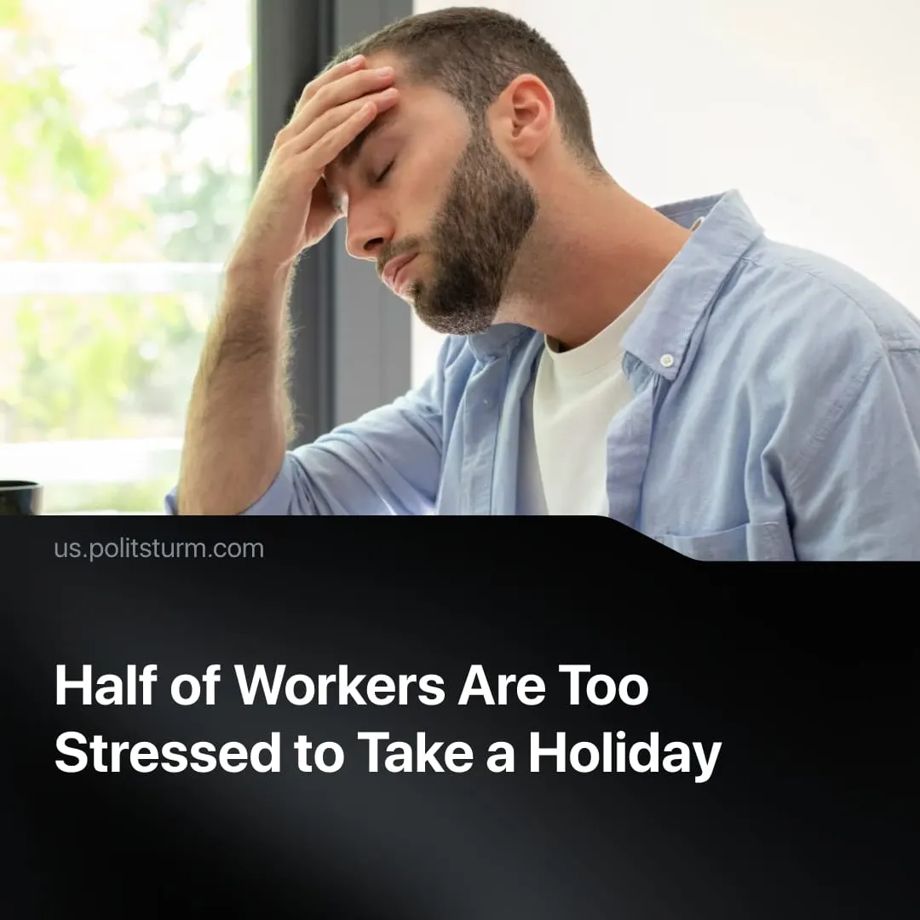

Original article
2026-09-17
2 min read

Nearly half of workers feel anxious about taking vacation due to accumulated work, with many choosing to avoid paid time off altogether. Meanwhile, capitalists spend hundreds of millions living in constant luxury.
Details. A recent study found that 48% of workers feel anxious before their paid time off even begins. During their holidays, 68% continue monitoring their inboxes and 65% work extra hours beforehand to compensate. Among Gen Z workers, 52% consider forgoing their holiday entirely to avoid the stress. Interestingly, a large majority of the workers also said that they wanted AI to help them return to office after their PTO.
► The capitalist class that lives off their labour has no such anxieties, delegating almost all day-to-day work to managers, whilst they live in almost constant luxury. For example, Jeff Bezos spent $500 million on a superyacht, around 7,800 times the average American annual salary. Bernard Arnault, the wealthiest person in France, chartered a private superyacht for his summer holiday valued at over $150 million. In India, Anant Ambani, son of Asia's richest man, spent an estimated $600 million on his wedding, while the average Indian worker earns under $500 a month.
Context. Capitalists are compelled by competition to maximise profits and reduce costs, including by employing new technology, intensifying labour, and laying off workers. This constant reduction in workforce fuels the PTO stress: each worker's workload is intensified, so taking time off risks falling behind and being fired.
► The study's proposed solution is an AI tool to prepare workers before they leave and catch them up on return. But while workers want AI to reduce their workload, capitalists will only use it to intensify work. Because "AI makes it easier to do more," workers are expected to increase their productivity, with work increasingly spilling into lunchtimes and weekends. AI also threatens job security, through the first eight months of 2026, 116,175 AI-linked layoffs were recorded in the US alone.
► Workers’ are also subject to increasing stress from rising costs of living. More than half of Americans say grocery costs are a major source of stress, and nine in ten believe the country is in a cost-of-living crisis. On top of that, America’s war on Iran has driven up fuel prices worldwide, raising commuting costs and cutting into real wages. These burdens only grow heavier for workers, while Wall Street continues to prosper.

Original article

