Wisconsin Sawmill Stops Hiring Children After 16-Year-Old Died On The Job
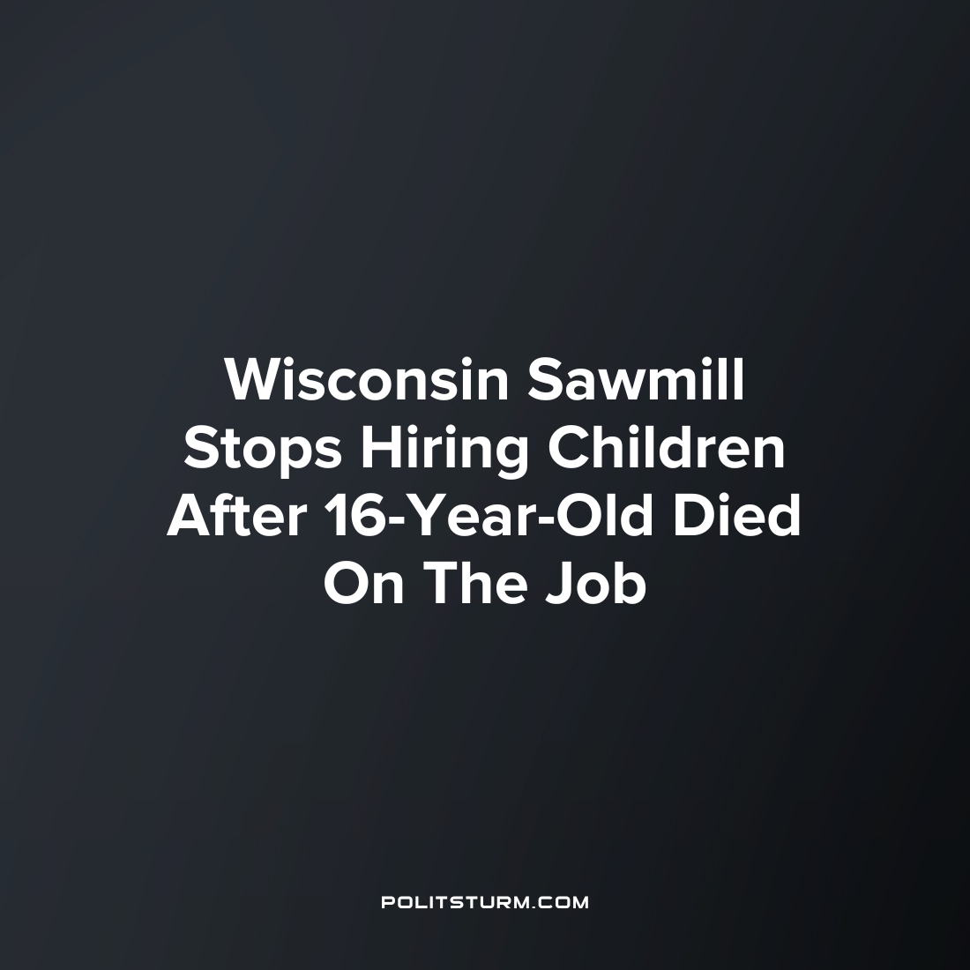

Original article
2023-09-19
2 min read

The US Department of Labor accused the company Florence Hardwoods of illegally operating machinery which risked children’s lives for profit. In response, the Wisconsin sawmill operator has said it will stop employing children after the devastating loss of a teenager who died on the job this summer.
In July, 16-year-old Michael Schuls died of "traumatic asphyxia," according to the coroner's office, two days after he became trapped on a conveyor for freshly cut stacks of lumber while working at the Sawmill company Florence Hardwoods, the local Green Bay Press-Gazette reported. According to his GoFundMe, the funeral was later attended by hundreds of people.
A report from the Florence County Sheriff's Office, obtained by the Press-Gazette, said Schuls had been left alone on the job and was seen on video trying to "straighten out the wood" on the conveyor, where he became trapped. He was discovered 17 minutes later, presumed dead.
In a statement on Thursday, Seema Nanda, the top lawyer at the US Department of Labor, accused Schuls' employer of negligence,
"Florence Hardwoods risked the life of a child by allowing him to operate dangerous equipment in violation of federal child labor laws, and now family, friends and co-workers are left to grieve," she said.
The statement came following a federal investigation into Florence Hardwoods that found that another three children between the ages of 15 and 16 had been injured on the job in the same sawmill location since November 2021. The company also employed nine children, some as young as 14 years old, "to illegally operate machinery," including saws for processing lumber.
As part of a September 6 consent order and judgment against the company, Florence Hardwoods has agreed to stop hiring anyone under the age of 18, having already fired those still working there in the immediate aftermath of Schuls' death. The company employs just over 60 people, according to its website. The company has also agreed to pay $190,696 in civil fines, for the infractions of labor laws.
This recent move by a capitalist is one of an endless list of exploitation by the capitalist class to seek maximum profits. This even includes exploiting children outside the scope allowed by law. While children are exposed to potentially hazardous workplace conditions and working long hours, the private profits are earned by the employer, who will pay a meager fine for the violations of labor laws and continue business operations.
Source: 1

Original article

