Will There Be a Nuclear War?
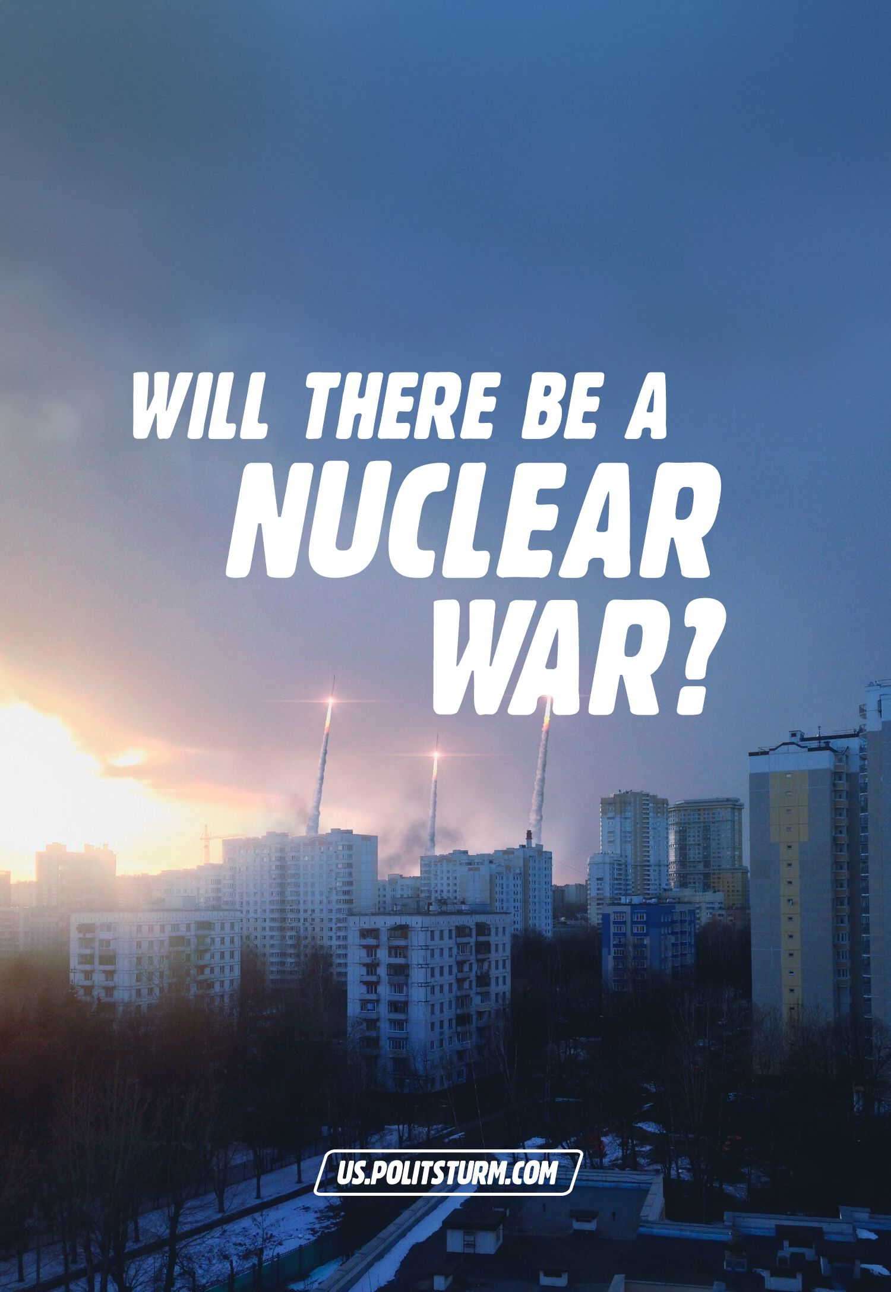

Original article
2023-11-01
33 min read

Words about the possible use of nuclear weapons and the subsequent plunge of countries into a global nuclear war have been actively filling the information space of Western and Russian media for the past two years. Society reacts in different ways: some people consider it a scarecrow or illusion, others are setting up bunkers, and the latter are passively watching, hoping for the best.
We examine whether nuclear war is possible, what are the arguments "for" and "against", and what should be done to ensure that the image of "atomic winter" remains only in mass culture.

I. How realistic has nuclear war become?
The list of the largest nuclear powers officially includes 5 states: Russia, USA, UK, France and China. Russia ranks 1st in terms of the number of warheads. North Korea, Pakistan and India also have nuclear weapons.
There are assumptions about the presence of nuclear weapons in Iran and Israel. However, Tehran claims that its nuclear program is only for peaceful purposes, and the International Atomic Energy Agency (IAEA), which controls Iran's nuclear program, says that it has no data confirming Iran's development of nuclear weapons [1]. At the same time, Iran has been found to have uranium enriched to 84%, while 90% is needed to build a nuclear weapon. [2] As for Israel, the Israeli authorities do not officially confirm or deny the presence of nuclear weapons, but some studies and facts suggest that Israel has nuclear weapons [3].
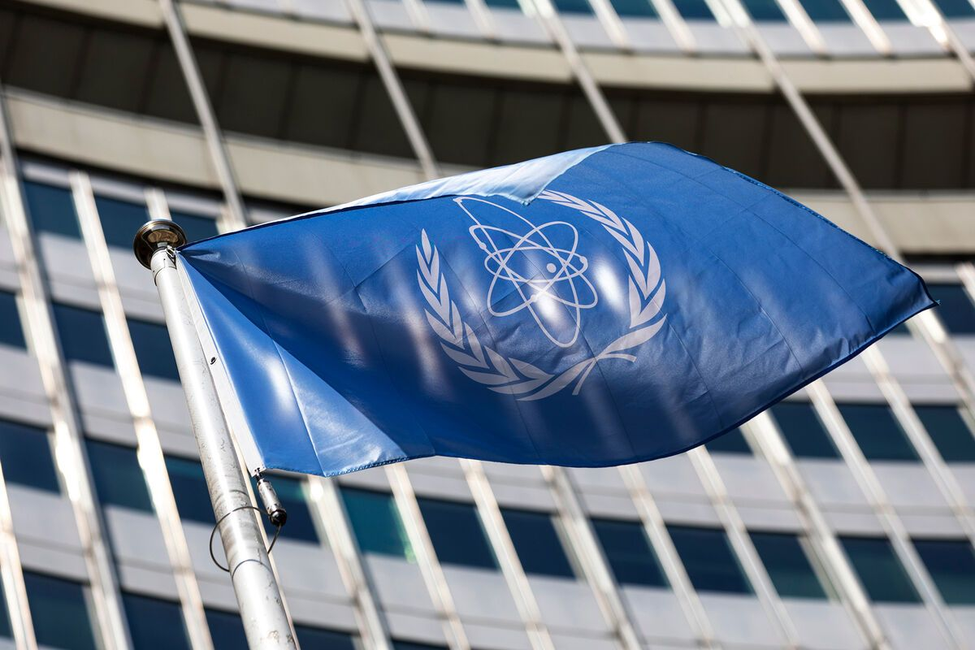
2022 began with another peaceful joint statement by Russia, China, the United States, the United Kingdom, and France against the proliferation of nuclear weapons, the prevention of an arms race, and the inadmissibility of nuclear war [4]:
"We declare that there can be no winners in nuclear war and it should never be unleashed. Since the use of nuclear weapons would have far-reaching consequences, we also reaffirm that nuclear weapons - as long as they continue to exist - must serve defensive purposes, deterring aggression and preventing war. We believe that further proliferation of such weapons must be prevented."
This statement was linked to the future 10th Conference to discuss the Treaty on the Non-Proliferation of Nuclear Weapons (NPT). It was presented by the Russian authorities as a special initiative and as a result of Vladimir Putin's diplomatic efforts. The statement was favourably assessed by the UN Secretary General, the German Foreign Ministry, the State Duma and the Russian Council of Federation.
One way or another, the statement was considered an "important historical event", as there had been no special results on these issues before.
On 9 January 2022, a Russian delegation arrived in Geneva for talks with the United States on security assurances. One of the issues in the talks was nuclear disarmament. Moscow needed uncompromising "ironclad guarantees" on the issue of NATO's non-expansion to the East and, in particular, on the non-admission of Georgia and Ukraine to the alliance [5] [6]. On the latter points, the talks have stalled [7] [8].
Earlier, in late 2021, Putin said that Russia's response to NATO's rejection of security guarantees would depend on military experts and could be "very different" [9].
The U.S. State Department said at the time that Russia was violating the right of sovereign states to choose which alliances to join, and that there could be no progress in negotiations as long as Russia was pulling troops to the border with Ukraine. [10] [11].
After the negotiations, The New York Times reported "hints" and "intimidation" from Russia about the deployment of nuclear weapons near the United States [12]. The Wall Street Journal recalled Putin's statement in November 2021: at that time he announced the readiness of the new Zirkon sounding missile, which he said had to be made in response to NATO threats.
"The approach time to those who give orders [i.e. NATO] is five minutes," Putin said at the time [13].
China supported Russian demands that NATO not expand [14].
President Lukashenko, during Russian-Belarusian military exercises, threatened his "adversaries" that he was ready to deploy not only nuclear but also "supernuclear" weapons if necessary [15]. Russia denied plans to deploy nuclear weapons in Belarus [16], but in March 2023 Putin said that there were plans to deploy tactical nuclear weapons in Russian storage facilities built in Belarus. 17] This was explained by the fact that the United States and NATO have been doing the same thing for a long time [17].
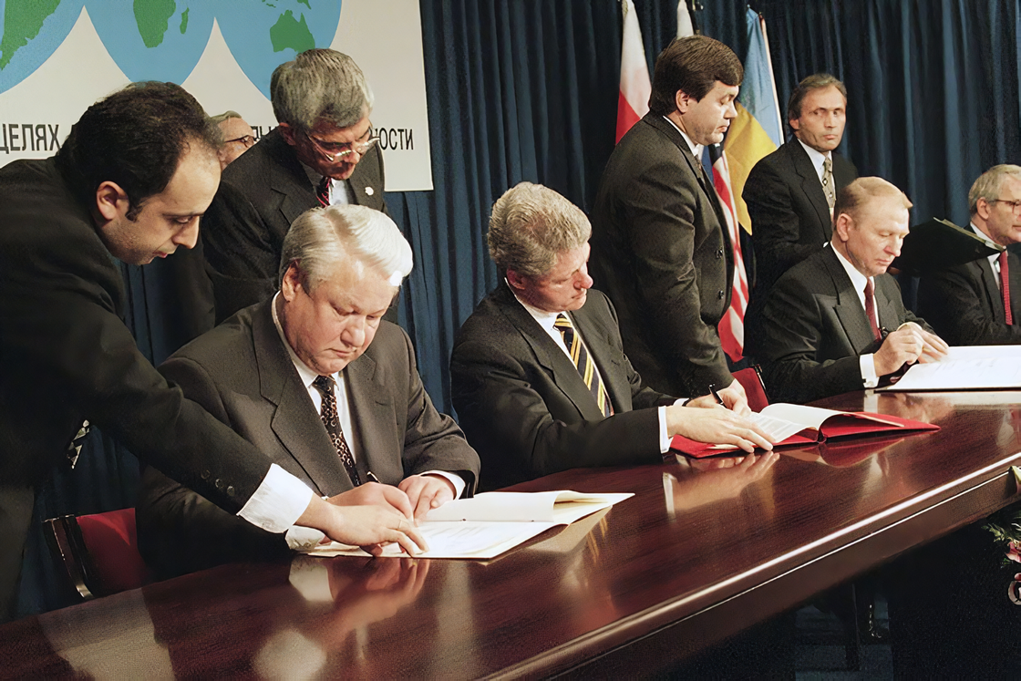
December 5, 1994 signing of the Budapest Memorandum
On February 19th, at the Munich Security Conference, Volodymyr Zelensky said that he would reconsider Ukraine's renunciation of nuclear weapons. According to him, the 1994 Budapest Memorandum, which guaranteed Ukraine security and sovereignty in return for giving up nuclear weapons, does not work and is not implemented by the signatories, so all package solutions will be questioned [18]. The FRG stated that the Budapest Memorandum has no legal force.
The Russian Foreign Ministry called the statement of the Ukrainian authorities "turning the whole situation upside down". The Russian Defence Minister Shoigu said at the time that Ukraine had the potential to store and build nuclear weapons [19]. Putin said it would be easier for Ukraine to obtain nuclear weapons if the US and Europe helped them do so [20]. The U.S. permanent representative to the UN said that the United States and its allies have no plans for such action.
For reference: The Budapest Memorandum, signed in 1994 by Russia, the United States, the United Kingdom and Ukraine, guaranteed Ukraine's security and integrity in return for the renunciation of nuclear weapons. The signatories committed Ukraine to respect its independence and sovereignty, refrain from the use of force, refrain from economic coercion, provide assistance in case of aggression, and not use nuclear weapons except in case of attack.
After the start of the ‘SMO’, accusations of unleashing World War III intensified and veiled intimidation became more direct. The U.S. imposed sanctions on Russia, calling it "an alternative to World War III."
Lukashenko saw sanctions as a risk of starting World War III and said that sanctions are "worse than war" [21]. Large Russian banks, some elites, major businessmen, and certain sectors of the economy fell under sanctions.
The Chinese authorities opposed sanctions against Russia and reported that only diplomacy could finally resolve the conflict in Ukraine, and called for negotiations [22] [23].
The nuclear power states began testing their weapons and developing plans for possible nuclear strikes [24] [25] [26].
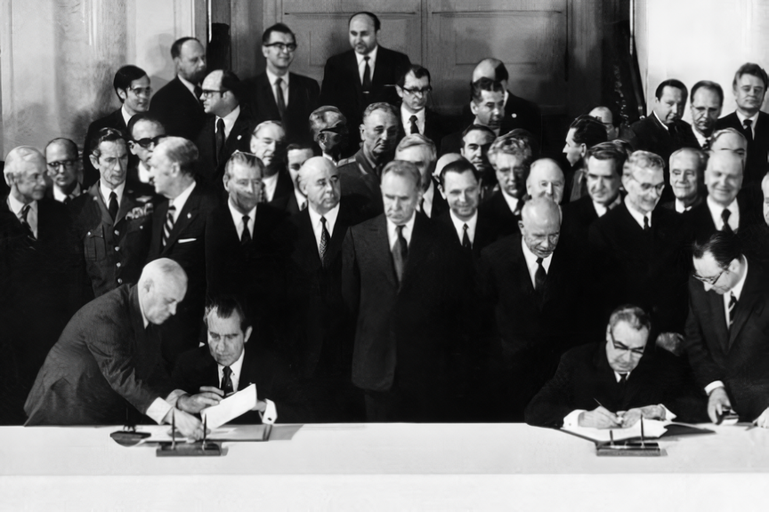
The NPT (Treaty on the Non-Proliferation of Nuclear Weapons) entered into force on March 5th, 1970.
In the summer of 2022, the very same X Conference of the Treaty on the Non-Proliferation of Nuclear Weapons (NPT) was held. The President of the conference reported that no consensus had been reached and no outcome document had been agreed. The only issue that was resolved was the date of the next conference in 2026.
The conference was followed by another round of accusations - Moscow blamed Kiev and the US for the lack of consensus; the US claimed Russia is at fault [27]. Russia's representatives in the UN stated that NATO could justify its use of nuclear weapons "for any reason," since the US doctrinal documents (National Defence Strategy, Nuclear Posture Review, and Missile Defence Review, 2022) stipulate the use of nuclear weapons under the pretext of "threatening its own vital interests or those of its allies". [28]. The Russian Foreign Ministry stated that Russia has never threatened to use nuclear weapons [29].
In fact, negotiations between Russia and the United States on strategic nuclear security are now considered frozen. The permanent members of the Security Council have not acceded to the treaty banning nuclear weapons. Nor has the issue of the nuclear deal with Iran been resolved [30]. Putin's announcement in February 2023 that Russia would suspend its participation in the Strategic Offensive Arms Treaty (START-3) with the United States further aggravated the situation [31].
Thus, since the beginning of the full-scale conflict between Russia and Ukraine, which involved (albeit indirectly) all the leading political forces of the world, the threat of a nuclear war has increased many times over. But still, the question of the reality of nuclear war during the Russian-Ukrainian conflict remains open.

II. 2023: Pro
All the arguments in favour of the fact that the authorities of the major imperialist powers are ready to use nuclear weapons are mainly reduced to political rhetoric.
In near-governmental circles, and among the right-minded part of the population, one can hear more definite statements "in favour" of the use of nuclear weapons, as has already been mentioned in detail.
At the same time, the heads of other imperialist states talk about the use of nuclear weapons mainly for the purpose of intimidating "enemies" and defence against attack. Among the military, theories of new types of operations in the conditions of nuclear weapons use are being developed. For example, in the summer of 2022, the US Department of Defence issued a lecture on the impact of nuclear weapons on the battlefield and the preparation of the armed forces to continue fighting after a nuclear strike [32]. Russia's Ministry of Defence is also developing types of military operations that do not exclude the use of nuclear weapons for deterrence purposes [33].
In October 2022, activists of the National Liberation Movement (NLM) held a rally in front of the U.S. Embassy. The most characteristic feature of this action, which shows the attitude of radical nationalists to the use of nuclear weapons, was a march with slogans and demands for a nuclear strike against the United States. It was expressed in the appearance of a man in a toy costume of the Russian missile "Sarmat", marching under the shouts of "On Washington!" [34]. The main slogan of the event was a phrase said by Putin in 2018. [35]: "We as martyrs will go to paradise. And they will simply drop dead."
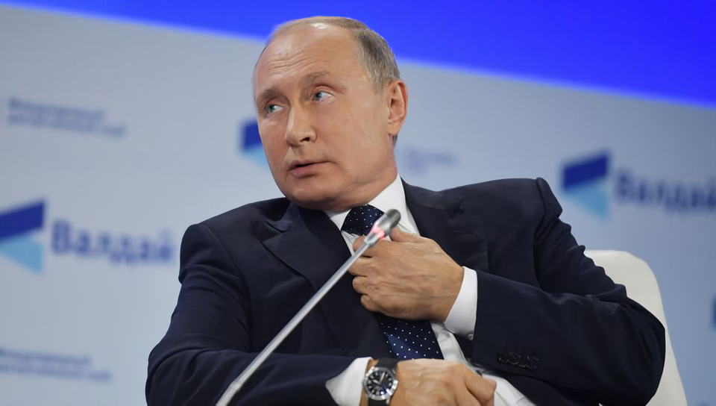
Vladimir Putin's speech at the Valdai Discussion Club 2018.
In April 2022, Margarita Simonyan, editor-in-chief of RT TV channel, when asked about the possibility of a world war, said that - either Russia will lose in Ukraine or World War III will start - and the second way, in her opinion, is more realistic.
"That it will end in a nuclear strike seems more likely to me." - Simonyan said [36]. At the same time, the RT chief did not specify who would strike first. In September 2022, nationalist Egor Kholmogorov, a columnist for the RT channel, stated:
"In the event of even a global nuclear war, it would be impossible to destroy all Russians. Of course, we are not like the Chinese, but there are quite a lot of us, scattered over a large territory. But the Ukrainian project will be finished forever. On the contrary, in case of triumph of the Ukrainian project, especially through military victory over Russa, the Russian people will end, as well as Russia, divided into many ukraines and non-Russians. That is, nuclear war is not the suicide of Russians as an ethnicity and a nation, unlike capitulation to Ukraine." [37].
"If the choice between a Ukrainian victory and a global nuclear war comes up, nuclear war is preferable...". [38].
"Orthodox businessman", "conservative" and chairman of the Tsargrad channel Konstantin Malofeev wrote in social networks: "... today all peoples of the world should pray for a Russian victory. The alternative to which there is only one: nuclear apocalypse"[39].
Alexei Zhuravlev, first deputy chairman of the State Duma Defence Committee, has repeatedly spoken out on state TV channels in favour of Russia's use of tactical nuclear weapons: "One Sarmat and that's it. There were British islands and then there are no British islands," Zhuravlev said on the programme "60 Minutes" [40].
Ramzan Kadyrov said in October 2022 that within the framework of the SMO "it is necessary to take more cardinal measures, up to the declaration of martial law in the border territories and the use of low-power nuclear weapons" [41].
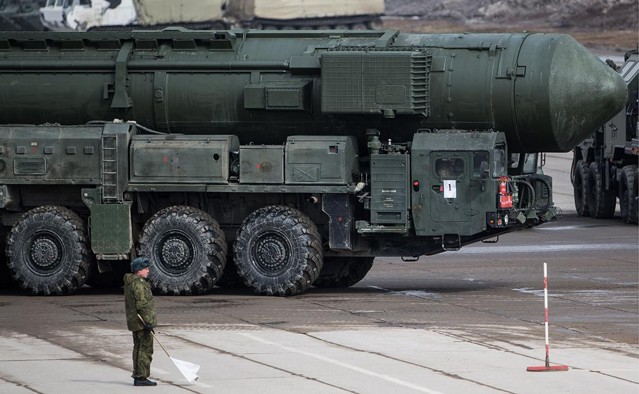
In autumn 2022, Putin, in response to NATO's "nuclear blackmail", promised to use all means to defend Russia:
"For the defence of our people, we will use all means. This is not a bluff. Our independence and freedom will be ensured by all available means" [42].
In early 2023, Medvedev commented that the U.S. was going to help arm Ukraine so that it could target Crimea:
"And it does not occur to any of the wretches to draw the following elementary conclusion from this: the loss of a nuclear power in a conventional war can provoke the beginning of a nuclear war. Nuclear powers have not lost major conflicts on which their fate depends." [43] [44].
In March 2023, news broke that a court in The Hague had issued an arrest warrant for Putin [45]. Medvedev responded to this in his Telegram channel as follows:
"Alas, gentlemen, everyone walks under God and missiles. It is quite possible to imagine a point application of a hypersonic carrier from the North Sea from a Russian ship against the Hague courthouse. It would not be shot down, alas. And the court is only a seedy international organisation, not the population of a NATO country. That's why they won't start a war. They'll be afraid to. And no one will be sorry. So, citizens of judges, look carefully at the sky...". [46].
In other words, the Russian authorities, together with prominent propagandists, use threats to use nuclear weapons. The threshold of such statements for the Russian leadership has long been passed. The messages given from the statements to the public field have become commonplace. And what do the authorities of other countries say?
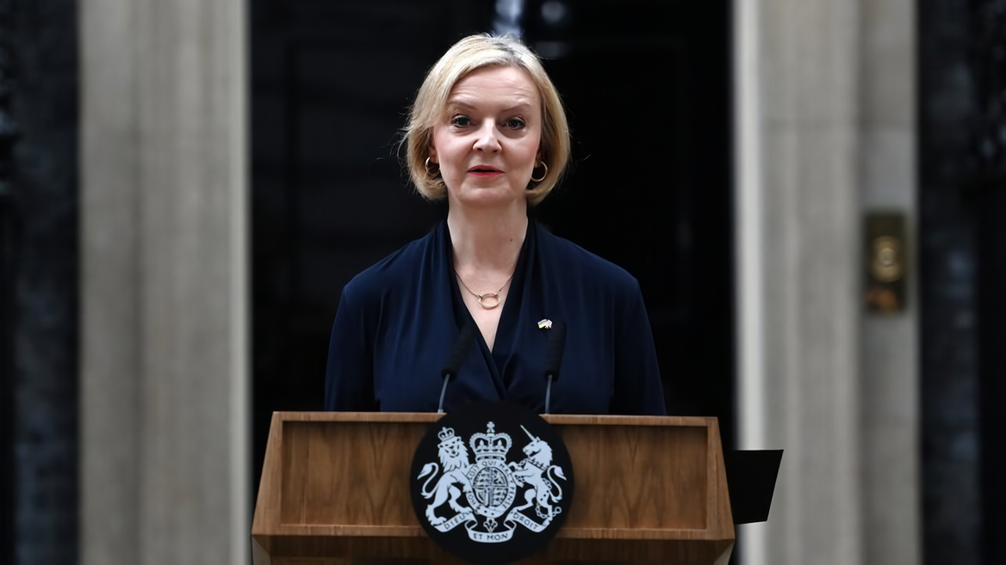
Liz Truss
British Foreign Secretary Liz Truss said she was ready to use nuclear weapons if the country was threatened: "I think it [the use of nuclear weapons - PS note] is an important responsibility of the Prime Minister. I am prepared to do it. [47].
US Secretary of State Blinken asserted: "The US would consider using nuclear weapons only in extraordinary circumstances, to protect the vital interests of the United States, allies and partners" [48].
In February 2023, the DPRK leadership stated that it could deal with any threats from the US with the help of its nuclear weapons. The ministry spokesman added that the country would be guided by two principles: "nuclear strike on nuclear strike" and "full-scale confrontation on full-scale confrontation" [49].
Chinese media reported that their authorities are going to significantly expand their nuclear arsenal to deter the US [50].
From a cursory analysis of the rhetoric of the politicians of the "great states," one can conclude that the use of nuclear weapons has become part of the rhetoric of the Western and Russian authorities. The population of all countries is gently prepared for the use of tactical nuclear weapons, justifying it by the special exclusivity of the nation, "defensive" position, protection from "enemies", etc.

III. 2023: Contra
At the same time, Russian and Western officials try to formally stand on the side of peace and "no first use of nuclear weapons at any outcome," without denying at the same time the possibility of their use. The main argument to which the governments' rhetoric is reduced in one way or another is this: Nuclear weapons are only a weapon of deterrence. Many politicians, diplomats, clerics, and public figures often make abstract pacifist peace statements in support of their countries' positions.
As already mentioned, the US, when imposing sanctions against Russia, called it an alternative to World War III.
"There were two courses of action: start World War III, start a physical war with Russia, or option number two: make the country that acts so contrary to international law pay the price for having done so," Biden said [51].
In response to questions about the possibility of Russia using nuclear weapons in Ukraine, Dmitriy Peskov advised to read the Russian doctrine on nuclear deterrence policy. Earlier, Peskov named the conditions for Russia's use of nuclear weapons in March 2022:
"We have a national security concept, it is in the public domain, you can read all the reasons why nuclear weapons can be used. That is, if there is a threat to the existence of the country, then it can be used in accordance with our concept." [52].
In late 2022, Putin stated that the threat of nuclear war was growing, but that Russia viewed nuclear weapons as a "means of defence" and did not intend to use them first [53]. Dmitry Medvedev also spoke on this issue, referring to the doctrine.
"Russia has the right to use nuclear weapons if necessary. In predetermined cases. In strict accordance with the Fundamentals of State Policy in the Field of Nuclear Deterrence. If we or our allies are attacked using this kind of weapons. Or if aggression using conventional weapons threatens the very existence of our state". [54] [55].
In November 2022, Joe Biden and Xi Jinping, following their first meeting, issued a joint statement on the non-use of nuclear weapons:
"President Biden and President Xi reaffirmed their agreement that nuclear war should never be fought and that it cannot be won, and emphasised their opposition to the use or threat of use of nuclear weapons in Ukraine" [56].
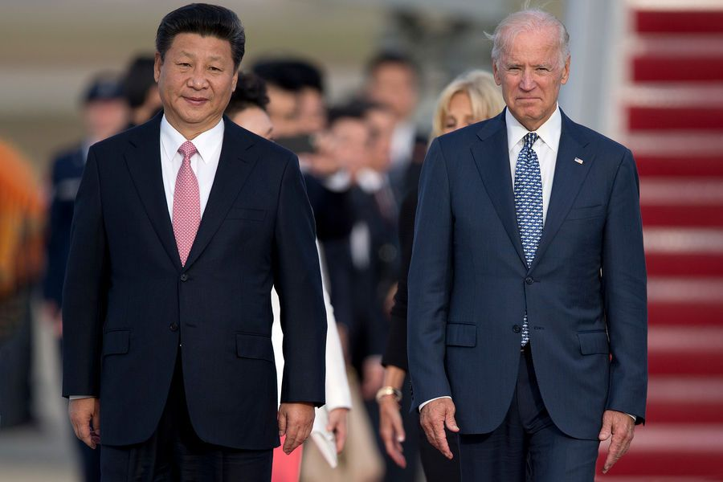
Xi Jinping and Joe Biden
In 2022, at a meeting with the IAEA director general, Putin said that Russia remains committed to nonproliferation of military nuclear technologies. He added, however, that there is an excessive "politicisation" of nuclear activities and it is necessary to reduce this rhetoric:
"We have always been in favour of states always having access to peaceful atoms and at the same time we believe, and have believed before, our position is that everything should be done to limit the spread of military nuclear technology." [57]
The UN Secretary General called on the world to abandon nuclear weapons for good:"Our world has been hostage to nuclear weapons for long enough. These devices of death guarantee neither victory nor security, they are designed only for destruction. Let us ensure that testing stops for good and send nuclear weapons into the archives of history once and for all." [58].
As a result, it can be seen that along with more frequent strong statements about the use of nuclear weapons, the authorities try to step back, formally hoping for "peaceful" conflict resolution and avoidance of a world war.

IV. Comparative Analysis
A review of the political agenda and the opinions "for" and "against" shows that the words about "the importance of solving the issues of peace and nuclear safety" are primarily used to protect the economic interests of big capitalists. For the ruling class, questions about the redistribution of spheres of influence, territories and markets are more important than questions of nuclear safety.

The problems of international politics tell us one thing: there are insoluble contradictions in the economic basis that cannot be solved within the framework of capitalism, and cannot be solved. The diplomatic "games", hypocritical, eclectic rhetoric of today's politicians is a reflection of the basic contradiction of capitalism - between the social character of production and the private-property character of appropriation of the products of labour.
Foreign policy is primarily aimed at redistribution of the world, seizure of territories for robbery and expansion of exploitation of other nations with the sole purpose of maximising profit. And the choice of one or another plan of action in the current conflicts will be determined, first of all, by the interests of big capital.
The use of nuclear weapons has its pros and cons for capitalists.
Pros: nuclear weapons are an instant destruction of the enemy's armed forces, economy and important state institutions - it is a powerful weapon for unambiguous defeat of the enemy, it is an "easy" victory.
Cons: destruction of means of production, labour force and markets; loss of opportunity to invest, sell goods, export capital, etc.; most importantly, it is a great damage to ecology, endangering life on Earth as such, as a result of which there is no sense at all in accumulating billions of dollars of capital.
Thus, taking into account all potential risks and benefits, official representatives of the authorities take a centrist, wait-and-see position in international relations, at the same time provoking each other. On the one hand, they "scare" with hints about the possibility of using nuclear weapons, with a reservation on conditions; on the other hand, they continue to talk about the importance of peace and justice, calling for an agreement.
The doctrinal documents of the nuclear powers describe basically the same conditions for the first use of nuclear weapons. As a rule, it is "a threat to the existence of the state or its allies". What can be understood by "threats" is not specified. For example, sanctions can be perceived as a certain "threat" to the economic and political integrity of the state system against which they are imposed.
History shows the clear attitude of the bourgeoisie to peace and security treaties.
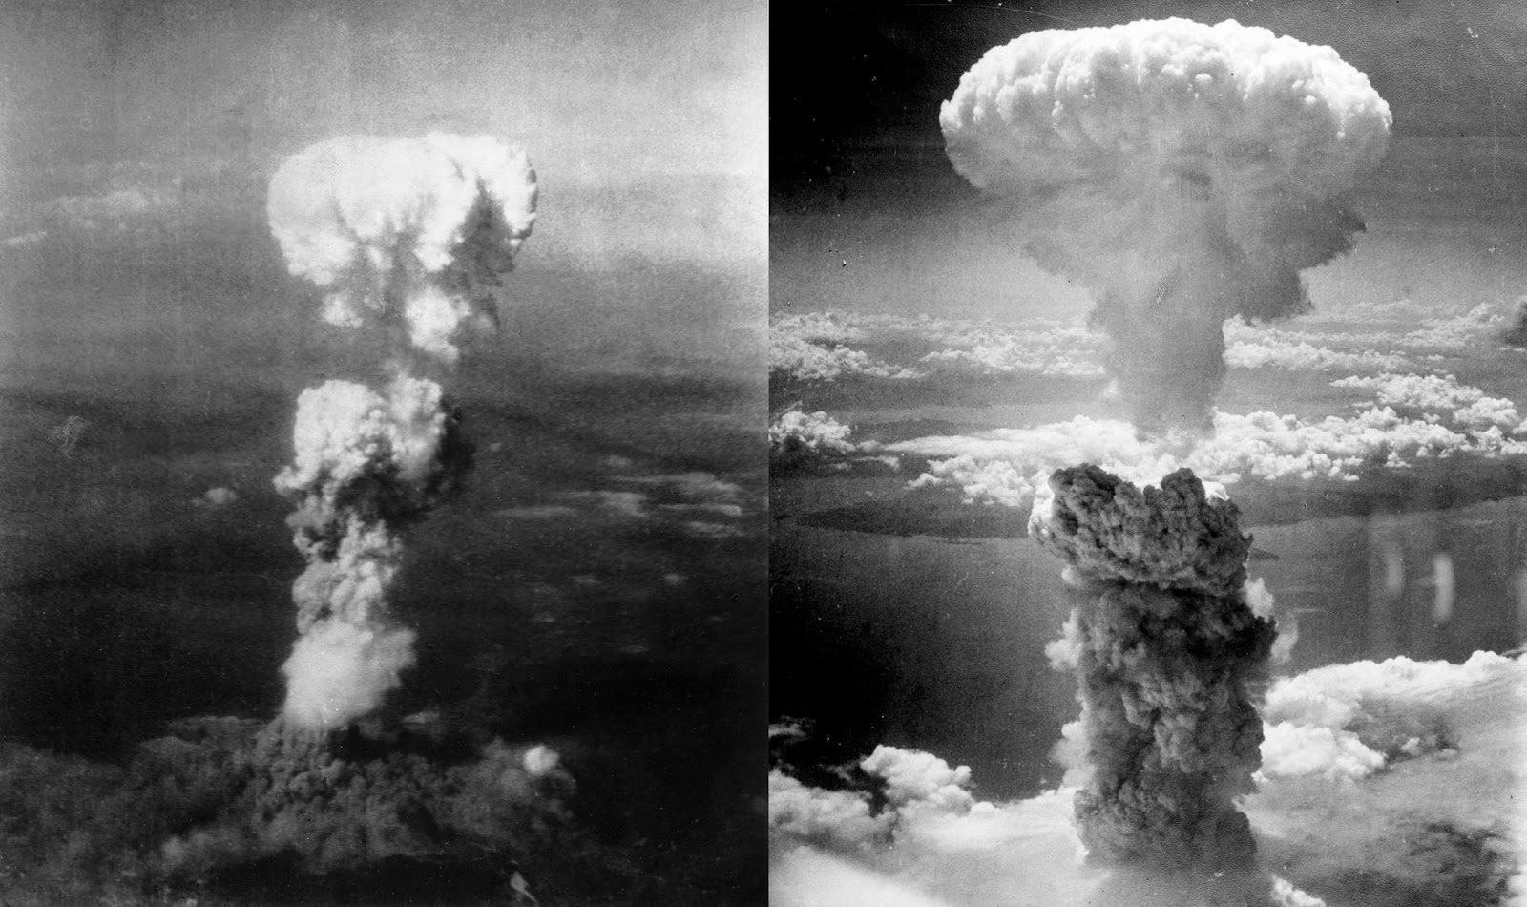
Atomic bombings of Hiroshima and Nagasaki
In early 1940, American scientists developed the physical principles of nuclear explosion. In July 1945, the United States conducted the first tests of nuclear weapons, and in August 1945 dropped two atomic bombs on the Japanese cities of Hiroshima and Nagasaki. More than 400 thousand civilians were killed and mutilated. These actions were not due to military or strategic necessity, but were mainly of political nature - demonstration of the US atomic power to the world and weakening of the USSR positions.
Based on all of the above, the following assumption can be made. The bourgeoisie is not interested in a world nuclear apocalypse with billions of dollars in casualties. Fear of losing sources of profit, markets and most importantly - labour force - is the only thing that restrains capitalists to use nuclear weapons. However, if any country is on the verge of defeat and loss of spheres of influence, it is possible to use tactical nuclear weapons, which will lead to retaliatory strikes and the probable outbreak of nuclear war.
Of course, this is only an assumption and one of the possible outcomes of events. Various kinds of "random" factors may intervene, which are equally capable of influencing in favour of one of the outcomes.
The only thing we can say for sure is that, based on the events of 2022-2023 and the intensity of the struggle between the imperialist powers, nuclear war is a very likely scenario, and the governments of the various powers are preparing for it.
However, even the real possibility of the world plunging into another world war, coming out of concrete objective conditions, is not yet a reality. There is still the possibility of the complete elimination of the nuclear threat, and with it the causes that give rise to it.

V. How to eliminate the threat once and for all?
History shows how the international policy of socialist states is fundamentally different from that of capitalist countries.
Throughout its existence, the USSR has played a leading role in the struggle for peace and security of peoples. The foreign policy of the USSR laid the foundation for the formation of legal norms and conventions on nuclear weapons, which contributed to the strengthening of peace, security and weakening the threat of the use of nuclear weapons.
Since 1946, the Soviet government made efforts to reach agreements on the prohibition of the use and development of nuclear weapons, and fought to strengthen peace and international security. The US and British governments ignored the Soviet statements and pursued an aggressive, militaristic policy against the international communist and labour movement. The main purpose of the creation of the imperialist NATO bloc was to suppress the world revolution.
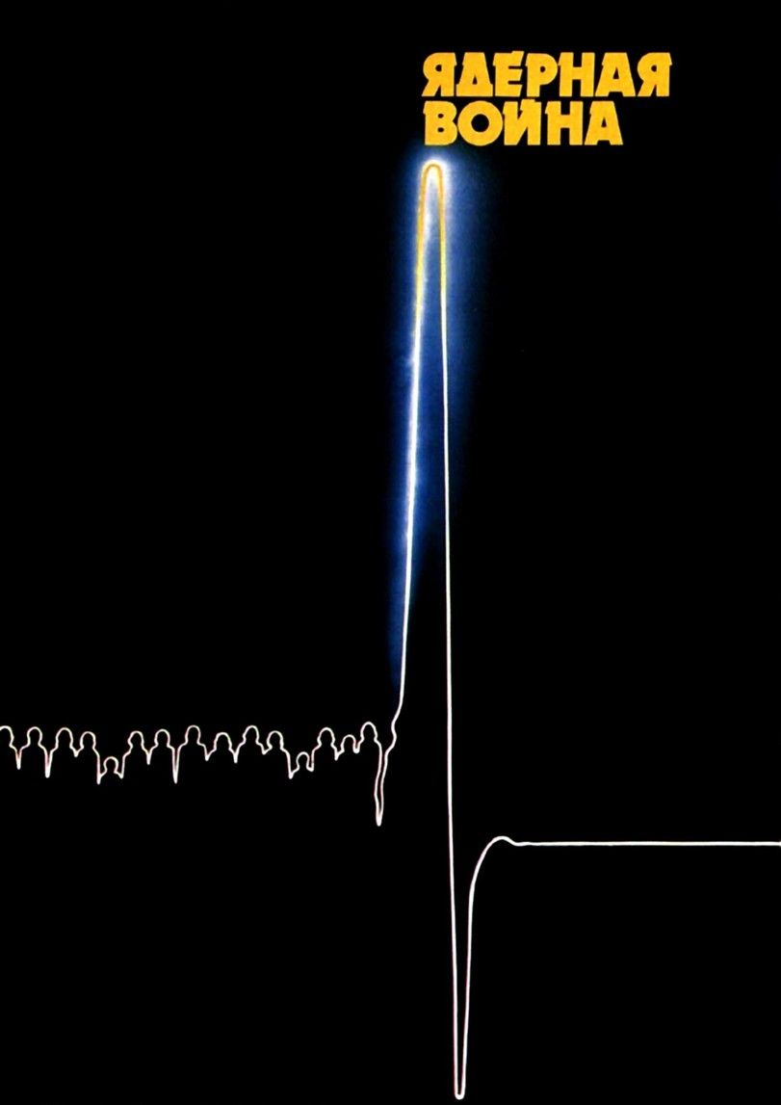
Soviet poster "Nuclear War" of the 1980s.
The deterrent from further use of nuclear weapons by the imperialist countries was the emergence of nuclear weapons by the USSR. In August 1949 the Soviet Union tested its first atomic bomb and in 1953 its first hydrogen bomb, which finally destroyed the US nuclear monopoly and dealt a serious blow to the aggressive actions of NATO.
The USSR's struggle for limiting the arms race and creating conditions for phased disarmament played an important role. This issue was repeatedly put forward by the Soviet Union at all UN sessions, but each time it was postponed or sabotaged by the Western countries.
In 1955-1958, the Soviet Union unilaterally decided to reduce its armed forces and stop testing nuclear weapons in order to ease the arms race and reduce tensions. By its example, the USSR demonstrated its readiness to resolve issues of world security. The USA and Great Britain responded to the initiative by further intensifying the arms race. In this connection, in 1958 the USSR resumed nuclear weapons testing.
The economic successes of the socialist countries, together with the expansion of international progressive anti-war demonstrations, put pressure on the imperialist power, which nevertheless led to a number of agreements to limit nuclear weapons.
The Treaty on the Prohibition of Nuclear Weapons Tests in the Atmosphere, in Outer Space and Under Water was signed on August 5th, 1963 in Moscow by representatives of the USSR, the USA and Great Britain.
The 1967 Outer Space Treaty - obliging not to launch objects with nuclear weapons or other weapons of mass destruction into outer space.
The Treaty on the Non-Proliferation of Nuclear Weapons of 1968 - established restrictions on the expansion of the number of countries possessing nuclear weapons in order to limit armed conflict with the use of such weapons. The treaty obliged states possessing nuclear weapons not to transfer these weapons and control over them to non-nuclear-weapon states; also not to assist them in their production or acquisition. The Treaty obliged non-nuclear-weapon States not to accept transfers of nuclear weapons from anyone, not to produce them, and not to seek assistance from anyone for this purpose.
In the period 1972-74, a set of mutual obligations between the USSR and the US on the prevention of nuclear war was developed: an agreement on the prevention of incidents on the high seas and in the airspace above them (1972); a treaty on the limitation of missile defence systems; an agreement on the prevention of nuclear war (1973), etc.
Thus, there was a certain balance of power during the period of the USSR. After the victory of the counter-revolution and the collapse of the USSR, many former treaties came to naught.
The experience of the Soviet Union shows what successes in economic and political questions the working people can achieve under the leadership of the communist proletarian party. At the same time, this experience shows what the slightest movement from the basic provisions of Marxism-Leninism, the weakening of the class struggle against the capitalist environment and the weakening of the struggle to strengthen the socialist planned economy leads to.
International statements and appeals for peace from the representatives of big capital in fact lead only to the spread of pacifist illusions. Only under socialism is the main aim of international politics the defence of the interests of the majority, i.e. the working class.
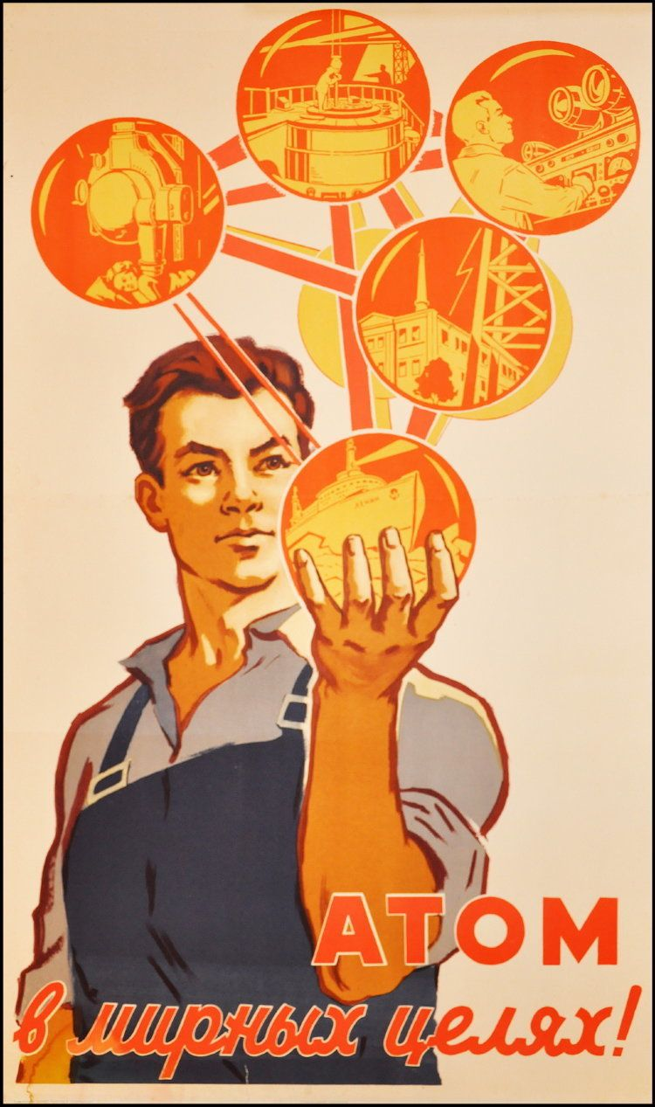
Poster "Atom for peaceful purposes" 1960
The modern world is a system of imperialism. The world is definitively divided between small and large capitalist predators, who struggle viciously for the redistribution of territories and spheres of influence, at the cost of the lives of millions of workers.
Capitalism has taken full root in all spheres of social life and in all small countries. The colonial system has largely disappeared. At the moment, the only progressive movement capable of preventing world wars and breaking the imperialist chain is a united communist movement based on the principles of proletarian internationalism and firmly following the theory of Marxism-Leninism.
At the moment the workers' movement is disorganised, infected with opportunism and right-left revisionist tendencies. Nevertheless, the working class remains the only progressive class interested in ending the wars of plunder and exploitation, which must realise its class interests.
Only a united communist movement, based on the principles of proletarian internationalism, firmly following the theory of Marxism-Leninism, resolutely fighting all the slightest manifestations of opportunism and revisionism in the labour movement, can once and for all destroy the possibility of unleashing a world nuclear war.
Sources
[1] RBC — The IAEA announced the absence of data on the production of nuclear weapons by Iran — dated March 5, 2023.
[2] RBC — Bloomberg reported the discovery of uranium enriched to 84% in Iran — dated February 19, 2023.
[3] FAS (Federation of American Scientists) — Status of World Nuclear Forces — dated March 28, 2023
[4] The Administration of the President of Russia — A joint statement by the leaders of the five nuclear—weapon States on the prevention of nuclear war and the prevention of an arms race - dated January 3, 2022.
[5] RBC — MFA revealed Russia's requirements to the United States on security guarantees — dated December 17, 2021.
[6] RBC — MFA ruled out compromises from the Russian side at the talks in Geneva — from January 10, 2022.
[7] RBC — "NATO is not negotiable." How Moscow assessed the security talks — from January 13, 2022
[8] RBC — Russia and the United States have not agreed on the issue of non—expansion of NATO - from January 10, 2022
[9] RBC — Putin allowed "very different" responses to the refusal on security guarantees — from December 26, 2021.
[10] RBC — The State Department reminded Russia of the right of countries to join unions at a meeting in Geneva on January 10, 2022.
[11] RBC — Blinken stated that "Russia put a gun to the head of Ukraine" — from January 9, 2022.
[12] The New York Times — Russia Issues Subtle Threats More Far-Reaching Than a Ukraine Invasion — from January 16, 2022
[13] RBC — Putin called the timing of the appearance of a new hypersonic missile in service — from November 30, 2021.
[14] RBC — China supported Russian demands for non—expansion of NATO - from February 4, 2022
[15] RBC — Lukashenko threatened to deploy "super—nuclear" weapons in Belarus - from February 17, 2022.
[16] RIA NEWS — The Foreign Ministry denied the words of the United States about plans to deploy nuclear weapons in Belarus — from January 27, 2022.
[17] RBC — Putin announced plans to deploy tactical nuclear weapons in Belarus — from March 25, 2023.
[18] RBC — Zelensky threatened to reconsider Ukraine's renunciation of nuclear weapons — from February 19, 2022.
[19] RBC — The Foreign Ministry called Kiev's statements about nuclear weapons "turned the situation around" — from February 24, 2022.
[20] RBC — The United States rejected the possibility of supplying Ukraine with nuclear weapons — from February 22, 2022.
[21] RBC — Lukashenko saw the risk of a third world war due to Western sanctions - from February 27, 2022
[22] RBC — China opposed unilateral sanctions against Russia — dated February 23, 2022
[23] RBC — China has named a way to finally resolve the conflict in Ukraine — from March 1, 2022.
[24] RBC — NYT learned that the United States is preparing a plan in case of a nuclear strike by Russia — from March 24, 2022.
[25] RBC — The EU decided to strengthen its defense capability in the event of attacks with nuclear weapons — from April 2, 2022.
[26] RBC — Shoigu reported to Putin that the strategic forces have begun enhanced duty — from February 28, 2022.
[27] RBC — The participants of the nuclear weapons conference did not agree on the final document — dated August 27, 2022.
[28] RBC — The diplomat stated about the possibility of NATO to justify the use of nuclear weapons — from August 11, 2022.
[29] RBC — Zakharova stated that Russia has never threatened with nuclear weapons — from June 24, 2022.
[30] RBC — Iran accused Eurotrinity of pushing for the failure of the nuclear deal — from September 10, 2022.
[31] RBC — Putin announced the suspension of participation in the Nuclear Missile Treaty — dated February 21, 2023.
[32] DVIDS (Defense Visual Information Distribution Service) — NUCLEAR WEAPONS EFFECTS 101 — from April 8, 2022
[33] RBC — General of the Strategic Missile Forces announced the development of a new type of military operations by Russia — from March 2, 2023.
[34] RIA NEWS— NLM activists hold an anti—American rally at the US Embassy in Moscow - from October 8, 2022
[35] RBC — "We will go to heaven as martyrs": what Putin said in Sochi — from October 18, 2018
[36] Online publication "We are watching": "An evening with Vladimir Solovyov" — Margarita Simonyan: there is no chance that we will just fold our paws — from April 27, 2022
[37] Telegram channel "Kholmogorov" — Any discussions about ethics — September 18, 2022
[38] Telegram channel "Kholmogorov" — Earlier, during the period of condescending myeshenichegonacheniya — September 17, 2022
[39] BUSINESS Online — Orthodox businessman Malofeev told why the world should pray for Russia in Ukraine — from September 22, 2022
[40] Telegram channel "URA.RU " — We don't care — May 18, 2022
[41] RBC — Kadyrov called "low—power" nuclear weapons a cardinal measure of the operation - from October 1, 2022.
[42] RBC — Putin promised to use all means to protect Russia — from September 21, 2022
[43] Telegram channel "Dmitry Medvedev" — Tomorrow at the NATO base Ramstein — January 19, 2023
[44] The New York Times — U.S. Warms to Helping Ukraine Target Crime — from January 18, 2023
[45] RBC — The court in The Hague issued an arrest warrant for Putin and Lvova-Belova — dated March 17, 2023.
[46] Telegram channel "Dmitry Medvedev" — There was a final collapse of the system of international law — March 20, 2023
[47] RBC—Trass declared its readiness to use nuclear weapons to defend the country — from August 24, 2022.
[48] RBC — Blinken called the condition for the use of nuclear weapons by the United States — from August 1, 2022.
[49] RBC — North Korea announced the possibility of coping with US threats with nuclear weapons — from February 2, 2022.
[50] Kyodo News — China mulls tripling nuclear warheads to 900 by 2035: sources — from February 11, 2023
[51] RBC — Biden called sanctions an alternative to the "Third World War" — from February 26, 2022.
[52] RBC — Peskov, on the question of the use of nuclear weapons, advised to read the doctrine — from September 17, 2022.
[53] RBC — Putin announced the growing threat of nuclear war — from December 7, 2022
[54] RBC — Medvedev declared Russia's right to use nuclear weapons if necessary — dated September 27, 2022.
[55] RBC — Medvedev recalled the grounds for the use of nuclear weapons — dated August 27, 2022.
[56] RBC — Biden and Xi Jinping urged to prevent the use of nuclear weapons — from November 14, 2022
[57] RBC — Putin stated that Russia is committed to the non—proliferation of nuclear weapons - from October 11, 2022
[58] RBC — UN Secretary General urged to forget about nuclear weapons — from August 29, 2022

Original article

