Wildfires Ravage Europe whilst War Budgets Grow
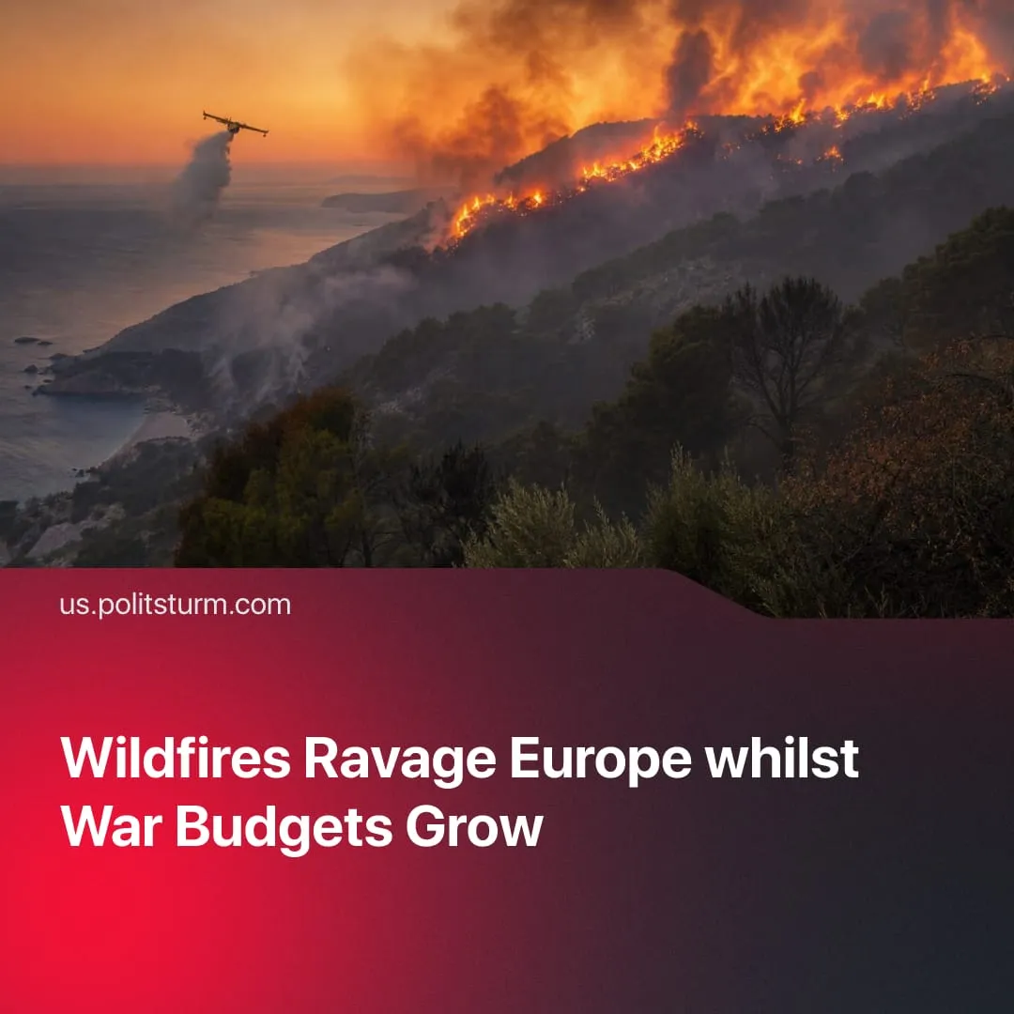

Original article
2026-08-06
2 min read

European wildfires labelled as the largest crisis since WWII. Instead of investing in prevention, capitalist states are funding the next world war.
Details. Wildfires have flared up in France, Greece, Spain, Portugal and the UK, driven by gale winds and intensified by repeated record-breaking heatwaves.
► In France, the fires have already burned more land (200,000 acres) than any year since 2006, and in Spain they have devastated over 1.5 billion square meters of land. France recorded its first 'fire cloud,' releasing ash and toxic gases that spread across borders. French health agencies are preparing for a surge in respiratory and cardiovascular hospital admissions.
► More than 300,000 people in France, Portugal and Spain have already been forced to evacuate their homes. The regional president of Madrid described the fire as the "worst fire" in the history of the entire region. The French president has called the situation "the worst crisis since World War II". Both Spain and France have mobilized parts of their military to assist firefighters in limiting the spread of the wildfires.
► The wildfires have already directly disrupted the daily lives of millions of workers. Across Europe, the heatwaves driving them are lowering crop yields, driving up food prices, and straining public infrastructure.
Context. Since the 1970s, scientists and politicians have been aware of climate change. The UN Climate Change Conference has since met 30 times. However, no real measures against climate change have been enacted, even as the Earth heats up faster than before. The very same summits were instead used by fossil fuel lobbyists and officials, who struck deals and influenced negotiations without having to disclose their affiliations.
► The French government has repeatedly acted counter-productively in limiting the extent of the wildfires. They cut the civil security budget, meaning fewer firefighting aircraft are now available. In January 2026, firefighters who took to the streets demanding better equipment and conditions were met with police violence.
► The EU itself recognises that climate adaptation will require €59-173 billion in annual investment until 2100 to protect agriculture, infrastructure and ecosystems. Current committed spending amounts to just €15 billion a year.
► This stands in stark contrast to the resources capitalists are pouring into war preparations. EU states will spend an estimated €450 billion on military budgets in 2026 alone, and US officials are seeking a $1.5 trillion military budget, whilst cutting into social welfare. Trump himself admitted it is "not possible" to fund daycare and Medicare "because we're fighting wars".
Politsturm regularly publishes Marxist-Leninist analyses of the worsening climate crisis, as well as other key political and economic issues. Follow us on Telegram, YouTube, Discord and X. Join us to help us in our work.

Original article

