Why Small Business Won't Save You from Poverty


Original article
2024-03-07
18 min read

In capitalist society, workers suffer from absolute and relative impoverishment. Because of poverty and misery, people are constantly experiencing financial difficulties and anxiety. They do not have the opportunity to fulfil themselves and satisfy their needs. They are forced to work at the expense of spending time on themselves, their family and even their own health, and every day they feel more and more oppressed by their employers.
All this causes dissatisfaction and the search for additional income, or an alternative source of earnings. Seeing "salvation" in small business, people try to find a way out of their situation by becoming owners themselves and opening "their own businesses" - refusing to work for a "boss" and opening their own enterprise. Moreover, they are also driven to this by the general ideological background of capitalist society, in which the "cult of success" is propagated from various sources.
However, in practice, all these sweet speeches turn out to be just a myth. The pursuit of one's own business is not able to free a person from poverty, and even if there are those lucky few who succeed, society as a whole remains poor.

I. The myth of "one's own business"
Capitalist media and pop culture inspire the layman with the idea that salvation from poverty (generated by capitalism) lies in building your own business.
It is claimed that this can help to achieve a high standard of living, solve financial problems, achieve self-actualization and never work for a "boss" again.
For example, this is what the Russian oligarch Igor Rybakov is broadcasting about. In his book "Thirst", he spoke about his own view of the history of the company's creation, about his personal view of the philosophy of entrepreneurship, and about how he decided to engage in philanthropy. For the last few years, Rybakov has been engaged in educational activities, among other things: he speaks a lot at business conferences and forums, supports aspiring businessmen, and actively uses his Instagram for this communication.
According to his website:
Igor Rybakov believes in the principle: that every person who has a place in society is obliged and responsible for transferring the accumulated experience and knowledge to other members of society. Transmission is life. Igor Rybakov, through his actions as an architect, forms and carefully patronizes the ecosystem that arises as a result of his actions, which creates "a more prosperous, harmonious and happy humanity" [1].
He begins his book "Current. How to Make Profitable Steps without Losses" with the usual demagoguery: "I wonder if you have often thought about what successful people do and what unsuccessful people don't do? And I tried to ask myself another question: what are successful people not doing and what are unsuccessful people doing?"
In his book, Rybakov urges not to be afraid of unpredictability and discomfort, but to try to see opportunities for growth in them and not to be afraid of losing what you already have. And in general, one should not be afraid of mistakes and failures, since one cannot become an entrepreneur without becoming a "champion of mistakes" [2].
Rybakov also urges you to surround yourself with entrepreneurs who are actively "updating", then you will "restart". That the mind should not be allowed to dominate the feelings. An entrepreneur is the only kind of person who can remove the outdated and bring in something new, etc. [3].
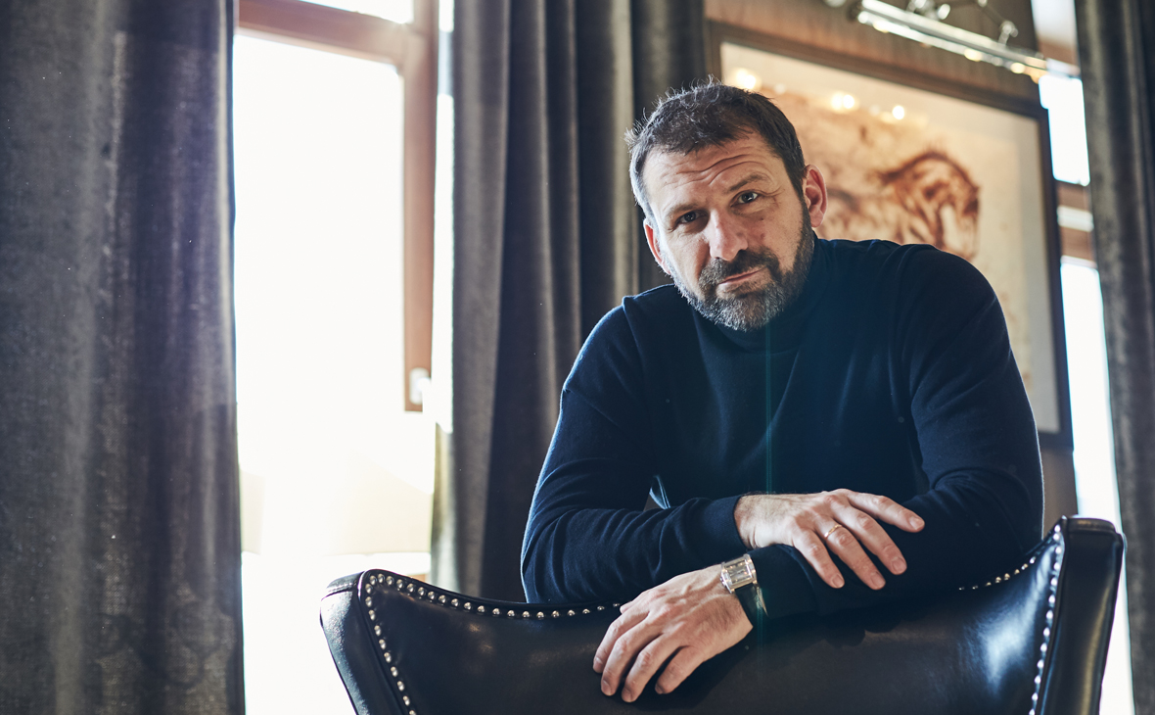
Igor Rybakov. Photo by RBC
Rybakov and his wife established the Rybakov Prize. The purpose of this award is to demonstrate the leading role played by entrepreneurs, patrons and philanthropists in society. All those who, on their own initiative, develop a school not only as a source of knowledge but also as a centre of attraction and development for local communities [4].
Rybakov transferred 1 million rubles to the account of his native educational institution in Magnitogorsk as part of this prize. The funds were allocated for the creation of an endowment. Funds that are invested and spent annually for the benefit of the institution [5].
In April 2020, during the Coronavirus Pandemic, Igor Rybakov announced a competition to create a monument to doctors fighting the disease. The finalists of the competition received 100 thousand rubles each [6].
However, Rybakov quickly forgets about his philanthropy when it comes to making a profit. So, in October 2021, he forced employees of organizations under his control to be vaccinated against the coronavirus. Wages were reduced by 20% for those who were not vaccinated on the initiative of the entrepreneur. The businessman promised to use the saved funds for the construction of schools and kindergartens. That's his "charity" [7].
Another example is Yuri Dudya, a German-born Russian journalist Youtuber (10.1 million subscribers). In his interviews, Dud constantly promotes capitalist propaganda, with his content (interviews with the successful and rich) popularising the "cult of success" through the dissemination of "success stories" [8].
Or here's another example — Evgenia Streletskaya's Youtube channel (1.58 million subscribers). It is dedicated to psychology, and we can hear in many videos that it is by building your business that you can improve your financial situation, and, as a result, your psychological health [9].
Where does this idea come from and why does it sit so firmly in people's heads?
The very idea of the obligatory desire to become a small businessman, a private entrepreneur, to open a business, etc. has existed for a very long time and was generated by bourgeois society itself.
Capitalism is based on private ownership of the means of production, exploitation of hired labour, and oppression of the majority (the working class) by the minority - the capitalists. Consequently, it is only through exploitation and the transformation of oneself into an owner that one can ensure material well-being.
Bourgeois morality and culture encourage the pursuit of ever-growing profits, rising above people and their exploited labour. These ideas permeate the entire bourgeois society and they are the ideas of the bourgeois class. Whichever class dominates, the ideology of that class is in turn the dominant one. From the class point of view, the cult of "one's own business" is petty-bourgeois.
The petty bourgeoisie is an intermediate class, that owns their own means of production but mainly uses their own personal labour to work said means of production, without reliance on hired labour. Consequently, they draw the bulk of their income not from the appropriation of someone else's labour, but from the results of their own.
Nevertheless, a small owner is still an owner who benefits from the prevailing socio-economic conditions and is interested in acquiring even greater profits.
Accordingly, this idea becomes the main one among small owners, as it is generated by the conditions of their existence. It is also well embedded in the head of the proletariat if they are not yet sufficiently educated to realize their own fundamental interests. The unconscious workers see in this idea salvation for themselves, with a minimum of costs, and do not understand that the transition to the class of the petty bourgeoisie is very difficult.
Moreover, the life of a small owner is not as rosy as it is presented in articles and programs like "3 Secrets of Success", etc.

II. Why is this a myth?
To start your own business, you need initial capital. Approximately this amount is between 100 to 500 thousand rubles. Paying for the rental of premises, buying equipment and consumables, issuing salaries to employees, and so on — are big expenses. Not every worker who barely makes ends meet and, moreover, is burdened with debts, will have such money.
Of course, it is possible to take a loan from a bank. The bank may even be willing to meet the new borrower halfway. But at the same time, many stories are known about small entrepreneurs who, having failed, ended up in even greater debts. Even finding the necessary amount to open your own business does not guarantee a novice entrepreneur the successful preservation and development of the business.
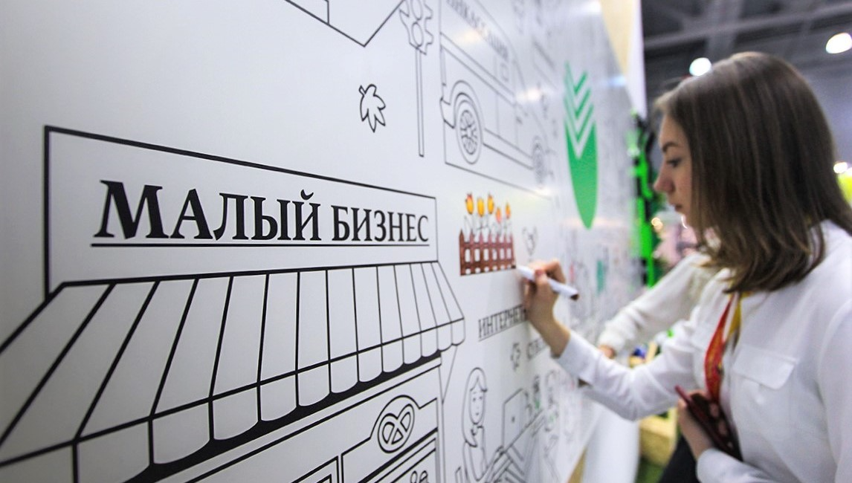
Photo by RBC
According to RBC, referring to the "Global Entrepreneurship Monitoring" — by 2014, data indicated that only 3% of small businesses in Russia managed to survive longer than 3 years - the rest of these enterprises went bankrupt. Only 3% of start-up entrepreneurs keep their business. The rest do not stand up to competition in the market (with the other small owners and large entrepreneurs) and find themselves in an even worse financial situation than before [10].
Imagine the situation where a novice entrepreneur still managed to "survive" after 3 years and was able to stand firmly on his feet. But he is still not immune from the pressure of monopolies, fierce competition and economic crises that are inevitable under capitalism and sometimes shake even industrial giants.
So, for example, according to the information portal Statista, due to the crisis in the Russian economy 2019-2022, the number of entrepreneurs decreased by 457 thousand [11]. The scale of the devastation is enormous and the former owner's material conditions have worsened.
Perhaps this state of affairs only affects Russia? As is obvious, capitalism affects small businesses in all countries.
In European countries, the situation with the survival rate of small businesses is somewhat better: in Norway, 6.15% survive longer than 3 years; in Finland - 6.65%; in Greece — 12.6% [12]. However, as can be seen from the figures given, the situation in Europe does not differ radically from Russia.
According to Rosstat, the share of small and medium-sized enterprises in the turnover of organizations has been declining over the past three years. Moreover, their number in real estate, construction, and freight transportation has decreased very sharply. A similar trend can be traced in culture, sports, information technology, public catering and wholesale and retail trade [13].
According to the entrepreneurs themselves, doing business in Russia is hampered by a huge amount of reporting, complicated accounting and a lack of assistance from the tax service. Monopolization of the market is also named among the reasons, with the entrepreneurs seeing it as the main obstacle to the development of their business. Others are certain that their businesses are not allowed to develop because of high taxes. In addition, entrepreneurs are concerned about the political and economic situation in the country, which is also what stops the development of their businesses according to some of them. Others complain about the lack of benefits from the state [14].
Small businesses are also going through hard times in developed capitalist countries after the financial crisis of 2008-2009 and the ongoing recession of the world economy. An assessment of the impact of the crisis on small businesses showed that many factors harmed this sector of the economy. Firstly an increasing number of deferred payments leads to an increasing shortage of working capital, which ultimately ends with a reduction in the liquidity indicators of enterprises. Secondly, an increase in the level of unfulfilled obligations, such as non-payment, disruption of delivery dates, and bankruptcy, which leads to the general reduction of small businesses. And lastly a lack of finance with an increase in the need for loans for most enterprises.

Risk Academy
Therefore, for small businesses, not only in the USA but also in European countries, there was a decrease in commercial activity, deterioration of financing conditions from banks; reduction of investment programs; reduction of the need for small enterprises in working capital and a reduction in the total number of small enterprises.
In many ways, only the support from the state, and not the "invisible" hand of the market, allows small businesses to still stay afloat. The support comes in the form of creating favourable conditions for innovation (USA, Canada, Japan, France, Germany) and social entrepreneurship (Great Britain), as well as stimulating the opening of new enterprises, creating infrastructure to support small businesses, ensuring the competitiveness of small enterprises, etc. [15].
Thus, it can be seen that without artificial incentives from the state, the only, inevitable result of running a small business is the ruin of the small business owner and their descent into the ranks of the working class. In the conditions of monopolistic capitalism, the small owner is unable to withstand competition not only against large corporations but even against his own kind.
So, the former owners return to the labour market as hired workers and face the question: what to do and how to improve their situation?

III. What to do?
The real salvation from poverty lies not in unsuccessful attempts for the absolute majority of the population to become capitalists themselves, but in building socialism and the dictatorship of the proletariat. To do this, every employee must realize that the way out of poverty and misery lies only through collective class struggle in order to establish a system where poverty and misery are no longer required - socialism.
Class struggle, through which social transformations are carried out, is based on the clash of economic interests between classes occupying different places in the system of industrial relations. In this struggle, each class defends its own interests. It is conducted and completed in the fields of politics and law, religion and philosophy, literature and art. It is conducted and completed not only by the economic pressure of one class on another, not only by the violence of one class over another but also in the struggle of ideas, in which the aspirations of all classes of society are expressed.
Saving a person from poverty is uniting with other workers from all spheres to wage a class struggle against the source of poverty: capitalism and the exploitation of labour.
It is important to understand that social production encompasses the entire process of producing material goods. Their exchange, distribution and consumption [16].
However, the creator of these material goods is primarily the working class. In the modern world, with its advanced technologies, the growing sphere of services and the constant complication of production, the role of the working class is steadily increasing. Objectively, it is becoming an increasingly progressive and creative class, and the bourgeoisie is becoming an even more parasitic one.
In addition, the working class represents the vast majority of the economically active population - those who create the wealth of society. Consequently, the state, the means of production and resources in the future should belong to, and be used in the interests of this class. These are the common interests and common destinies of the entire world proletariat. In their struggle for socialism, the workers must establish a revolutionary-democratic socialist state, which will have as its task the destruction of the remnants of capitalism, the protection of socialised property and lead and direct the construction of socialism.
Under socialism, production is no longer conducted for the sake of profit, but for the sake of producing what people need, in the interests of the whole society, for the benefit of all working people. The main goal of socialist production is not the profit earned by the minority, but the rise of the living standards of the majority.
Capitalist production, based on private ownership of the means of production and exploitation of wage labour by capital, is subordinated to the goal of extracting the maximum profit appropriated by capitalists. Profit is formed from the surplus value created by the working class.
The bourgeoisie recognises itself as a class that objectively benefits from exploiting the proletariat. At the same time, the capitalist class understands the precariousness of their position and is ready to do anything to preserve their right as an exploiter. Modern capitalists are the last and strongest class of all the exploiting classes that historically ruled the world, therefore the workers of the whole world must unite at all costs for the sake of a joint struggle for their liberation and the liberation of all humankind, for the construction of socialism.

What is the result?
According to their economic position, small proprietors occupy an intermediate position between the main social classes — workers and large capitalists. They have in common with the workers that they (mainly) live by their own labour; and with the capitalists that they are private owners. Their precarious situation does not allow the petty bourgeoisie to be a completely revolutionary class capable of leading society to progress.
Small business and becoming a small owner will not save a person from poverty and misery; it will not save them from the dictatorship of big business, global overproduction crises and wars. No matter how bourgeois propagandists advertise the dream of owning "your own business", this is a myth.
In the world of monopolistic capitalism, even in advanced countries, there is less and less space for small businesses. In the era of imperialism and the further development of industrial society, large monopolies are no longer interested in the appearance of competitors, which include small owners. They need a reserve industrial army of labour to increase competition for jobs between employees, to further divide the working class and to extract maximum profit by paying workers the minimum wage for their labour by lowering the price of labouring power. The fate of the small proprietor is almost inevitable proletarianization.
Only by taking up the struggle for the general class interests of the working class under the leadership of the Marxist-Leninist Communist Party, society will be able to achieve a radical change and progressive restructuring of society.
The salvation of the working class is a class struggle, principled and uncompromising.
The road to liberation from poverty lies in the awakening of class consciousness and awareness of one's importance in the economic structure of society; in the establishment of the dictatorship of the proletariat - as the class that is the sole creative and progressive force for the construction of socialism. In doing so the workers alone can build a society where there will be no poverty and misery as phenomena, and where there will be no exploitation of labour — a society of free workers; a free association of producers.
Sources
- Igor Rybakov 's website
- About Business: "What successful people don't do: the principles of billionaire Rybakov" from November 4, 2019
- VC.ru : "Top-9 New Year's tips for entrepreneurs from Igor Rybakov" from December 11, 2020
- Social Information Agency: "A million for school: Rybakov Foundation established an annual award for the best project "School – center of Society" on March 14, 2019.
- GlobalMSK.ru : "Person. Rybakov Igor Vladimirovich"
- Social Information Agency: "Russian billionaire will erect monuments to hero doctors" from May 20, 2020
- Business News Agency: "Billionaire Rybakov will sharply reduce the salary of unvaccinated employees" from October 27, 2021
- YouTube: VDUD
- YouTube: Evgenia Streletskaya
- RBC: "Business lives for three years" from January 22, 2014
- Partner of the Franchise: "Statistics and indicators of entrepreneurship in Russia in 2023 — a study by industry" from May 1, 2022
- RBC: "Business lives for three years" from January 22, 2014
- RG.RU : "Experts told what hinders business development" dated June 22, 2021
- tass: "Russian entrepreneurs told what hinders business development" dated March 23, 2021.
- Ivaniy P. V. "State strategy of small business support in the USA"
- Mayer V. F. "Consumption"
RBC: "Igor Rybakov: "The more I am a philanthropist, the faster my capital grows" from October 22, 2018

Original article

