Why Marxism Is Still Relevant Today
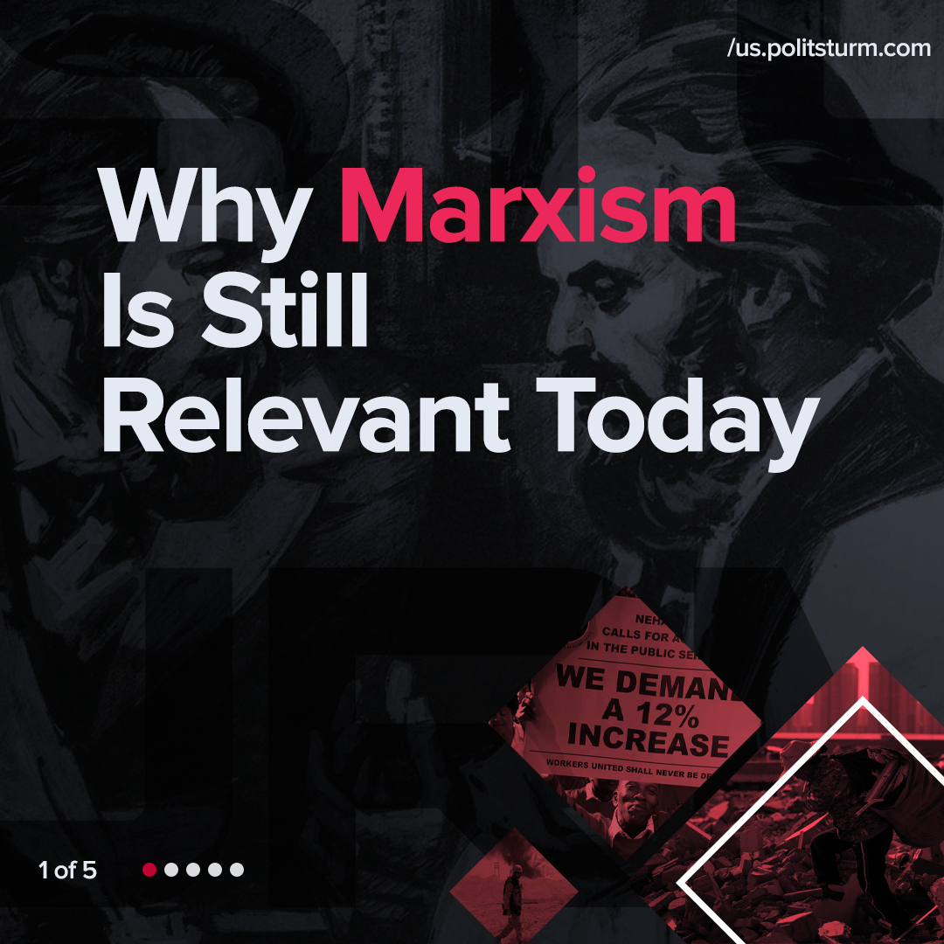

Original article
2022-01-06
1 min read

Error loading image

Error loading image

Error loading image

Error loading image

Original article

