Why Is Trump Rushing Russia-Ukraine Negotiations?
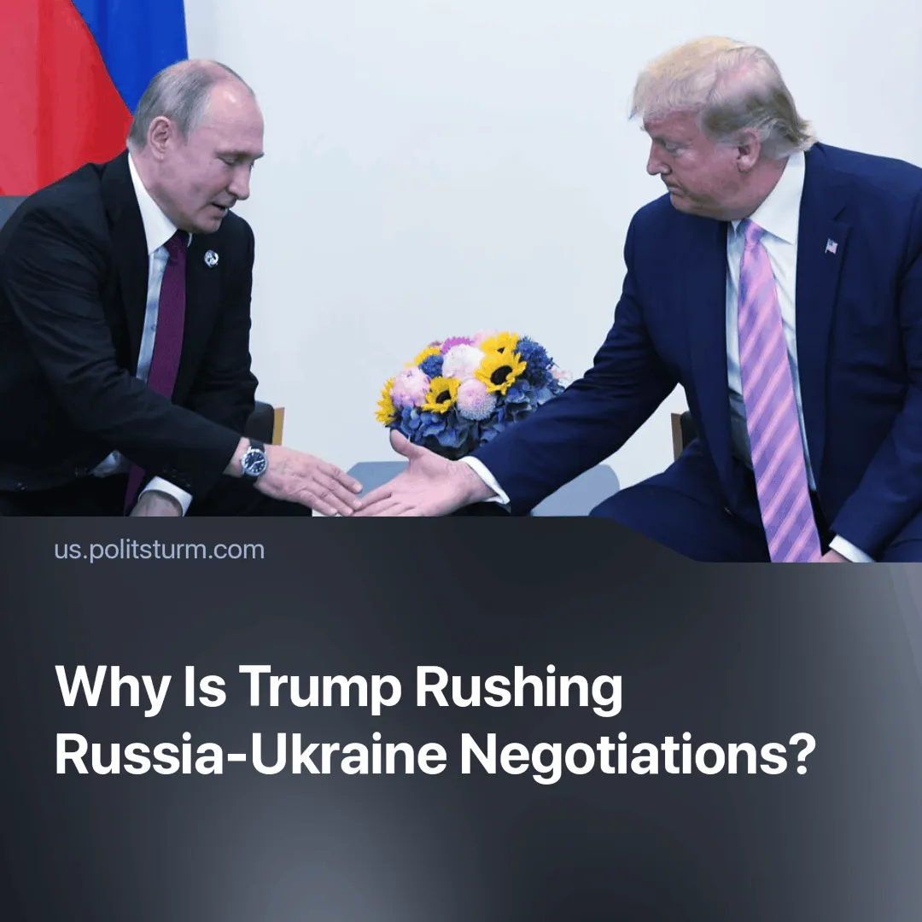

Original article
2025-02-15
2 min read

After a 90-minute phone call with Vladimir Putin on February 12, Donald Trump announced that negotiations to end the Ukraine conflict would begin "immediately." He described the conversation as "lengthy and highly productive," emphasising that both leaders agreed to work closely together.
Details. This is the first phone call between American and Russian presidents for 3 years. Previously Biden had refrained from engaging directly with Putin, whom he had labeled a 'war criminal'.
► Trump indicated that a face-to-face meeting with Putin could happen soon, potentially in Saudi Arabia. While he also spoke with Ukrainian President Volodymyr Zelensky, Trump remained vague about Ukraine's role in the negotiations.
► Defence Secretary Pete Hegseth stated that Ukraine’s NATO membership is unlikely and that the U.S. will shift its focus from European and Ukrainian security to U.S. borders and countering China.
► A leaked document allegedly prepared by Trump’s team outlines freezing front lines at current positions, suspending Ukraine’s NATO membership for 20 years, and establishing a demilitarised zone with European peacekeepers.
Context. Trump's approach represents a stark departure from the Biden administration, which insisted on Ukraine's direct involvement in any negotiations.
► During his campaign, Trump promised to end the conflict in "24 hours," though he provided no specific plan.
► Trump's push for a rapid resolution of a 3 years conflict has raised concerns among EU countries who fear exclusion from the peace process, seeking a role in negotiations after Trump's direct engagement with Putin.
Important to Know. Trump's rhetoric is connected with a change in priorities in American policies. The United States seeks to minimize costs where a compromise can be reached without major losses.
► After his inauguration, Trump emphasized the fight against China as the main enemy of the United States. The current situation contributes to Russia's increasing dependence on Chinese capital: Moscow is becoming a supplier of cheap resources and partially dependent on the Chinese market.
► It is possible that the US President hopes to play on the growing discontent of Russian capitalists with unequal "cooperation" with Chinese capital. Freezing the conflict on terms favorable to Russia could restore the ties of the Russian economy with the international market and thereby weaken China's position.
► Trump is trying to form a system of compromises designed to freeze the conflict for some time and allow the United States to exit the conflict with minimal losses. Unlike Biden, who resolutely relied on Ukraine, Trump makes it clear that concessions will have to be made by both Russia and Ukraine.
Conclusion. Trump is not actually interested in peace as a principle; he merely wants to refocus U.S. military attention on theatres he considers more strategic. Freezing the conflict appears to be a means of weakening Beijing's position in the long term.

Original article

