Why Does Europe Still Buy Russian Gas?
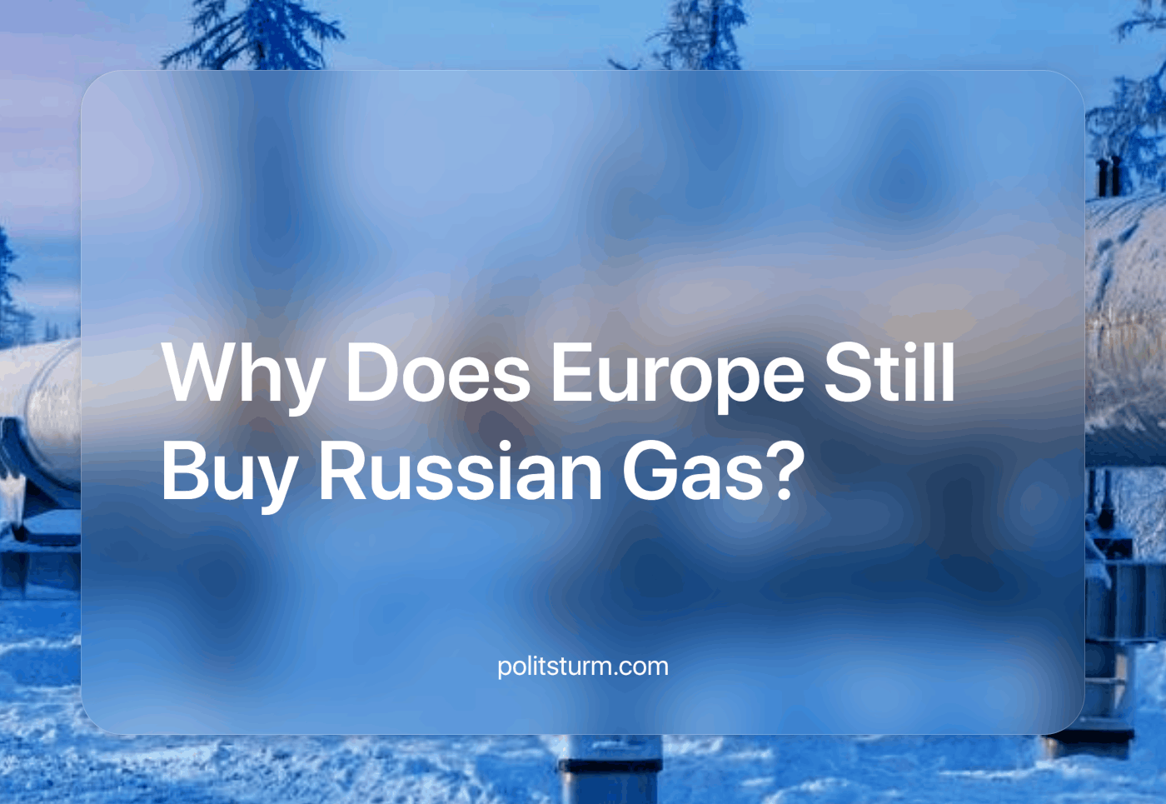

Original article
2024-05-26
9 min read

For more than two years, we have witnessed the pressure of "unprecedented" EU sanctions on Russia. Since then, more than 10 packages of sanctions have been adopted, providing for a variety of measures, mainly trade restrictions. The purpose of the sanctions is to limit the development of entire sectors of the Russian economy, but what is the reality?
We will not go into the whole discussion of sanctions, their course, sequence, divergence of expectations and faits accomplis, but for the sake of clarity we will look at a few examples.
Russian oil is subject to a fairly faithful price cap of $60 from December 2022, which at the time of imposition was even higher than the Urals price at the time (~$50). If the aim was to create economic instability or to act as a deterrent, an embargo would be more effective. But capitalism isn't about efficiency, it's about making a profit. And Russian resources are quite cheap, and their volume means that demand can be met for years in advance.
Imports of diamonds and nuclear energy were also excluded from the discussion of the 10th package of "extraordinary" sanctions. Not only is the EU not imposing sanctions on nuclear energy, where Russia is a leader, it is even continuing to cooperate. Hungary and France have blocked EU sanctions against Russia's nuclear industry because, according to Politico, "more than half of Hungary's electricity comes from a nuclear power plant controlled by Rosatom" [1].
It's important to note that the US just recently imposed sanctions on the nuclear industry, while Russia previously supplied more than half of its enriched uranium to the US - and what was the result? As the Wall Street Journal put it, "prices rose by 30% even as the bill was being debated in September 2023" [2].
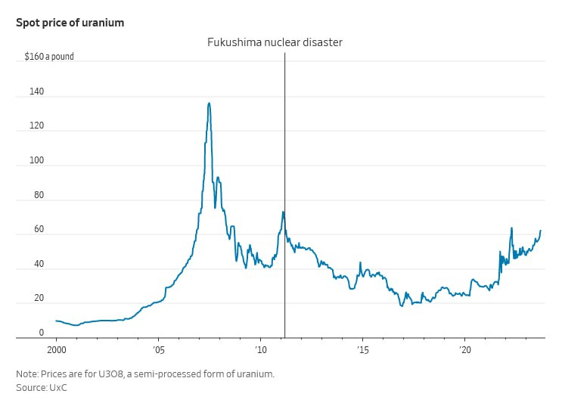
Let's go straight to the story of Russian gas supplies to Europe.
In 2021, gas (pipeline gas) from Russia will account for about 50% of Europe's imports. Currently, it is 9%, but there is a nuance. It consists of the fact that Russia has started to supply more compressed natural gas (CNG), and if this is taken into account, gas imports directly from Russia currently stand at 15%.
As a result, in the winter of 2023, due to sanctions that were not fully thought through, the energy system in Europe was hit by a crisis that pushed up electricity prices, which is still being felt by ordinary citizens. Many companies received compensation or tax breaks for the spike in electricity prices... but residents received record-high bills for light, hot water and heating.
According to a report by Kpler, Russia is currently the second-largest CNG supplier to the European Union in terms of volume. In 2023, Russia will account for 16% of the EU's total imports of fuel, up 40% from 2021. Despite a slight decrease in the volume of deliveries in 2023 compared to the previous year, data for the first quarter of 2024 show that they increased again by 5%. It should be noted that France, Spain and Belgium accounted for the majority of the EU's CNG imports in 2023, purchasing 87% of the fuel between them [3].
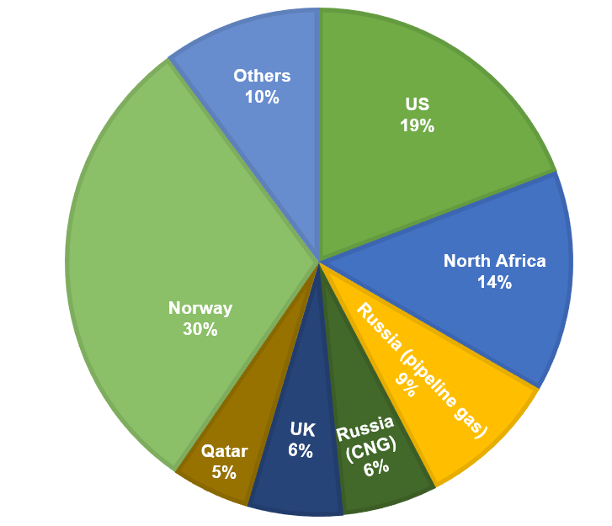
However, about a quarter of Russian CNG is used by Europe... for resale. Well, apparently, money doesn't smell. Apparently, Ukrainian and European workers will continue to bear witness to the spectacle of "surprise" that their ruling classes put on for them - for some reason, sanctions against Russia have not been successful.
In addition to this 15% of gas resources are directly imported from Russia (which European politicians call a successful rejection of Russian resources), Europe has doubled the flow of refined petroleum products from India, which in turn became one of the main importers of Russian oil in 2023. Put simply, Europe is no longer buying oil from Russia but is now buying Russian refined oil (in the form of petrol, kerosene, and diesel) from India. This has an extremely negative impact on European workers, who bear the additional costs of this diversification of supply [4].
The situation with pipeline gas is no better. The only functioning gas pipeline to Europe runs through Ukraine, whose contract with Gazprom expires at the end of this year. And for some reason, Ukraine did not even think of cutting off supplies in February 2022 or after. Still, now the pragmatic government directly states that Ukraine is ready to extend the agreement with Gazprom if there is a corresponding request from European countries. The agreement can be concluded not directly but through some intermediaries [5].
And such a request from European countries is quite possible. At the moment, the EU is planning to completely abandon pipeline gas as early as 2027. Austria imports 98% of its gas from Russia, and Hungary is also heavily dependent on Russian pipeline gas. Hungary has recently signed a gas supply agreement with Turkey, from where the same Russian gas that is being sent to Turkey via the Turkish Stream pipeline is expected to be sent to Hungary.
This is generally a characteristic feature, especially for Eastern Europe - very aggressive rhetoric (Russia is an existential threat, etc.), refusal to pay lip service to Russian resources... and then buying the same Russian resources from their European counterparts, with their markup, of course. As a result, oil, gas, diamonds, etc. are used throughout Europe, the only thing that changes is the importing country and the higher cost of it. Instead of direct and more profitable relations with the supplier, an "acceptable" intermediary in the form of another state is introduced into the system. The result is simple - the residents get higher prices for housing and utilities, petrol and due to the rising costs of logistics for all other goods as well - while even higher profits are reaped by the parasitic intermediaries.
This contradictory policy, where they aggressively declare one thing and quietly do the opposite, is just another example of the dead end of capitalism. Hiding behind the statements about the community of common Western liberal interests, the defence of the state, democracy, freedom of speech, and the interests of the class, in reality, the class interests of the bourgeoisie are imposed. If it is still profitable to buy resources from Russia, they will be bought through intermediaries. Let's imagine, for example, that in 2028, when there will be no gas purchases from Russia for a year, one of the options will be to buy the same gas through Turkey, which is a member of the EU and at the same time is quite loyal to the relations with Russia (or the refined product from India). On paper, imports from Russia will be 0%, but in reality, it will probably be more difficult to determine which gas went to the EU and which remained in Turkey itself - Turkish or Russian.
At the same time, this policy negatively affects the citizens of the EU, the citizens of Ukraine and Russia, the prices of essential food, petrol, heating and light are rising. The capitalists are simply passing these costs on to the workers, and in the case of CNG, they are also reselling Russian gas for a profit.
The measures taken not only do not lead to the declared objectives - ceasefire, the opening of negotiations, etc... - but on the contrary, they favour the capitalists and lead to the prolongation of the conflict at the expense of the workers' lives, at the expense of the worsening of their living standards.
Under capitalism, as long as the main thing is profit, wars will continue, because war is only a logical continuation of economic competition when financial capitals can no longer compete peacefully for markets. It is only possible to prevent future wars, which will inevitably occur in different parts of the world, by changing the economic system, the main objective of the economy. The main goal of socialism is the continuous growth of the economy in order to increase the welfare of the people and give them more and more opportunities to realise their potential, fulfilling their ever-rising material and cultural standards.
Socialism with a planned economy does not require wars for its normal functioning, as they are destructive to both the workers and the economy. It is inconceivable that the workers of the socialised means of production should lobby through the Soviets to send themselves to kill and be killed in a war for profit, and to grow the aggressive military industry to the detriment of heavy and light industry and agriculture (i.e., the material basis for their rising living standards). While, under capitalism, the lobbying for new "aid" packages for Ukraine by various American companies from the military-industrial complex is no secret.
As long as the workers do not come to class consciousness and are not led by communist parties that have mastered Marxist-Leninist theory, the workers will continue to be surprised by the tricks and deceptions of the capitalists. On the one hand, they give promises and hopes, on the other hand, they profit from the difficulties of their neighbour. The ongoing trade in energy resources with Russia shows the essence of "true European values" - not democracy and freedom of speech, but a despicable thirst for profit. We aim to create real communist parties, and are involved in this work - join us.
Sources: 1, 2, 3, 4, 5

Original article

