Why Do Russian Capitalists Need Ukraine?
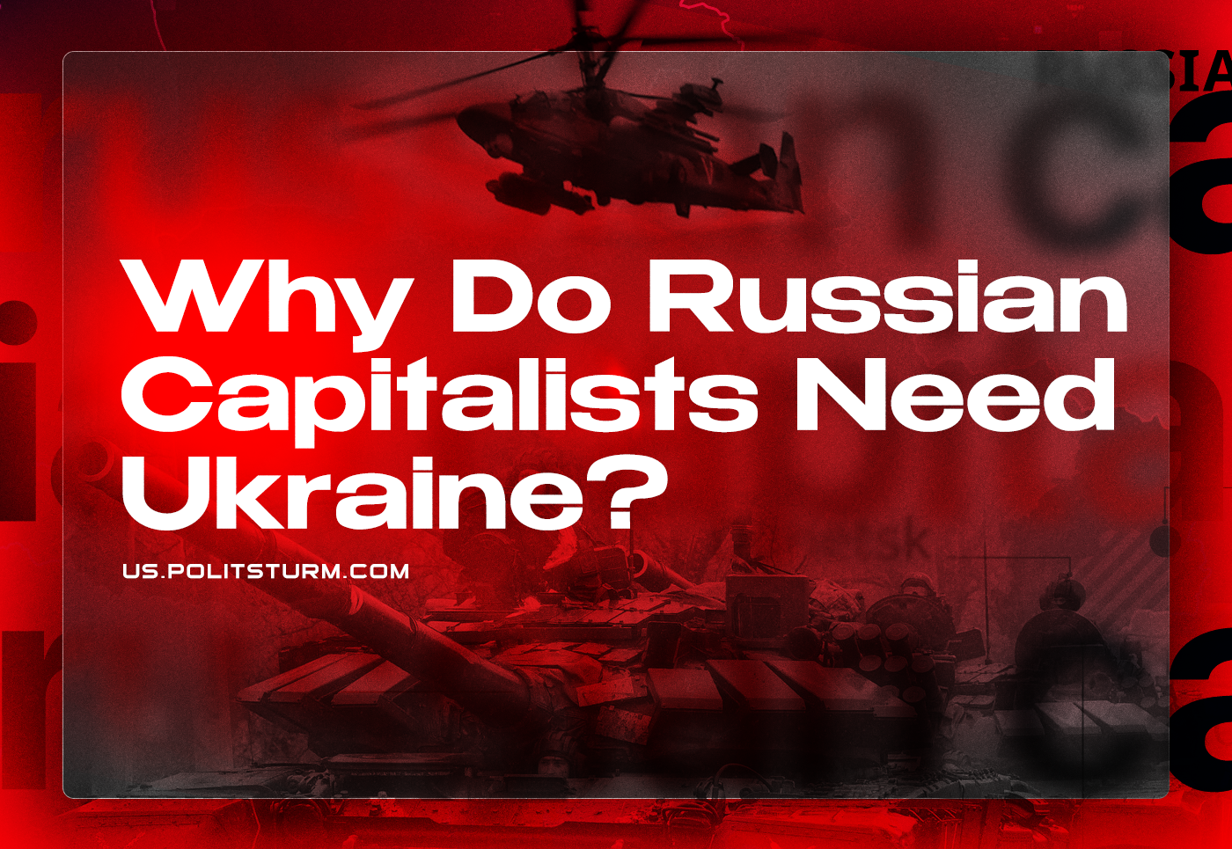

Original article
2023-01-07
17 min read

Uncovering the alleged interests of capitalist states and their politics is the cornerstone of Marxist analysis. Through this analysis we can reveal the true image of the particular state’s political and national interests as well as its domestic and foreign policy. Russian capital and its interests in the near abroad and in Ukraine are no exception.
Since the beginning of March, many Russian leftists have advanced various theories that take different approaches to show the true motives of the Russian capital in Ukraine. Oleg Komolov (Russian blogger, member of “ROT-Front”, openly declares the necessity to revise Marxism-Leninism and “mix” it with Wallerstein’s world-system theory – Politsturm), being true to himself, said that the “special military operation” is nothing more than an example of the “global deglobalization process”. "KrasnoBY" (broad-left organization in Belarus – Politsturm) in its video with the loud title "Ukraine, Russia, War. Russian interests in the Conflict” only devoted seven minutes of the almost eighty-minute video to the interests themselves.
Unfortunately, most of the left completely avoids analysis of the Russian capital’s real interests in Ukraine, limiting itself to common phrases and statements. The theoretical inaccuracy in the position of a number of leftists, as well as the strengthening of state propaganda, urgently requires the comprehensive analysis of the real interests that Russian capital is pursuing in Ukraine.

How does the Russian Federation define its interests?
Before we will go deep in the analysis of the real Russian capital’s interests in Ukraine it is worth looking at how state propaganda presents them to the general public.
A characteristic feature of propaganda regarding the Russian goals in Ukraine is that it actively avoids any mention of possible economic interests. Instead we hear statements about denazification and demilitarization. According to propaganda, Russia is protecting its security and national interests and combating NATO expansion, saving the Donbass and the “Russian world” in Ukraine. The result is an illusion shared by some ordinary Russians (and even "a number of inconsistent leftists") that believe that Russia is pursuing purely non-economic goals in Ukraine.
In reality, the Russian capital in Ukraine has economic interests which largely determine the imperialistic policy of the Russian Federation in recent years.

Economic interests of Russian capital in Ukraine
Immediately after the collapse of the Soviet Union and the formation of a stable capitalist class in Russia, Russian capital began to penetrate Ukraine. Its economic interests were dictated by a number of factors:
First of all, it is the high industrial potential inherited by Ukraine from the Ukrainian SSR;
Secondly, the high degree of interconnection between the Russian and Ukrainian economies with the presence of close technological, logistical, as well as production and mining industry ties;
Thirdly, it’s the natural desire of the Russian monopolistic capital to expand into the former Soviet republics due to their geographical and economic proximity.
According to the “Monitoring of Mutual Investments in the CIS Countries”, Ukraine was the largest recipient of Russian investments among the CIS countries before Euromaidan – at its peak they exceeded 17 billion dollars. Ukrainian investments to the Russian economy were much more modest: only 1.4 billion dollars. However, this did not stop Russia from bypassing the remaining countries of the CIS in terms of attracting Ukrainian capital.
Thus, investment ties played an important role in maintaining and expanding the economic interaction between Russia and Ukraine and the development of their informal integration [1; 2; 3; 4].

a) Interests in oil and gas sector
The first object of the Russian capital expansion was the Ukrainian oil refining industry.
From 1998 to 2001 Russian investors gained control over the three largest Ukrainian oil refinery factories - Lisichansky, Kherson and Odessa. One more ⎼ Kremenchug ⎼ became the property of Russian investors back in 1994. For comparison, the total design capacity of the two remaining Ukrainian refineries was 20 times less than four Russian ones. In total, in 2001⎼2006 Russian capital controlled more than 90% of the design capacity of Ukrainian oil refining industry as well as 85% of oil supplies and 70% of the retail market.
At the same time, it should be noted that until 2011-2012 Russian and Western capital (for example joint venture company TNK-BP) jointly captured the Ukrainian market. And only after 2012 with some certainty we can say that unity between Russian and Western capital in “devouring” this young market began to give up. Contradictions started to arise between them, which at first led to their demarcation, and only after it to the direct clash.
Thanks to the annexation of Crimea, Russian capital gained control over the company Chernomorneftegaz, which produces gas and oil on the territory of the peninsula and the Black Sea shelf. Until 2014, TNK-BP in cooperation with Western companies Shell and Exxonmobil, were developing the Yuzivska gas field in Donetsk and Kharkiv regions.
Already in January 2021, Naftogaz of Ukraine launched gas extraction in the Svyatogorskoye field, which created a possible threat to the Russian gas monopoly on the European market.

b) Interests in metallurgical sector
At the same time, the oil and gas sector, due to its relatively small volumes, is still a secondary Russian capital investment direction.
Importance of the oil and gas sector at the very least was significantly inferior not only to the Ukrainian gas infrastructure network by which Russia exported its gas to Europe, but to the metallurgical sector as well. Russian metallurgical companies JSC "Metalloinvest" owned by Alisher Usmanov and PJSC "Severstal" owned by Alexei Mordashov met serious competitors on the international market in the face of Ukrainian Rinat Akhmetov’s "Metinvest" and the corporation "Industrial Union of Donbass" owned by Sergey Taruta.
The struggle of the Russian capital with Ukrainian metallurgists began right after the USSR collapsed. Growth of the metallurgical segment of the former fraternal republic was considered by Russia as a threat to national security due to obvious preferences over Russian capitalists that Ukrainian metal producers had from Ukrainian authorities. The confrontation entered an active phase within this century.
Starting from 2003, quotas were set annually for the import of Ukrainian large-diameter pipes to Russia, which made them uncompetitive on its domestic market. In addition, since 2006 the Russian Federation imposed a special duty on all imported large-diameter pipes including Ukrainian ones. Ukraine did not remain in debt, and in 2005 the government of Yulia Tymoshenko passed legislation through Parliament that established the same customs duties on crude oil and gasoline.
At the same time, following a collective complaint from OJSC “Magnitogorsk Iron and Steel Works” , OJSC “Novolipetsk Iron and Steel Works” and PJSC “Severstal”, special duties were imposed on all Ukrainian metal products. Its level was initially declared to be around 25–30%.
The "war" of Ukrainian and Russian metallurgists was part of the global scrap metal market redistribution process. Similar quotas and duties which were imposed by the United States on the import of Ukrainian steel products in 2018 and in 2019 Europe acted the same way - one would think that both are main allies of Ukraine after events of 2014.
The confrontation between Russian and Ukrainian metallurgy was connected with the struggle for the semi-finished products markets (slabs and square billets), from which rolled metal is produced for the target markets of the USA, Europe and China. According to the data provided by GMK Center, Ukrainian metallurgical companies in 2021 covered 34% of the EU's demand for slabs and 50% of demand for square billets.
In total, Russia and Ukraine control 84% of the European, 57% of the US and 23% of the Asian semi-finished products market.

c) Interests in labor resources
The labor resources of Ukraine (about 25 million people) are the object of Western and Russian capital’s keen interest. The following statistics clearly demonstrate significant transformations in the structure of Ukrainian labor migration:
Error loading image
Central and Eastern Europe are the main directions of labor migration from Ukraine. Russia ranks second in this regard.
Moreover, if earlier the balance between these two directions fluctuated at 45% to 55%, after the introduction of a visa-free regime between Ukraine and the EU in 2017 80% of all labor migrants reoriented to the West and only 20% continued to work in Russia.
The largest increase in labor migrants is characteristic of Poland. Thus, from 2010 to 2017 the share of Ukrainians among all foreigners who received permits for temporary and permanent residence in Poland increased from 29.5% to 67.1%. In addition, from 1.8 million of temporary work permits issued in 2017, 1.7 million (94%) were issued specifically to Ukraine citizens [5].
According to the State Border Service from 2017 to 2020 the average number of annual border crossings between Ukraine and Poland amounted to 24 million people, while for the same period the average annual number of crossings of the Ukrainian border with Russia amounted to only 4.5 million people.
As with natural resources, labor resources are an asset that the Ukrainian state actively “exports” to other countries. After the 2014 migration crisis in Europe and the decrease of migration flows from Asia and Africa, Ukraine has become the main labor resources donor for Europe.
Ukraine at the state level supports and stimulates the active departure of citizens abroad. This purposeful program is dictated primarily by the desire of the Ukrainian government to increase the flow of money transfers to the country and hence selling its labor force with more profit. Thus, the average wage in the EU exceeds the average wage in the Russian Federation by 6 times. In addition, remittances from labor migrants working in the countries of Central and Western Europe totaled 9.8% of the country's GDP in 2020. This is more than 15 times more than the amount of remittances from labor migrants working in Russia [5].
Thus, in a situation where the main labor flows of Ukraine are redirected from East to West, the clash of two capitals interested in cheap labor is only a matter of time.

d) Interests in agricultural sector
Ukrainian agriculture shares the same fate with the metallurgical sector. For many years it acted as one of the main competitors of Russian capital on the international market. The struggle between Russian and Ukrainian agrarians had two stages.
The first one is the displacement of the Ukrainian goods by the Russian agro-industrial complex on the domestic market in 2013⎼2017. This was done through the introduction of export duties. During this period, the share of Ukrainian grain products in the Russian market decreased from 11% to 0.5%.
The second one is the clash of interests between Russian and Ukrainian agro-industrial complexes on the European and Asian markets in 2018⎼2021. The growth in trade of Ukrainian and Russian grains and legumes proceeded unevenly and depended on a specific region. For example, over the past eight years on the European market, Ukraine’s growth was 240% versus Russia’s 44%. In the Asian region,Ukraine had 17% growth against the Russian 142%, in North Africa 22% versus 36%, respectively.
The grains and legumes trade dynamics indicates that Ukraine increased grain exports by more than 2.5 times from 2011 to 2020. Ukraine ranks 5th in the world in exports of corn (4884 million dollars) and wheat (3595 million dollars), 4th in exports of barley (877 million dollars). The Ukrainian grain market covers about 19.5% of the needs of the EU (for individual grains, for example, corn about 52%), 25.2% of the needs of the Asian market and 24.4% of the African market [6].
Over the same period, Russian farmers also increased grain exports to the world's largest markets. Around 40% of grain exports were conducted to the EU countries, 28% to the Asian [7] and 23% to the North African market in 2021.
Thus, the interests of Russian and Ukrainian farmers collide on many foreign markets. The Russian and Ukrainian agro-industrial complexes are fighting against each other to ensure the sales market for their products (struggle is going on for EU, China, Egypt and the countries of the Persian Gulf). The trade restrictions caused by the pandemic and the economic downturn that followed it worsened the hostility between the agro-industrial complexes of Ukraine and Russia and forced them into the fight for new sales markets.

e) Interests in other industries
Along with the considered spheres of the Ukrainian economy, a few words should be said about other equally important ones. In 1998⎼2008 Russian investors showed an active interest in the Ukrainian media. This aspect included the acquisition of a stake in central television (1+1, 2+2). In addition, one of the significant sectors of the Ukrainian economy, which attracted the attention of Russian capital, is tourism (Crimea, Odessa).

Russian political interests
However, one shouldn’t think that the interests of Russian capital are strictly limited to the economic ones - there are a number of goals that Russian capital pursues In Ukraine.

1) The Russian Federation uses the situation in Ukraine to solve a number of domestic economic problems.
This includes not only an intention to replace Central Asian labor migrants with ones from the “fraternal” state, thus reducing inter-ethnic tension within Russia and gaining the possibility to keep the minimum wage level through the use of cheap labor from Ukraine.
In addition, the production capacities and resources of Ukraine can significantly strengthen the wealth of the Russian capitalists, increasing their ability to export raw materials and eliminating the direct competitor.

2) The situation in Ukraine is being used to solve a number of internal political problems.
First of all, we are talking about the restoration of the shaken political elite’s popularity by means of a “small victorious war”. To accomplish this task, the Russian bourgeois ideologists are trying through propaganda to revive the "Crimean consensus", which in 2014⎼2015 rallied the broad masses of the people within the country.
The real conflict between Russia and Ukraine in this case turned out to be a convenient excuse to declare not only that the annexation of Crimea was a vital necessity to Russia, but also that preservation of the “Russian world” and true sovereignty can be achieved only through saving brotherly people of Ukraine from "fascism".

3) Ukraine is an arena where Russian and Western capitalists confront each other.
The primary goal of the Russian capital in Ukraine is to preserve and expand its sphere of influence. Russia seeks to regain not only the lost zone of influence in Ukraine, but to expand it as well, thus preventing its final absorption by the Western capital.
In such a situation, zones of influence and buffer areas, which move the border of contact further from state borders, acquire special significance for each of the parties. This allows not only the creation of puppet regimes in such areas and deployment of military bases, thereby expanding zones of influence - in case of a military conflict, military operations will take place away from home territories and hostilities can be conducted by someone else's hands.
In this regard, control over the Crimean peninsula, Snake (Zmiinyi) Island and such large ports as Odessa, Sevastopol, Nikolaev and Mariupol are strategically important to keep control over the Black Sea.
Moreover, the appearance of the DPR and LPR on the territory of Ukraine and the seizure of a portion of the territories of Zaporozhye, Kherson and Nikolaev regions strengthens the Russian capital’s diplomatic position in negotiations with the West restraining it from direct takeover of Ukraine through its entry into the EU and NATO.
All this increases the weight of Russian capital in international politics and forces western and other world centers of power and capital to compromise and make concessions.

Conclusion
Despite the statements of Russian propaganda on “non-economic nature of Russian interests in Ukraine” and some lofty and honorable goals, a materialistic analysis of the Russian-Ukrainian relations real development indicates the opposite.
Under the slogan of the “Russian world”preservation, Russian capitalists hid their desire to single-handedly exploit Ukrainian workers. Disguised under calls to protect national interests there is only desire to keep and even increase the niches controlled by Russian companies on key sell markets (which are, but not limited to oil, gas, metal structures and semi-finished products, grain crops).
A distinctive feature of the modern Russian capital’s expansion into Ukraine is that it is directly linked to the intensification of competition for sales markets between the two. It was noted above that the Russian capital faced fierce competition from the Ukrainian one in many economic spheres and on many markets.
That is why the expansion of Russian capital to Ukraine proceeds for the most part not in the form of a simple absorption or capture, but rather in the form of physical and direct destruction of competitors and their production capacities.
The principle "let it belong to no one" becomes obvious after we take a look at how Russian capital is using the seized production capacities. Production facilities (with the possible exception of only oil barges) are either not used at all, which leads to their complete degradation and closure (for example, the Alchevsk Coke and Chemical Plant), or its physical destruction (for example, the “Azovstal” metallurgical plant).
The latter indicates that Ukraine is an arena of confrontation not only between Russian and Ukrainian capitals, but between Russian and Western capitals as well. In competition with it, Russian capital is advancing using not economic, but political and military means. This lies in the creation of puppet states (DPR and LPR), buffer areas and establishment of military bases.
What do these facts indicate?
1. The main contradictions of global capital have escalated to the extreme due to successive global economic crises and the COVID-19 pandemic.
2. It is the end of the stability of the modern capitalist system.
3. The world economic crisis and the collapse of the stable capitalist system lead to "trade wars" which then are replaced by the imperialist war.
4. World redistribution of spheres of influence and imperialist wars will develop into a political crisis.
5. The contradictions between the bourgeoisie and the workers, the bourgeoisie and the peoples of the dependent countries will become more and more acute.
6. The proletariat and the peoples of dependent countries, fighting capitalist exploitation and war danger, will organize themselves into a party to fight for freedom and peace.
Sources:
1. Kvashnin Yu.D. Russian-Ukrainian Investment Ties after Euromaidan // World Eсonomy and International Relations, 2018, 62 (4), P. 63.
URL: https://www.imemo.ru/en/publications/periodical/meimo/archive/2018/4-t-62/russia-economics-politics/russian-ukrainian-investment-ties-after-euromaidan (accessed: 30.12.22)
2. Kuznetsov A.V., Baronina Yu.A., Gutnik A.V., Kvashnin Yu.D., Nevskaya A.A., Makarova A.A., Chetverikova A.S., Shchedrin A.V., Mdivani G., Danilov Yu.A. Monitoring of mutual investments in CIS countries - 2016. Saint Petersburg, Eurasian Development Bank, 2016. Report no. 39. 71 p.;
3.URL: https://www.ukrinform.ru/rubric-economy/2527861-investicii-na-krovi-rossia-lider-kapitalovlozenij-v-ukrainu.html (accessed: 21.06.22);
4.URL: https://www.currenttime.tv/a/rossiyskie-aktivy-ukraina/31846953.html (accessed: 21.06. 22).
5. Olga Gulina, Oleksii Pozniak. Ukrainian migration to Russia and Europe:new trends and its consequences // Journal of social policy studies. 2018. T. 16. № 4. pp. 561–576.
5. URL: https://latifundist.com/analytics/23-obzor-rynka-zernovyh-kultur-2021-eksport-proizvodstvo-tendentsii (accessed: 22.06. 22).
6. https://www.agroinvestor.ru/analytics/news/37580-evrosoyuz-v-2021-godu-stal-liderom-po-importu-prodovolstviya-iz-rossii/ (accessed 30.12.22)

Original article

