Who Were the “Communists” in Power in Nepal?
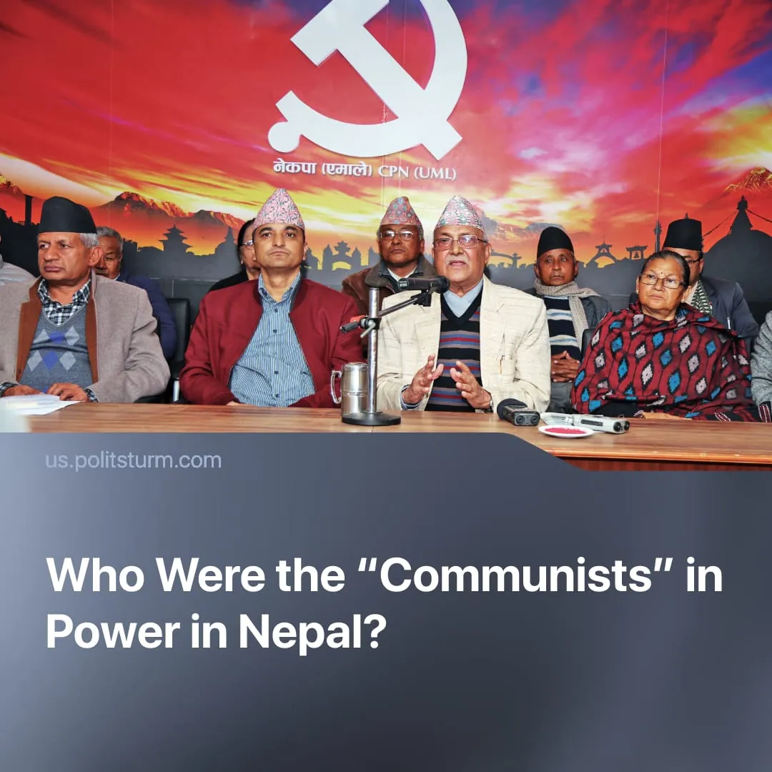

Original article
2025-09-20
4 min read

The overthrown ‘Communist Party’ in Nepal represented the country in the largest international association of Marxist-Leninists. Its opportunist views and actions met no criticism.
Details. The “Communist Party of Nepal (Unified Marxist-Leninist)”, which headed the government of Nepal until the protests, has been participating in the “International Meeting of Communist and Workers’ Parties”. This broad structure, created and functioning with the active participation of the Communist Party of Greece, unites groups and organizations that formally identify themselves as Marxist-Leninists.
► Representatives of the “CPN (UML)” took part in the annual “Meetings”. In 2018, they spoke about the “Nepali interpretation” of Marxism, supported Chinese imperialism, and presented their activities as a model to follow.
Quote: “The NCP has truly set an example to all Communists of the world that given hard work, determination and commitment to serve the people of the lowest strata of the society, the road to socialism is also possible through ballot and dedication to the principles of constitutional supremacy…”.
► One year earlier the party reconciled religion with Marxism: “We the Nepalese communists have seen the seed of Marxist thoughts in egalitarian ideas propounded by Buddha. We have applied Marxism in our country’s concrete context”.
► The party did not participate in the meetings after 2019, which may have been connected to growing internal problems and splits. However, it did not make official statements about terminating its membership in the “IMCWP”.
► The “CPN (UML)” continues to be officially listed among the “Communist and Workers’ Parties” on the Solidnet website – a platform for participants of the “Meetings”. In 2023, one of the “Joint Statements” on the site was supposedly signed by the “All Nepal National Free Students Union”. This organization is the youth wing of the “CPN (UML)”.
► The fact that the party representing the “IMCWP” in Nepal was removed from power did not cause any reaction from the leadership of this structure. On Solidnet, statements were published only by the “Communist Party of India”, the “Communist Party of India (Marxist)”, and the “Communist Party of Sri Lanka”.
► The statements by the “CPI(M)” and the “CPSL” acknowledged the grave situation in the country but made no mention of the role of the “CPN (UML)”. The “CPI” was more direct and openly blamed the “CPN (UML)” for losing the trust of the people.
Quote: “The CPI underlines that the divisions among communists in Nepal have also contributed to this crisis. The people of Nepal have repeatedly given their mandate in favour of the communists. But this mandate has been undermined by compromises with parties driven by narrow agendas, resulting in dilution of communist principles, weak governance, and corruption, disappointing the people and contributing to the present crisis.”
► This position, however, is not consistent. Earlier we wrote about how CPI supported India in the conflict with Pakistan.
Context. Protests took place in Nepal in early September. They were caused by the dire economic situation: poverty, growing social inequality, high unemployment. The immediate trigger for the protests was the ban on social media introduced by the government of the “CPN (UML)” and the “Nepali Congress”. After civilian casualties, the protests escalated and led to the fall of the government. Leaders of the “CPN (UML)” held key positions in the overthrown Nepalese government.
► The party leadership has become notorious for nepotism. Rajkumar Gupta, Minister for Federal Affairs and General Administration, resigned in July 2025 after a leaked audio revealed him accepting bribes for influencing political appointments and land deals. The party is also frequently accused of favoring political heirs and family members of deceased leaders.
► The “CPN(UML)” claims to be the representative of the interests of “blue-collar and white-collar workers, peasants, petty bourgeoisie and national bourgeoisie”. In power, it has confined itself to minor welfare measures. These reforms have not addressed structural poverty or mass unemployment.
► In December 2024, the Oli government signed a Belt and Road Initiative framework with Beijing.
Important to Know. This ‘communist party’ is an opportunist organization with a pro-Chinese orientation. It was used to cover the dictatorship of the bourgeoisie with the name and formal affiliation of “Marxist-Leninists”.
► Communism is now discredited and equated with corruption, foreign dependence, and state violence against youth in Nepal. This will allow imperialists of India and the West to channel mass discontent into their own camp, seeking to secure a new client government as part of their intra-imperialist rivalry with China.
► The positions of this opportunist party, well known long before the protests, were never directly criticized on the “Solidnet” platform.
► This case is not unique. Among the members of the “IMCWP”, which is supposed to unite Marxist-Leninists, there are also the social-chauvinists of the “CP of Russian Federation”, the Jucheists of the “WPK”, and the Chinese capitalists of the “CP of China”. Their membership in the “IMCWP” allows them to deceive workers in their respective countries, and complicates the work of communists in exposing them.
► This situation as a whole has not met criticism from the founder of the “IMCWP” – the Communist Party of Greece. In its materials it has consistently described its work in the IMCWP as positive and strengthened opportunists and social-chauvinists for decades by its uncritical approach.
► The story of the “CPN (UML)” confirms the necessity not only of condemning opportunists but also of resolutely and straightforwardly breaking with them. In this case Lenin’s words are applicable: “As a slogan… unity today means unity with the opportunists and submission to them (or to their bloc with the bourgeoisie). This is a slogan which in actual fact aids the police and the reactionaries, and is disastrous to the labour movement.”

Original article

