Who Paid for Europe's Energy Crisis?
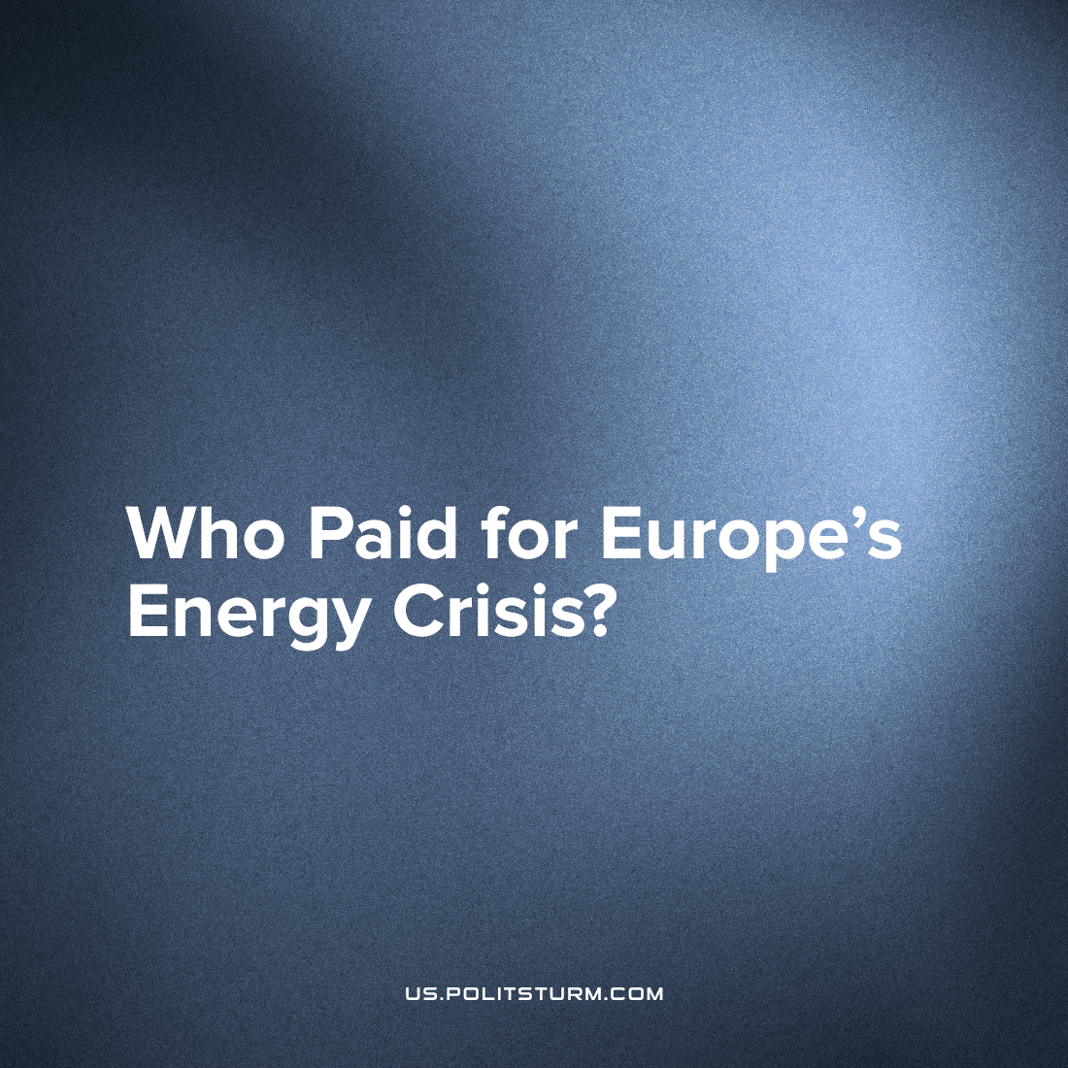

Original article
2023-01-20
3 min read

As you likely know, after the escalation in Ukraine and subsequent sanctions on Russia's cheap gas and oil, Europe began experiencing an energy crisis. This was a critical shortness of fuel for the European market for countless industries, none more intimate than the heating of homes and stoves which drastically shot up prices.
However, if we analyze this crisis more closely – we can doubt the validity of such an increase.
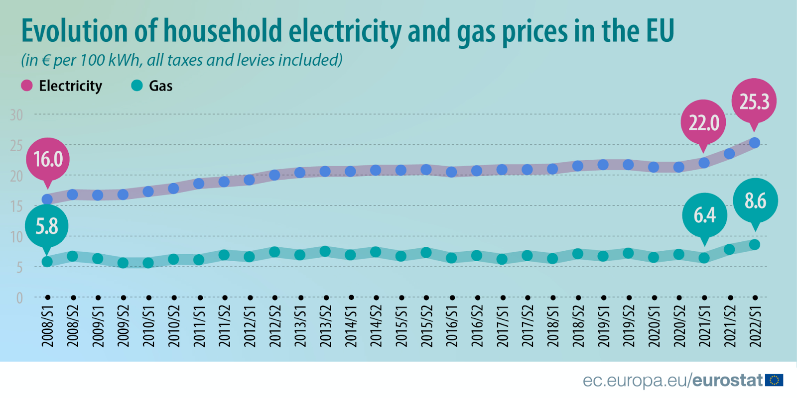
Source datasets: nrg_pc_204 and nrg_pc_202
Europe was hit by a trillion dollar cost from these new energy prices which Bloomberg reports in the fallout of Russia’s military intervention in Ukraine.
Error loading image
Even while more facilities come online to import liquefied natural gas, the market is expected to remain tight until 2026, when additional production capacity from the US to Qatar becomes available.
But who exactly paid 2022's trillion dollar sum? Maybe it was the corporations, those with the most, who suffered the greatest burden.
Well, as we know, the government is a tool in the hands of the ruling class. This is often seen most directly through their “help in difficult times” – like Obama's 700 billion dollar bailout payments during the 2008 crash. Europe's outrageous spending on energy supplies exceeded 700 billion euros at the end of November.
Their old but golden scheme: nationalization of expenses and privatization of profits.
So, as usual, workers should take fewer showers and eat their dinner cold rather that companies shouldn't miss record profits.
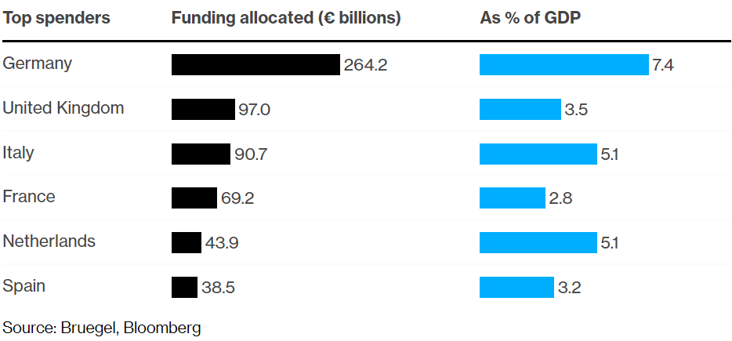
And yet, despite the help from the government, companies have raised prices, debts have grown catastrophically, the standard of living and income of ordinary Europeans is falling.
In fact, these circumstances advances the interests of the oil and gas capitalists on both sides of the conflict, US, UK and Ukraine on their license fees and place in the industry, and the Russian gas capitalists who are the exporters.
Without this conflict, they might be worried about the prevailing trend: their falling rate of profit.
Error loading image
The ruling class of the rich don't feel this directly, they can leave hot water running and the electric heaters blasting while the gas is low; only the working class will experience the deadliness of the situation. The ruling capitalists have, in fact, much to gain from this misery and their violent speculation on the fuel market.
Even while more facilities come online to import liquefied natural gas, the market is expected to remain tight until 2026, when additional production capacity from the US to Qatar becomes available. Following this winter, the region will have to refill gas reserves with few deliveries from Russia, intensifying competition for tankers of the fuel.
Elsewhere, US and Canadian imperialists acquire new gas reserves in the Congo amid a flurry of gas infrastructure construction (including gas export out of Tanzania and Mozambique) to open up the region, these close possessions for the North Americans will enable profitable export to the European market in the long term.
Despite all this capital movement increasing gas supply, there will be little respite for the increasing burden on the regular person in the years ahead.
We see that the energy crisis and the cessation of cheap supplies of resources from Russia threaten only a regular increase in prices for workers.
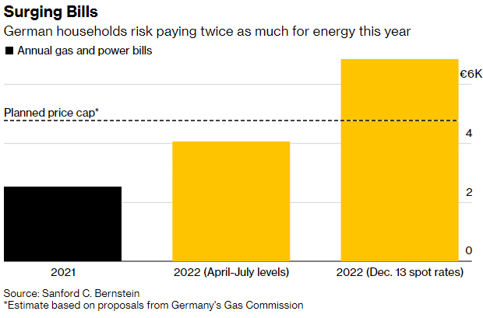
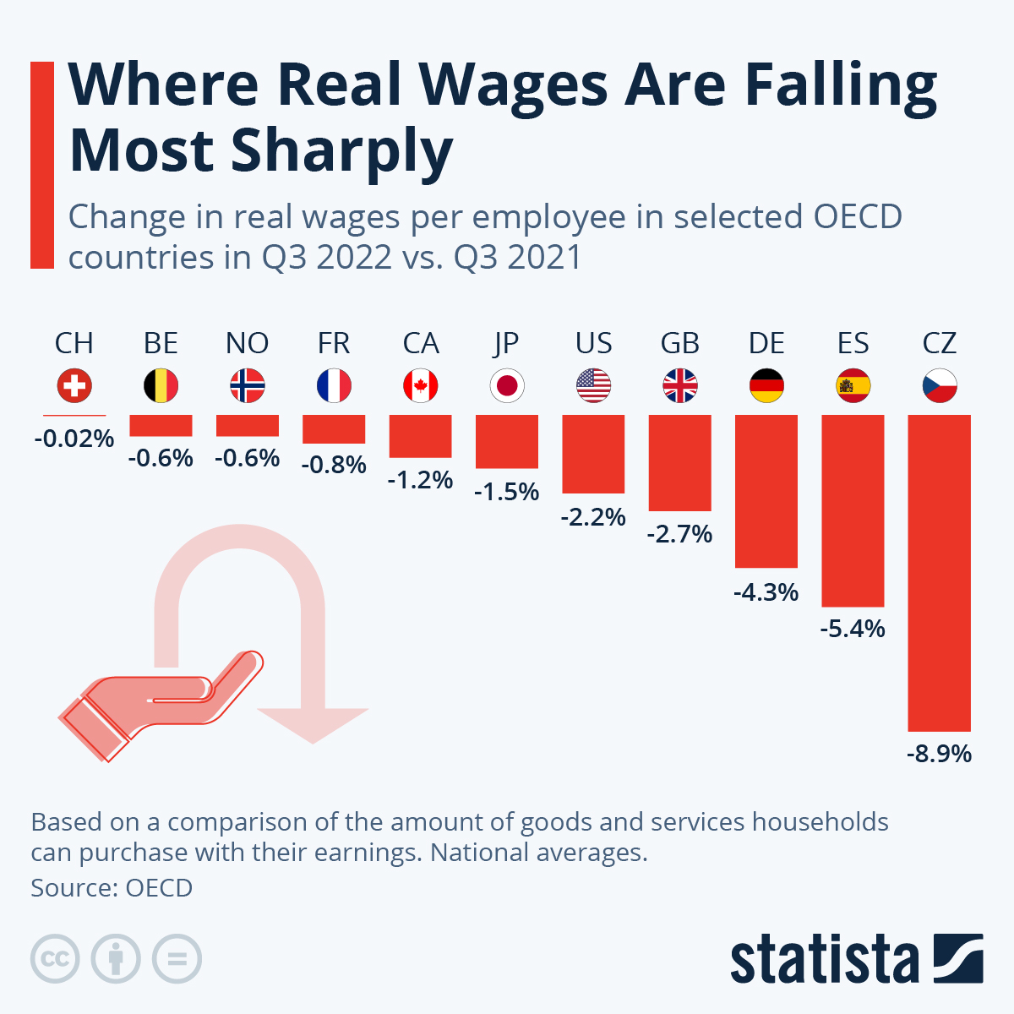
The costs of the bourgeoisie are shifted to the shoulders of the working class by allocating more and more loans, subsidies from the government for "helping the economy".
Ordinary citizens need to start asking the question – how can we simply hope to save our pennies and learn to live without the basics while our exploiting overlords continue to act and rule as normal?
The answer is to turn hopes into actions with the beginning of the formulation of political issues by the trade unions and the formation of a vanguard workers' party on the basis of the Marxist-Leninist theory.
Sources: 1, 2, 3.

Original article

