White House Urges Unemployed to “Find Something New”
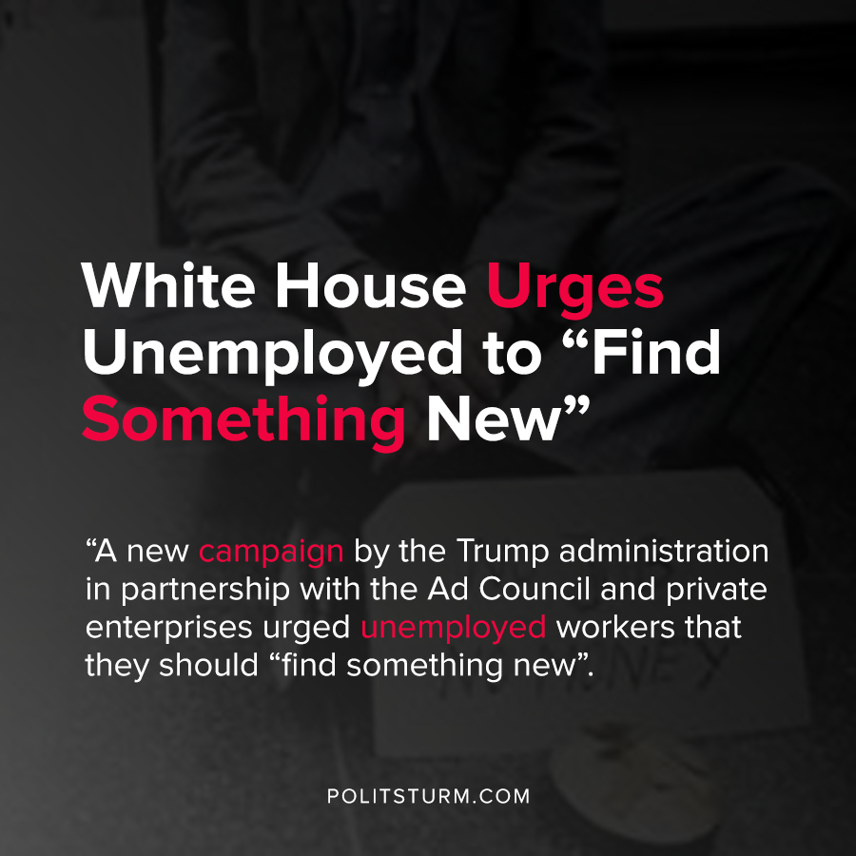

Original article
2020-07-15
1 min read

A new campaign by the Trump administration in partnership with the Ad Council and private enterprises urged unemployed workers that they should “find something new” in response to increased national unemployment. The ad campaign is targeted at unemployed workers who do not have a college degree to discover the “different pathways that exist to career success”.
The website links to the Trump administration’s ‘Pledge to American Workers’, and even touts America’s “historic economic expansion”, and “record low unemployment”. The current unemployment rate is at 11.1%, according to the Bureau of Labor Statistics.
The campaign to “find something new” is the latest attempt by the Trump administration to manipulate the poor objective conditions that workers are currently facing into an opportunity. Trump, who is facing re-electing later this year, is grappling with record high unemployment and a pandemic that has hit the United States harder than any other country.
Despite the rhetoric and manipulation by the Trump administration, workers across the country are thrown into the army of the unemployed with limited opportunities for employment. The capitalist class perversely benefits from the downward pressure on wages that arises from such a situation.
Workers searching for new jobs in the current situation will not resolve the objective shortcomings of the capitalist system. The capitalist system has failed the American worker, and a new, socialist system would objectively fix the unemployment and limited opportunities that workers have. Whereas capitalism is riddled with unemployment, exploitation, and poverty, a socialist economic system would be able to eliminate unemployment altogether.
Sources:1 , 2 , 3 , 4

Original article

