White House Seeks More Funding for Israel and Ukraine in $106B Funding Request
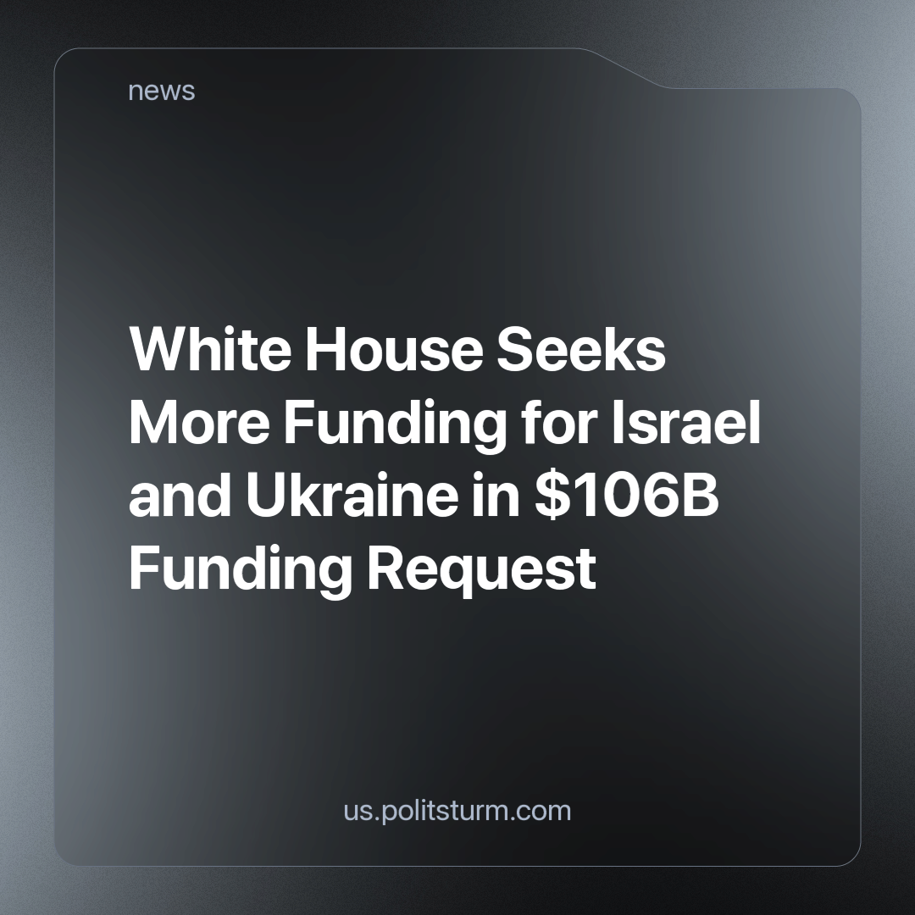

Original article
2023-11-02
1 min read

If approved, $61.4 billion in aid would go to Ukraine, and $14.3 billion would go to Israel. The White House requested $9 billion in aid for humanitarian assistance to Ukraine, Israel, Gaza "and other needs." The funding for Ukraine would go toward additional weapons and equipment, support for the country to provide "critical services to its people and sustain its economy," assistance for displaced Ukrainians, and nuclear and radiological incident response capabilities, among other resources, according to a White House fact sheet.
Aid to Israel would fund the country's air and missile defense systems' readiness, including support for the Iron Dome. It would also go toward replenishing Department of Defense stockpiles that the White House said "are being drawn down to support Israel in its time of need," and increasing U.S. embassy security, the fact sheet said. This planned increase in funding helps Israel continue its imperialism against Palestine.
The proposal also includes $13.6 billion for U.S. border security to deal with large numbers of Latin American and Caribbean immigrants at the southern border, as well as fentanyl trade and $4 billion in military assistance and government financing designed to counter China's regional imperialism efforts in Asia.
The continuation of US foreign imperialist policy would see an increase in conflict in Ukraine, Israel, and the rest of the world. US policy is aimed at keeping their capitalist interest over other imperialists such as China, no matter the cost of human lives. The continued support of Israel and Ukraine is meant to continue their past global hegemony against other imperialist states, in this case, Russia, Iran, and China.
The working class will be the ones who pay for the capitalist wars and will die for the profits of a few. It is in our interest to unite these working classes to overthrow the current exploitative capitalist system.
Source: 1

Original article

