Where Does The Chain Of Imperialism Break?
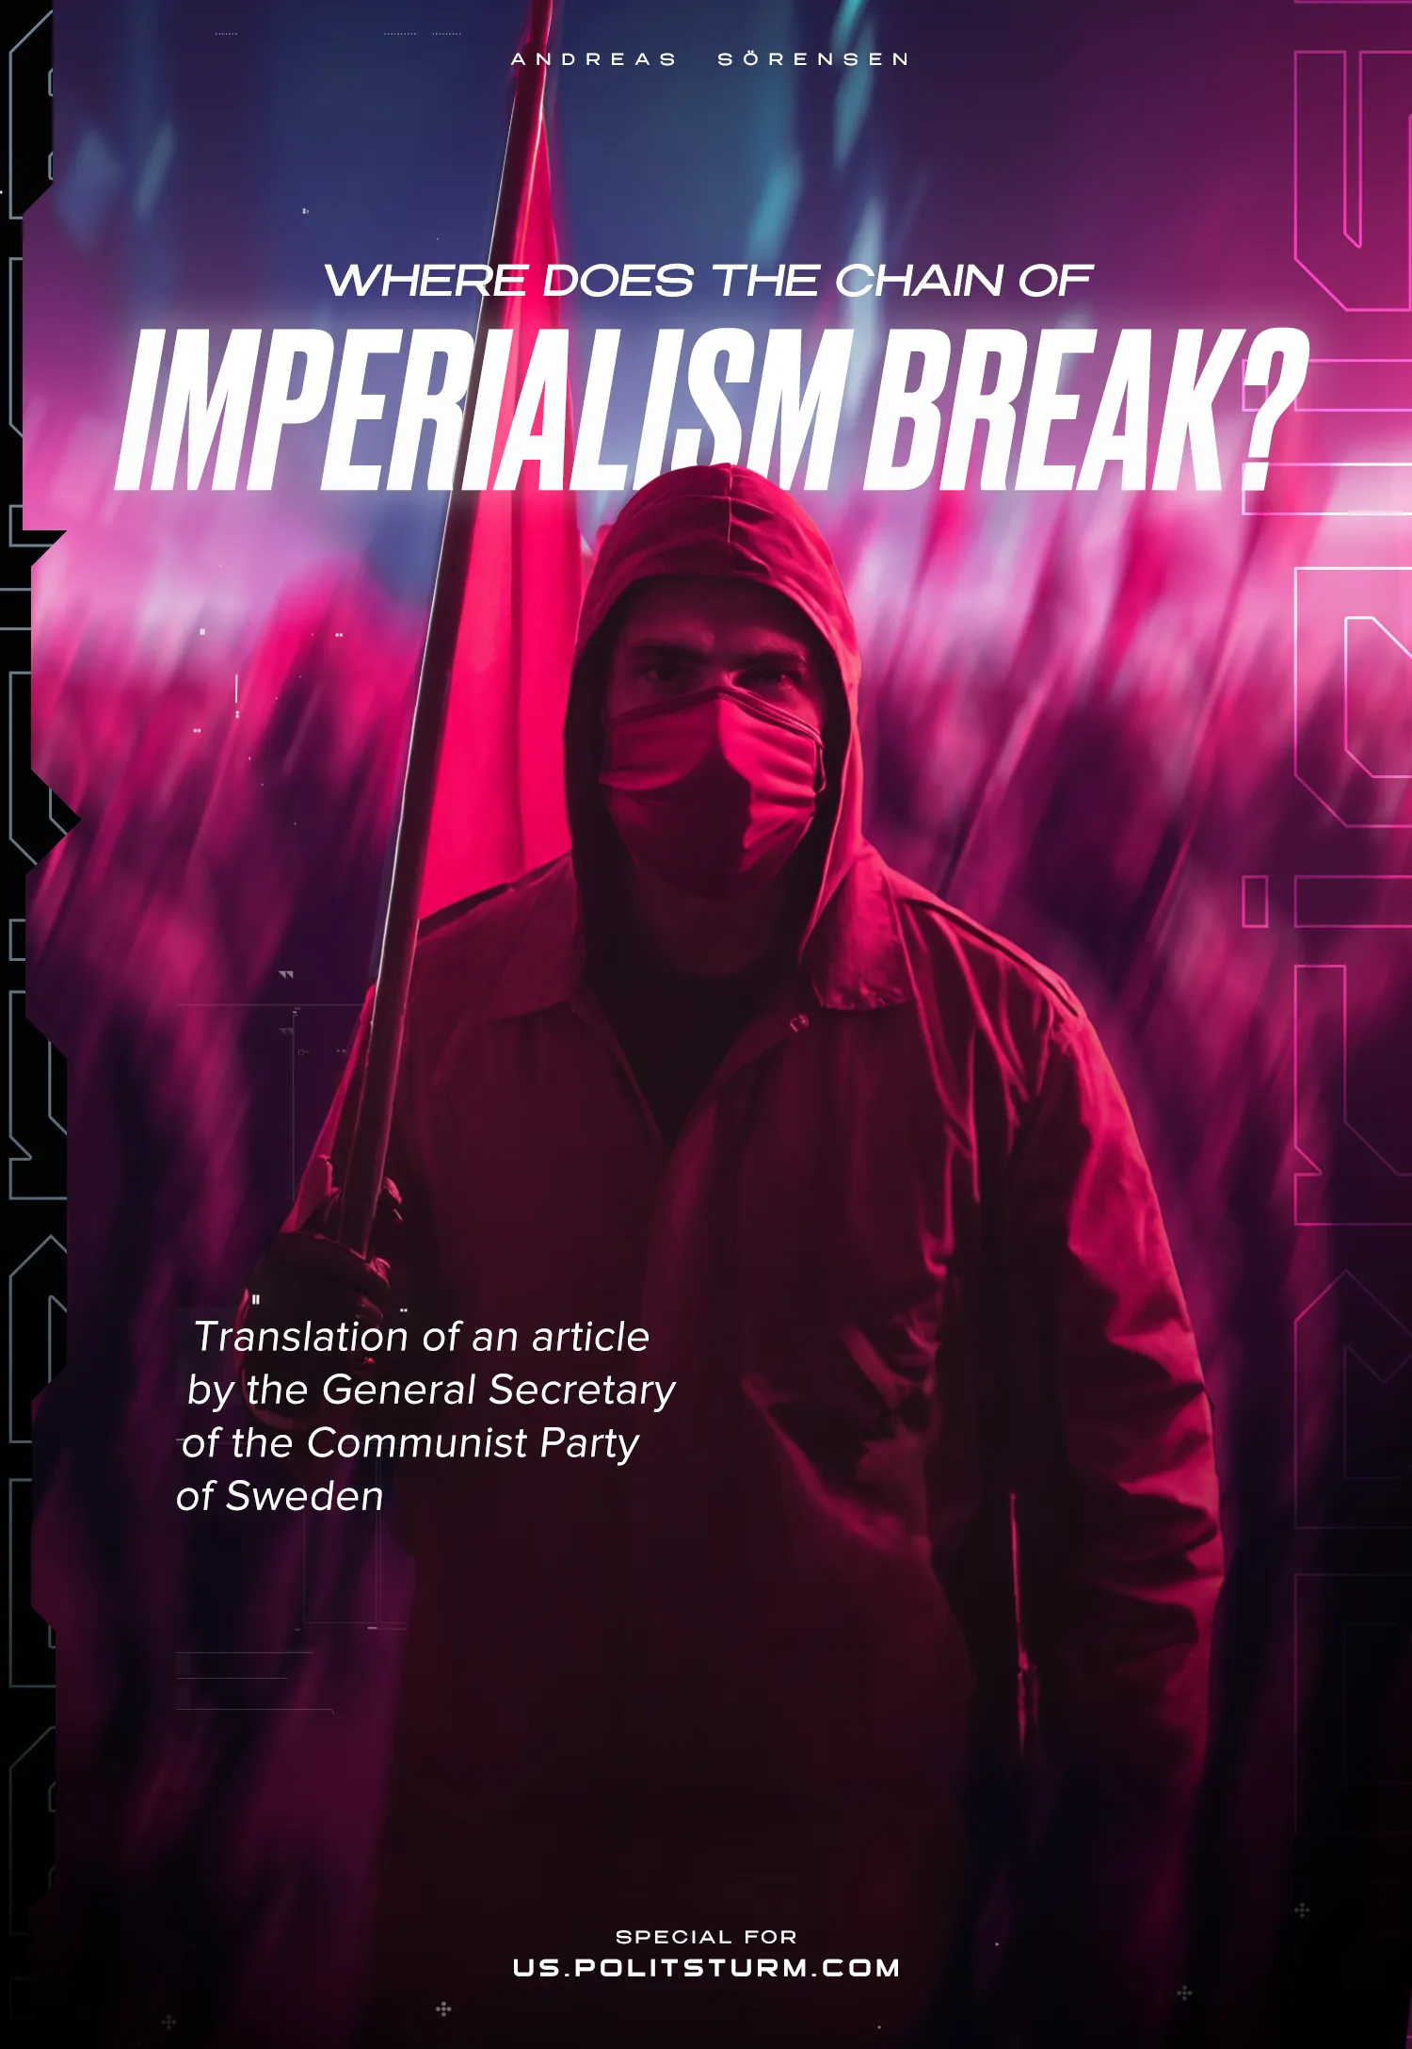

Original article
2024-10-05
13 min read

We are publishing the translation of an article written by the leader of the Communist Party of Sweden, Andreas Sörensen. In this piece, the author answers the question of what is necessary to successfully break through the front of capital.
Sörensen refutes one of the key arguments of social-chauvinists. This argument claims that support for Russia, China, and other supposedly "anti-imperialist" forces is necessary to weaken the US-EU bloc, after which the conditions for revolutions in the countries of this bloc and around the world will be created.
The author rightly notes the example of the October Revolution demonstrates the possibility of such an event even in a far from the most developed country (as the Russian Empire was).
The possibility of such an event depends on many factors. Special attention is given to the subjective factor. The presence of this factor contributes to the victory of communists in each individual country, regardless of its position within the imperialist system. "There is one concern of the Communists and that is to strengthen the subjective factor in each individual country; to organize and create as class-conscious working-class population as possible, which can also act for socialism in the simplest possible way.," the author writes.
Reducing communist strategy to the support of the "weak link" in all cases helps capitalists conceal contradictions and complicates the fight against capital: "Seeing the world as a football match is appropriate in one place: the football stadium... Out of certainly well-meaning and curious people, this logic creates counter-revolutionaries."
The original article titled "Var bryts imperialismens kedja?" was published on the “Riktpunkt” website on December 12, 2022.
Any feedback, questions, and discussions on the topic are welcome.
The world is characterized by increasingly sharp contradictions between the imperialist blocs; the division of the world is complete, and the re-division is becoming a concrete reality. The logic of capitalism is leading to ever-fiercer – and deadlier – conflicts. Humanity is being torn apart and the question is becoming a burning one: which side are we on?
Many simplify the answer. They place it within the given framework, the framework given to them by the very logic of capitalism. When NATO pushes eastwards, they take the side of its opponents. Capital is pitted against capital, and many choose as if it were a football match: two teams play, and one is to be cheered on. At the very least, one has a worse opinion of one side.
In a given football match, there are only two teams. It is common to choose to support the underdog, the weaker team that is predicted to lose. But what happens if you do the same thing when different capitals start fighting?
The concrete case of Russia is the given example, but the question can of course be abstracted and the logic applied to every single case where imperialist wars are going on or where protests are going on. Where contradictions are heightened, quite simply.
The case for Russia becomes self-evident to the unreflective. They see something that can slow down US imperialism. In the case of Ukraine, they choose to accept the argument that Russia will denazify Ukraine (I wonder: hasn't the Russian “Special military operation” driven even more people in the opposite direction?) with the logic that it is better to live under Russian capitalism than Ukrainian Nazism. It's almost as if Russian capitalism exists in a different dimension!
The more extreme ones cry out with a loud voice: Russia is in danger of being dismembered and becoming a colony and supplier of raw materials for Western imperialism! This, they say, must not happen. That is why Russia's struggle against Western imperialism is a struggle for its national self-determination and should be supported. In support of this reasoning, one finds the report of some obscure think-tank. In other words, speculation is running at full speed.
The whole argument does nothing but turn upside down any communist strategy and tactics, which must start from building the communist movement in each country, if only because we can never be absolutely sure where the weakest link is. Instead, it chooses to prop up the imperialist chain, wherever it seems a little weaker! They simply do not see the forest for the trees; they do not see capitalism because all the expressions of capitalism are in the way.

A worldwide system of financial slavery
Three months after Lenin's death, Stalin gave a series of lectures at the Sverdlov University in Moscow. These lectures were transcribed and published as the book ‘On the Foundations of Leninism’. Unfortunately, the text is not available on the internet in Swedish, but hopefully, this is only a matter of time. In terms of clarity, it is virtually unparalleled.
“Formerly, the analysis of the pre-requisites for the proletarian revolution was usually approached from the point of view of the economic state of individual countries. Now, this approach is no longer adequate. Now the matter must be approached from the point of view of the economic state of all or the majority of countries, from the point of view of the state of the world economy; for individual countries and individual national economies have ceased to be self-sufficient units, have become links in a single chain called world economy; for the old "cultured" capitalism has evolved into imperialism, and imperialism is a world system of financial enslavement and colonial oppression of the vast majority of the population of the world by a handful of "advanced" countries.” [1]
As capitalism developed and became imperialism, the conditions for revolution also changed, Stalin explained. Whereas before it was a question of judging individual countries, now it is a question of the system as a whole.
First of all, this is an interesting formulation, since Stalin downplays the role of the "advanced" countries and opens up the possibility that the revolution can take place elsewhere. The experience of the Russian Revolution made this abundantly clear – Russia was hardly the most advanced of capitalist countries (indeed, Lenin called Russia a "crude" and "medieval imperialism" [2] and highlighted in his analyses how French and German banking capital dominated the Russian banking market [3]), yet the revolution took place here.
It is not difficult to see how Stalin followed in Lenin's footsteps in the sense that they considered imperialism as a system, not a stage reached by each individual country. From this insight they also formulated corresponding revolutionary tactics – since capitalism is global, so must be the road to revolution.
“Formerly, it was the accepted thing to speak of the proletarian revolution in one or another developed country as a separate and self-sufficient entity opposing a separate national front of capital as its antipode. Now, this point of view is no longer adequate. Now we must speak of the world proletarian revolution; for the separate national fronts of capital have become links in a single chain called the world front of imperialism, which must be opposed by a common front of the revolutionary movement in all countries.
Formerly the proletarian revolution was regarded exclusively as the result of the internal development of a given country. Now, this point of view is no longer adequate. Now the proletarian revolution must be regarded primarily as the result of the development of the contradictions within the world system of imperialism, as the result of the breaking of the chain of the world imperialist front in one country or another.”

Where does the front of capital break?
With this perspective established, we approach the more interesting – and in the eyes of many modern "Marxists" – more controversial part. Stalin asks, "...Where, in what country, can the front of capital be pierced first? "
The answer to this question is as simple as it is obvious: " The front of capital will be pierced where the chain of imperialism is weakest..."
The important question now becomes to examine what this means in practice – and we do well to bear in mind that Stalin is discussing capitalism-imperialism as a worldwide system.
“...the proletarian revolution is the result of the breaking of the chain of the world imperialist front at its weakest link; and it may turn out that the country which has started the revolution, which has made a breach in the front of capital, is less developed in a capitalist sense than other, more developed, countries, which have, however, remained within the framework of capitalism.”
Here is the crux of the matter: the front of capital and the chain of imperialism can be broken in any of the countries which are part of the world capitalist system. Here it is clear that Stalin is not referring only to those countries which actually have a capitalist economy, regardless of whether it is more or less developed. He goes so far as to say that the front of capital can be broken even in the colonies – he takes India as an example.
“Where will the chain break in the near future? Again, where it is weakest. It is not precluded that the chain may break, say, in India. Why? Because that country has a young, militant, revolutionary proletariat, which has such an ally as the national liberation movement – an undoubtedly powerful and undoubtedly important ally. Because there the revolution is confronted by such a well-known foe as foreign imperialism, which has no moral credit and is deservedly hated by all the oppressed and exploited masses in India.”
The front of capital can be broken in a colony; it can be broken even where capitalism is not entrenched. This means that where the chain is finally broken does not depend on a given country's foreign policy, its international relations or its level of development. Is the country part of the capitalist world system? If so, the chain can be broken there. This was also the case with Russia, whose weak position we have already commented on.
But where, in the end, does the chain break? Of course, it does not depend on any single factor, but on a combination of factors. How stable is capitalism in a given country? How well organized is the opponent? The answer to these questions and many more determines the situation. It is worth pointing out, however, that in the end, it is nothing but the organization and consciousness of the working people, and their party-vanguard, that turns quantity into quality. It is always the struggling people who finally break the chain of capital, in whatever country it may be. That is why Stalin also highlights in the case of India a "young, fighting, revolutionary proletariat" which has an ally in the "national liberation movement" and perhaps precisely because we can never know with certainty where the chain will prove weakest, it becomes all the more important to organize in every country in the direction of socialism.
“The chain proved to be weaker in Russia, although Russia was less developed in a capitalist sense than, say France or Germany, Britain or America.”
One historical exposé later, the turn has come to our time. Can we draw relevant conclusions from this? Can we use the classics as a guide?

Marxism turned on its head
For classical Bolshevism, which is revolutionary in its very essence, there was no other concern for communists than revolution: the front of capital could, theoretically, be broken in any country drawn into the capitalist-imperialist world system, no matter what position in the hierarchy it occupies or who its enemies are. In each country, the subjective factor had to be prepared and strengthened.
When you take one or other side in an imperialist conflict, something happens that is very easy to understand: you strengthen the front of capital in the country you are taking a stand for. Whether or not a revolutionary situation exists, one makes the creation of such a situation more difficult, above all because one's position helps to conceal the contradictions within the given country. When Communists take a stand for Russia in the present situation, they encourage the masses to do likewise, and thus also make it more difficult to oppose capital in Russia, in whose interests the Russian state acts.
By not accepting that the front of capital must be broken where it can be broken, it limits the number of countries where the revolution can be carried out and thus strengthens the global front of capital.
There is one concern of the Communists and that is to strengthen the subjective factor in each individual country; to organize and create as class-conscious working-class population as possible, which can also act for socialism in the simplest possible way.
If Russian capitalists were now – against all odds – to be completely subdued and turned into an obedient supplier of raw materials to Western imperialism, would that mean that the tactics of the Communists must change or that the Communists must now defend Russia? No, the subjective factor must remain the main focus of communists, not least because we also know that the only way forward is socialism, not one or other direction of capitalist development.
Seeing the world as a football match is appropriate in one place: the football stadium. Translated into reality, it becomes a recipe for disaster because it leads straight into the arms of capital. Out of certainly well-meaning and curious people, this logic creates counter-revolutionaries and, for anyone fighting for socialism, these people become a further obstacle in the way.
Andreas Sörensen

Sources:
[1] All quotations are taken from pages 30-32 of Stalin's Problems of Leninism, published by Arbetarkultur in 1941 (The source of the English translation of the work is Stalin, Works, Volume 6, published by Foreign Languages Publishing House in Moscow in 1953, pages 71-196, available online – Politsturm)
[2] The quotation is from Lenin's article The Discussion on Self-Determination Summed Up, written in 1916.
[3] The discussion of bank capital in Russia can be read in the third chapter of Lenin's book Imperialism, the Highest Stage of Capitalism.

Original article

