What is Social-Chauvinism?
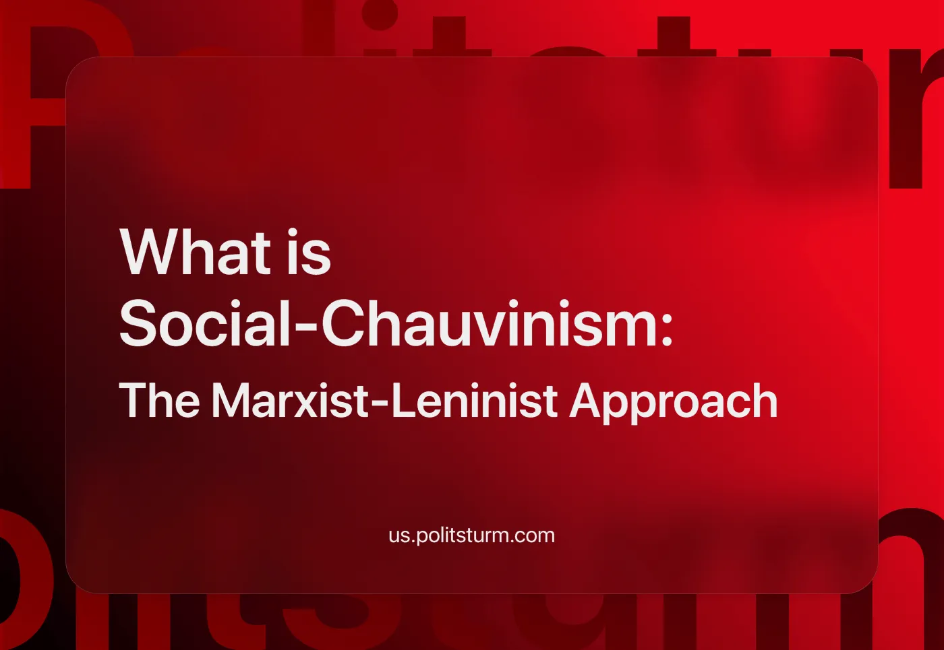

Original article
2024-09-28
34 min read

The word “social-chauvinism” has increasingly been used among international communists since 2022. How do we define social-chauvinism? What are the class origins of this current? We prepared a compilation of quotes from Lenin’s works, answering these and other questions.

I. What is Social-Chauvinism?
Lenin poses this question and gives an answer in his work “Socialism and War”, written after the outbreak of World War 1:
“Social-chauvinism is advocacy of the idea of “defense of the fatherland” in the present war. Further, this idea logically leads to the abandonment of the class struggle during the war, to voting war credits, etc. Actually, the social-chauvinists are pursuing an anti-proletarian, bourgeois policy; for actually, they are championing not “defense of the fatherland” in the sense of fighting foreign oppression, but the “right” of one or other of the “great” powers to plunder colonies and to oppress other nations.
The social-chauvinists repeat the bourgeois deception of the people that the war is being waged to protect the freedom and existence of nations, and thereby they go over to the side of the bourgeoisie against the proletariat.
In the category of social-chauvinists are those who justify and embellish the governments and bourgeoisie of one of the belligerent groups of powers, as well as those who, like Kautsky, argue that the Socialists of all the belligerent powers have an equal right to “defend the fatherland.” Social-chauvinism, being actually defense of the privileges, advantages, robbery and violence of one’s “own” (or every) imperialist bourgeoisie, is the utter betrayal of all socialist convictions and of the decision of the Basle International Socialist Congress.” — Vladimir Lenin, “Socialism and War” (1915).
Lenin points out that social-chauvinism not only shares similar grounds with opportunism, but the first is a variant of the latter:
“The economic basis of “social-chauvinism” (this term being more precise than the term social-patriotism, as the latter embellishes the evil) and of opportunism is the same, namely, an alliance between an insignificant section at the “top” of the labour movement, and its “own” national bourgeoisie, directed against the masses of the proletariat, an alliance between the servants of the bourgeoisie and the bourgeoisie, directed against the class that is exploited by the bourgeoisie. Social-chauvinism is a consummated opportunism.
Social-chauvinism and opportunism are the same in their political essence; class collaboration, repudiation of the proletarian dictatorship, rejection of revolutionary action, obeisance to bourgeois legality, non-confidence in the proletariat, and confidence in the bourgeoisie. The political ideas are identical, and so is the political content of their tactics.” — Vladimir Lenin, “Opportunism, and the Collapse of the Second International” (1915).
The core element of social-chauvinism is “the defense of the fatherland”, or the defense of one of the “great powers” (i.e. the countries of this or that imperialist bloc).
Today we see two main blocs – the US-EU bloc and the Chinese bloc – actively using social-chauvinists to promote their bloc as “progressive”.
In the first case, we have different kinds of social-democrats and left reformists showing their support for the ruling regimes in Ukraine, Israel, the European Union, United States under the slogans of “democracy”, “liberty”, “freedom” and “independence”.
The latter, including both social-democrats and self-proclaimed “communists” from various pseudo-communist organisations, uses the same phraseology but targets it in defence of China, Russia, Iran, Venezuela, Islamists in Palestine, etc.
One of the arguments of the adherents of the latter camp, located in the countries belonging to the bloc of American and European states, is that they can not be considered social-chauvinists if they defend the opposing bloc; i.e. defend China against the US.
For example, this is the position of the leaders of the recently proclaimed ‘American Communist Party’. Blogger ‘Haz’, the ‘Executive Chairman’ of the ‘ACP’, wrote on his X account: “[Social-chauvinism] is opportunist alignment with imperialism, while advocating for ‘social’ policies at home” [1].
He is supported by “Midwestern Marx” (also now part of the ‘ACP’). They accuse Politsturm of allegedly incorrect application of this term to their organisation in our material on the formation of the ‘ACP’: “There has been no shortage of terms used by both rightists and leftists to describe the ACP; Politsturm International has used the term “social-chauvinists” (albeit in a completely incorrect fashion)...” [2].
However, we see that Lenin specifically highlights: social-chauvinism is “defense of the privileges, advantages, robbery and violence of one’s “own” (or every) [our emphasis – PS] imperialist bourgeoisie”.
In essence, defending another imperialist bloc against one’s “own” imperialist bloc doesn’t essentially differ from simply defending the capitalists: both tactics include “the bourgeois deception of the people that the war is being waged to protect the freedom and existence of nations”.
In summary, social-chauvinists are those who align themselves with the interests of the bourgeois government, whether “their own” or that of the competitor bloc, advocating for and advancing capitalist policies. They help the capitalists of this or that imperialist state to unite the nation around their interests and ultimately act against the interests of the proletariat.
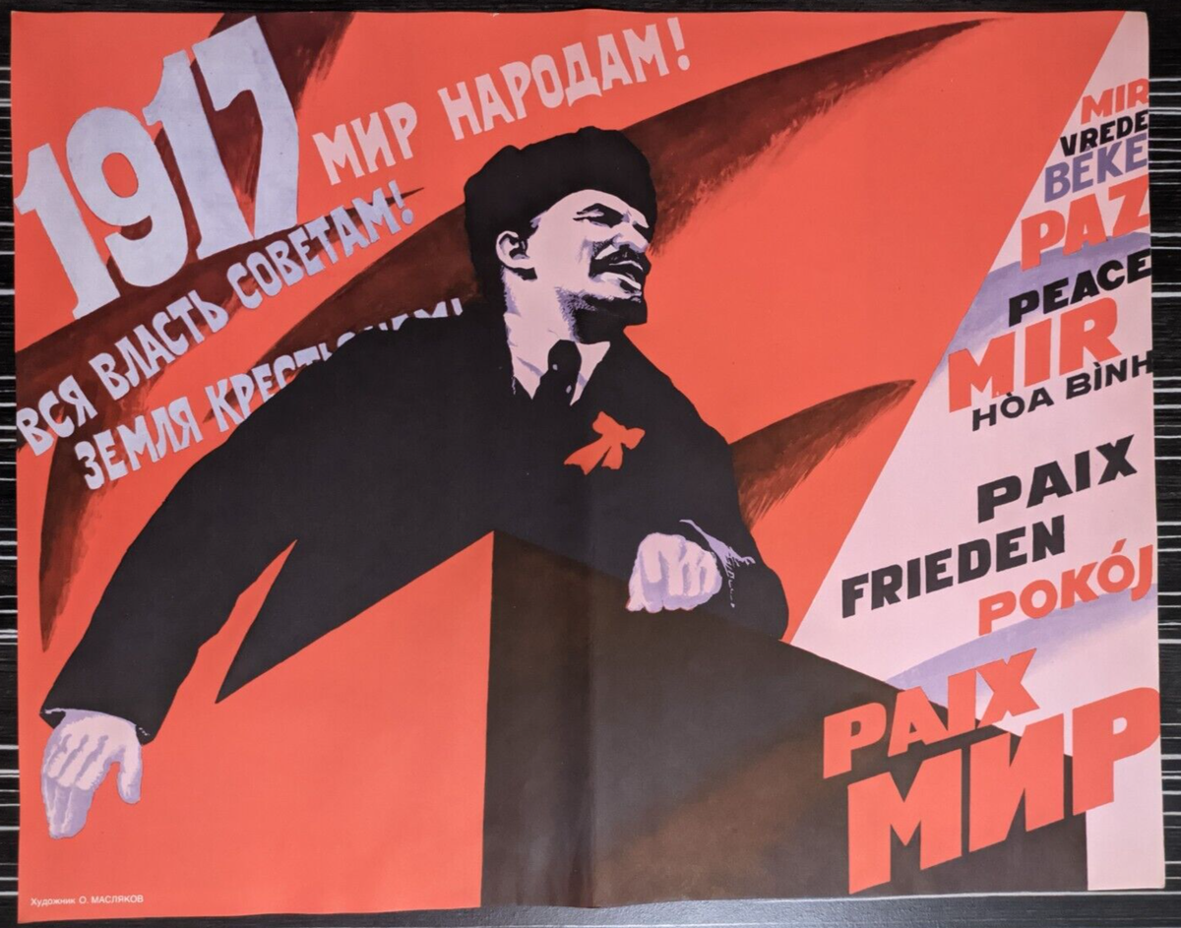
Lenin, Peace to the People

II. The Class Position and Origins of Social-Chauvinism
What is the class position and social basis of social-chauvinists? Lenin answers:
“...Objectively the opportunists are a section of the petty bourgeoisie and of a certain strata of the working class who have been bribed out of imperialist superprofits and converted to watchdogs of capitalism and corruptors of the labour movement.” — Vladimir Lenin, “Imperialism and the Split in Socialism” (1916).
Lenin gives an overview of how the bourgeoisie bribes the social-chauvinists. Their advocacy for slogans analogous to “defence of the fatherland” is rewarded with handouts that represent a tiny fraction of their enormous superprofits.
“What is the economic implication of “defence of the fatherland” in the 1914–15 war? The answer to this question has been given in the Basle Manifesto. The war is being fought by all the Great Powers for the purpose of plunder, carving up the world, acquiring markets, and enslaving nations. To the bourgeoisie it brings higher profits; to a thin crust of the labour bureaucracy and aristocracy, and also to the petty bourgeoisie (the intelligentsia, etc.) which “travels” with the working-class movement, it promises morsels of those profits.” – Vladimir Lenin, “Opportunism, and the Collapse of the Second International”.
“...monopoly yields superprofits, i.e., a surplus of profits over and above the capitalist profits that are normal and customary all over the world. The capitalists can devote a part (and not a small one, at that!) of these superprofits to bribe their own workers, to create something like an alliance (recall the celebrated “alliances” described by the Webbs of English trade unions and employers) between the workers of the given nation and their capitalists against the other countries.” — Vladimir Lenin, “Imperialism and the Split in Socialism” (1916).
We see a detailed account of the emergence of social-chauvinists within the proletarian movement, outlining their class affiliation, the underlying motivation behind their actions and the attitude Marxists should have toward this deviation:
“The social-chauvinists are our class enemies; they are bourgeois within the working-class movement. They represent a stratum, or groups, or sections of the working class which objectively have been bribed by the bourgeoisie (by better wages, positions of honour, etc.), and which help their own bourgeoisie to plunder and oppress small and weak peoples and to fight for the division of the capitalist spoils.” — Vladimir Lenin, “The Situation Within the Socialist International” (1917).


III. Who Supports Social-Chauvinists?
As we have seen above, social-chauvinism is a variation of opportunism.
“Opportunism and social-chauvinism have the same ideological-political content... it is the opportunist trend that has become the chief bulwark of social-chauvinism…” – Vladimir Lenin, “Socialism and War” (1915).
In the case when social-chauvinists support their own imperialist state, the answer seems to be simple: they are bribed by the capitalists of their nation (or become free agents). They find support among the groups of their own working class who are bribed or deceived as well.
However, who is supporting the social-chauvinists, who expound the interests of the capitalists of the opposite bloc against their “own” bourgeoisie? We can point towards several potential groups of interest.

3.1 Unconscious, Deceived And Bribed Groups Of Workers And Petty Bourgeoisie
As Lenin wrote above, social-chauvinists find support among layers of the working class that have been bribed by the capitalists in various ways. It should be added that social-chauvinists also target the most unconscious, deceived layers of workers. They are convinced that the decline in living standards is not due to the laws of capitalism as a whole but is the fault of a particular ruling group of the bourgeoisie and its particular policies. Therefore, they believe that putting another group of capitalists in power would stop this process.
In another case, they claim that if a group aligned with the competing camp of capital comes to power in their country, the workers will lose and fall into far greater oppression and, therefore, “their own” imperialist bloc must be supported. This was primarily the logic of social-chauvinists during World War 1. This is what the social-chauvinists who support Russia nowadays claim as well:
“We will do everything in our power to help workers and oppressed peoples understand that we have a side in this war; that it is in every working person’s interest for Russia to defeat NATO, and for Palestine and the wider middle-eastern resistance to defeat zionism and kick imperialism out of the middle east; that these huge blows at our common enemy can only help accelerate the shifting of class forces in the world and create better conditions for the struggle against imperialist domination and exploitation everywhere else.” – “Washington Declaration: Build the Worldwide Axis of Resistance!” by the ‘World Anti-Imperialist Platform’ [3].
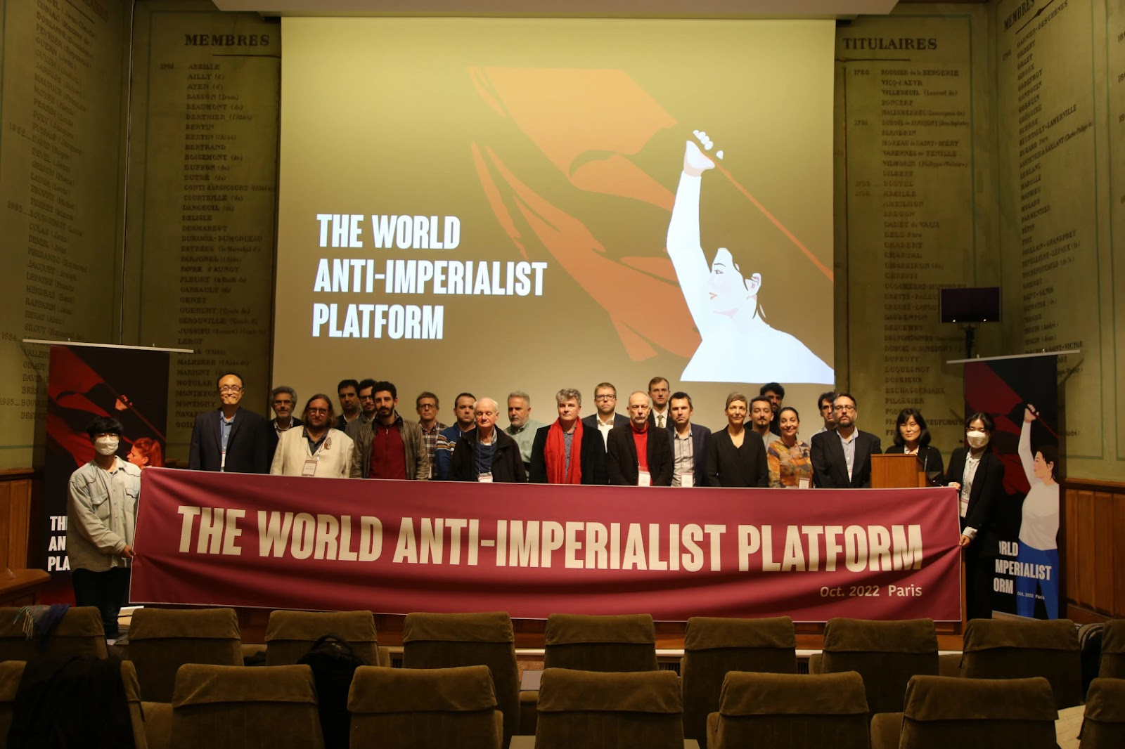
"World Anti-Imperialist Platform" Paris Meeting
In other cases, social-chauvinists may adopt the ideological rhetoric of the competing imperialist state, positioning it as a defender of certain values (e.g., anti-monopoly, anti-“neoliberal”, national sovereignty or “traditional values”). By doing so, they justify their support for this rival imperialist power while obscuring the fact that this state is not essentially different from their enemy and aims for exploitation and global competition.
This rhetoric often involves vilifying their own domestic ruling class while elevating the foreign capitalist state as a supposed champion of “progress” or “peace”, presenting a competing imperialist bloc as an alternative. For example, the same “Haz”, the ‘Executive Chairman of the ‘ACP’, wants to “reclaim the American Republic”:
“Communists do not want to ‘socialize’ people’s actual belongings or even businesses…In the meantime, what Communists seek is the overthrow of the monopolists, the bankers, big pharma, big agriculture, big tech, and others - which have hijacked the American republic in the name of the ‘sacred institution of private property.’” [4]
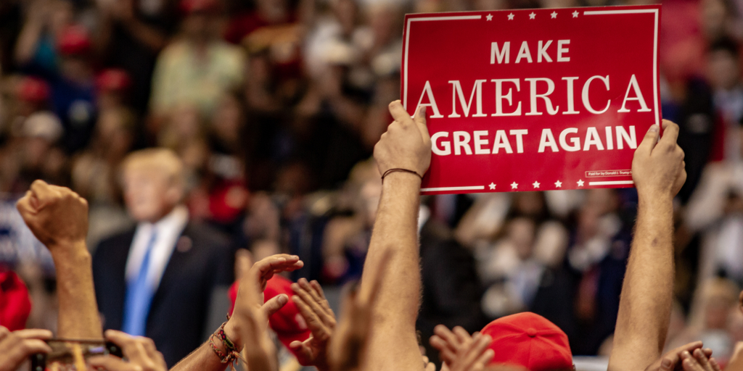
In the case of the Chinese bloc, this is facilitated by both the false “communist” propaganda of the PRC and the “defence of traditional values” promoted by the Russian Federation. Social-chauvinists argue that the workers will benefit if a “nationally oriented” capitalist group comes to power. The case of Hamas in Palestine is vulnerable to the same logic. We have explained this topic in detail in our material.
By fostering a nationalist or patriotic sentiment, social-chauvinists obscure the real class contradictions at play. They appeal to the frustrations of small business owners, middle-strata professionals, and deceived sections of the working class, whose living conditions are rapidly deteriorating in the context of another crisis of capitalism. Diverting their anger away from capitalism itself, social-chauvinists direct it at foreign enemies or specific individual domestic “elite” figures (instead of classes).
Instead of shattering these illusions and demonstrating that capitalism as a system is the main cause of workers’ problems, the social-chauvinists play along with the reformists.

3.2 Competing Capitalist Groups At The National Level
In capitalist states, there are often rival factions of capitalists, each vying for dominance within their national economies. These groups may have different interests: some might represent industrial capital, others finance capital, and others – export-oriented or domestic-focused industries. Though they compete economically, they generally agree on maintaining capitalism.
The big monopoly (imperialist) bourgeoisie directs the state to act in its interest. This includes wars, both commercial and military. While this happens, the small and middle capitalists are ruined at a faster rate and the tendency for capital to centralise in fewer and fewer hands accelerates.
This creates dissent amongst the small and middle capitalists towards the ruling group (which almost always solely represents the interests of big capital), as well as amongst competing groups of monopoly capitalists.
They would prefer peace and stability on the international level, and the utopia of free competition – which they do not realise has precisely led to winners and the formation of monopoly. As a result, they support initiatives in this direction; deceiving the workers about the nature and cause of war, as well as seeking peace and some form of ‘solidarity’ with their small to middle counterparts abroad who feel the very same pressure.
The social-chauvinists who act according to the interests of these groups often use populist anti-monopoly rhetoric, while still defending private enterprise:
“The Communist critique of private property allows for pro-people policies, including lowering taxation, ending government subsidies for the monopolists, and removing red tape – to actually happen.” – ‘Executive Chairman of the ‘ACP’ [4].
“Other people too, including those in the non-monopoly section of the capitalist class, can become aware of the destructive and divisive character of monopoly capitalism, coming to see it either as the cause of problems in society or as the system which obstructs their solution…
…Small business owners may have their own reasons for opposing monopoly power, and their support for anti-monopoly policies can prove important in blocking reactionary mobilisations against the labour movement and the left…
…Some of the people in these middle strata can and should be won for anti-monopoly and progressive policies.” – “Britain’s Road to Socialism”, ‘Communist Party of Britain’ 2020 Programme [5].

Combining a wide set of sentiments (from nationalist to social-democratic and pseudo-communist) with a superficial critique of monopoly power, social-chauvinism serves as a useful ideological tool for the capitalist groups in opposition to the currently ruling capitalist regime.
When one group of capitalists seeks to gain favour over another, they may encourage different rhetoric to rally popular support behind their specific agenda. We see that in many countries, involved in inter-imperialist rivalry, one faction of capitalists is often pushing for aggressive foreign policies (imperialist expansion or protectionism), while another favours less ambitious cooperation with international capital.
Essentially social-chauvinists align with these agendas, whipping up nationalist sentiment to steer the working class into supporting capitalist interests rather than the workers’ own class struggle.
It helps competing capitalists to present themselves as defenders of the whole nation or the whole people against the “excesses” of the monopolists. However, ultimately they still protect what matters most to them – the capitalist state and the system of capitalism as a whole.
In essence, social-chauvinists call for reforms that would curb the power of the ruling group of capitalists, but preserve capitalism itself, essentially fighting for a return to a “more competitive” environment. The latter inevitably results in the emergence of another strong group of capitalists and prevents the working class from uniting around its own class interests. We covered this in our review about competition.
This ideological stance is valuable to the competing national capitalists, but not to the communists and the working class.

3.3 The Capitalists Of The Opposite Bloc
As we described above, social-chauvinists of today can support an imperialist bloc against “their own” imperialism.
They often frame their alignment with the competing imperialist bloc as a necessary step to counterbalance the power of their domestic ruling class or to oppose what they see as a more aggressive or dangerous imperialist power. In this sense, they are still serving the interests of capitalism, but under the guise of pragmatism or false “anti-imperialism”.
After more than a century of the communist struggle, the capitalists understand the importance and potential power of the communists.
The capitalists got used now to deceiving workers with different symbols and rhetoric. For example, imperialist China has communist symbols and its ruling party has the word “communist” in its name. The same applies to Vietnam, North Korea, as well as pseudo-communist “parties” of many countries.
Just like the Western capitalists subjugated the social-democrats a century ago, the Chinese bloc and its allies try to turn the communist movement into its own “social-democracy”, to create supporters of their imperialist policies on the left. This is often done by bribes as well.
While the information on open funding is usually unavailable, we can see these connections using secondary signs. As openly stated by the Chinese Embassy in the UK:
“China is ready to enhance dialogue and exchanges with political parties and organisations from all countries, and join hands with them in promoting the building of a community with a shared future for mankind, so as to inject more stability and positive energy into the world.” [6]
China invites the members of pro-China organizations for offline conferences:
“The CPC attaches great importance to its friendly exchanges with the Communist Party of Britain. Our two parties have engaged in close interactions in recent years. Comrade Griffiths has visited China and attended symposiums many times, which further enhanced mutual understanding and deepened the friendly relations between our two parties.” [7]
Prominent opportunist British politician, George Galloway, known for his support of Russia, China and Iran, had a program on the “Russia Today” channel, which is funded by the Russian government. The leaders of the ‘ACP’ also appeared on “Russia Today” [8] and even participated in the press conference of the Permanent Mission of the Russian Federation in the United Nations [9].
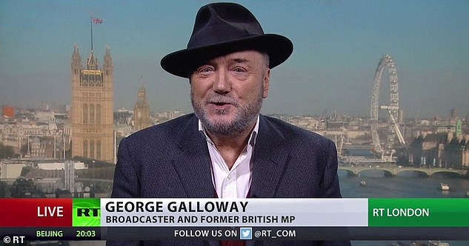
George Galloway on Russia Today
Similarly, the US-EU camp promotes its own interests amongst groups and individuals in the opposing camp. Besides well-known and long-bribed social-democrats, they engage in supporting other elements in the left political spectrum.
For example, the German “Rosa Luxemburg Foundation”, affiliated with the German opportunist “Die Linke” party, organised various conferences in Russia with numerous broad-left Russian bloggers [10]. Along with similar other structures (just like SPD’s “Friedrich Ebert Foundation”), the “Rosa Luxemburg Foundation” receives money from the German state [11].
During the 2019 Hong Kong protests, some of the student leaders met with US embassy officials [12]. The pro-China social-chauvinists have no issue pointing this out and criticising it as Chinese media itself does. However, when political organisations (like the aforementioned CPB) meet with their preferred group of imperialists themselves, they see no contradictions.
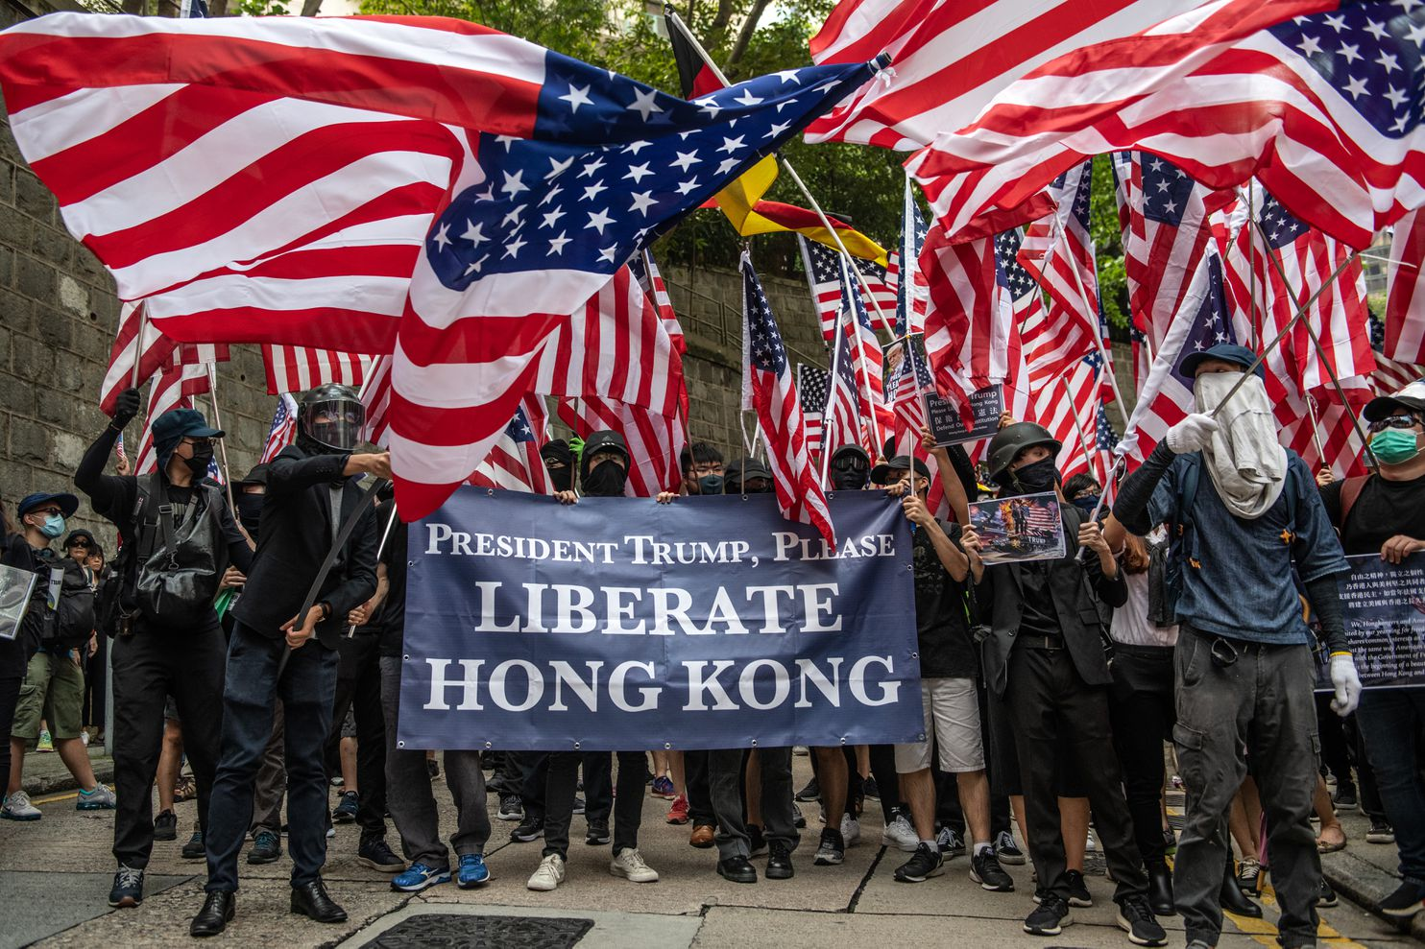
In 2022 Russian broad-left blogger Andrey Rudoy*, known for the creation of the Russian “Union of Marxists”, and a group of his followers were invited to France. There he participated in a press conference with the leader of “La France Insoumise” Jean-Luc Melanchon. The latter thanked no one else than the president of France – Emmanuel Macron – for assisting in Rudoy’s visit, publicly connecting Rudoy* with the French imperialists.
While formally speaking out against imperialist wars, this blogger and the left-wing reformists associated with him are oriented toward Western capital.
In one of the posts on his personal Telegram channel [13], he pointed out that Russian trade unions had received extensive funding and support from reformist structures in various Western countries. This support was sharply reduced after the launch of the so-called ‘Special Military Operation’ due to pressure from Russian state structures. The essence of the message is that because of Russia’s actions in Ukraine and the withdrawal of Western capital, the labour movement in Russia cannot develop. And that Western capitalists are better than Russian capitalists because trade unions can be created under them.

Andrey Rudoy*
Social-chauvinism is traditionally associated with supporting imperialism primarily in military matters. However, we see that left-reformists and opportunists like Rudoy* spread ideas that if Western capital provides more opportunities for the Russian labour movement, then it is more progressive and should be supported in its struggle against Russian and Chinese capital. From here, in turn, it is easy to make one step toward supporting Western countries in military matters.
These few examples show us that today capitalists of all sides are interested in having their agents in the opposite bloc to defend them and promote their agenda, and they find these agents on the left.
When social-chauvinists support an imperialist state, even if that is not “their own”, but rather a competing imperialist state, they are still operating within the same framework of advancing capitalist interests on a global scale.
They serve the same function as the “good old” traditional social-chauvinists: mobilising sections of the population, particularly workers and small capitalists, behind the interests of this or that imperialist bloc.
*recognised as a foreign agent in Russia

IV. How To Fight Social-Chauvinism?
The most effective way to combat social-chauvinism and its influence among workers and communists is through a relentless and principled defense of proletarian internationalism and a clear, uncompromising opposition to imperialism in all its forms.
“During the two odd years of the war the international socialist and working-class movement in every country has evolved three trends. Whoever ignores reality and refuses to recognise the existence of these three trends, to analyse them, to fight consistently for the trend that is really internationalist, is doomed to impotence, helplessness and errors.
The three trends are:1) The social-chauvinists, i.e., socialists in word and chauvinists in deed. People who support “defence of the fatherland” in an imperialist war (and above all in the present imperialist war). These people are our class enemies. They have gone over to the bourgeoisie...
...2) The second trend, known as the “Centre”, consists of people who vacillate between the social-chauvinists and the true internationalists...they are for all sorts of peace campaigns, for peace without annexations, etc., etc. – and for peace with the social-chauvinists. The “Centre” is for “unity”, the Centre is opposed to a split. The “Centre” is a realm of honeyed petty-bourgeois phrases, of internationalism in word and cowardly opportunism and fawning on the social-chauvinists in deed...
...3) The third trend, that of the true internationalists...Its distinctive feature is its complete break with both social-chauvinism and “Centrism”, and its gallant revolutionary struggle against its own imperialist government and its own imperialist bourgeoisie. Its principle is: “Our chief enemy is at home.” It wages a ruthless struggle against honeyed social-pacifist phrases (a social-pacifist is a socialist in word and a bourgeois pacifist in deed; bourgeois pacifists dream of an everlasting peace without the overthrow of the yoke and domination of capital) and against all subterfuges employed to deny the possibility, or the appropriateness, or the timeliness of a proletarian revolutionary struggle and of a proletarian socialist revolution in connection with the present war…
...It is not a question of shades of opinion, which certainly exist even among the Lefts. It is a question of trend. The thing is that it is not easy to be an internationalist in deed during a terrible imperialist war. Such people are few; but it is on such people alone that the future of socialism depends; they alone are the leaders of the people, and not their corrupters.” — Vladimir Lenin, “The Situation Within the Socialist International” (1917).
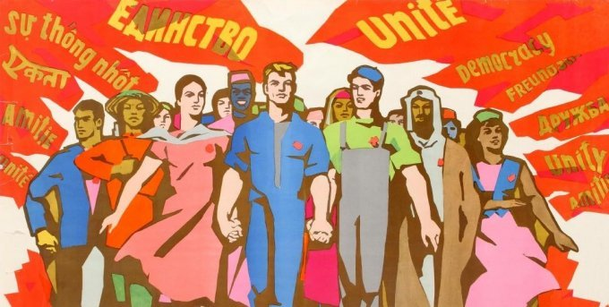
Proletarian internationalism fosters unity amongst workers across national lines
Just like in the period of World War 1, there are open social-chauvinists and true internationalists. However, there are also those whose actions on the international scale can be considered as centrist. In the past centrists sought to preserve a false unity with social-chauvinists. They attempted to maintain “unity” by avoiding direct confrontation with opportunists or trying to downplay the contradictions in the name of such “unity”.
The “International Meeting of Communist and Workers’ Parties”, held annually, demonstrates the modern means of promoting such policies. The declarations and resolutions of these “meetings” provide broad words about “unity” and “solidarity” among their participants [14]. Among them, we find the open promoters of social-chauvinism: “Communist Party of the Russian Federation”, “Workers’ Party of Korea”, “Russian Communist Workers’ Party”, “Hungarian Workers’ Party”, “Communist Party of Vietnam” and dozens of similar structures [15].
“What about the majority resolution? It does not contain a word of censure for the traitors, or a single word about opportunism... One might think that nothing serious has happened, that an accidental and minor error has been made which calls merely for a repetition of the old decision, or that a disagreement has arisen which is inconsequent and not of principle, and can be papered over!
This is downright mockery...of the workers. As a matter of fact, the social-chauvinists wish nothing else but a simple repetition of the old decisions, if only nothing changes in practice. This is, in fact, a tacit and hypocritically disguised amnesty for the social-chauvinist adherents of most of the present parties.” – Vladimir Lenin, “On The Struggle Against Social-Chauvinism” (1915).
Communists can not fight social-chauvinists by participating in joint events with them. This is being done, for example, by the CP of Greece (the KKE) – one of the leaders of the unofficial “Marxist-Leninist pole” in the IMCWP. Its youth section, KNE, keeps working with the youth section of “New Communist Party of Yugoslavia” (the NKPJ) – a small social-chauvinist group in Serbia – even after the KKE issued a number of materials against this deviation [16]. The KKE itself regularly signs statements with social-chauvinist structures [17].
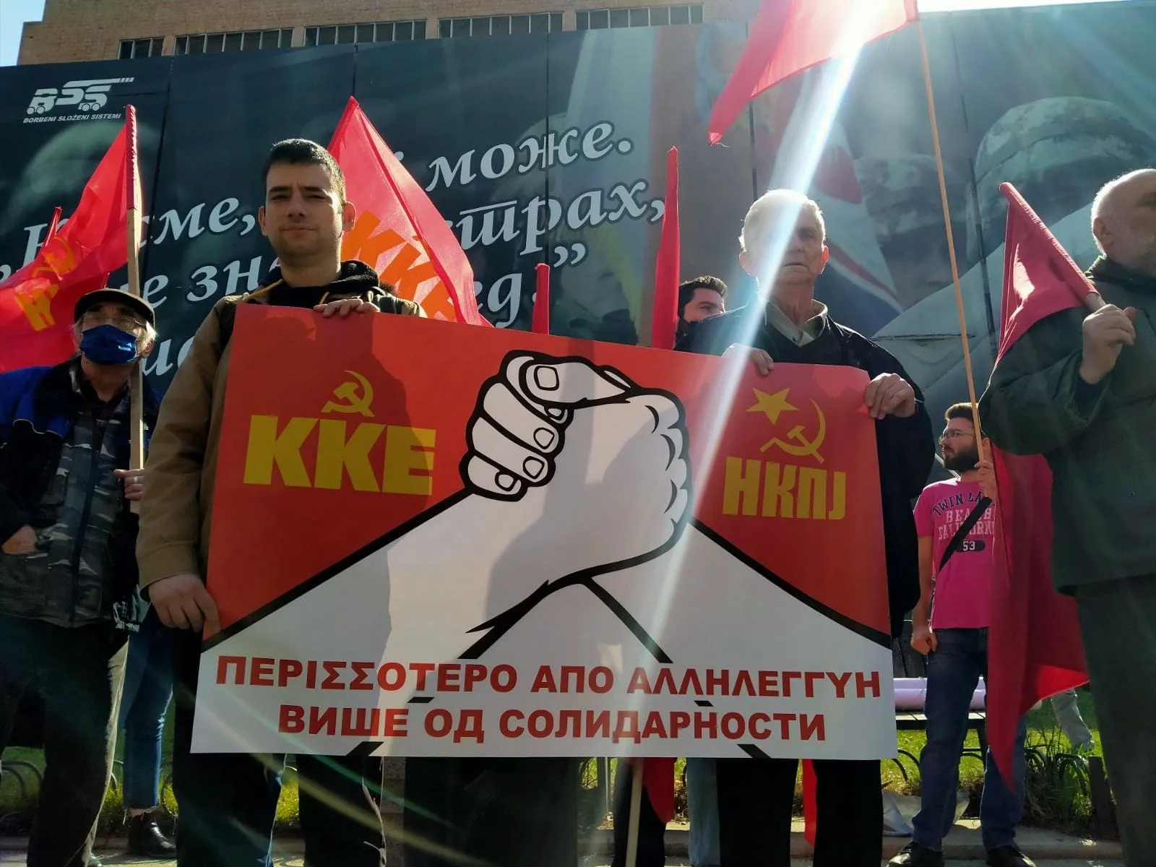
The KKE and the NKPJ at a joint event in 2022
If communists agree to fight social-chauvinists, yet publicly work with them, accept greeting letters [18] from them or even send them letters of congratulations [19], they take one step forward and one step back at the same time.
If this is done with the aim of “influencing” the leaders of social-chauvinist organisations and leading them to the path of internationalism, then this is a wrong method, as Lenin also wrote about:
“The present-day Social-Democratic parties and their Executives are incapable of seriously changing their course. In practice everything will remain as before; the “Left” wishes expressed in the majority resolution will remain innocent wishes; an unerring political instinct prompted this in the adherents of Troelstra’s party and of the present Executive of the French party, when they voted for such a resolution...
If the workers were told this in a straightforward way, they would know the truth; they would know that to give effect to “Left” wishes, a radical change is necessary in the line of the Social-Democratic parties; a most stubborn struggle is necessary against the opportunists with their “Centrist” friends. As it is, the workers have been lulled by “Left” wishes, while the Conference refused to call by name, loudly and clearly, the evil which must be combated if those wishes are to be realised.” – Vladimir Lenin, “On The Struggle Against Social-Chauvinism” (1915).
It’s impossible to imagine Lenin sending a letter of congratulations to Bernstein, or greeting the renegade SPD on the 1st of May, as he was always against this kind of “joint action”.
It must not be forgotten that these events, declarations and greetings are being watched by communists and workers all over the world.
For example, what will they think of the opportunist “Communist Party of The Russian Federation”, the “Russian Communist Workers’ Party”, the “Communist Party USA” and the American “Party for Socialism and Liberation”, if they are openly and officially called “communist and workers’ parties” by the Communist Party of Turkey in the materials of their recent party congress [18]?
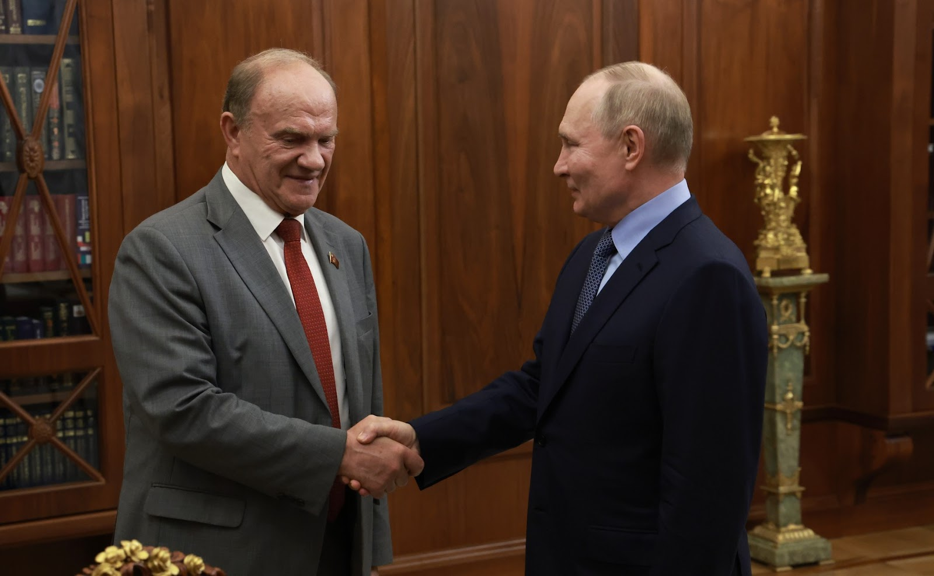
"Communist Party of The Russian Federation" leader Zyuganov and Russian President Putin
They will think that if Turkish communists consider these organisations to be “communist and workers’ parties”, then there is a high chance it’s true, and will inevitably play into the hands of the social-chauvinists in deceiving the masses. On the other hand, conscious workers and communists, familiar with the stance of these organisations and their policies (that we have outlined previously), will easily identify a policy that is extremely close to what Lenin called centrism or, more plainly, hypocrisy.
This is used on the national scale as well. Social-chauvinists use international relations to portray themselves as a part of the international communist movement, gaining prestige among unconscious layers of workers and deceived but well-intentioned communists. The international recognition of them makes the struggle against social-chauvinism more difficult in each country.
“The diplomatic leaders, who are at present conducting a chauvinist policy within the Social-Democratic parties, will make excellent use of the weakness, the indecision and the insufficient clarity... Astute parliamentarians that they are, they will distribute the roles among themselves: some of them will say that the “serious” arguments of Kautsky and Co. were not appreciated or analysed, and that therefore they must be discussed in a wider gathering; others will say, “Were we not right when we said that no deep-seated differences existed, if the women adherents of the Troelstra and Guesde-Sembat parties were able to agree with the Left-wing German women?”.
The Women’s Conference should not have aided Scheidemann, Haase, Kautsky, Vandervelde, Hyndman, Guesde, Sembat, Plekhanov and others to blunt the vigilance of the working masses. On the contrary, it should have tried to rouse them and declared a decisive war against opportunism. Only in that case would the result have been, not a hope that the “leaders” named above would “reform”, but a mustering of forces for an arduous and bitter struggle.” – Vladimir Lenin, “On The Struggle Against Social-Chauvinism” (1915).
We must systematically show that any attempt to reconcile Marxism-Leninism with social-chauvinism is an abandonment of the struggle against imperialism. The solution is to draw a firm and uncompromising line between those who genuinely stand for proletarian internationalism and social-chauvinists, as well as those who, under the banner of “unity”, tolerate or collaborate with social-chauvinists.
“We know that there are many who would follow this path and confine themselves to several Left phrases. However, their road is not for us. We have followed a different road, and will go on following it; we want to help the working-class movement and the actual construction of a working class party, in the spirit of irreconcilability towards opportunism and social-chauvinism.” – Vladimir Lenin, “On The Struggle Against Social-Chauvinism” (1915).
Let’s not forget that social-chauvinism emerges as one of the currents of opportunism. Therefore, in order to combat social-chauvinism, communists must remain uncompromising in their opposition to opportunism. It is better to have a smaller, more dedicated movement that is ideologically clear and organised than a large, politically confused one. As Lenin stated, “Better fewer, but better.”
Only a consistent and direct policy, an open and undisguised truth about the state of our movement and its opponents will help to separate the opportunists from the genuine communists and raise the position of the communists in the eyes of the workers.
“The ground for such propaganda is prepared; to practice that propaganda, one need only break with the opportunists, those allies of the bourgeoisie, who are hampering revolutionary work both directly (even to the extent of passing information to the authorities) and indirectly.” — Vladimir Lenin, “The Question of Peace” (1915).
So, the best way to fight social-chauvinists is through uncompromising ideological clarity, public exposure of their opportunism, and the building of strong communist parties, applying Marxism-Leninism to modern conditions in both theory and practice.
Unity cannot be maintained at the expense of communist principles, and it is better to openly split with opportunists than to allow the workers’ movement to be diluted by false alliances with forces that ultimately serve imperialism.

Conclusion
Lenin’s theory gives us a clear picture of social-chauvinism as an opportunist distortion of Marxism.
Social-chauvinists are opportunists, agents of the bourgeoisie who promote and support the policies of the bourgeois state. Through nationalist and chauvinist rhetoric, through different reservations, concessions and falsifications of Leninism they try to promote the idea that the imperialist camp they aligned with is better (or a “lesser evil”) compared to the other.
Social-chauvinists are used to deceive, bribe and subdue the workers in favour of the interests of the capitalists, whether it’s “their own” or another imperialist camp. Their primary target is to penetrate the communist movement, replace its Marxist-Leninist theory with broad phrases of false “anti-imperialism”, “anti-colonialism”, “national sovereignty”, “independence”, etc. and turn the movement into an ally of one of the blocs in their competition for redivision of the world.
In supporting a foreign imperialist state, social-chauvinists ultimately contribute to the very same global capitalist competition they claim to oppose. Rather than challenging the imperialist system as a whole, they become pawns in the inter-imperialist rivalry, helping one bloc of capitalists in their struggle against another. This misdirects the workers away from the class struggle, encouraging them to side with one group of exploiters over another, instead of recognizing that both blocs are fundamentally the same and follow the same policy of redivision of the world and fight for profits.
Supported by different layers of workers, petty bourgeoisie and competing groups of capitalists on both national and international levels, social-chauvinists are used to deceive working people and turn the communists into blind followers of the imperialist policies of this or that camp.
By doing so, they preserve the division between workers of different nations, perpetuate imperialist wars, and reinforce the capitalist system by legitimising the dominance of one group of capitalists over another.
The only consistent position is to oppose all imperialist blocs and promote international solidarity among the working class. It is crucial to purge the ranks of the communists of opportunist tendencies. Only a disciplined party-vanguard that is fully committed to the principles of Marxism-Leninism can fight the influence of social-chauvinism and organise workers. Join our organisation to work on reviving the communist movement across the globe.

Sources
[1] Twitter @InfraHaz – FRANCE’S PAN-LEFTIST “VICTORY,” A REALITY CHECK – July 7, 2024
[2] Midwestern Marx Institute – On the Historical Unity of the Canadian and U.S. Working Class Movement – August 17, 2024
[3] CPGB-ML – Washington declaration: Build the worldwide Axis of Resistance! – July 12, 2024
[4] Infrared Substack – The Rise of MAGACommunism – September 18, 2022
[5] Young Communist League UK – Britain’s Road to Socialism – January 2020
[6] Embassy of the PRC in the United Kingdom – The Chinese Embassy in the UK Holds a Chinese New Year Luncheon for Representatives of British Political Parties to Discuss China’s Practice and the Global Significance of Building a Community with a Shared Future for Mankind – February 25, 2024
[7] Embassy of the PRC in the United Kingdom – Remarks by Ambassador Zheng Zeguang at Online Event Celebrating the 100th Anniversary of the Founding of the Communist Party of China Jointly Hosted by the Consulate General of China in Manchester and the Communist Party of Britain – 26 June 2021
[8] Russia Today – Americans facing ‘economic degradation and misery’ due to US foreign policy – Jackson Hinkle on RT panel – 7 June, 2024
[9] UN Web TV – Press Briefing: Dan Kovalik, Jackson Hinkle and Christopher Helali following their recent visit to Donbass and Moscow – 3 July 2024
[10] Telegram @soctov – A couple of weeks ago, Rudoy* published an interesting post on his Telegram channel – April 16, 2024
[11] Focus Online – Trace of money: How the state supports millions of a left-wing anti-hatred industry – June 6, 2020
[12] YouTube @CTGNAmerica – This photo shows a US diplomat meeting with Hong Kong protest leaders – August 9, 2019
[13] Telegram @Ru_doy – The Insidious West and Trade Unions in Russia – April 5, 2024
[14] SolidNet – The fight against fascism is the common task of today! – November 1, 2019
[15] SolidNet – Resolution On Condemning The Blockade And Solidarity With Cuba – October 31, 2023
[16] Facebook @SKOJ [Union of Communist Youth of Yugoslavia] – SKOJ At The 13th Congress Of The Communist Youth Of Greece – February 14, 2023
[17] SolidNet – Solidarity with the Sudanese People, for Peace, Freedom and Democracy – October 31, 2023
[18] TKP – TKP 14th Congress Turkey Conference Convened: Strengthening For Revolutionary Tasks, Through Strengthening Towards Revolution And Socialism – September 9, 2024
[19] SolidNet – CP of Greece, Letter of congratulations on the election of Tô Lâm as General Secretary of the CC of the Communist Party of Vietnam – August 6, 2024

Original article

