What Was the Red Army Fighting For?
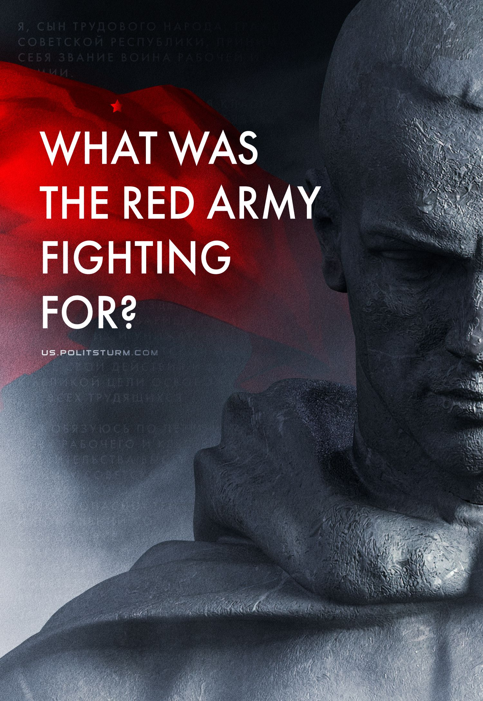

Original article
2023-03-03
14 min read

February 23rd, 2023 marks the 105th anniversary of the Red Army. Bourgeois propaganda, distorting the history of the Soviet Union, did not miss the opportunity to do so again. Declaring itself the "successor" of the USSR, the Russian authorities have changed this holiday into the "Defender of the Fatherland Day", trying to create the appearance of continuity and connection between the socialist workers' and peasants' army and the modern armed forces of capitalist Russia. As a result, for the majority of the population, this day is perceived simply as "army day", or as "all men's day". But what was the Red Army really like, who did it serve and what values did it fight for?

I. The History of the Red Army
After the October Socialist Revolution, the newly emerged state of workers and peasants faced the task of armed defense against external and internal counterrevolution.
In the early days of Soviet power, the form of organization of the armed forces of the working class was the Red Guard, the basis of which began to take shape back in 1905-07, in the form of voluntary workers' combat squads and detachments. By the beginning of 1918, its number was more than 150 thousand people. However, these forces were not enough to fight the external intervention of the imperialist countries and the internal counter-revolution.
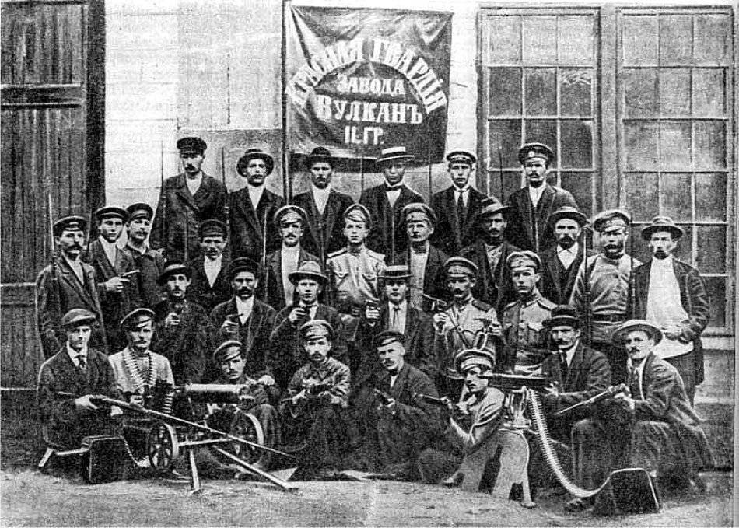
Since December 1917, Soviet Russia was in a state of negotiations with Germany to conclude a separate peace. Internal and external conditions demanded peace: the economy was in a ruined state, the old army was not functioning, and a new one was not created. The people, tired of war and devastation, demanded peace.
On the question of peace in the Central Committee of the Bolshevik Party, there were disputes in which three well-known positions stood out: 1) "immediate peace on any terms" (Lenin); 2) "continue the war" (Bukharin); 3) "no peace, no war" (Trotsky).
Lenin believed that in order to protect the Russian revolution, it was necessary to sign peace on any terms, despite the heavy demands of the German bloc. So the Soviet government would have the necessary time to restore the economy, create a new army and fight the counter—revolution, and most importantly, would justify the trust of the workers, peasants and soldiers who demanded peace.
After the discussions that had been going on since December 1917, at the meeting of the Central Committee on January 8 (21), 1918, Lenin criticized the left bias of the supporters of the "revolutionary war" and raised the question specifically: peace or war. As a result, Trotsky's centrist formula "we do not sign peace, we stop the war, we demobilize the army" won. Despite the uncertain and interim nature, this tactic of delaying negotiations gave the Soviet Government valuable time to analyze the situation. Sending Trotsky to Brest, Lenin asked him to delay the negotiations as much as possible, but when Germany put forward an ultimatum — to accept it immediately.
At the same time, on January 15 (28), 1918, Lenin signed a decree of the Council of People's Commissars (CPC) on the formation of the Workers' and Peasants' Red Army (Red Army) on a voluntary basis, and on January 29th (February 11th) - the formation of the Workers' and Peasants' Red Fleet (WPRF).
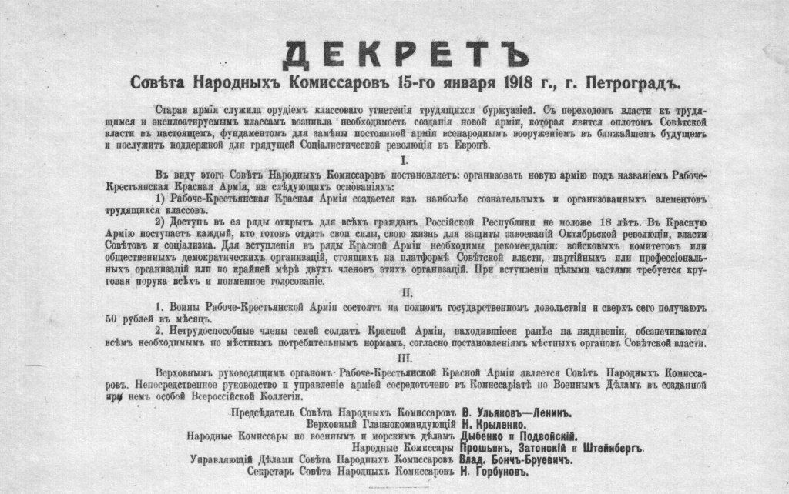
The decree briefly outlines the nature, essence and tasks of the Red Army:
"The Old Army served as an instrument of class oppression of the working people by the bourgeoisie. With the transition of power to the working and exploited classes, it became necessary to create a new army, which will be the bulwark of Soviet power in the present, the foundation for replacing the standing army with national weapons in the near future and will serve as support for the coming socialist revolution in Europe. In view of this, the Council of People's Commissars decides: to organize a new army called the Workers' and Peasants' Red Army ..." (Decree of the CPC on the organization of the Red Army. January 15 (28), 1918)
Despite the agreement with Lenin, Trotsky announced his formula in Brest on January 28th (February 10th) and the Soviet delegation defiantly left the negotiations without signing peace. German imperialism immediately took advantage of this, and already by February 18th the German army went on the offensive against Soviet Russia along the entire front line. A direct threat to Petrograd was created. On the morning of February 19th, the next day, the Soviet government sent Germany a request for peace on any terms. But the German army continued to advance.
On February 21st, the SNK adopted the decree "The Socialist Fatherland is in danger!" and began the active formation of the Red Army on a voluntary basis.
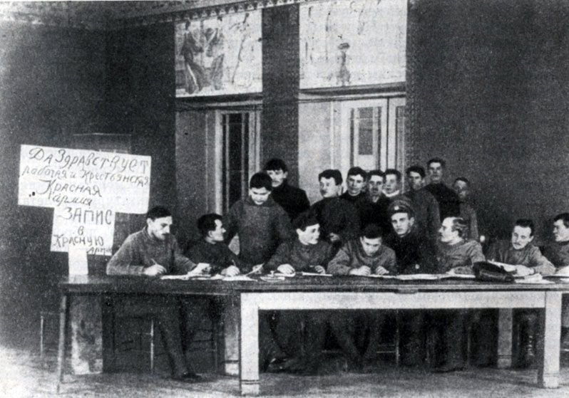
It was on February 23rd that the mass enlistment of volunteers began in the ranks of the Red Army, who were able to stop the German army's offensive on Petrograd. Only after that did the German government respond to the Soviet Republic by presenting new peace conditions. On March 3rd, peace was signed.
In the future, in the conditions of increased internal intervention and civil war, it was necessary to quickly create a mass regular army and transition to compulsory military service. On July 10th, 1918, the decree of the Central Executive Committee "On compulsory recruitment into the Workers' and Peasants' Red Army", adopted on May 29th, was formalized by law.
1919 was the year of major victories in the Civil War. By the end of 1919, 3 million people had joined the ranks of the Red Army. A particularly decisive circumstance in strengthening the Soviet armed forces was the transition of the middle peasantry to the side of the Soviet government. By the end of 1920, the size of the army had grown to 5.5 million people. The social composition of the army for the period of 1920 consisted of two main groups: workers — 15%, peasants — 77%, others - 8%.
The unifying force in the ranks of the Red Army were members of the Bolshevik Communist Party. In August 1920, their number in the army was about 300 thousand people — almost half the number of the party. Thanks to political work in the rear and at the front, education of soldiers and workers in the spirit of internationalism through political departments, revolutionary military councils (RMC), through military commissars and party organizations of units and divisions, the success of the Red Army was ensured.
From 1927 to the end of the 30s, during the industrialization and collectivization of agriculture, serious economic successes of the USSR were achieved. This made it possible to raise the technical level of the Red Army to the level of modern armies at that time.
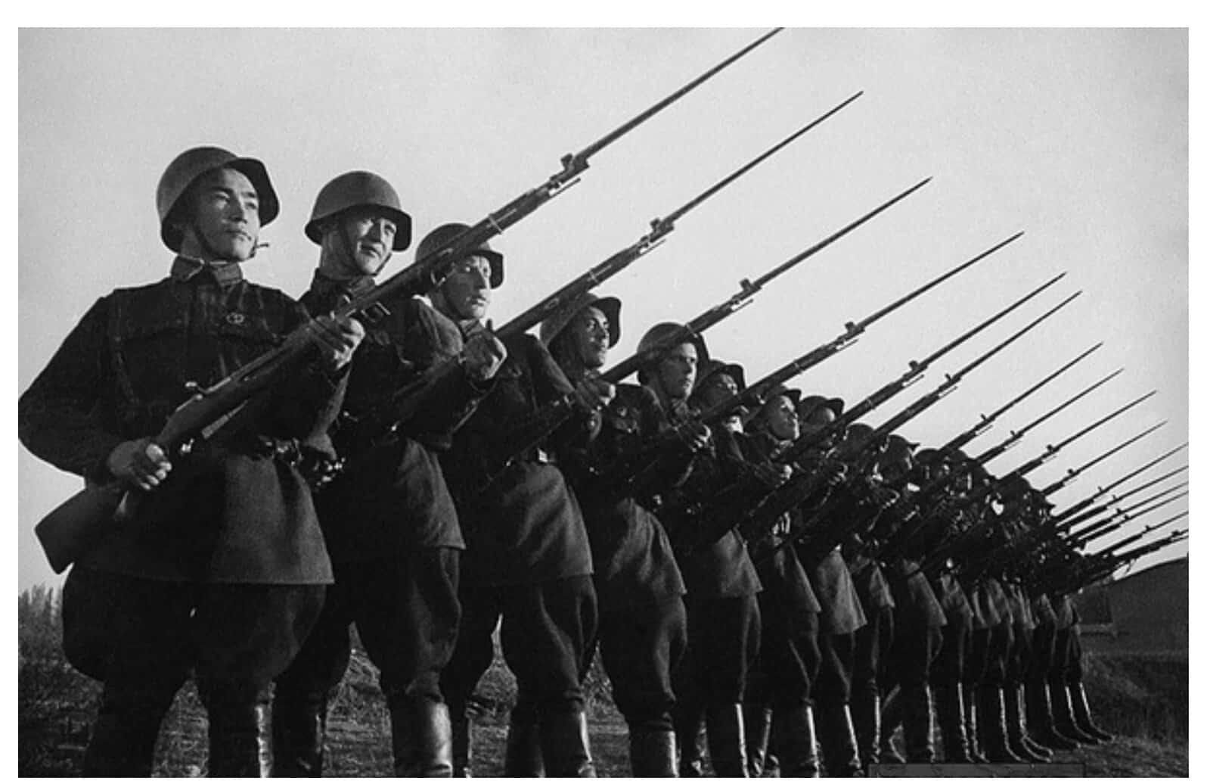
This was how the economic, political and social foundation of the Red Army was created, which later won the most terrible war in the history of mankind — the war of the world's first socialist international state for its freedom and independence, for the liberation of the peoples of Europe from fascism, against the open, reactionary, terrorist aggression of world capital.
II. What did the Red Army fight for?
Unlike the hypocritical patriotism imposed in capitalist countries, which the capitalists themselves do not follow, the patriotism of the Soviet people, their love for the socialist motherland had a concrete character.
The Red Army is an army of workers freed from exploitation, defending a country built with their own hands from enslavement by world capital. This army defended the power of the working class and the world's first socialist state — the pillar of the world system of socialism, where the right to work, housing, free medicine and education had a concrete material embodiment.
The Red Army is an army of conscious, politically enlightened people who are aware of their class interests and clearly know what they are fighting for.
It is a friendly union of nations, people and workers brought up on the ideas of proletarian internationalism. Thanks to this, during the Great Patriotic War, all the people of the USSR stood up to defend the socialist fatherland. Russians, Belarusians, Ukrainians, Armenians, Kirghizs, Kazakhs and many other ethnic groups and peoples of the Soviet country fought in the ranks of the Red Army.
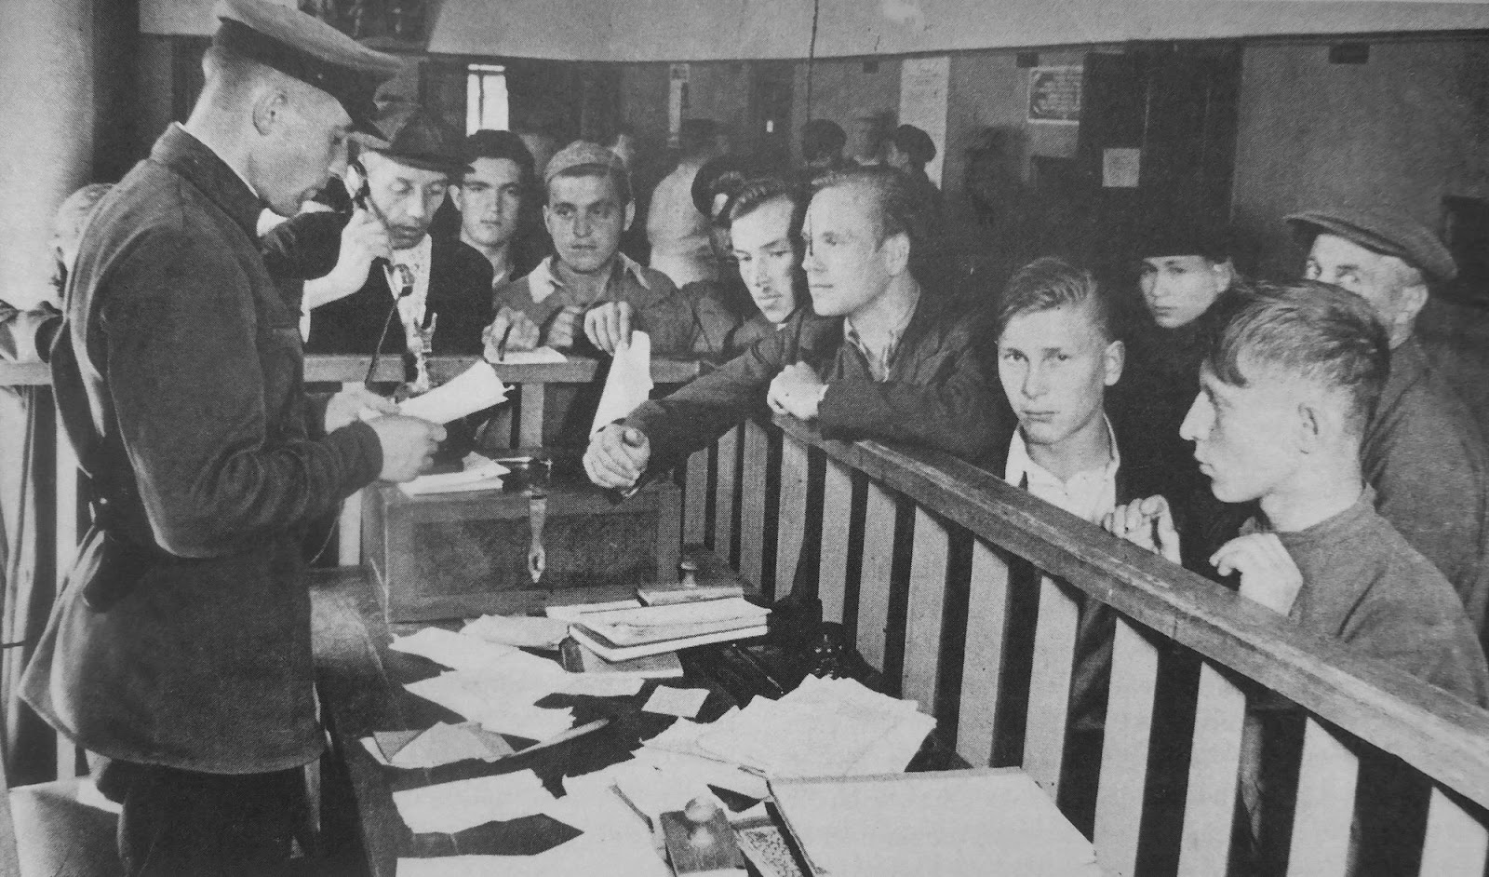
During the Great Patriotic War, the Soviet people did not need to explain why they should leave their former life and be mobilized into the Red Army. The cry of the Holy War, thrown into the vast expanses, was understandable and close to millions of Soviet citizens.
During the Second World War, the Red Army soldiers knew what they were fighting for: for a free socialist republic of workers, the conquests of the October Revolution and the right to life and development without the exploitation of labor.
III. About the Modern Russian Army
And what is the current army fighting for?
For example, the Russian Federation is a product of counter—revolution, a rollback from socialism to capitalism.
The "perestroika" of 1985, despite the declaration of the goal of resolving the economic and economic problems of the USSR, actually led to the collapse of the Soviet Union and the restoration of capitalist relations in 1991.
Against the background of privatization and the collapse of industry, the former Soviet army was also being destroyed and transformed into the army of the capitalist state. The national bourgeoisie that came to power began to need to protect its own interests.
In 1993, under the leadership of the new Defense Minister Pavel Grachev, who supported Yeltsin's policy, the White House was shelled and the parliament was dispersed. The bourgeoisie finally destroyed the Soviet system and established the foundations of a new order.
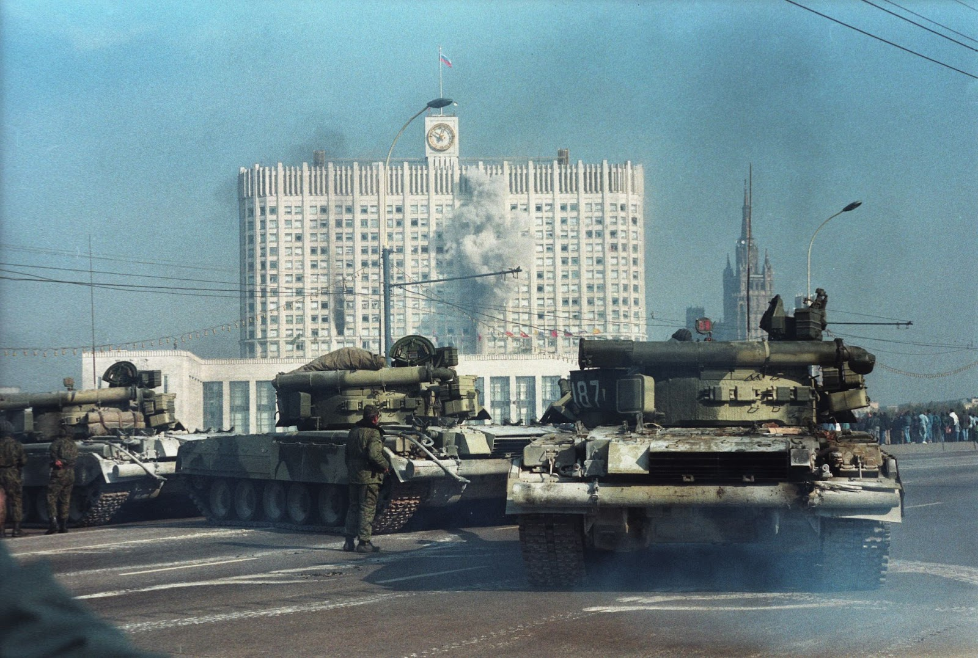
This was followed by two Chechen wars, in which the final destruction of all the principles of internationalism and friendship between peoples took place. These wars have completely shaped the face of the armed forces of the Russian Federation.
The participation of Russian troops in subsequent local conflicts only strengthened their class role as an instrument and conductor of the interests of big capital.
The authorities of capitalist countries lie when they say that the army is apolitical towards the state. Only formally, the army is removed from politics. In fact, the army is always involved in the political and economic struggle for the interests of the capitalist class. Only the interests and needs of the soldiers themselves often remain unsatisfied by the bourgeoisie, and its attitude towards them is dismissive.
The army under capitalism is the silent weapon of capital. The state is trying to make sure that the class struggle does not concern the army, so it tries in every possible way to butter up the soldier's share. Hence: an increase in salaries for military personnel, repayment of loans from the budget, the issuance of apartments and many other indulgences. This is due to cuts in the health care budget and cuts in other social benefits. Moreover, the increase in allowances applies not only to the armed forces, but also to other law enforcement, legal federal state and civil institutions: Rosgvardiya, Yunarmiya, Federal Penitentiary Service (FPS), Federal Security Service (FSS), police, foreign intelligence services, as well as judges, prosecutors and employees of the investigative committee.
As a result, it turns out that the workers pay twice for the entire power apparatus of the capitalist state.
In addition to official troops, private military campaigns (PMCs) are common in capitalist countries. The services of mercenaries allow capitalists to expand their range of opportunities. PMCs are used to perform particularly dirty work or covert operations where it is impossible to resolve the conflict through diplomacy. By the forces of some mercenary armies, it is even possible to carry out a coup d'etat in a small country.
The contingent of these military organizations is diverse: from people seeking to earn money quickly to open Nazis and ardent chauvinists who directly declare their own views.
Of course, not all military personnel and even mercenaries in modern capitalist armies are absolute opponents of the working people. It is important to understand the main reason why a person becomes a mercenary or joins the ranks of the imperialist army is the difficult social and economic living conditions created by capitalism.
Under the slogans of "protecting the motherland", "protecting national peace", the big capitalists of all countries and nations send the poor to death for increasing their own profits, simultaneously poisoning the consciousness of society with a stream of chauvinistic, nationalist propaganda.
And what, in the end, is this "homeland" for the worker, for which the bourgeoisie is so actively agitating to perish? This is a system of exploitation of millions of ordinary workers who create all the riches of the surrounding reality with their labor, in the interests of the super-rich minority. A system that alienates a person from the results of his work and his own human being, oppressing him with mortgage and debt slavery.
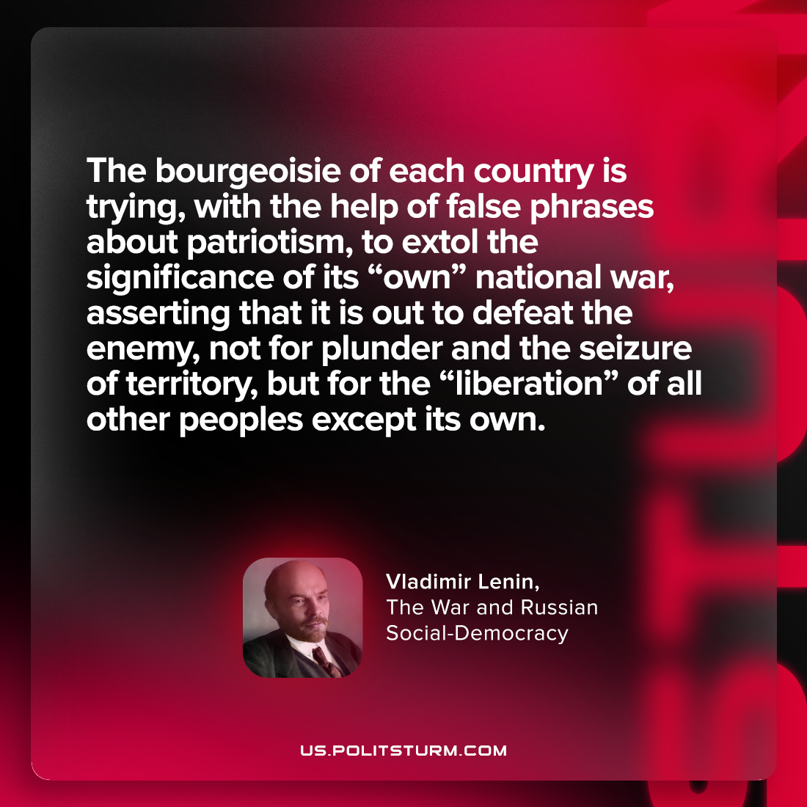
What is the Result?
Based on a concrete historical analysis of the USSR and the Russian Federation, it is clear that there can be no question of the continuity of the Red Army and the Armed Forces of the modern Russian Federation.
The homeland for Soviet workers is not an abstract Russia — it is the Union of Soviet Socialist Republics, a society freed from exploitation for the first time, the most progressive socio-economic system compared to capitalism.
The "motherland" for Russian oligarchs is the union of a parasitic minority living off the profits earned by the blood and sweat of the majority of the working population.
In order not to succumb to the lies and prevarications of the exploiting class, it is necessary to understand the class essence of the state and social system. The first step on the way to awareness is the study of Marxism-Leninism — a scientific materialistic method that tears off the masks of the reactionary bourgeoisie and shows its true face.

Original article

