What is Wrong with the Russian Education System?
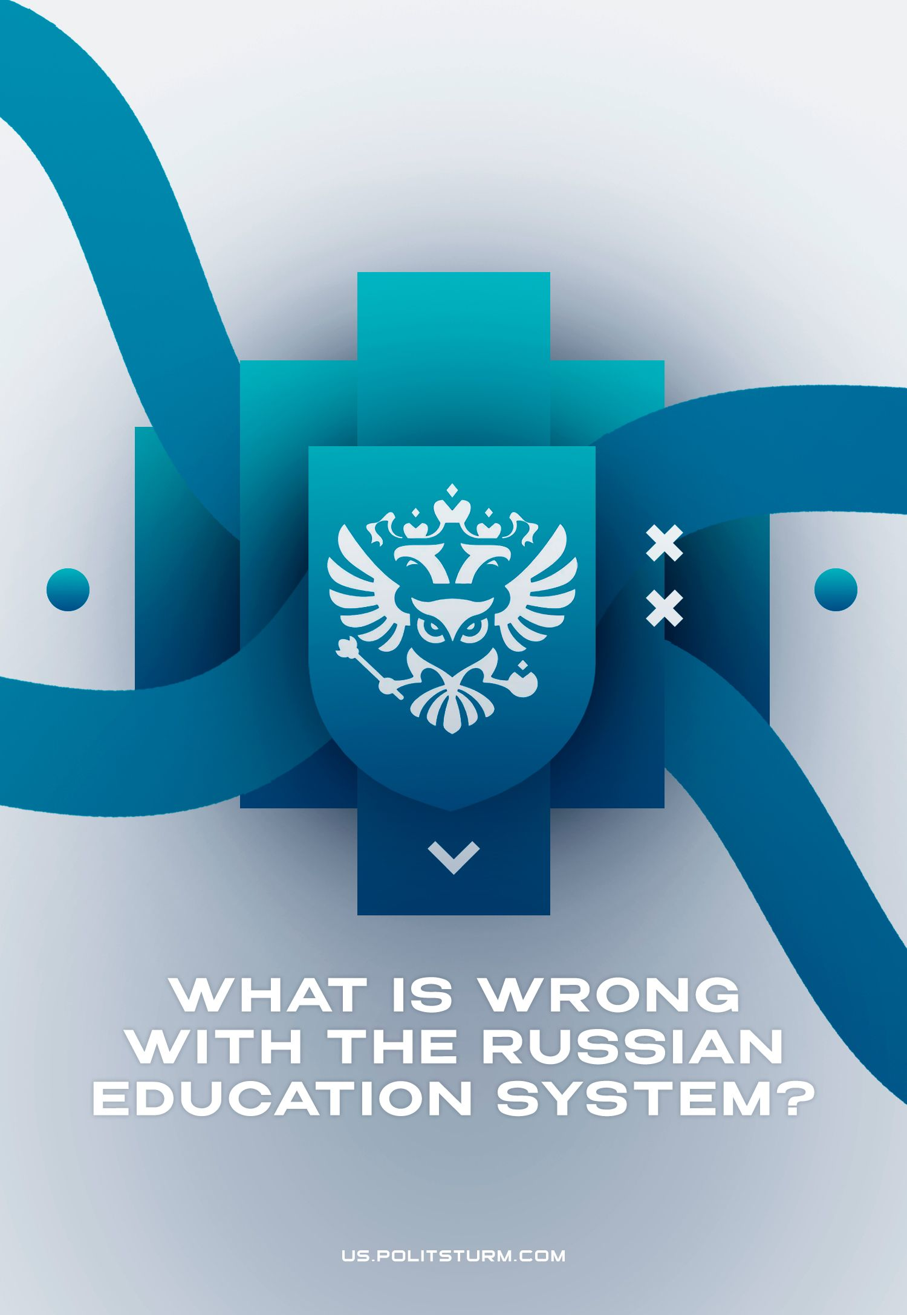

Original article
2023-10-14
39 min read

Education is arguably the most important human need after food, housing and sleep. It opens up new horizons for the individual and humanity as a whole. Education expands one's perception of the world and allows one to make art as well as comprehend the social sciences, mathematics, engineering, etc.
After the collapse of the USSR, the Russian Federation inherited its educational system. Axiomatic is the assertion that over more than 30 years of bourgeois power, as a whole, it has not developed, but degraded due to insufficient funding, unsuccessful reforms and optimization, clericalization, and bourgeois ideology. After the start of the Ukrainian crisis, the authorities of the Russian Federation announced a “reform” of the higher education system. In practice, this “reform” is limited only to the renaming of educational levels. But what is the general state of education in Russia?

I. Problems of Education in Modern Russia

1.1 Inequality in Education
The main factor in the formation of modern education in Russia was the destruction of the Soviet system of universal education. Under capitalism, two categories of education arose on the ruins of this advanced system: private and public.
Private education in Russia has been developing since 1990. By 2018, there were about 700 private schools in the Russian Federation. About 80% of these schools occupy the average price range in which the cost of education is 15–30 thousand rubles per month, 15% of them are elite schools where the cost of education exceeds 30 thousand rubles. The remaining 5% are relatively cheap schools; this category also includes religious and national schools, where the cost of education does not exceed 15 thousand rubles per month. Unsurprisingly, the city in which private education is most popular is Moscow.
Fees are fixed in 58% of schools, and in 28% they depend only on which classes are taken. The cost of studying at a private school may include certain added options. Most often, the cost includes meals (71% of surveyed schools), textbooks (87%) and extracurricular activities (77%). Also, tuition fees may include additional classes (64%), transportation to school (13%) and other services (27%).
Clients name the following main advantages of private school education: qualified teachers, “prestige”, good technical equipment, a greater chance of entering a university, and also the fact that children from “good families” study in private schools.
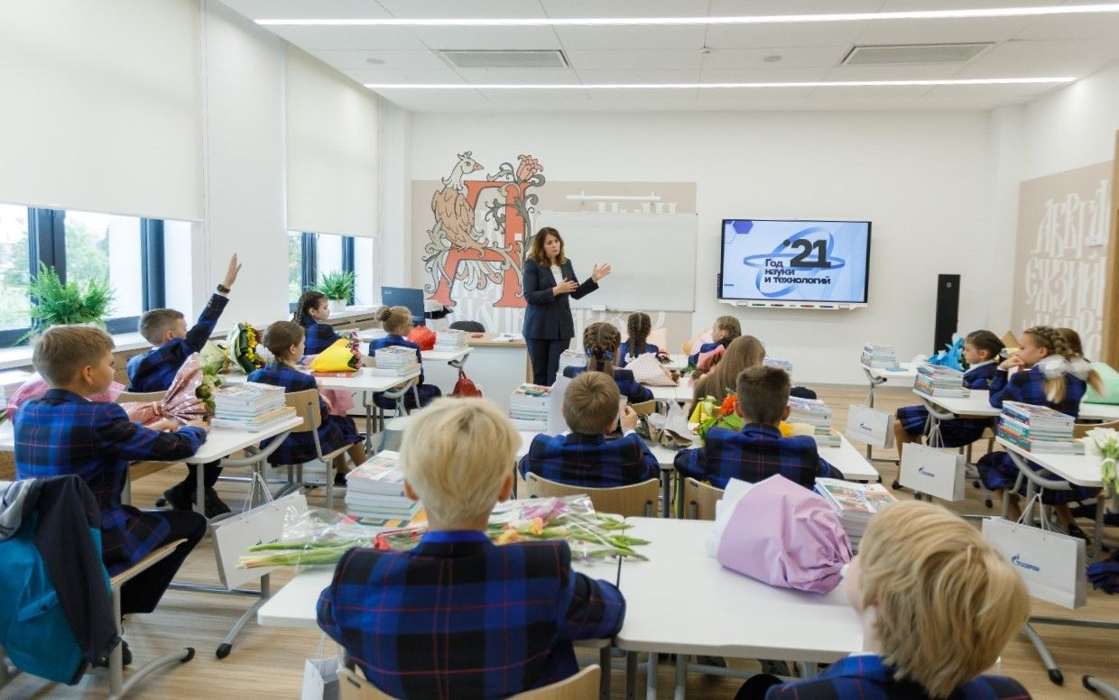
Source: “Delovoy Peterburg”
It is widely believed that private education is better. Even private schools themselves like to claim that they have more modern teaching methods, better material support, comfortable conditions, high-quality repairs, qualified teachers, etc. Also, private schools often organize extra-curricular activities for students, which is especially important for busy parents.
The separation of the educational system into private and public schools creates a serious problem. This practice breaks the unified general educational space, which would provide all citizens with equal access to quality education. Instead, there are two competing systems, between which there is a significant gap in the quality of education.
Step by step the state is shedding its social obligations by “outsourcing” education. In the capitalist system, any business must be profitable if it wants to survive — this is precisely what justifies the high cost of education in the private education sector. The median salary in the Russian Federation (for 2018) was 26 thousand rubles. Considering this, it is difficult to talk about access to private kindergarten, school or university education for the broad masses if in fact it really does surpass the public education system. It turns out that quality education is out of reach to the majority of Russians — they are forced to be content with what they have.
Thus unequal access to education is created. It begins already at the kindergarten stage — as of 2021, only 37 regions (out of 48) had 100% availability of kindergartens. Despite the officially high percentage of kindergarten availability, in reality, there are still huge queues and infrastructural problems of modern development that hinder the actualisation of children's right to education.
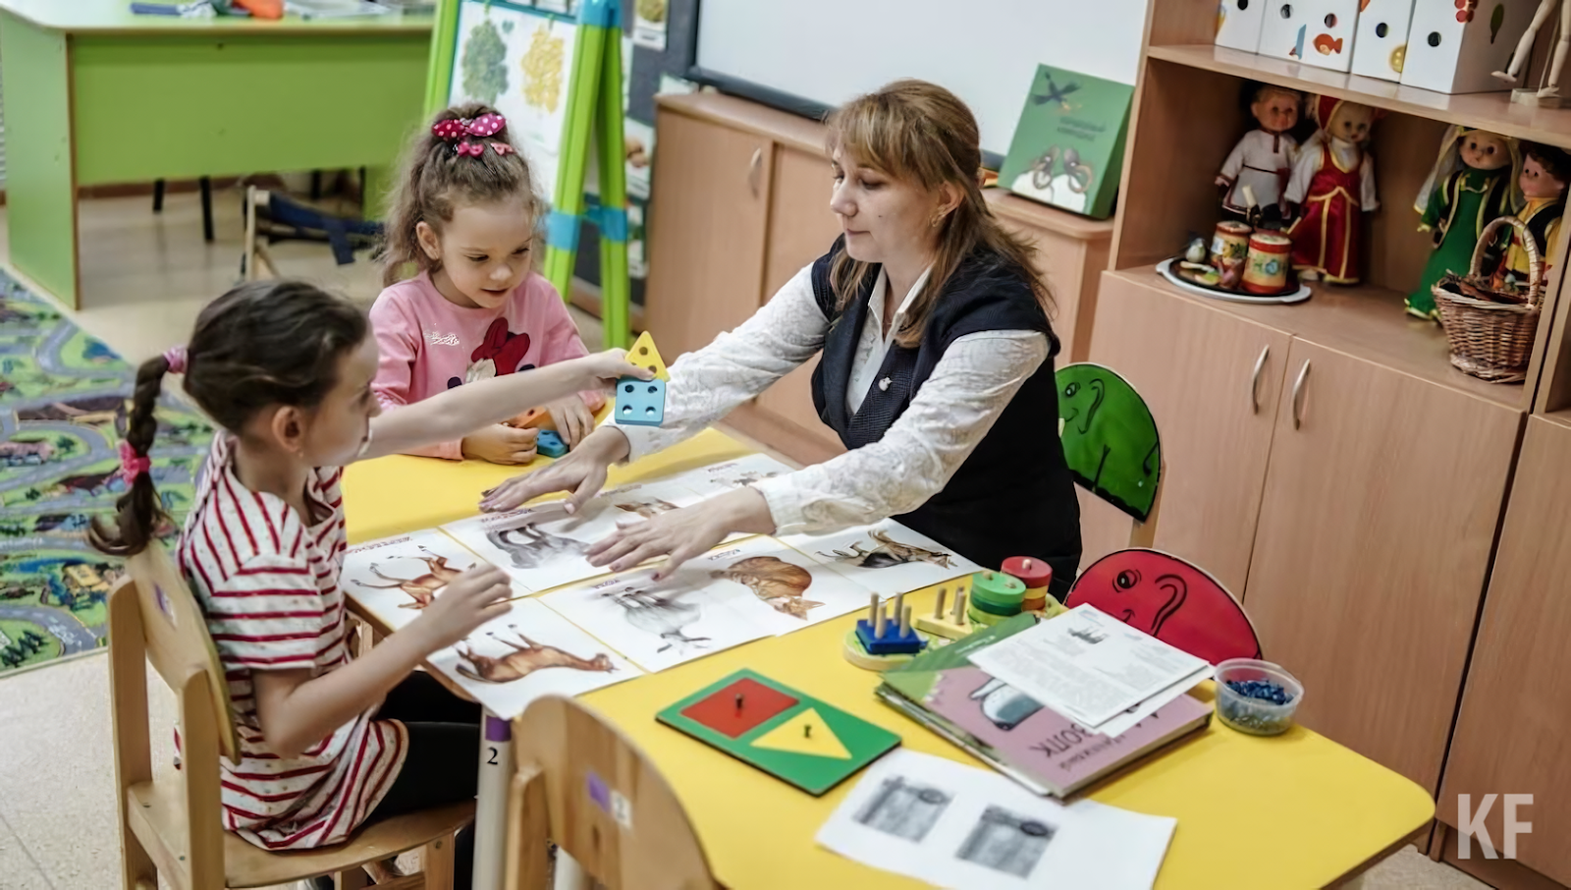
Source: Kazan First // “To the kindergarten through the Supreme Court: there are not enough places in the kindergarten in the Pestrechinsky district of Tatarstan”
Here is just one of many particular examples: a resident of Murino had to seek a place in a public kindergarten through the courts. An alternative to the district kindergarten was a kindergarten 49 km away from their place of residence.
The problem of social stratification in relation to the availability of education has a profound impact on a person's personality. According to a recent study, the social circle of each student has the greatest influence on their academic success. Thus, children from more affluent families from early childhood have somewhat more fertile ground for the development of their abilities, while children from poor families often have negative role models before their eyes, they are less motivated and sometimes have a significant number of psychological problems.

1.2 Bourgeois Worldview
The school, as well as the university, is the natural tool which the ruling class uses to propagate the bourgeois worldview and state ideology.
The ideology of the ruling class is expressed in several aspects: instilling bourgeois moral values in children from an early age, fostering national solidarity and cultivating an idealistic and metaphysical worldview.
Taken alone, the inculcation of certain values is not a negative phenomenon, because every ruling class strives to make its ideology and philosophy dominant in the public mind. The question is what kind of values and views are instilled in bourgeois schools and universities.
This is particularly evident by comparing the ideology of Soviet education and modern bourgeois education.
The Soviet system, albeit with varying degrees of success, tried to develop in children the qualities and traits necessary for the development of socialist society. These qualities are:
— collectivism and the overcoming of narrow petty-bourgeois individualist views;
— instilling a feeling of responsibility as a citizen of the Soviet Republic;
— a scientific worldview based on dialectical and historical materialism and the latest achievements of science.
The modern system as such does not really pursue the goal of educating a person and a citizen in accordance with high moral standards. The school under capitalism is only a tool for teaching a person the basic knowledge that is necessary for him to become one or another specialist in accordance with the needs of the labor market.
Another matter is that the bourgeois school is forced to engage in educational work in order to instil loyalty to the existing socio-economic order in a person on the one hand and on the other hand to prevent attempts to protest or rebel against it. Thus, the bourgeois school is a tool in the hands of the capitalists for their necessity of inducing a bourgeois worldview in people.

What is the bourgeois worldview?
The bourgeois school instils mercantile spirit and individualism in its students and inculcates the cult of "success". The system of educating a person to be an active citizen and team player as a whole has been replaced by an egoistic desire for personal enrichment. The surrounding world is perceived as hostile and competitive, in which people live on the principle of "every man for himself."
The system puts pressure on the student, suggesting the idea of the existence of two different worlds. The world of "successful people" or "winners" with higher education, "unique" and "distinctive" personalities, successful businessmen, entrepreneurs and influential people – and the world of the"rest": workers, peasants, "losers", the contemptible mass.
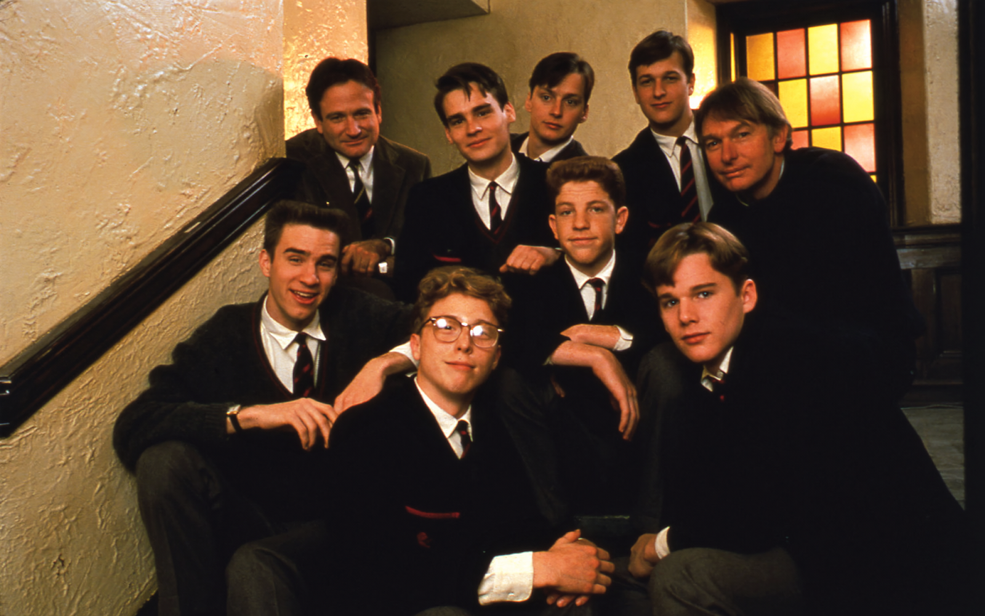
Shot from the film "Dead Poets Society", 1989
Such attitudes are dictated by the entire structure of the capitalist system. The school does not invent anything new but only pursues these views which mirror capitalist society. Many of the difficulties that conscientious workers encounter in standing up for their rights stem from the beliefs that have been instilled in them. The constant competition and the fragmentation of society that has grown out of this leads to a lack of skills for collective action and the irrational belief in pushing one's own luck.
In addition to imposing a common bourgeois worldview, the oligarchic state uses the school as a tool for more prosaic propaganda on current political issues. These are, for example, "Conversations on the important", through which the ruling class of the Russian Federation brings up a pseudo-patriotic, solidaristic position among young people. It is also worth noting the inculcation of loyalty inherent in many capitalist powers to the symbols of the bourgeois state: the flag and the anthem.
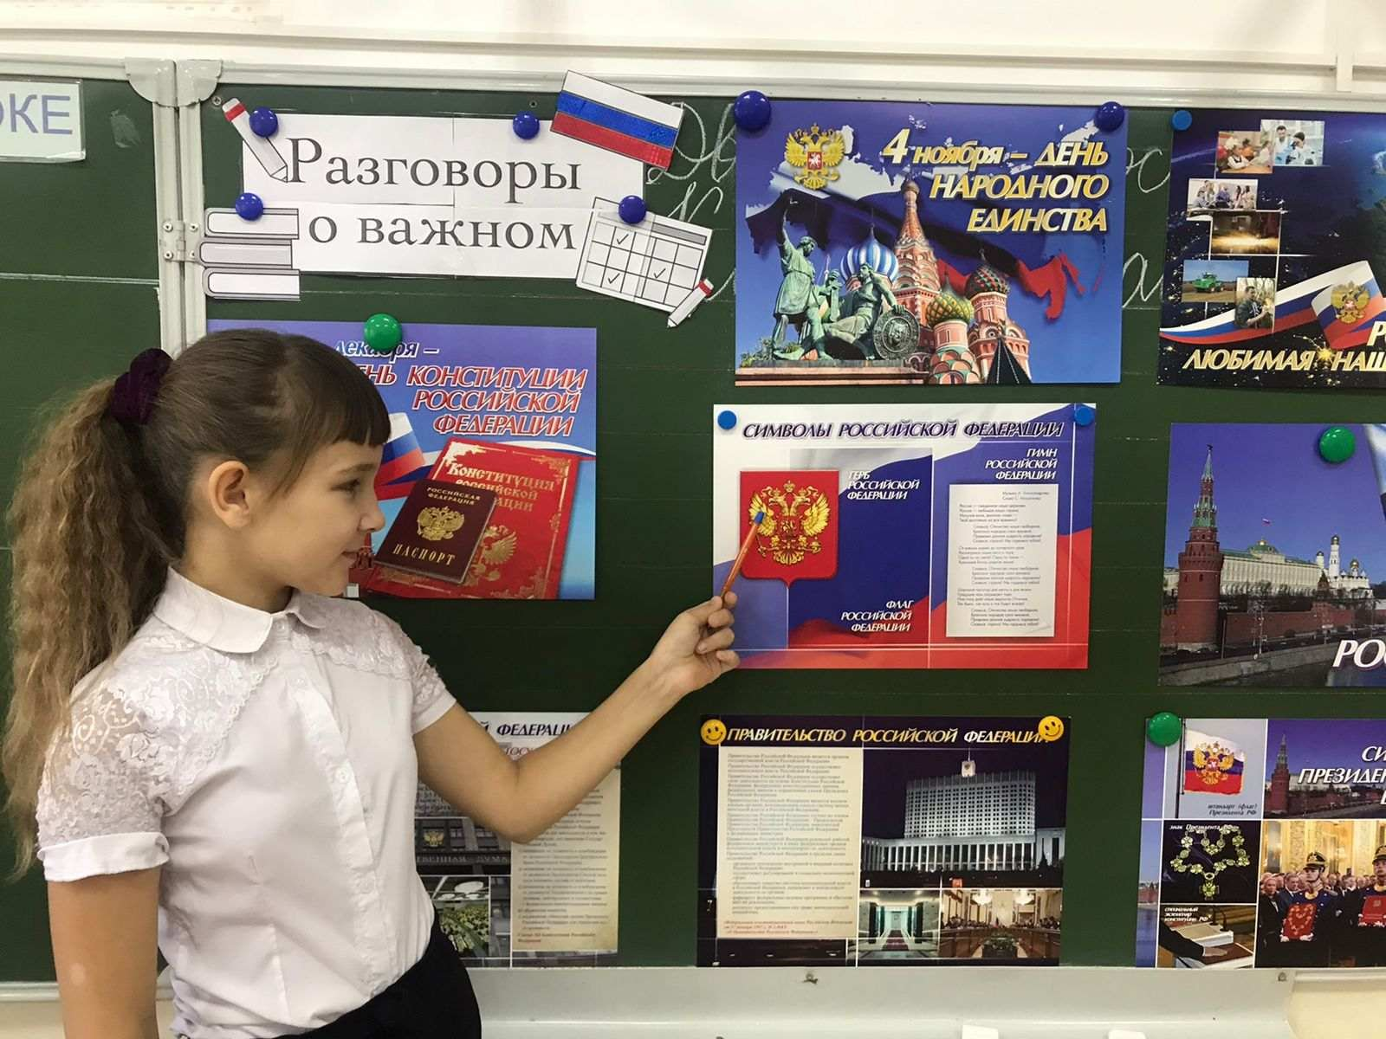
Source: Official website of the Administration of the city district - the city of Kamyshin
The performance of the anthem and other signs of devotion to the bourgeois state blurs the vision of potential future representatives of the working class, confusees their social consciousness and makes it difficult to recognize class antagonisms.
The school is also a source of instilling the particular ideology needed by the ruling class. With such an ideology it is easy to promote certain conclusions that interest the ruling class. For example, the metaphysical assertion that the state of the Russian Federation has always existed, that there is no significant difference between the USSR and the Russian Federation, that the “tops” are at one with the “lower classes”, that the authorities are always right and that the people should rally around the bourgeois leader.
A thousand-year history of Russia. Social sciences (social studies, history) teach that the modern Russian state is the result of the activities of early feudal rulers, tsars and emperors. This is partly true, but only partly, since, naturally, the activities of the rulers of the past left their mark on both culture and the specifics of the current state of affairs. Nevertheless, the textbooks do not deal with the class question of feudal relations and, moreover, of the bourgeois state.
Thus, questions about the nature of the ruling class in various epochs of Russian history, the state as a repressive apparatus in the hands of these classes, the position and struggles of the broad mass of the working people, etc., remain completely on the sidelines. Only a retrospective vision of the historical process is exposed and its complexity and inconsistency are hidden. As a result, the bourgeois school is trying to create the appearance of the “continuity” of Russian history, in which the tsarist, Soviet and modern periods are not opposing forms of social development in Russia, but equal stages of a “thousand-year history”.
Anti-Sovietism. However, Russian history clearly shows that the class question is the most important issue when it comes to the state. If we consider the chapters on the revolution, for example, in the textbook "History of Russia in the 20th – early 21st century" by A. O. Chubaryan, then this is how the RSDLP (b) is described:
“What is the social essence of Bolshevism? Soviet historians called the Bolsheviks the party of the working class, but a significant part of the workers did not support the Bolsheviks and most of the party did not consist of them (especially after the Bolsheviks came to power). The workers never dominated the leadership of the party either, so today historians view Bolshevism as a more complex phenomenon, formed not on the basis of a clear class division, but in connection with the destruction of old social structures, the growth of social radicalism, and the marginalization of the masses.
The marginal strata of the population (unemployed, unsettled in everyday and social terms, urban residents, part of the intelligentsia) were inclined to support the simplest, slogan solutions to the complex problems facing the country.”
In fact, the authors of the textbook argue that the Bolsheviks express the interests of certain marginals who have seized power. Further: “the Bolshevik dictatorship further split society and exacerbated social contradictions,” thus, the responsibility for the Civil War is completely transferred to the Bolsheviks, as if only the actions of the Bolsheviks were its cause.
Despite the fact that the USSR, according to state textbooks, was formed as a result of a "seizure of power", the textbook notes the successes of the Soviet people, the achievements of the political and economic nature of the socialist state, and individual cultural and scientific figures. At the same time, the Soviet regime is called "totalitarian", and the party is presented as an elite few "snickering at the top".
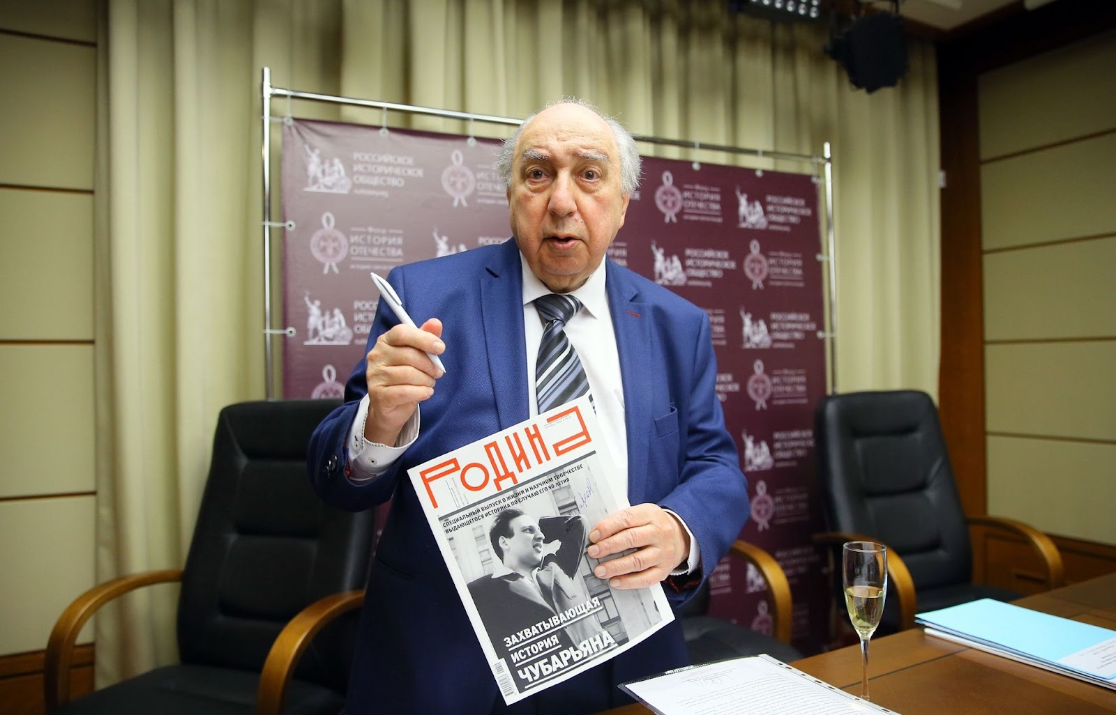
Alexander Chubaryan, author of the textbook "History of Russia in the 20th – early 21st century" // Source: Rossiyskaya Gazeta
This opposition implicitly forms the idea that perestroika, which was the result of the disintegration of the Soviet state, was a political and economic change widely supported by the people. Extract from the same textbook:
“The country has consciously made its historic choice by abandoning the communist regime and the economic omnipotence of the state. This is evidenced by the results of several all-Russian presidential and parliamentary elections, in which the majority of the population supported the reformist parties and their leaders.”
Thus, the communists are separate, the people are separate, and socialism is presented as something imposed from above, rather than an expression of the will of the working majority. At the same time, capitalist reforms are presented as the will of the "people". Thus the cynical view that the modern bourgeois government is at one with the “people” is formed on very thin ground.
Solidarism serves as a reliable weapon in the struggle of the capitalists against proletarian consciousness. Modern politicians have many times expressed the idea of a single people with the goal of a “common prosperous future”, while ignoring the fact that society is divided into classes and, accordingly, the antagonism of the opposing classes' interests. A striking example of the promotion of solidarism can be a completely unambiguous quote from a textbook on social science for grade 11 edited by L. N. Bogolyubov, A. Yu. Lazebnikova, V. A. Litvinov:
“Ideology, which reflects common national-state interests, can play a special role in political life. Along with the interests of various social groups, the interests of the entire people can be identified, which will form the core of such a national ideology. There is general agreement in a number of democracies on the issue of core values. Such an ideology becomes a spiritual guide that helps to strengthen the integrity of society, its upward development”.
From this angle of view on the structure of the state and society, the school inspires the idea of the unity of the "top" and "bottom" of society; promotes the idea that the political elite and power in Russia are always right. Instead of a clear and sober class analysis of any structure of power, the school introduces into the common consciousness the idea of “rallying” the people around the state, leaving aside its socio-economic nature.
Religion also acts as an assistant in promoting the ideas of solidarity and "class peace". Over the past decade, clericalism has been actively introduced in Russian schools. The state is trying to introduce lessons on the basics of Orthodox culture, priests and priests are often invited to schools to speak on various public issues or hold events reminiscent of cult gatherings.
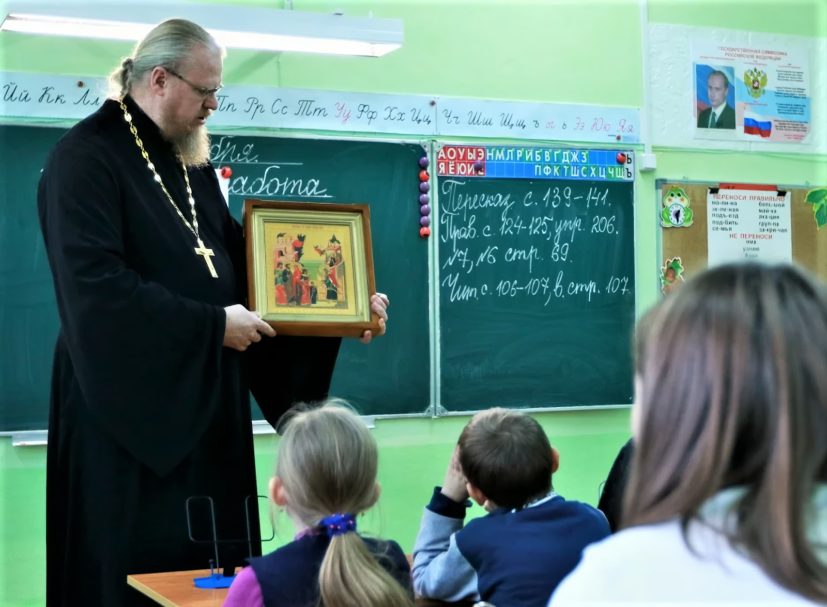
Source
But religion tightly envelops a person not only at school but also outside it. It is of significant note that the number of churches in the Russian Federation in 2021 was about 37 thousand, while there were about 41 thousand general education schools. At the time of the collapse of the Soviet Union, there were only 2.5 thousand churches in the Russian Federation.
Religion brings students a very simple and very convenient view of the world for the ruling class: "Everything is the Lord’s will." Religious thinking knocks out of the human consciousness the idea of a man being the creator and master of his own destiny, it subordinates his thoughts and aspirations to the will of the supernatural.

1.3 Fragmentation of Knowledge
Capitalism uses the division of labor to achieve a high level of efficiency in the economic system. The division of labor is a qualitative differentiation of labor activity in the process of society's development, leading to the isolation and coexistence of its various types.
The division of labor has a contradictory character in history. On the one hand, it helped to achieve a certain level of production and science and, accordingly, of social development. On the other hand, man has become to a certain extent one-sided. When capitalism was a progressive form of social structure, in particular, due to the higher specialization of workers, it led the people to the progress of the productive forces. But in the era of imperialism, on the contrary, capitalism restrains and enslaves the development of human potential. The existing division of labor in society is clearly manifested in the education system.
As capitalism strives for ever greater economic “efficiency”, the ruling class begins training potential future representatives of the working class from a young age, which naturally limits the full development of the individual, leads to a narrow view, and makes it vulnerable to reactionary propaganda.
The division of labor chains a person to a certain sphere of activity, in a certain way disfigures his body and mind, a person becomes an appendage of the profession and production as a whole. And this state of affairs is laid down already at the school stage by dividing student specializations into "humanitarians" and "techies".
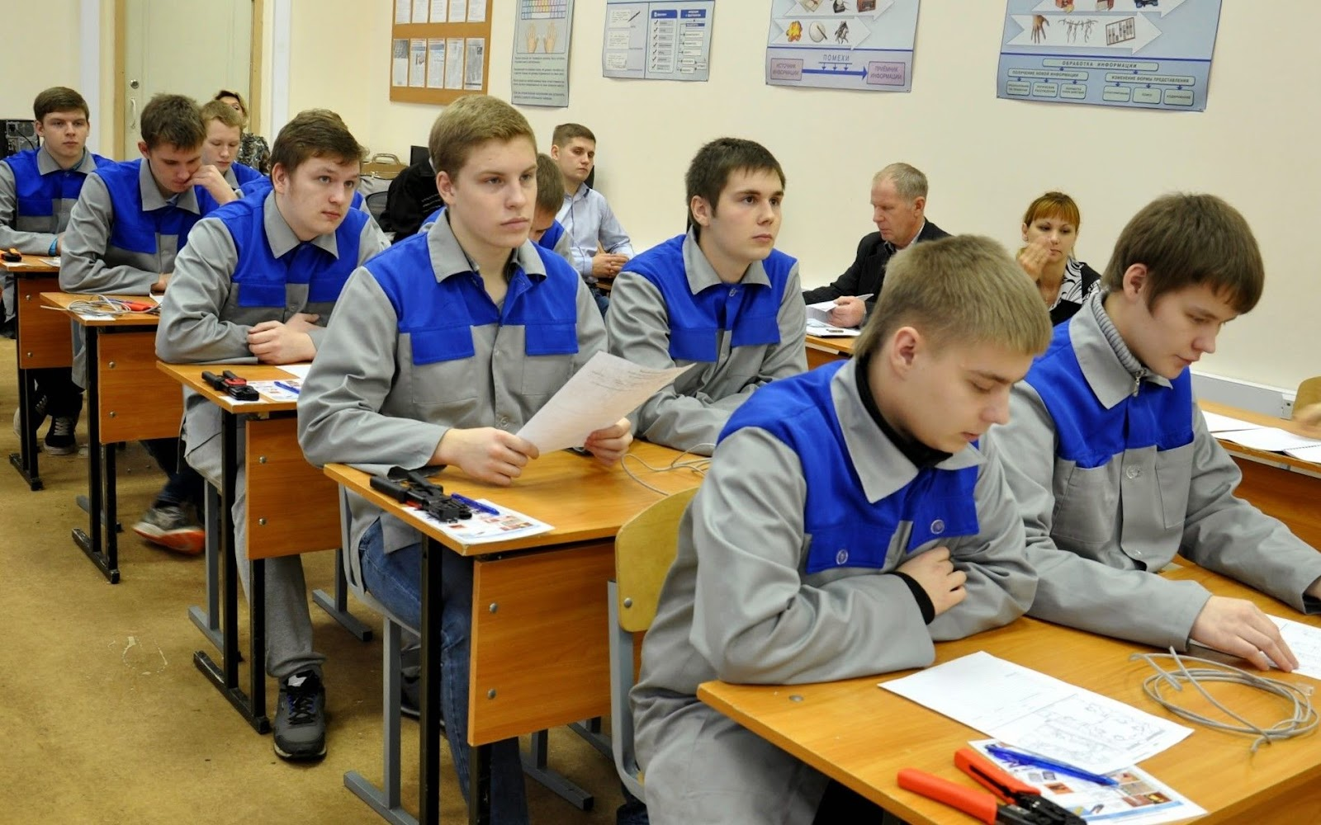
Source
Subjects are divided into natural sciences and technical study (mathematics, physics, chemistry, etc.) and humanitarian (languages, history, social studies, etc.). The relationship between objects of even one “circle” is rarely or partially and primitively revealed. As a result of this, the knowledge obtained also turns out to be fragmented, unrelated to each other. Accordingly, an incomplete, superficial and fragmentary vision of the world formed at school is created in a person’s head, depending on the “specialization” of the student.
A more rigid manifestation of this is the division of classes into liberal arts and engineering from an early age. The division of children is carried out into different profiles of education already from the 5th grade. There are also gymnasiums, lyceums with in-depth study of individual subjects, and then universities.
Such an approach to teaching schoolchildren, as noted above, forms a fragmented worldview, an inability to think comprehensively, and to see the world as a integral and holistic whole. Society is polarizing, people grow apart so that it is sometimes difficult for them to find a common language on fundamental issues.
The notorious division of students into “humanitarians” and “techies” also has a number of far-reaching consequences: fewer opportunities for personal development, a decrease in the creative potential of humanity as a whole, less independent thinking and greater vulnerability to various kinds of manipulation. This is actively used by the bourgeois state, sowing clericalism, a pseudoscientific understanding of the world, and false ideas and concepts in the proletariat.
The way to overcome the eclecticism of knowledge and one-sidedness of thinking is dialectical materialism, which is ignored by bourgeois science and the education system – if it is taught at all then it's done only in a limited format. Dialectical and historical materialism are progressive teachings, because they proceed from the material reality of the world, the dialectical nature of the movement of matter (including the movement of matter in complex forms – like human society). It is this approach that is able to explain the true patterns of development, as well as the historical process, i.e. give complete, holistic information about reality.
Ultimately, an upbringing under the current education system significantly limits a person's opportunities for self-realization and limits the set of skills and knowledge necessary for a fully-fledged and fulfilling life and to work towards the transformation of the world.

1.4 Degradation of the Material and Technical Base
As mentioned above, one of the main reasons to introduce and develop a system of private schools was the terrible material and technical condition of the state ones. Private educational institutions were presented as a solution to the problem.
Indeed, a well-known problem of public schools is their deplorable condition and technical equipment. This is one of the most popular reasons for choosing a private school. The state program "Modernization of School Education Systems" promises to repair a considerable number of schools, namely 7300. Nevertheless, this is approximately only 1/5 of their total number. The authorities assume that all other schools are in perfect order.
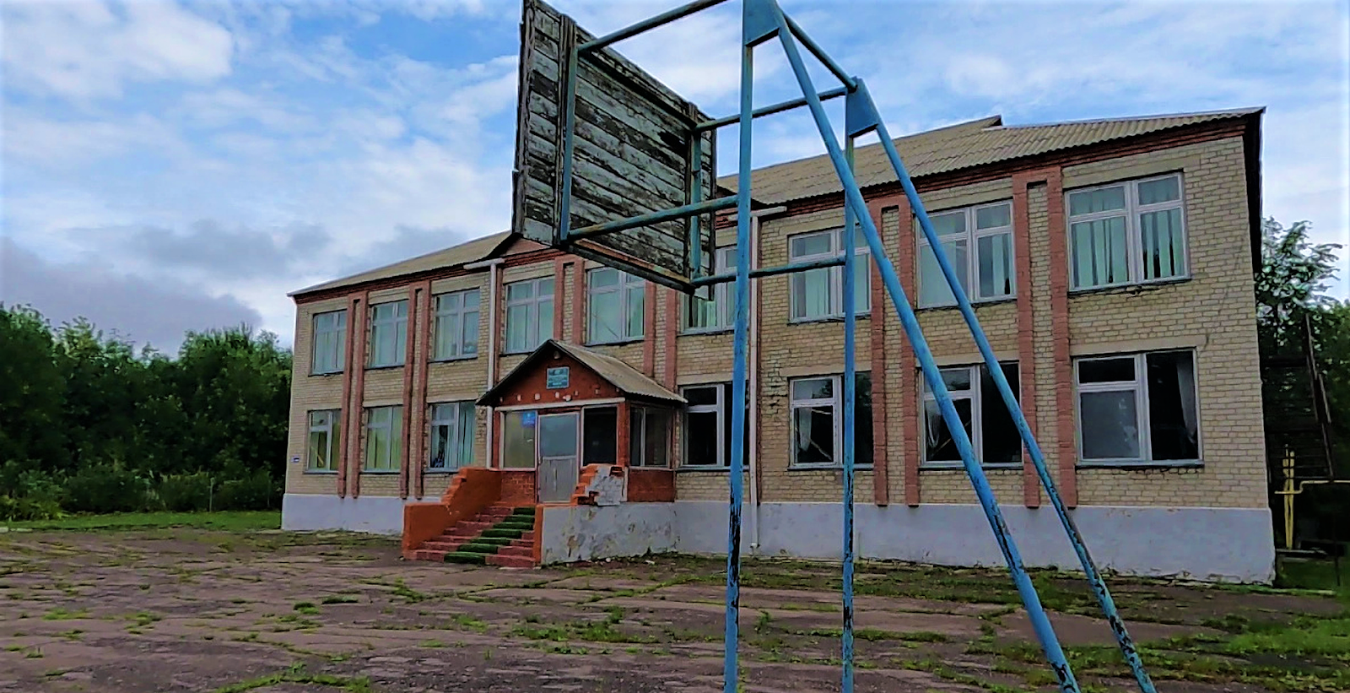
Source: Vesti Voronezh
At the same time, public schools can also be divided into two large groups: rural and urban. Perhaps this fact will seem surprising, but more than half of the schools in Russia are rural. And this is despite the fact that over the past 20 years, their number has halved. The destruction of the general education system is clearly visible in rural schools. For example, in the Leningrad region, the ratio of the number of urban to rural schools is 52% to 48% in favor of the rural schools. They employ 25% of the total number of managers and 33.6% of the teaching staff. In general, about 28% of children aged 7 to 17 study in rural schools in Russia.
More than 15.1% of rural school buildings are wooden. In some regions more than 2/3 of all schools are wooden: for example, in the Republic of Sakha (Yakutia) 72.2% of schools are made of wood, in the Republic of Komi – 70.9%, in the Republic of Tyva – 69.4%, in the Nenets Autonomous Okrug – 67.5%. More than 4,000 schools require major repairs, 300 are officially in disrepair. Over 15% of rural schools are not equipped with warm toilets. In some regions, this figure reaches 70%. In 13% of schools, there is no central heating and the same proportion do not have running water.
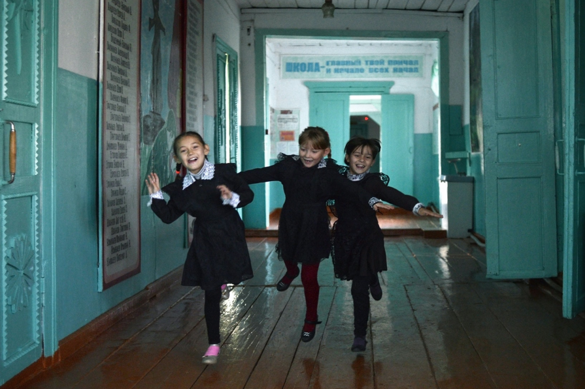
Source: Smapse Education // "Half-life of infrastructure and a vague future: prospects for a rural school in Russia"
At the same time, the number of urban schools, as well as rural ones, continues to decrease. During the optimization period since 2001, the number of schools has decreased by a quarter. Despite the prejudice that urban schools are better equipped, in reality, this is far from always the case, and in many schools, even in megacities that are considered to be prosperous, there are still the same problems.
Often parents are forced to fight for decent conditions for students, uniting to put pressure on local officials, as happened, for example, in Yekaterinburg. Many such cases are described in the regional media.
The problem of material and technical equipment in schools is so acute that it has reached the national level. The "Modernization of School Education Systems" was mentioned above. It sets itself the big task of overhauling and equipping thousands of schools. Nevertheless, senior officials were forced to admit the existence of a problem in this area. In some cases, the construction of new facilities, despite the fact that the buildings should be put into operation this year, has not even reached 5% completion.
It is always worth dividing the promises made by the government by a large margin for a more accurate picture. The ruling class loves to fool the workers by promising them a comfortable life "sometime in the future."
At the same time, the equipment of schools – both rural and urban, as well as private – remains heterogeneous. Even at the level of one city, if in one school you can find a complete set of technological innovations, then a school from a neighboring district may be completely unsuitable for teaching pupils in modern times.
The time of the pandemic turned out to be especially indicative; when schools were transferred to a distance learning format. The educational system and the state could not provide students with the necessary equipment or establish systems for online teaching and recording progress. As a result, teaching was often carried out by artisanal methods, which naturally affected the quality of students' education.
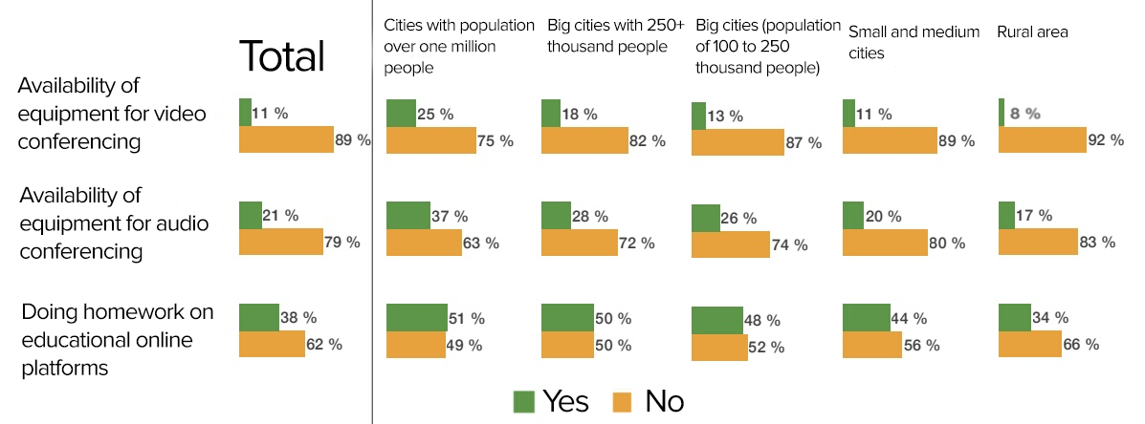
Dzen.ru // ActivityEdu: "The quality of education is falling: how will the online mode affect the knowledge base"
The pandemic served as a stress test for the education system and clearly showed failures, including in the technical equipment of schools.
1.5 Unified State Examination
The Unified State Examination (USE) can be regarded as the most high-profile and controversial education reform of all time in modern Russia. Every year, Russian graduates take this exam, which is associated with a colossal level of stress. Often students approach the exam with a “make or break” feeling.
In general, the USE is perceived negatively in society.
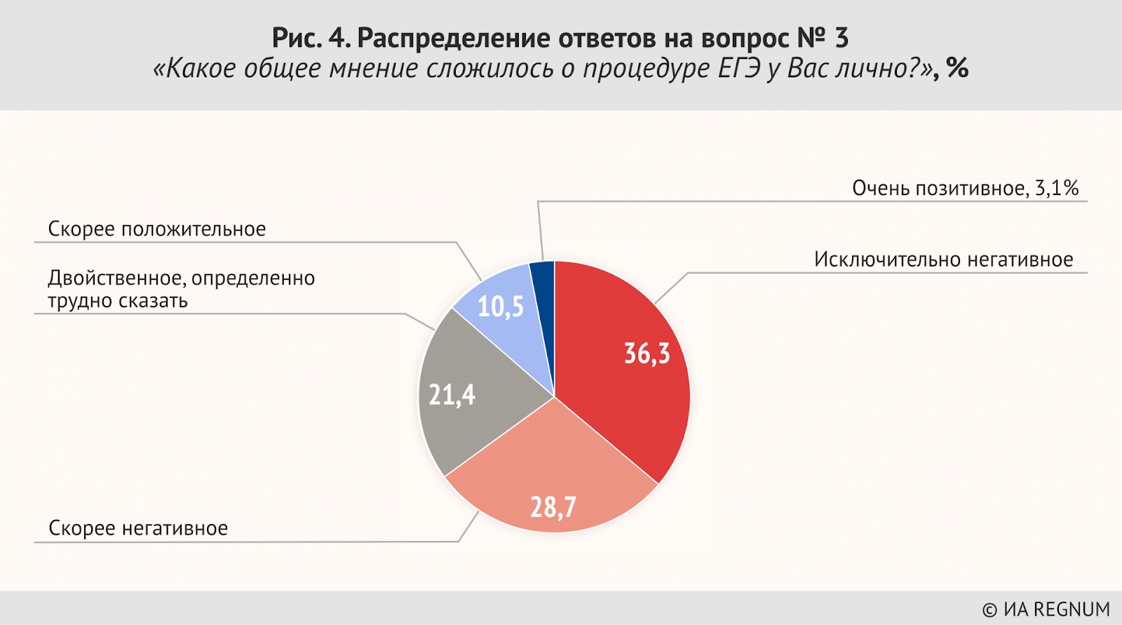
Fig. 4. Distribution of answers to question No. 3 “What is your personal opinion on the USE procedure?” Rather positive (10.5%) Very positive (3,1%) Dual, hard to define (21,4%) Rather negative (28.7%) Exceptionally negative (36,3%)
The author of the idea was the Minister of Education Vladimir Filippov, the first experiments on the USE date back to 1997. Over the following years, experiments were carried out on the examination, and since 2009 the USE has become mandatory.
The main goals of the USE were declared to be the standardization of admission to higher and secondary educational institutions, as well as the provision of equal opportunities for all applicants. In part, the reform really coped with the task, but there are a number of significant nuances that, from a good idea on paper led to the creation of the main headache for all graduate students.
The USE was designed to eradicate corruption in university admissions, and to some extent, it actually worked, at least according to officials. But to say that the USE completely eradicated it, or at least significantly reduced the level, is impossible. Moreover, it can be argued that the level of corruption in general has increased, only the course has changed and the “cash flows” have flown away from the university's admissions to other hands.
For example, Olympiads have become a popular corruption scheme for getting into a university. Here is how “RIA Novosti” describes this scheme:
“Since 2008, getting into a university through a system of prestigious subject Olympiads has become relevant and gaining momentum. This, one might say, is an elitist form of corruption. Getting into the system is almost impossible for a barely successful student. The future winner of the Olympiad must still be capable in discipline or study with a teacher who is on the commission, which costs about 10–12 thousand rubles per lesson. The elitism of olympiads is due to the high price of the lessons”.
Thus, the reform, which aims to equalize the chances of students with different levels of income, only transferred inequality from one place to another.
However, in corruption schemes, petty crooks always suffer. So, in 2015 in Nizhny Novgorod, a student tried to pass the USE in mathematics for another student. He pasted his photo into the passport, but the commission officer figured out it was fake. The student was charged with a criminal sentence. In the same year, in the Karachay-Cherkess Republic, a graduate sent his father to take the exam. The video surveillance helped to identify the fraud.
The USE is not able to assess the level of knowledge. Firstly, supporters of the USE argue that the tests most objectively assess the level of knowledge of the student, but at the same time, the tests are unified and not suitable for everyone: the exam does not take into account the individual inclinations of the student, the type of thinking and the speed of their thought processes. Secondly, the USE shows only how well the student prepared for the exam, but not how well he mastered the school curriculum as a whole.
The USE dominates the high school education program. At its core, preparing for the exam and studying the school curriculum are parallel tasks for the student, and often students throw all their efforts into preparing for tests and "abandon" the main subjects. The superficiality of the exam and, as a result, a shallow depth of knowledge is one of the key issues attributed to the USE by society.
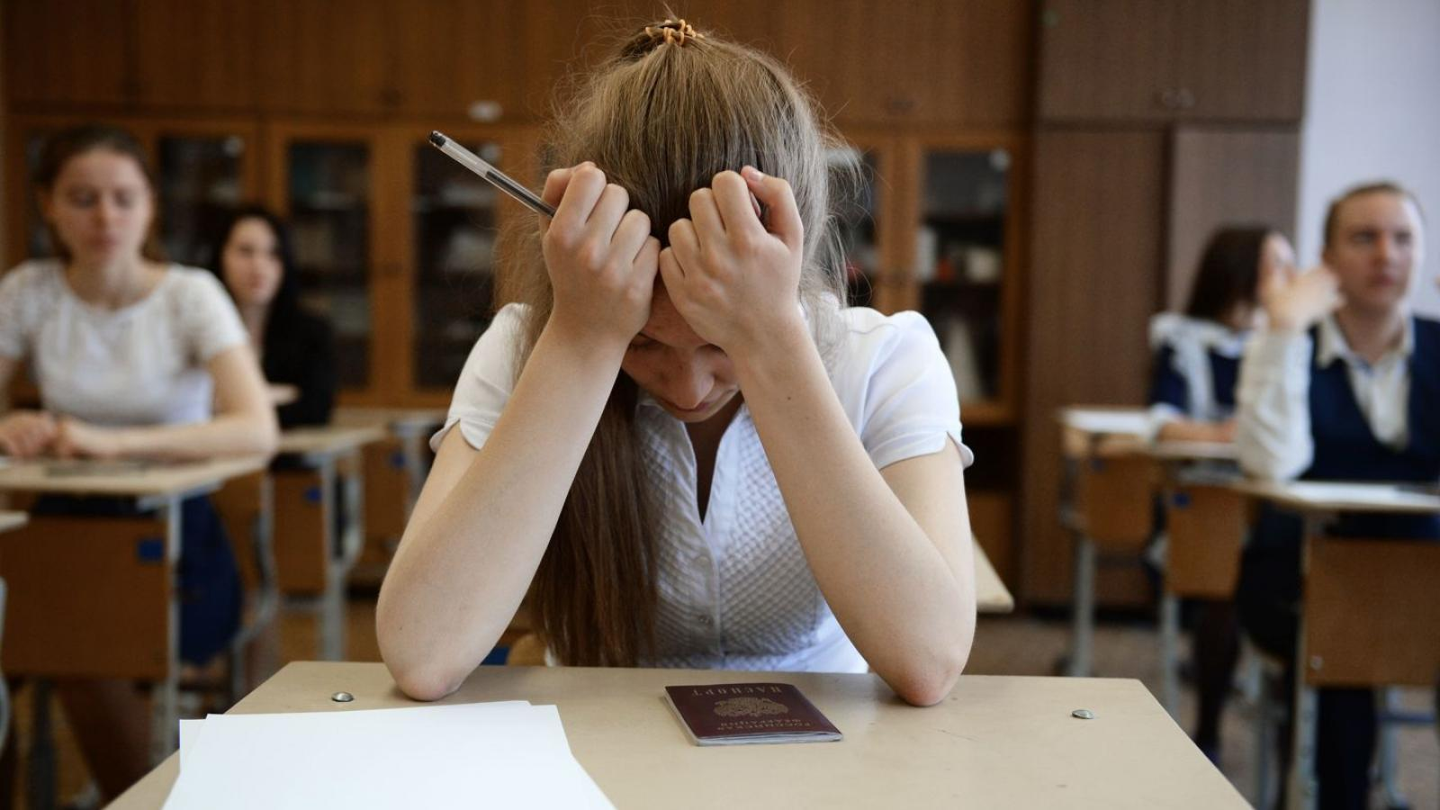
Source
The main issue is that the USE causes unreasonably high stress for students. Schoolchildren tend to perceive the exam as something fatal – they overvalue the exam. No wonder the Internet is full of instructions and tips on how to reduce the level of anxiety and stress in exams. Unfortunately, after each period of passing exams in the news feed, you can see news about the suicide of teenagers who took the exam results too close to their hearts.
For example, due to a poorly passed exam in chemistry in 2021, an eleventh grader committed suicide in the north-west of Moscow. The 17-year-old boy could not bear the fact that he did not justify the hopes placed on him by his parents.
Losing consciousness during an exam from stress or inappropriate conditions is not an uncommon case. Exam organizers often introduce excessive security measures to examinees thus increasing already high levels of stress. For example, because of the suspicion of "foul play", a high school student was forced to remove her bra in front of the executive committee. It's not even worth talking about cases when examinees are simply not allowed to drink water or go to the toilet as they are so commonplace.

1.6 Bologna System
The inclusion of Russia into the so-called “The Bologna process” is a broad topic that deserves at least some mention. Russia began to implement the Bologna system in September 2003. The stated main goal of the Bologna process was to increase the prestige and competitiveness of Russian universities in the world market, attract foreign students with money to Russian higher education, and open up new prospects for Russian citizens.
The Russian authorities carried out their transformations with the best of intentions: they wanted to standardize the education system, make it more understandable and flexible. It was the flexibility and division of subjects into basic and "in-depth" that were presented as the advantages of the Bologna system.
But in the case of the Russian Federation, the situation “we wanted the best, but it turned out as always” was repeated. The old Soviet “speciality” was not reformed properly: the “reformers” only took the old program and split it into two parts without an actual deep restructuring. Thus, on the one hand we have undereducated specialists – "bachelors" and on the other hand we have specialists with an extended period of study called “masters”.
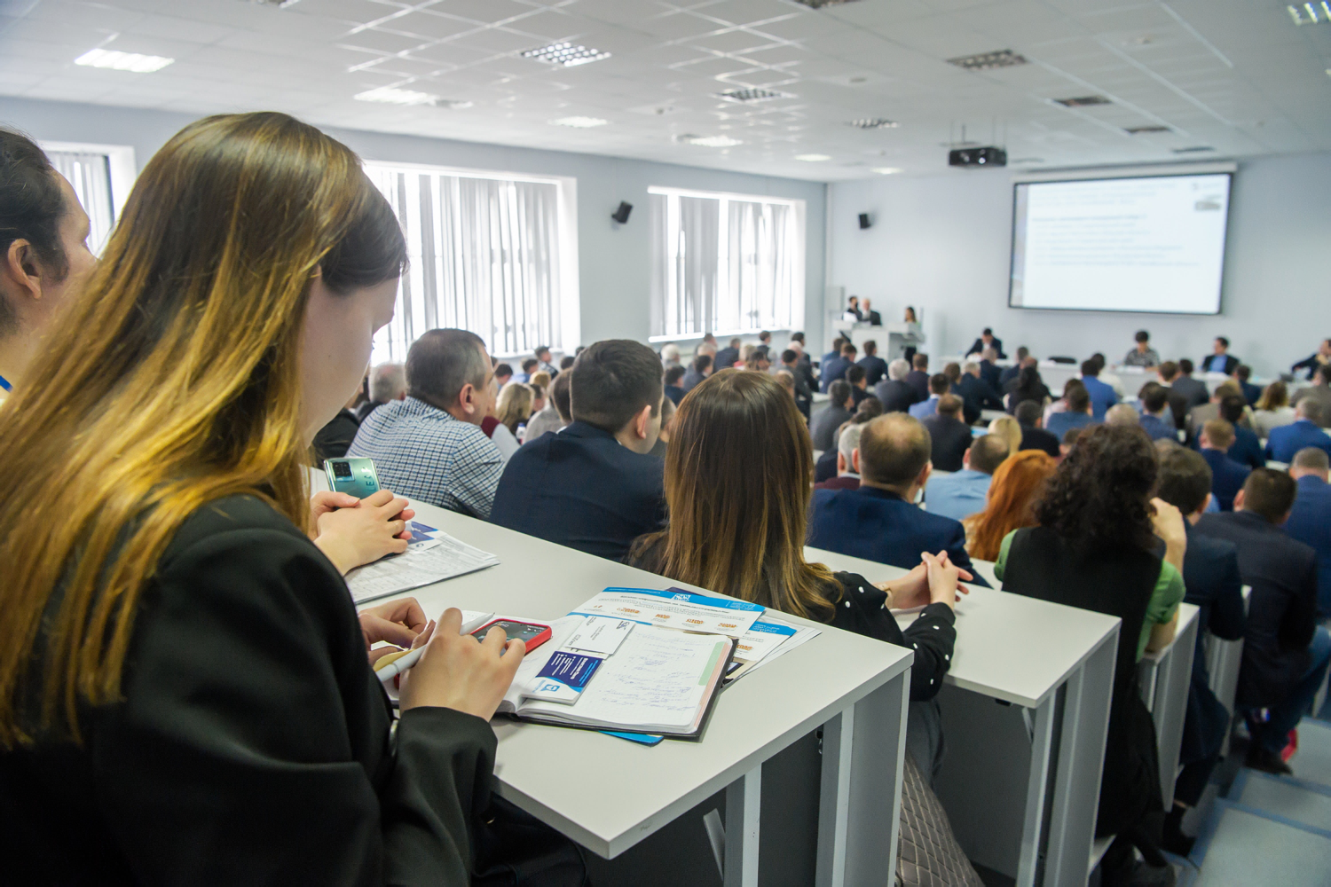
Source: Biznes Online // "Bachelor's degree is not enough, but a Master's degree is difficult, long and not for everyone".
The government of the Russian Federation sometimes makes attempts to “improve something” in the education system, but at the same time, it has absolutely no desire to allocate the necessary funds for this. The system was not fully reformed largely because there were not enough trained personnel. After all, along with the introduction of the Bologna system, the optimization of educators was carried out, respectively, where the workload of the teachers grew, but their salaries remained the same.
After the start of the Ukrainian crisis and the imposition of Western sanctions, the authorities announced a "reform" of the higher education system. This year, Russian President Vladimir Putin signed a corresponding decree. All the "changes", in fact, came down to only minor cosmetic measures: changing the names of educational levels and terms of study. In fact, the Bologna system in its eclectic form continues to exist in Russia, along with all the other problems of higher education.

II. Answers of the Soviet Education System
After the victory of the October Revolution, the Bolsheviks faced tasks of gigantic proportions. One of these tasks was the elimination of illiteracy among the masses and the introduction of a broad system of universal education. The Soviet government not only successfully coped with the task of creating such a system, but also made it exemplary for many other countries of the world.

2.1 History of the Soviet School
The issue of education of the population was a priority for the Bolsheviks. The 1918 constitution of the RSFSR stated: “In order to ensure that the working people have real access to knowledge, the Russian Socialist Federative Soviet Republic sets itself the task of providing the workers and the poorest peasants with a complete, comprehensive and free education”.
The regulation "On the unified labor school of the RSFSR" from October 16, 1918 adopted the free, joint education of children. Measures were introduced to democratize the school, tsarist remnants were abolished, and the school was separated from the church. Education in the native languages was legalized in the national republics.
In the 1920s measures were taken to eradicate illiteracy. In the 1860s and 70s. the percentage of the population that was literate in Russia was 1.7%. In 1897 – 9.4%, by 1917 there was a 30–35% literacy rate. Despite the high growth rates of literacy, this was still not enough for the full-scale modernization of the country, conceived by the Bolsheviks.
On December 26, 1919, the Council of People's Commissars adopted a decree "On the elimination of illiteracy among the population of the RSFSR." In the first paragraph of the decree, compulsory literacy education in the native or Russian language (optional) was announced for citizens aged 8 to 50, in order to provide them with the opportunity to “consciously participate” in the political life of the country.
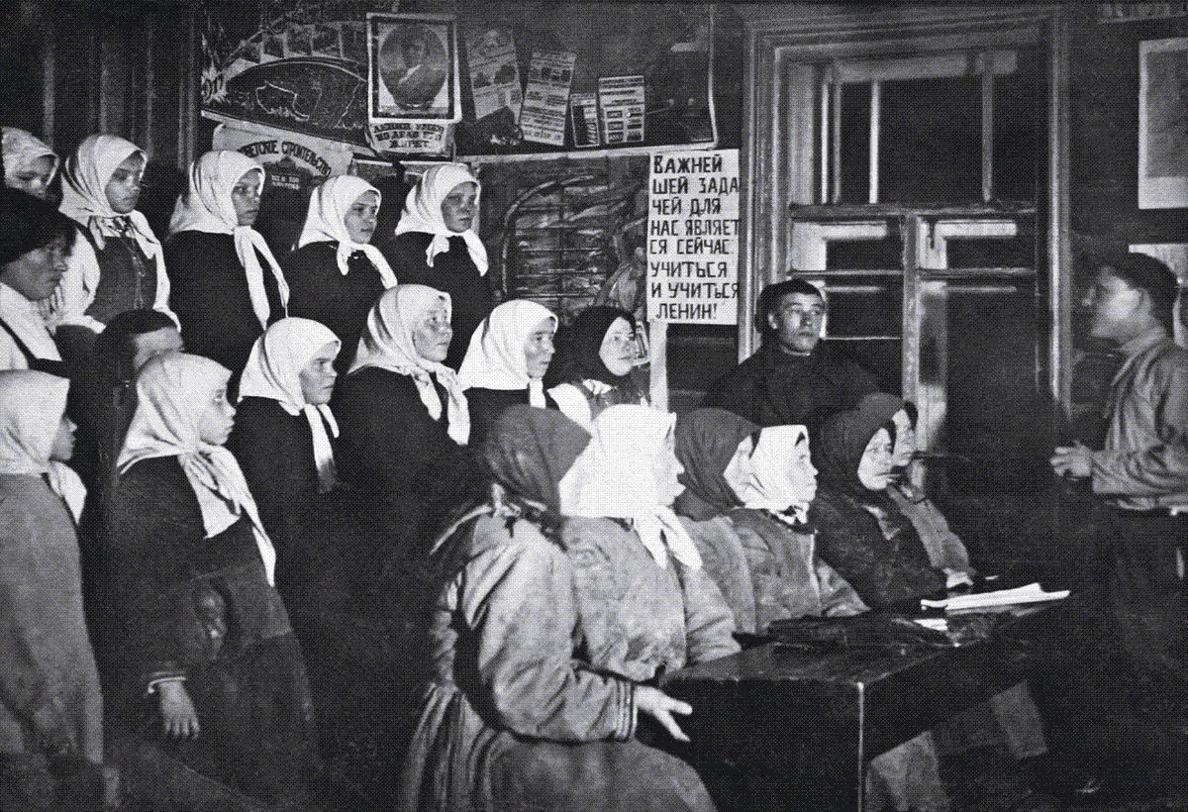
Source
At the initial stage of eradicating illiteracy, the goal was to teach people how to read, write and do simple arithmetic. Schools for the semi-literate became the second step in the system of education for workers and peasants. The learning objectives were more extensive: the basics of social science, economic geography and history.
The elimination of illiteracy was carried out in difficult economic and social conditions, but even despite such difficulties, education remained the most important priority of the Soviet government. It was encouraged, for example, in the following way: for those who were learning to read and write, the working day for the entire period of study was reduced by two hours with the same salary.
By 1926, the literacy of the population was estimated at 40%; by 1939, among people aged 9–49, literacy was already 87.4%. By the end of the 30s. in the USSR, the system of school education in the modern sense was fully formed: it was standardized, unified school textbooks were developed, the formation of a network of higher educational institutions that produced teachers and educators for subsequent work was completed.

2.2 Mass Character of Education
The Bolsheviks were well aware that the successful building of socialism is possible only if the relations of production correspond to the nature and level of development of the productive forces. That is why the introduction of advanced forms of production, and the consolidation of the economy could not occur without the multilateral development of education.
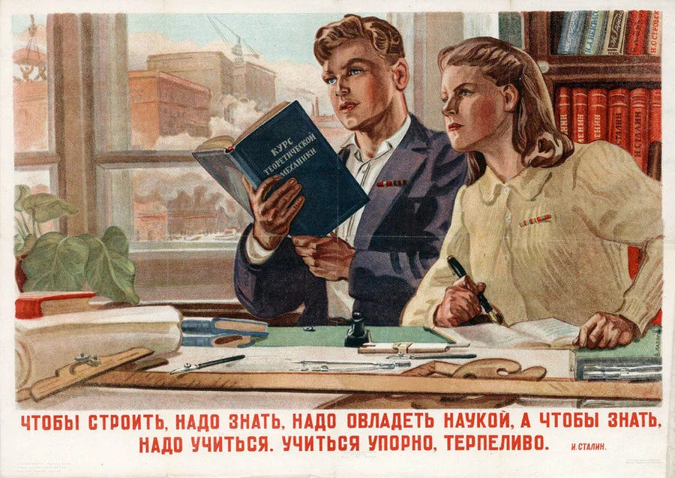
"In order to build, you need to seize knowledge and master science. In order to know one need to study stubbornly and patiently" – Joseph Stalin"
In addition, only an education system accessible to the masses could fulfil the task of a socialist society: to give a person all the necessary tools to realize their potential, meet their needs and transform the world. Without education, it was impossible to talk about the elimination of Russia's backwardness and lack of culture.
Since the basic contradiction of capitalism between labor and capital is resolved during the transition to socialism, its manifestations are also abolished. Thus, the elimination of capitalism made it possible to implement the slogan of accessible education for the masses.
In parallel with the elimination of illiteracy, a completely new Soviet education system was being built. On November 20, 1917, the Collegium of the People's Commissariat for Education of the RSFSR adopted the official "Declaration on Preschool Education". Kindergartens began to open across the country and educational programs were developed.
In 1918, a decree was introduced on the separation of school and church, and the principle of secular education was introduced. In 1930 universal compulsory free education was introduced. Schools were created for all segments of the population, there were evening schools, and schools for working youth. In 1949, universal seven-year education was introduced everywhere in the USSR.
On June 6, 1956, a resolution of the Council of Ministers of the USSR "On the abolition of tuition fees in senior classes of secondary schools, in secondary specialized and higher educational institutions of the USSR" was issued. Thus, education for senior classes and students became free.

2.3 Dialectical and Historical Materialism
In addition to the mass character and accessibility of education for everyone, the curriculum included the latest knowledge of the time in various sciences and was constantly revised and updated. The school set itself the goal of forming a holistic, broad view of the world in a person and forming the basis for further development.
The most important innovation in Soviet education, about which bourgeois historians are usually silent, is the use of the achievements of the philosophy of Marxism. A single, integral Marxist worldview served the Soviet people in the education of future citizens.
Such teachings as historical and dialectical materialism served the Soviet school as a connecting tool that combined the knowledge of various disciplines with each other into a single integrated picture of the world. The dialectical method of cognition helped to see the integrity and at the same time the change and development of society, history, nature and man himself through the resolution of dialectical contradictions arising in the process.
Explaining the relationship between objects, teaching the skill to consider the world in its motion systematically, and not superficially and fragmentarily, became the most important step both for the development of science and education and for the education of a new person, a citizen of the socialist system.

III. Development Prospects
Modern technologies open up the broadest prospects for education. Even in the capitalist world, we see that knowledge and information in general has the ability to instantly spread throughout the globe. In the future, the development of technology can further contribute to easy access to cutting-edge information on a broad variety of interesting subjects for both students and scientists or enthusiasts.
The use of modern IT technologies can also help in the formation of a unified education system, making it more global, inclusive to the broad masses, accessible to people living outside industrial centers, but at the same time more flexible, changeable, interactive and exciting for students.
Neural networks are capable of bringing elements of personalization into the learning process. To become a personal assistant for the student, one has only to direct the power of technology not to increase the profits of the capitalist, but to develop human potential. Based on a variety of indicators, neural networks are able to form a learning path in the most flexible and appropriate way for each particular child.
Modern technologies are certainly able to reduce the level of inequality of access to educational benefits among the population from a wide variety of regions. But we should also not forget that technologies by themselves do not solve problems, and in this case, especially, it is very important in whose hands they are. And if, under the capitalist system, technology only allows entrepreneurs to rake in more cash, including in the education sector, then under socialism, they will be put at the service of all workers.
Conclusion
The sphere of education in Russia is systemically degrading, and this fact is becoming increasingly difficult for both officials and ordinary people to ignore. We have tried to highlight the most acute problems of modern Russian education, highlighting the root cause of the decay – capitalist social relations. They, in turn, provide for the rise to fragmentation and narrowness of knowledge, bureaucracy, lack of funding and material and technical support for schools.
It is impossible to build a progressive education system on a conservative, backward economic base, to which modern Russia and other republics of the former USSR have gradually receded. Moreover, the problems we have described are not something unique and characteristic exclusively of the education system of the Russian Federation and other post-Soviet states: upon closer examination, we will see much in common with education in other capitalist countries around the world. Of course, the problems of other states have their own unique specific manifestations, but they have the same root.
Only socialism is capable of resolving the problems and contradictions characteristic of capitalist education, eliminating the currently taught narrowness of thinking, instead bringing human thought, learning and technological progress to a qualitatively new level, driving our advancement ever forward.
Bibliography
- V.S. Zaitsev. Private education in Russia: A. Miller Library CJSC Publishing House, 2018.
- L. N. Dukhanina, T. A. Mertsalova, A. A. Belikov, R. V. Gorbovsky, S. I. Zair-Bek, Yu. A. Matyunenko. Private schools in Russia: state, trends and development prospects. Analytical report : National Research University “Higher School of Economics”, Institute of Education. — M.: NRU HSE, 2019.
- S. V. Tarasov. Problems of modern rural school // Universum: Bulletin of Herzen University, 2010, no. 12.
- S.I. Zaire Bek. Portrait of a Russian rural school / S. I. Zair-Bek, T. A. Mertsalova, K. M. Anchikov // Monitoring the Economics of Education. National Research University Higher School of Economics. 2020. No. 35.
- Sokolova A.G., Arkhipov A.V. Application of Neural Networks in Education: Opportunities and Challenges // Innovations and Investments. 2023. №2.

Original article

