What is Happening with Russia’s IT after the Ukrainian Crisis?
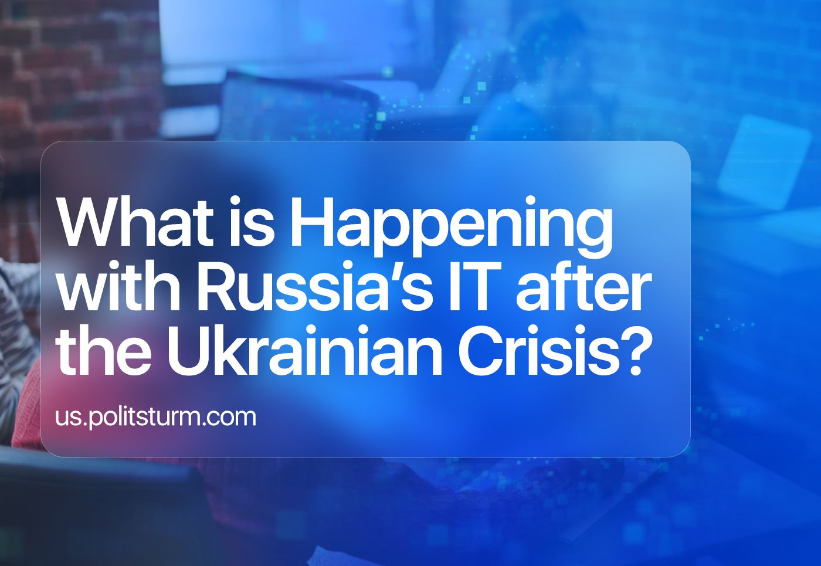

Original article
2023-04-11
13 min read

I. Market Situation
Since February of 2022, more than 170 foreign IT companies have announced their withdrawal from the Russian market, and almost 50 more have reported restrictions in working with Russian users. Among them: Microsoft, HP, Dell Cisco, SAP, Poly, Avaya, Oracle, IBM, TSMC, Nokia and Ericsson, Samsung, Apple.
"The final customers suffered the most here: their software turned into a brick overnight," says the chairman of the board of directors of SearchInform.
Another serious problem is the refusal to support the software of "lower-level" systems. We are talking about industrial automation: controllers, sensors and software that controls them.
"The problem is both in the equipment, which is mostly Western, and in the software that is "sewn into it." By and large, few people know in detail and are sure that at some point some sensor or controller "will not decide" to raise the temperature by 2-3 degrees and / or "will not leave the flap closed," warns the CEO of Reksoft Consulting.
In August 2022, according to a survey by the National Agency for Financial Research, every fifth Russian company stated that the current situation with foreign software does not allow them to function normally.
Before the refusal of Western companies to service their software in Russia, the public sector used mainly foreign software. Now the state is becoming the main investor and customer in the Russian market.
"With such an increase in its role in the industry, competition may decrease in the future, but at the moment we probably don't have any other options. This is much better than if the state did not support the business in any way," says a leading Smart Engines specialist in the development and implementation of data recognition and extraction systems.
The public sector and other domestic users have significantly expanded the capabilities of Russian software suppliers. On February 21, TASS announced that the revenues of Russian IT companies in 2022 increased by 35.3% or 615.5 billion rubles compared to 2021.
The CEO of IVA Technologies predicts the growth of the Russian IT market for at least 3 years, further assumes the consolidation of players and the formation of mega-holdings with production chains established in the domestic market.
Despite the cautiously optimistic forecasts, the prospects for the development of the Russian IT industry are not so "rosy". The growth of the industry is limited primarily by two factors: the lack of highly qualified personnel and the limited supply of computing power.

II. Shortage of Specialists
Even before the 'Special Military Operation', one of the main questions of the Russian IT industry was "What to do with the shortage of IT specialists?". Back in 2021, the government estimated the shortage of specialists in the field of digital technologies stood at 1 million people.
Some had hopes of attracting some of the personnel of the departed Western IT companies:
"Western vendors have left, and someone has fallen into euphoria - now our personnel problems will be solved! I do not share this optimism: foreign companies have relocated the most valuable employees, it has become more lively except with "juniors” and the average level, but a serious vendor does not need a lot of them," said the chairman of the board of directors of SearchInform.
Even before the special operation, about 5% of IT specialists left Russia and in 2022 another 6% left, and by the end of 2023 25% of the total number of IT workers planned to leave. A relatively small percentage of those who left in 2022 is explained by the delay in the queue for mobilization from the state and the fact that companies do not allow employees to work from abroad.
Error loading image
Companies do not want to weaken control over employees, are afraid of changing the attitude of the Russian state towards foreign workers and are afraid to provide remote access to their infrastructure. In addition, non-residents have increased tax deductions:
"A person who has spent more than 183 days abroad in the last 12 months loses the status of a resident. This means that his employer must deduct personal income tax from his salary at a higher rate — 30%," said HeadHunter's director of organizational development.
There are employers who pretend that they do not know about the employee moving abroad. According to the HeadHunter director, it is quite realistic for the tax service to track that a person has lost the status of a resident and issue a fine of 20% of the unpaid amount and penalties for the period of incorrect withholding of personal income tax.
These factors are so important that Kaspersky Lab offered their employees who wanted to move to other countries after the start of SMO to simply quit.
Error loading image
The shortage of workers in the IT industry does not prevent companies from putting pressure on employees, since in many other sectors of the Russian Federation the situation is worse and there is no respite from mobilization, so the queue of people who want to work in IT is only growing. Due to the crisis and the departure of many companies from Russia, people lost their jobs, faced the need to retrain urgently and chose an area that, with rising inflation and instability in the market, will at least not sink their income level.
There are more and more courses promising a quick IT profession, and their popularity is growing against the background of an unstable economic situation. At the same time, employers are less willing than before to hire novice specialists: companies first of all reduced the number of starting vacancies and curtailed internship programs.
In the first quarter of 2022, 95,000 vacancies in IT were opened, which is 25% less than a month earlier. The number of resumes in this period increased by 15%, to 286,400. In total, the number of vacancies for Russian companies has decreased by 75% during the SMO.
"The number of resumes has always been significantly lower than the number of vacancies. Since February, the situation has turned in the opposite direction. We are now seeing that the number of opportunities for potential candidates is less than the candidates themselves," says HR Director of the IT company KROK.
Despite the fact that the influx of new employees has increased and that some of the specialists who worked in the departed foreign companies have been left without work, the shortage of personnel objectively persists. The General Director of MoyOfis estimates it at the same 1 million qualified specialists.
Error loading image

III. Supplies of High-Tech Products
The second obstacle to the development of the Russian IT sector is the withdrawal of companies selling high-tech products and the restriction of the supply of such products from the West and Taiwan. The Russian Association of Electronic Communications draws attention to the lack of "hardware" as a growth limiter for the Russian IT industry:
"Thus, the shortage of equipment and components becomes one of the main factors that will have a negative impact on the growth of the IT industry along with the general economic downturn and sanctions pressure," RAEC analysts write.
"There are big problems with the availability of hardware parts. The purchase of many types of equipment has become either impossible or takes longer, and prices have increased significantly," explains the leading Smart Engines specialist in the development and implementation of data recognition and extraction systems.
"Even though we have a lot of design centers and chip manufacturers in our country, we still, like the rest of the world, depend on Taiwanese TSMC, Chinese factories such as SMIC," says the CEO of IVA Technologies.
If software can still be written in Russia, then Russia is actually completely dependent on foreign suppliers for hardware. Even those products that are considered Russian, largely use foreign elements. The White House has calculated that the sanctions of the United States alone will reduce Russian imports of high-tech products by a factor of two.
The situation is relatively better with access to Internet, telephone and television traffic. The telecommunications industry works mainly with Chinese equipment suppliers. The share of only one Chinese Huawei is about 50% of the total equipment used by Russian operators.
Error loading image
However, China cannot provide Russia with microchips, and all modern electronics work on them. China will be able to supply only relatively low-end chips to Russia in the near future, which will slow down the development of the industry.
In addition, most alternative suppliers somehow use American technologies in production, which will force Chinese and other foreign factories to refuse Russian companies.
Even if Russia wants to manufacture advanced microchips on its territory under the conditions of sanctions, the establishment of this process may take decades. Even the USA, which is afraid of export dependence on key technologies, cannot yet create assembly lines of advanced processors at home without a drop in quality due to a complex multi-stage production system.
Much more likely, the development of domestic production will be replaced by gray supplies. So, in any case, the managing director of the international lobbying company among IT Baikal Communications Group believes:
"Against the background of sanctions, counterfeit foreign processors may appear on the market under the guise of Russian ones, and this trend may blur the achievement of goals in real import substitution."
"In fact, the Russian electronics market will be able to exist at the expense of smuggling, when foreign equipment will be unofficially supplied to Russia from third countries that will resell it at an inflated cost," Forbes reports the words of the chairman of the Council of the Association of Manufacturers of Electronic Equipment and Appliances in Russia.
It is worth noting that there is a difference between the two types of importation of electronics "contraband".
Parallel import is the import of goods with the permission of the state, with the payment of duties and VAT, but without notifying foreign copyright holders.
Gray import is the delivery of goods from which duties were not taken and which can avoid other taxes. Gray imports are not considered by the manufacturer as an official purchase of the end user, therefore the manufacturer's warranty and service are not covered by it.
The margin for the presence of another participant in the supply chain with parallel imports can reach 20%, as with gray imports, if there are not enough goods on the market — what can be expected if supply chains collapse after Western companies refuse to cooperate with Russian ones. Intermediaries who have left Russia carry branded goods mostly through Dubai (UAE), namely European brands come to Russia more often through Turkey.
The shortage and the rise in price due to the margins on the goods forced the electronics market in Russia to sink. In 2022, although the prices of goods increased, the electrical engineering market brought 27.8% less profit compared to 2021.

IV. What is the result?
- Despite the continued growth in the profits of IT companies, Western sanctions in the field of high technologies have had a negative impact on the state of the industry as a whole:
- Specialists are waiting for an unstable market situation and an increase in labor intensification;
- Phones, laptops, computer accessories and other equipment have become more expensive;
- Counterfeit goods have increased and it has become more difficult to return defective goods or repair a broken one;
- Russian civil servants and ordinary consumers will receive a raw product for a high price;
- Without chips and conductors, the defense industrial base of the Russian Federation will deteriorate over time.
Once again, all the talk about the development of technology turned out to be nonsense. The state has not built high-tech production facilities in Russia that could retain specialists and create domestic equipment and microchips, as well as bring domestic software to mind.
The Russian authorities have not developed their own industry and are not going to develop it. Instead, we continue to hear false promises about the development of high technologies in Russia, routine pre—election phrases about the importance of science and education - but in the end all the money will go into the pockets of the oligarchs as usual.
Only under the power of the workers is it possible to carry out genuine modernization, because only the workers are interested in the genuine development of their own country, and not in enriching the elite, because the power of the workers is responsible to the whole people, and not to a handful of oligarchs at the top.
Sources
- Rozetked.me "List of companies that leave and stay in Russia"
- Forbes.ru "IT to yourself: how the IT sector lived a year after the start of the "special operation" in Ukraine" dated February 24, 2023
- Cnews.ru "Business is begging the authorities to allow the use of pirated foreign software. Now he is being imprisoned for seven years" from December 16, 2022.
- Tass.ru "Revenues of Russian IT companies increased by 35.3% in 2022" dated February 21, 2023.
- Digital.gov.ru "Chernyshenko: Russia lacks a million specialists in the field of digital technologies"
- Forbes.ru "More than 30% of IT specialists have left Russia or are planning to relocate" dated September 26, 2022.
- Forbes.ru "They become less loyal": why IT companies forbid employees to relocate" from August 31, 2022
- Forbes.ru "Junes are not needed: why IT has become more difficult for graduates of IT courses to find a job" from August 8, 2022
- RBC "The number of vacancies in the IT sector has decreased in Russia, and the number of resumes has increased" from April 4, 2022
- Forbes.ru "Without chips and conductors: how technological sanctions will affect Russian companies" from February 28, 2022
- Forbes.ru "Prohibition on development: how Russian technologies will survive without semiconductors" from March 4, 2022
- Forbes.ru "Importation is still there: how the chain of electronics suppliers to Russia changed in 2022" from January 26, 2023

Original article

