What is Happening in Serbia?
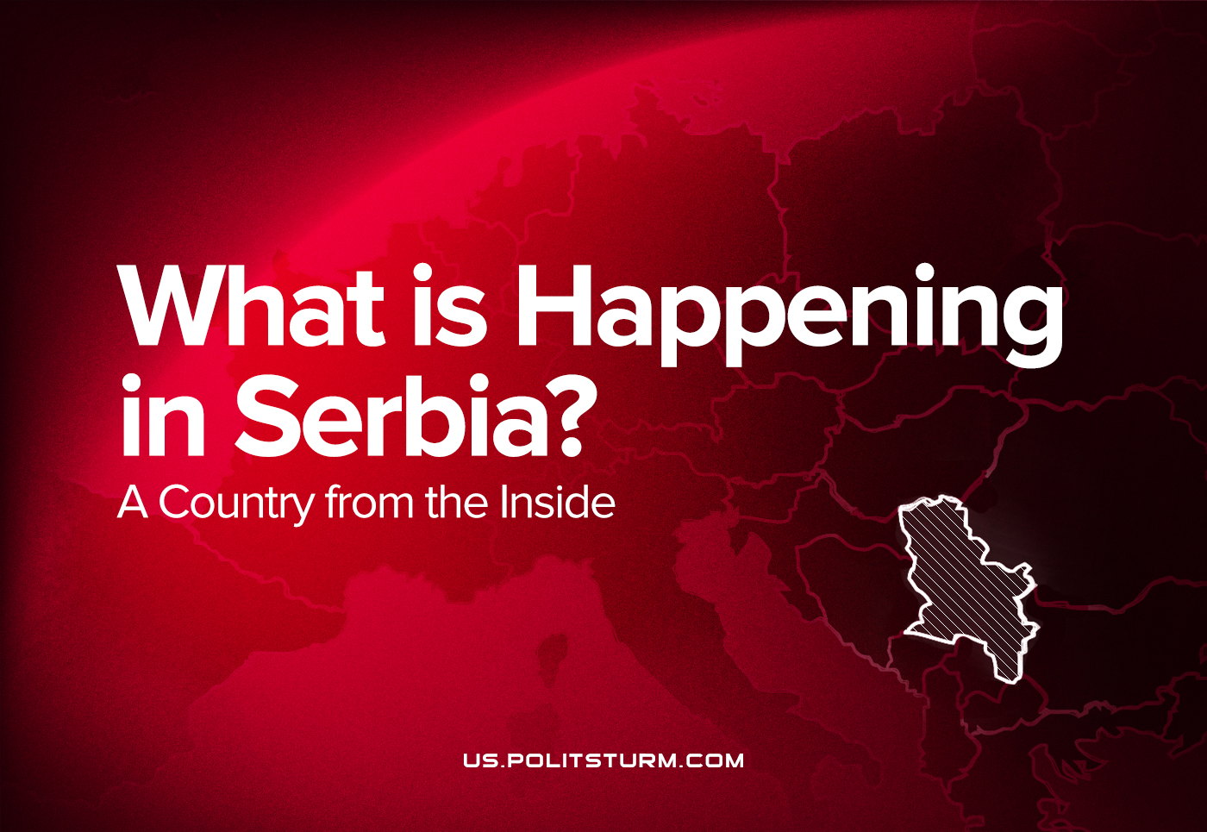

Original article
2022-07-27
9 min read

Our comrade from Serbia wrote an article briefly explaining the current situation in the country.
Serbia is a country, in some ways, a consistent follower of the path of the SFRY. After the break with the Soviet Union, the Yugoslav government tried to play on the contradictions between socialist and capitalist countries. Serbian capitalism is trying to follow a similar path. This article will briefly present the main social and economic characteristics of modern Serbia.
The main concern of the Serbian bourgeoisie at the moment is accession to the EU. This is due to its objective economic weakness in comparison with other capitalist associations. In the era of imperialism, when there are no free markets anymore, the possibility of selling products and making a profit opens only with membership in one of the imperialist cartels, and it must join one of them.
Geographical location and economic predisposition objectively allow membership only in the European imperialist alliance – the European Union. However, here comes into play the fact that, due to inter–imperialist contradictions, Serbia’s key ally in solving the “main national problem” – Albanian separatism in Kosovo and Metohija – is the Russian Federation, and this puts the Serbian bourgeoisie in a special position. This problem is in fact the main obstacle to Serbia’s accession to the EU, although both sides try not to focus attention on it, so as not to destabilize the situation.
Western imperialism has gained enough benefits in the Balkans thanks to the conflict between Serbian and Albanian capitalists. The Kosovo separatist bourgeoisie is an obedient ally of Western imperialism; Kosovo itself is full of military formations, and there is also a large NATO military base Bondsteel.
Error loading image
The economic conditions for Serbia’s accession to the EU have already been met. Serbia has become a market for foreign goods, and cheap Serbian labour makes it possible to transfer the production of large monopolies there. In fact, this is all that the EU would be interested in if a national conflict had not unfolded here in the nineties. Everything else is a pure bureaucratic formality, except for the recognition of Kosovo’s independence.
However, Serbia’s purchasing power and the amount of cheap labour it can provide cannot fully compensate for the benefits that European imperialists receive from the existence of the Kosovo crisis.
These circumstances put the Serbian bourgeoisie in a twofold position. On the one hand, it needs to join the European Union. On the other hand, the Western imperialism, which has achieved great results in Kosovo and Metohija and does not want to let them go, rejects the Serbian bourgeoisie, because it asks to do what the Serbian government can hardly consciously do – to give up a significant part of its territory.

The future of the Kosovo issue
The question of the independence of Kosovo and Metohija is persistently planted in the media space as the main political issue. Regardless of whether liberals or nationalists are in power, the Serbian government understands its position and is fighting to get as many benefits as possible, while the Albanian nationalists under the auspices of the United States confidently refuse to make any concessions, and even support the current agreements.
So, in the clash of interests and aspirations of the two sides, Serbian is doomed to actually lose its position with every step. The latest example illustrating this state of affairs is the agreement on the Association of Serbian Communities, the implementation of which the Albanian authorities defiantly refuse. According to the agreement, it was supposed to create a self-governing community of municipalities with a Serbian majority of the population in Kosovo and Metohija. The association proposal came as a result of the Brussels Agreement of 2013, which was agreed upon and concluded by the Governments of Kosovo and Serbia. In accordance with the powers granted by the European Charter on Local Self-Government and the legislation of Kosovo, participating municipalities will have the right to cooperate in the collective exercise of their powers through the community. The community had to have a complete overview of the areas of economic development, education, health, urban and rural planning.
It was expected that the Community would be officially established within the legal framework of Kosovo in 2015, but it was postponed indefinitely due to conflicts over the scope of powers. It was a tactical attempt by Serbia to create in Kosovo something similar to the Republika Srpska in Bosnia.
The future of Kosovo and Metohija is inevitably linked to the question of the position of the largest imperialists, and any further solution to this issue will depend solely on the relations between the United States, the EU, and Russia, which, obviously, will become even more complicated.

The impact of national problems on socio-political life
The plans of the Western imperialists to destroy Yugoslavia were not difficult to implement due to the situation created by the leadership of the LCY to solve the national question. The famous ”SASA Memorandum” (Memorandum of 16 members of the Serbian Academy of Sciences and Arts) from 1986 defended nationalist views on relations between the Yugoslav peoples. The memorandum was condemned as containing “the blackest nationalism” even by Slobodan Milosevic, the leader of Yugoslavia in the 90s.
Unfortunately, nationalism already at that time began to prevail among the Serbian people. Defeats in the wars of the 1990s and complete impotence in the struggle for the preservation of Kosovo within its territory led to the emergence of the “Weimar syndrome”. Such circumstances are ideal for the revival of national and religious prejudices, which in the future lead to an extreme strengthening of nationalism.
“The ideas of the ruling class are in every epoch the ruling ideas, i.e. the class which is the ruling material force of society, is at the same time its ruling intellectual force.” – K. Marx, German Ideology
Naturally, in such a society and among various leftists, “anti-capitalists”, socialists, etc., social chauvinism prevails. If we add to this the terrible theoretical training of personnel who do not realize the danger of social chauvinism and defend such ideas, it becomes clear in what a difficult situation this movement is in. The leftists are not interested in the theory and practice of the struggle of the proletariat, proven throughout history, and they declare any attempt to study and apply it as “dogmatism” and “sectarianism”.
The desire to somehow prove itself in the world as a consequence of the “Weimar syndrome”, taking into account the weakness of Serbian society in all other respects, led to the fact that professional sports came to the forefront of public life. An extremely large percentage of Serbian children dream of sporting success, and their passion for sports is almost at the level of religion. An example is the country’s attention to sports and Novak Djokovic’s personal life at the level of a reality show.

The working class
The size of the Serbian working class does not give it too significant a role in the international division of labour. The fate of the Serbian working class is a typical example from Eastern Europe. With certain concessions in the labour market and in labour legislation, Serbia manages to attract foreign investment and play its role in reducing the price of labour at the international level.
Because of this situation, more and more companies are moving their factories to Serbia. According to Serbian President Aleksandar Vucic, 180 factories were imported to Serbia from 2014 to 2019. Nestle is opening a large factory with an investment of 67 million Swiss francs. From March 7 to March 14 of this year, 7 new factories were opened or construction began, including: the Turkish company Erenli, the German company Bizerba, the Hungarian feed mill UBM, the Turkish company Teklas.
German Kontinental is also building a huge factory. The number of workers in German companies has increased from 17 thousand to 75 thousand workers over the previous 5 years. The Chinese company Zijin, which privatized the metallurgical factory in Smederevo, is one of the largest exporters from Serbia. The Chinese company Linglong is building a giant tire manufacturing factory in Zrenyanin. From 2011 to 2020, the inflow of foreign direct investment amounted to 24.7 billion euros.
Strikes on working conditions are rare, and spontaneity and apoliticality prevail in them. Many leftists, due to the aforementioned poor theoretical training, fall into economism. There are two main groups in the trade union movement, representing pro-state opportunism and liberalism. The most prominent representative of the first group is the “Independent Trade Union”, which is also the dominant trade union in Serbia, organizing once a year, on the first of May, a rally at which phrases about the importance of the working man are heard from the pulpit. In fact, the same thing, only with a slightly more liberal rhetoric, is promoted by the United Branch Trade Unions “Independence”. Liberal unions are actively involved in politics, although they are extremely small: this is the Sloga trade union and, interestingly, the military and police unions.

Conclusion
Serbia today is an example of a typical Eastern European country. A special feature is the forced situation of the Serbian bourgeoisie. The economy based on foreign investments has had some success. Unemployment has decreased significantly over the past 10 years. Rural producers often suffer from events on the international market, which are regularly followed by their protests, after which the state intervenes in their favour to the extent that it can do so.
Most people see corruption and inconsistent application of laws under the slogan “we have good laws, but they are not applied” as the main problem. The process of raising the level of public consciousness is as difficult as possible in the current conditions. Correcting this situation is a huge task, the implementation of which has not yet begun to a large extent.

Original article

