What is Happening in Myanmar?
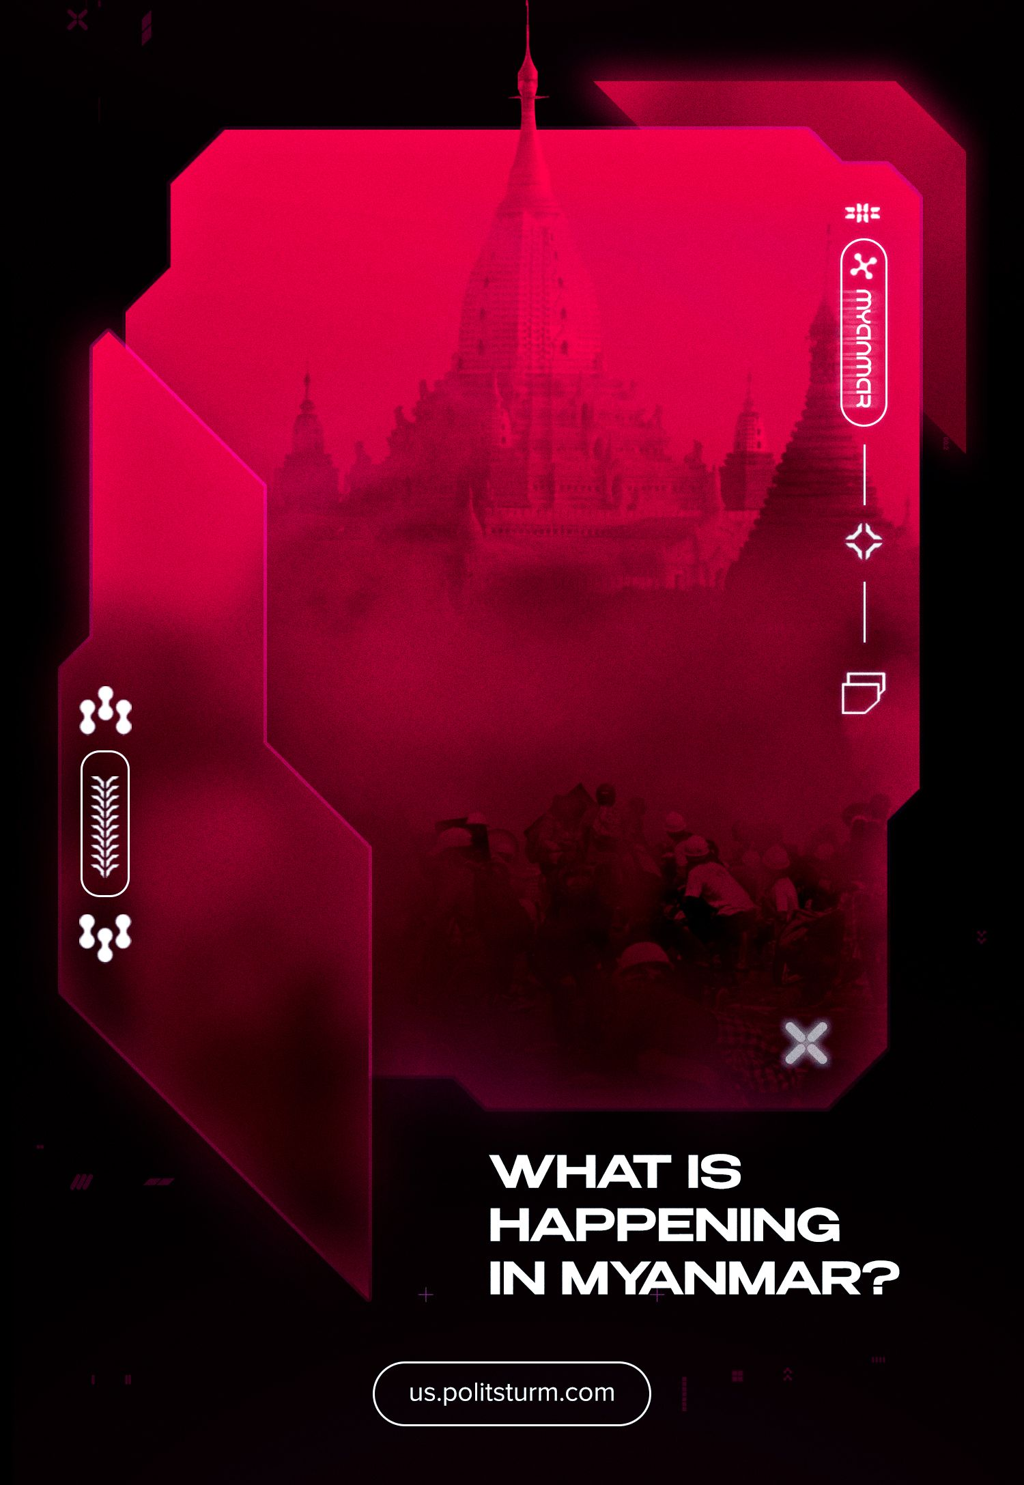

Original article
2024-03-14
68 min read

Myanmar, formerly known as Burma until 1989, is a Southeast Asian country with a population of 60 million. Since 2021, Myanmar has been embroiled in a brutal civil war between the military, which had seized power in the country, and the opposition. This conflict has been exacerbated by other national conflicts and the intervention of other states.
Our new material explores what is happening in Myanmar, the causes of the conflict, and the interests pursued by major imperialist powers in the region.

I. Background of the conflict

1. National liberation movement before the Second World War
In order to understand the current situation in Myanmar, it is essential to provide a historical context and show the emergence and development of the main political forces in the country.
Myanmar was formerly known as Burma. It had been a British colony since the early 19th century. Following the First World War, a national liberation movement started to take shape.
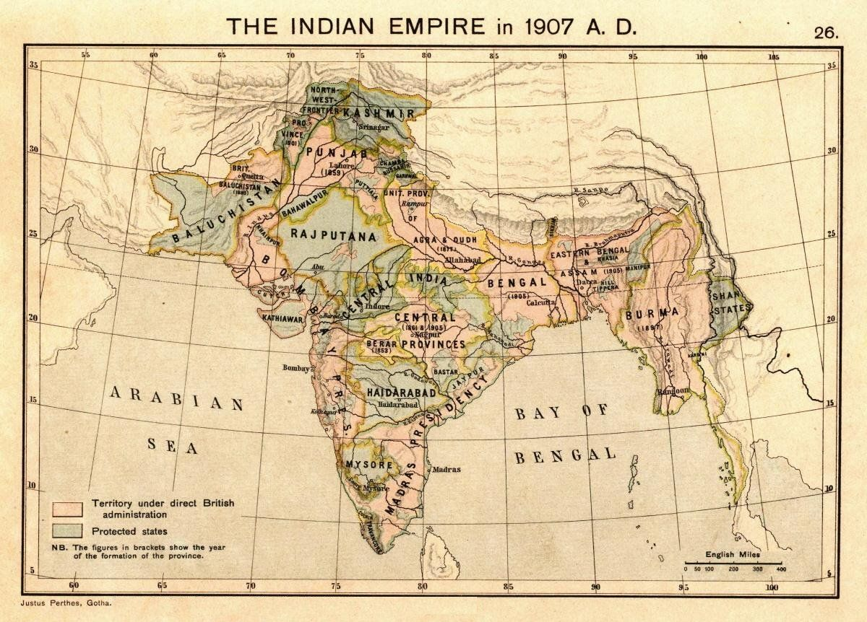
In the early 1930s, a peasant uprising led by Saya San broke out and was crushed by the British. After the rebellion was defeated, the nationalist Dobama Asiayone (Dóbăma Ăsì-Ăyòun, meaning We Burmans Association, DAA), also known as the Thakhins, took over. The word "Thakin" ("Lord") was traditionally used when addressing the British colonizers. This emphasized the nationalists' desire to make Burmese masters of their own country. However, they were not a single party: the association included followers of Sun Yat-sen's ideology, social democrats, Marxists, and fascist admirers.
Analyses of the reasons for the Saya San Rebellion's defeat came to different conclusions. Some Burmese saw it as a lack of weapons and the need to seek help from abroad. Others blamed the lack of an ideological base.
Throughout the 1930s, socialist literature was disseminated, and book publishers, shops, and libraries were opened. Students and intellectuals read and translated into Burmese the works of the classics of Marxism-Leninism, as well as those of the British Fabian social democrats while discussing the biographies of Hitler and Mussolini and studying the experience of revolutions in Ireland and Turkey.
Burmese nationalism took peculiar forms and incorporated elements of various political doctrines. However, the ideological basis of the national liberation movement was socialism and anti-imperialism. Almost all agreed that future Burma should be independent and socialist, but they had no unified answer to the question of "how to raise the people to fight against British rule and where to get the means and weapons to do so".
In the second half of the 1930s, the Takins were joined by the All Burma Students' Union under the leadership of Aung San, a future leader of the independence struggle. Under his influence, as well as under the impression of the political processes in neighboring India, which was also fighting against Britain, the Takins became radicalized. They turned to political strikes, tax refusal campaigns, peasant "hunger marches'' and the organization of guerrilla movements.
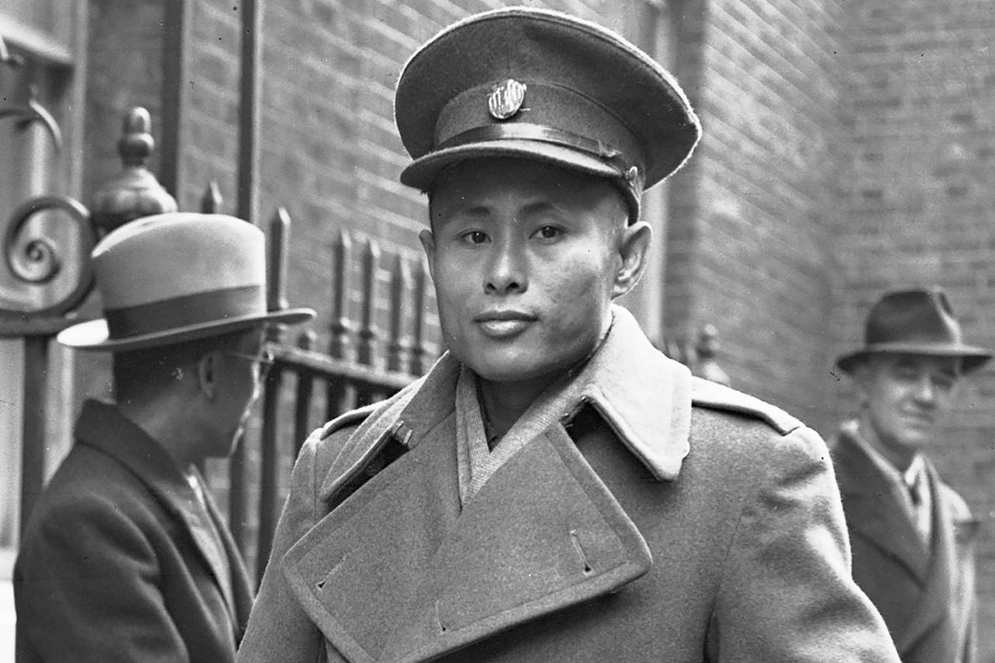
After a series of strikes organized by Aung San between 1938 and 1939, the British arrested many of the movement's leaders. The repression of the national liberation movement increased hatred of the colonizers. Just as in the case of the Sai San rebellion, the defeat of the strike movement was seen in the lack of an ideological base and guerrilla struggle.
To solve the first problem, on 15 August 1939 in the city of Rangoon, five Thakins, including Aung San, Thakin Soe, and Ba Tin, known as Goshal (a Bengali born in Burma who had links with the Bengali branch of the Communist Party of India) founded the Communist Party of Burma (CPB).

However, the organization was not actually a party: it had neither a mass base nor any links with the international communist movement and was just a small group of left-wing Thakins with a passion for Marxism. The British soon arrested most of the CPB leaders, including its future leaders Thakin Soe and Thakin Than Tun, so for the first two years of its existence the party had little activity.
Nevertheless, the communist leaders continued their theoretical work in prison. Thakin Soe wrote several materials justifying the need to support the anti-Fascist coalition and a temporary alliance with the British to fight the Japanese: if the fascists won, life would be even worse.
A few months later, in early 1940, the more right-wing Thakin Socialists set up an illegal People's Revolutionary Party with the aim of armed struggle against the British. The leadership also included communists Aung San and Hla Pe. At first, the PPR hoped to receive support from the Soviet Union or the Chinese Communists.
However, Japanese intelligence soon became active in the region: after the outbreak of the Sino-Japanese War, Britain began to supply aid to the Kuomintang (also referred to as the Guomindang) via the Burma Road. Japanese militarists, wishing to weaken the supplies, began to establish contacts with anti-British forces in Burma, seeking to portray Japan as the liberator of Asia from imperialist oppression.
After the outbreak of World War II, a pro-Burma independence “Freedom Bloc” was formed with the participation of the Thakins. But in May 1940, the British imposed martial law. The colonial government arrested most of the Thakin leaders, as well as leaders of the labor and peasant movements. This reinforced pro-Japanese sentiment among the movement's leaders.
Aung San and a number of Thakin leaders escaped arrest because they were in India at the time. On their return to Burma, they were forced to flee to China in the hope of establishing contacts there. After Aung San’s fruitless search in Hong Kong, he was noticed by the Japanese intelligence and agreed to fight alongside the Japanese against the British in exchange for help in building a national army and immediate independence for Burma.
In February 1941, he secretly returned home and informed the underground leaders of the People's Revolutionary Party of his agreement. After receiving a favorable response from most of the leaders, who put Burma's freedom first, he headed back to Japan at the head of a group of "thirty comrades" intended to form the basis of a future Burmese army. Later, one of the leaders of the movement, the right-wing socialist U Ba Swe, explained the appeal to Japan by the fact that the British colonial regime differed little from the fascist one:
«...We decided that to fight British imperialism, which was already firmly entrenched in Burma, we would accept help from Japan, and then, if the fascist Japanese replaced British oppression with Japanese oppression, we would fight them before they could secure their rule».
The Communists were against this decision, but most of their leaders were in prison and could not exert serious influence.
In 1941 and 1942, the People's Revolutionary Party (PRP) published two manifestos signed in the name of the Communist Party of Burma (CPB). These put forward the idea of armed struggle against the British and the Japanese if they did not fulfill their promise to grant Burma independence, denounced the weakness of the British administration, and put forward the slogan of support for the anti-colonial and anti-capitalist revolution of the workers and peasants.

2. Japanese occupation and the rise of communists
Following Britain's declaration of war in December 1941, Japanese troops began their invasion of Burma through Thailand. Britain was unable to organize either the defense of the country or the evacuation. With no roads between Burma and India, tens of thousands of refugees died in the jungles and mountains trying to escape the Japanese invasion.
Along with the Japanese, a few units of the “Burma Independence Army” (BIA) led by Aung San and his "Thirty Comrades" entered the country. Within months, the experienced troops of the Japanese 15th Army had taken over much of the country.
As the Japanese advanced, more and more people joined the BIA, but soon after the British fled the country, it became clear that Japan was in no hurry to fulfill its promises. On the contrary: the Japanese sought by all means to limit the influence of the independence fighters and established their own occupation regime. The Burmese administration was deliberative, and the new Burma Defence Army under Aung San included what seemed to the Japanese to be the most loyal elements.
Communists under the leadership of Thakin Soe characterized the PRP and the BIA as a fifth column of the Japanese. Indeed, despite creating its own Burmese army - something the British would never have agreed to - Japan established its own, equally brutal, occupation regime. It was obvious that Japanese militarism had become the main enemy.
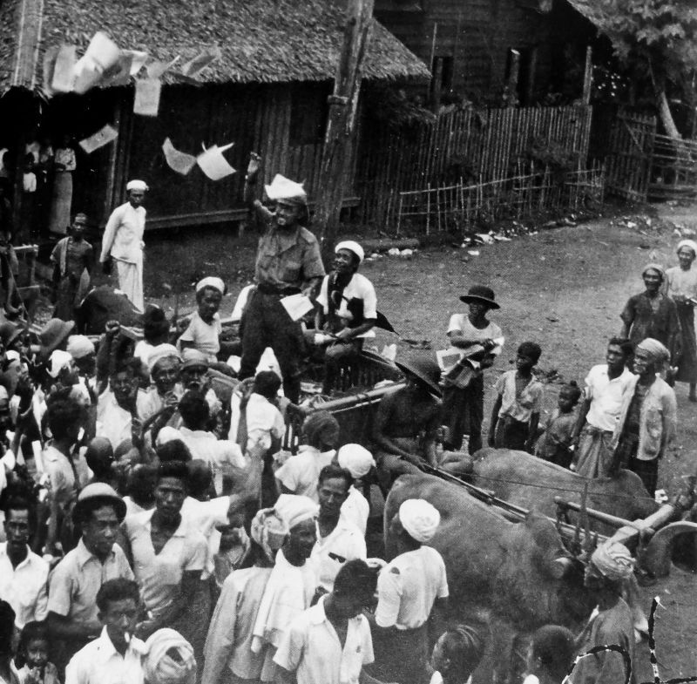
After seeing the true intentions of the Japanese, Aung San also came to the conclusion that an anti-Japanese struggle was necessary. However, he felt it was necessary to wait for the right moment to revolt. He was supported by young officers and left-wing patriots, including the communist Thakin Tan Tun. Their supporters legitimised themselves and joined the resistance movement in one group or another.
Thakin Tan Tun even managed to take up the post of Minister of Agriculture in the helpless government. The PRP leadership forced him to keep his post in order to divert the attention of Japanese intelligence. They began to prepare the army for an anti-Japanese uprising.
The other part of the communists and the leftist Thakin took anti-Japanese positions from the beginning. The British colonialists kept them in jail until the last moment. After being released from Mandalay City prison before the Japanese arrived, the communists and PRP representatives held a meeting on April 30, 1942, where both sides agreed on the need to establish contacts with the anti-Fascist coalition and to prepare the anti-Japanese resistance for an uprising at the right time.
During the Japanese occupation, Thakin Soe became the head of the CPB. Before the war, he had worked as an oilman. Thakin Soe read a lot of Marxist-Leninist literature in a bookshop where he used to "look" at books because he could not buy them. With his ability to recite entire works from memory, he gave lectures on Marxism even in prison.
Between 1942 and 1943 he developed illegal work under the occupation and transformed the CPB from a small circle into a full-fledged political force. The first anti-Japanese guerrilla units were organized under the leadership of Thakin Soe. Another group of communists, led by Thakin Thein Pe, managed to go to India and establish links with the British, who agreed to ally with them against the Japanese.
Also in late 1942, a parallel CPB emerged under the leadership of Thakin Kyaw Sein, one of the "Thirty comrades" who had become disillusioned with the Japanese "liberators". This organization set up underground cells and launched anti-fascist agitation. Soon, however, an attempt was made on the life of its leader. He was arrested in hospital by Japanese counter-intelligence. The information they received and the arrests that followed put an end to the organization's activities.
Due to the diversion of forces to the war in the Pacific and the general turn of the war towards the countries of the anti-Fascist coalition, the Japanese were eventually forced to declare a formally independent state in Burma, albeit a puppet one. The government was given more autonomy and the small Burma Defence Army was incorporated into a much larger national army.
This had a huge psychological impact on the population, and the flight of many of the landlords, moneylenders, and industrialists of the British era made it impossible for the country to return to its pre-war colonial status.
Under these conditions, the struggle against the Japanese occupation regime unfolded under the leadership of the Communists. The successes in this struggle, as well as the victories of the Soviet Union in the struggle against Nazi Germany, made the small Communist Party of Burma one of the leading forces of resistance.
It is important to note that throughout this period, the Communists were the only organized force on the ground. The People's Revolutionary Party was a clandestine organization modeled on Ireland's Sinn Féin, with no specific ideology, although many propaganda workers were influenced by the Communists and later joined the CPB. The resistance in the army was similar. The main goal of all the resistance forces was freedom and independence for Burma, and ideological differences were put aside for this.
The uprising, originally planned by the resistance and the Burma National Army (BNA) for the end of 1943, was repeatedly postponed for various reasons. At the same time, the guerrilla activities of the anti-Japanese forces continued. Under the control of the CPB, there were about 30,000 guerrillas who contributed to 2/3 of the Japanese invaders’ total losses.
As a result of the negotiations, a united front of all resistance forces, the Anti-Fascist Organisation (AFO), was established in August 1944. On 3 November 1944, the Communists issued a statement on the final formation of a united front, the "vanguard of the revolution", between the CPB and the PPR.
The parties spoke under the common slogan "freedom, democracy, socialism", recognized the fallacy of hopes for independence at the hands of the Japanese, and warned against excessive hopes for the British, who wanted to destroy the USSR at the hands of Germany and Japan and thus eliminate the gains of socialism. The statement emphasized the necessity of the anti-Japanese struggle and preparations to develop into a struggle against British imperialism after the liberation of the country.
In early March 1945, the AFO was renamed to The Anti-Fascist People's Freedom League (AFPFL). The 29-year-old Minister of Defence, General Aung San, was elected chairman, and one of the CPB leaders, Thakin Tan Tun, was elected general secretary.

The AFPFL Central Military Council was formed. Aung San was chosen as military leader, Thakin Soe was given the post of political leader, and Thakin Tan Tun became in charge of guerrilla and foreign affairs. This demonstrated who had real power and credibility: four leaders of the PRP, including Officer Ne Win, also became members of the Council but were not given specific positions.
At the turn of 1944-1945, the guerrillas gave considerable support to British troops. At the end of March 1945, the AFPFL leadership went underground and the uprising finally began. The country was liberated as quickly as it had been occupied, but this time it was done by real liberators in the form of the anti-fascists. In August 1945, the last Japanese units left Burma.
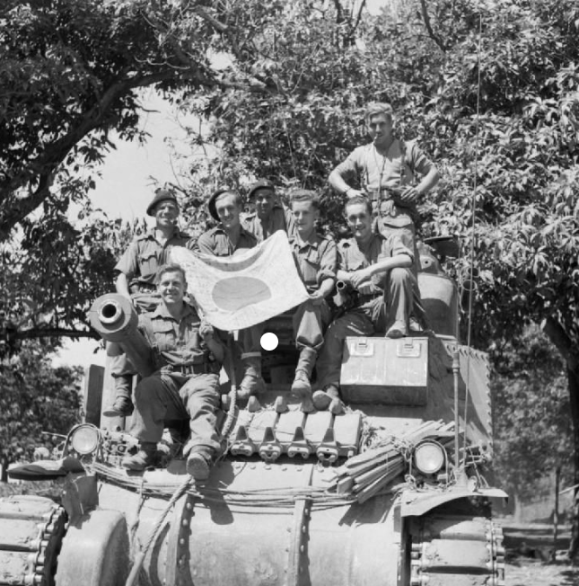

3. The struggle for independence
British attempts to restore the pre-war regime immediately after liberation failed due to the presence of a large and well-equipped Burmese army, subordinate to the AFPFL.
A political struggle began between the League and British troops. For example, having submitted to the decision to disband its troops, incorporate part of them into the colonial army, and surrender their weapons, the League immediately created the People's Volunteer Organization (PVO), which included all formally demobilized soldiers. The AFPFL refused to join the Executive Council - the new government under the British governor - after refusing to include some of the League's candidates.
At the beginning of 1946, the first congress of the AFPFL was held, and most of the delegates were communists. Key positions in the League by that time were occupied by the Communist Party and the former People's Revolutionary Party, renamed the Socialist Party. At the same time, the problems of the League as a broad union of various organizations were revealed. Difficulties in the fight against the British and the crumbling illusions of a quick and easy conquest of independence after the victory of the uprising led to fluctuations on the right and left flanks. The right began to leave the League in order to cooperate with the British.
Issues in the Communist Party also played a role. Despite their leading position in the resistance movement and the League, the communists faced a number of problems.
First of all, these were the specific conditions in which the PBC had to work in the first years of its existence. The difficult situation of British repression and Japanese occupation, unpreparedness for a sharp change in conditions and tactics of work, the absence of a core of the industrial proletariat, theoretically savvy personnel, as well as strong ties with the international communist movement led to grave consequences for the CPB and threatened to undermine its position in the popular front.
At the second meeting of the AFPFL Supreme Council in May 1945, Thakin Than Tun presented the theory of "peaceful development", which was an adaptation of the ideas of the American right-wing revisionist Earl Browder, the head of the CPUSA at that time. Browder believed that American capitalism after the war would become “enlightened”, stop supporting anti-communists, and begin helping all developing countries and colonies. He portrayed the post-war world as a community of peace-loving nations helping each other. Thakin Than Tun learned about it from Thakin Thein Pe, who in turn learned about it from the Indian communist Joshi during his work in British India; The CPI published Browder's works and agreed with them.
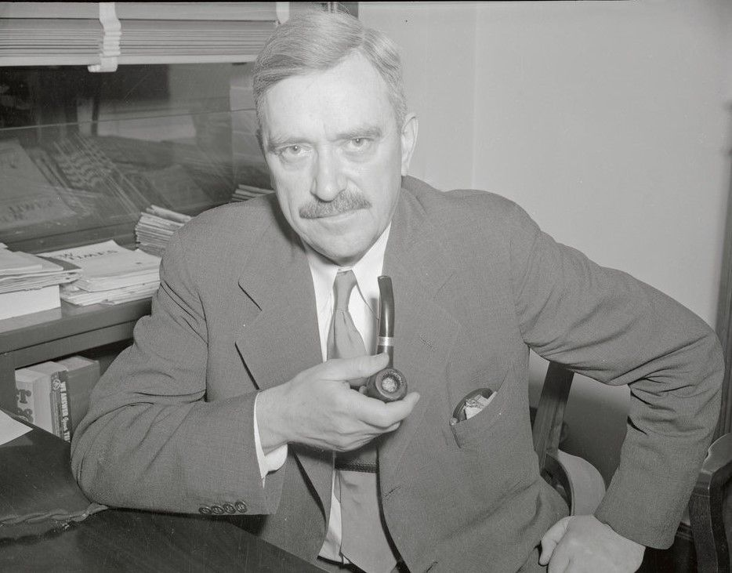
In this regard, the CPB proposed to lay down arms and stop providing armed resistance to the British. The People's Revolutionary Party opposed disarmament. Aung San was able to reach a compromise: the struggle for independence would proceed peacefully, but if it failed, an uprising would begin.
At that time, the Communists had much more influence in the League than the PRP. Under the united front agreement, both sides pledged not to create an official party until independence was achieved, but to continue to work within the framework of the AFPFL. If such a party were to be created, then it would have to include both sides.
However, at the II Congress of the CPB, held in Rangoon on July 20–21, 1945, the tactics of Browderism were adopted. More than 120 delegates from all over the country were present, representing 6 thousand party members, not counting mass organizations affiliated with the CPB. Thakin Than Tun was elected Chairman of the Politburo of the Central Committee. Thakin Thein Pe became the General Secretary. After the congress, the CPB unilaterally tore up the agreement on a united front.
Aung San continued to take a position of compromise. He was ready to prevent a split and agreed to the formation of one party under the control of the communists. A number of left-wing leaders of the PRP adhered to the same position.
On August 7, 1945, the Central Committee of the CPB issued a statement in which they agreed to accept members of the PRP on an individual basis and called for not changing the League's program documents in case of refusal to accept them into the ranks of the Communist Party. Information about further negotiations is contradictory, but from the available data it follows that Thakin So wrote a letter to Aung San about the impossibility of maintaining a united party, expelled him from the Central Committee, gave evasive answers, stated the impossibility of a group joining the party due to problems in the united front and the impossibility of admitting a number of officers to the CPB because of their “militaristic inclinations.”
As a result, after the legalization of the CPB, the People's Revolutionary Party also began the process of creating a legal party, which was called the Burma Socialist Party.
Some communists considered the actions of the AFPFL to be slow and condemned the League as a bourgeois organization. They were headed by the former general secretary of the CPB, Thakin Soe, who was removed from his post at the Second Party Congress in July 1945. At the expanded plenum of the CPB in February-March 1946, Thakin Soe delivered a memorandum accusing the new party leaders of passivity. The latter made counter-accusations.
The leftist group declared itself the "Red Flag Communist Party" in opposition to the original CP of Burma, which adopted a new party flag in 1946, white with red stars. The British outlawed the Red Flag Party, after which it went underground and began guerrilla warfare.
These actions of the schismatics complicated the already difficult situation in the country and made it difficult for the communists to cooperate within the AFPFL. Meanwhile, the situation was heating up: in the city, residents were struggling to make ends meet, while old landowners came to the village, demanding the return of their lands. The British were preparing plans to arrest the leaders of the AFPFL. The persecution of “people's volunteers” and the shooting of an anti-colonial demonstration aggravated the situation.
Ultimately, the British government, which at that time consisted of a Labor Party majority, was forced to come to an agreement with the League. After the outbreak of the general strike, a new governor was appointed to Burma, who invited the League to enter the Executive Council (the government under the governor) as a majority, after which elections to the Constituent Assembly were called. AFPFL also received a majority on the council. Thakin Thein Pe became minister of forestry and agriculture in Aung San's pre-independence government, the highest position ever held by a communist in the British colonial empire.
“The Red Flag'' declared the agreement a surrender to the British. At the same time, Thakin Tan Tun argued that the concept of open war against the British was politically incorrect and unrealistic. Appealing to the Allied conferences in Tehran, Yalta, and Potsdam, as well as the activities of the UN, Thakin argued that armed struggle was not necessary.
At the same time, contradictions between the communists remaining in the League and other AFPFL organizations intensified. The reason was the decision of the leadership that League members should not speak on behalf of individual parties. The decision was directed primarily against the Communist Party, which was active in rural areas. This strained relations between the Communist Party and the rest of the leadership, and CPB leader Thakin Tan Tun resigned as secretary general of the AFPFL, although the party itself remained part of the League.
The entry of the AFPFL into the government, the termination of the general strike, and the arrests of its leaders by the British further strained relations with the communists. On October 10, 1946, the League's executive committee expelled the CPB. The party leaders decided not to appeal to the Supreme Council and finally left the League. This action had disastrous consequences for the party: part of the cadres left the CPB to remain in the League, whose authority among the people was enormous, the communists lost the leadership of many broad organizations, and the AFPFL itself shifted to the right.
In the summer of 1947, there seemed to be a rapprochement between Aung San and the communists. Still conciliatory, Aung San continued to advocate socialist transformations and the construction of socialism, which was reflected in the two-year plan program he developed.
After right-wing politicians left the Executive Council, the communists began negotiations with the AFPFL leadership to restore unity. This was demanded by many ordinary members of the League and the Communist Party, as well as grassroots peasant and worker organizations, which were sometimes unclear about the differences in the positions of the League and the CPB.
But on July 19, right-wing radicals led by U Saw, a pro-British politician, shot almost all the leaders of the League with weapons illegally sold to them by British army officers. As a result, Aung San and six members of the Council were killed. U Saw hoped that in the ensuing turmoil, the British would invite him to form a government. His hopes were not justified, but as a result, the government lost a key politician who sympathized with the communists and was known to millions of people in the country.
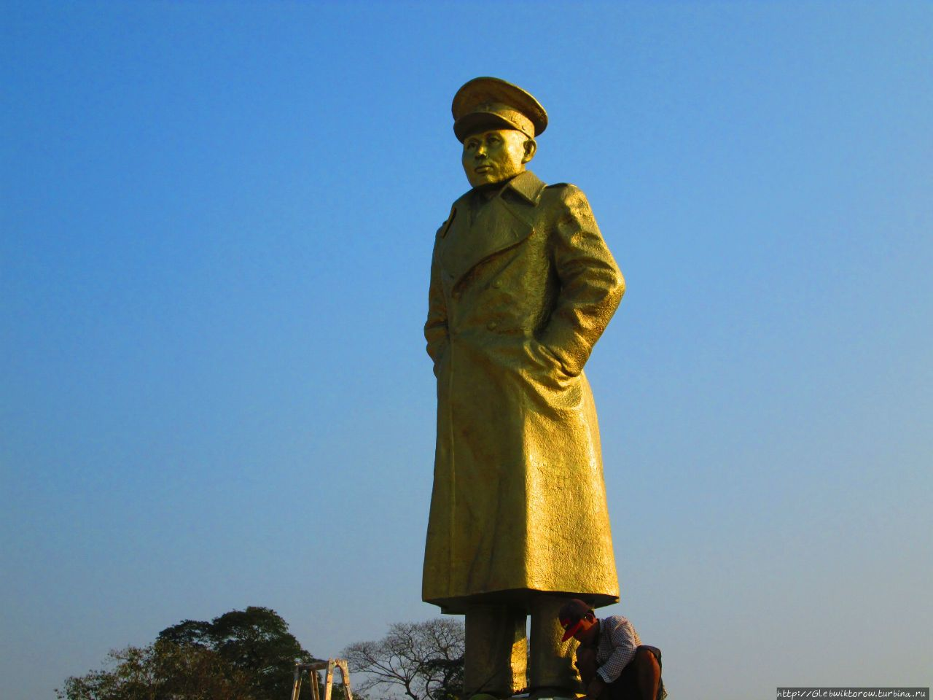

4. The beginning of the civil war
The death of the main leader of the anti-colonial struggle shifted the AFPFL policy even further to the right. Although the communists continued negotiations, it became obvious that the right and moderates were not ready to allow the CPB to strengthen. On September 24, 1947, the constitution of the Union of Burma was adopted. It proclaimed an independent republic uniting all the peoples of the former British Burma. The communists voted for it with reservations. On January 4, 1948, Burma officially gained independence.
Now the contradictions between different forces began to appear more and more clearly. The main political forces in Burma in 1948 were the League and the Communist Party.
The League was based on two factions - the Socialist Party and the People's Volunteer Organization; The League had an overwhelming majority in parliament and locally. The Socialists retained revolutionary phraseology, but in reality, they represented the interests of landowners and the bourgeoisie; many socialist leaders were landowners and capitalists themselves.
In turn, the leader of the CPB, Thakin Tan Tun, was one of the most famous leaders of the national liberation movement, almost second after Aung San. The communists were popular among the peasants and in the trade unions, controlling the All Burma Trade Union Congress and the All Burma Peasants' Union.
In the spring of 1948, a civil war began in the country with a decree on the arrest of communists. However, even before it, the Communist Party of Burma began to turn: from the right deviation and liquidationist sentiments, the leadership of the CPB moved sharply to the left and began to focus on the uprising.
In 1947, representatives of the CPB participated in the conference of the Communists of the British Empire in London. In early 1948, they participated in the second Congress of the Communist Party of India. In India, party representative Ghoshal prepared theses in which he advocated guerrilla warfare, preparation of an armed uprising, and a break with the previous “Browderist” course.
Under the influence of establishing ties with communists in different countries, the successes of the Chinese Communist Party in the war against the Kuomintang, and the uprisings in India and Indochina, the Burmese communists overestimated their strength.
On March 27, 1948, a meeting was held in Rangoon to mark the anniversary of the anti-Japanese uprising, during which the leaders of the CPB addressed workers with calls to fight for power. On the night of March 27, the government issued a decree arresting the party leadership, after which the CPB went underground.
Initially, the Communist Party had an advantage: thousands of peasants joined it, and the Communists enjoyed support among soldiers and “people's volunteers” who went over to the side of the CPB.
The government hastened to offer the Communists a 15-point “Left Unity” program: developing ties with the USSR, nationalizing foreign monopolies, improving the living conditions of workers, refusing foreign aid (if it is accompanied by political obligations), nationalizing lands and distributing them among poor peasants, uniting all democratic forces in the “Marxist League” and propaganda of Marxism. The government also nationalized two foreign companies.
But this plan was rejected by the communists and part of the PVO as lacking specifics. As a result, the people's volunteers split: more than half opposed the government. At the same time, the newly created PVO “White Bandages” did not join the CPB, but began an independent struggle.
Moreover, the program, its rhetoric about Marxism, and the ostentatious nationalization of the two companies attracted the attention of Western imperialists who were already fighting against the communists in China, Malaya, Vietnam, and the Philippine Islands. In an effort to prevent the emergence of communists on the shores of the Indian Ocean, they quickly found a loyal force in the Socialist Party and began to provide military and financial support to the government of Burma.
Finally, the Communists themselves were in no hurry to take offensive action. In May 1948, the Central Committee of the CPB confirmed the course toward the military path of taking power and came up with a Maoist strategy that prioritized guerrilla warfare in rural areas. As a result, the CPB quickly lost the broad support it had gained in the cities, especially in labor organizations, over the previous three years. The communists numbered about 15 thousand guerrillas, united in the People's Liberation Army of Burma. They were joined by two of the "thirty comrades" and Takin Chit, one of the leaders of the PRP.
At the same time, the 1st and 3rd battalions of the Burmese army, numbering 3,000 people, rebelled and declared themselves the “Revolutionary Burma Army”. In 1950, the BPLA (Bamar People's Liberation Army) and the RBA united to form the “People's Army,” led by Thakin Than Tun. At the same time, the Communist Party finally stopped attacking the cities and switched to the Maoist tactic of “surrounding the cities with the countryside.” In the territories captured by the communists, the division of land between peasants began.
In parallel with this, the uprising of the Karen began - one of the national minorities historically hostile towards Burma, on whom the British relied. A number of other nationalities rebelled along with them. Also, after the victory of the Chinese Communists, Kuomintang forces settled in the northeastern regions of Burma and continued to invade Chinese territory.
Thus, several sides clashed in the civil war: the government, the “white flag” communists (CPB), the “red flag” communists, “people’s volunteers” and national minorities.
However, the government held out. This was not least due to disagreements among the rebels. Communists and people's volunteers acted separately. They failed to create a united front and failed to gain the support of national minorities. Moreover, when the Karen launched an attack on the largest port of Rangoon, through which the government received military aid, the PVO threw its forces into the defense of the government.
The government army was small, but well-trained and steadily received support with equipment and equipment from capitalist countries, primarily the United States. The British Labor Party also provided loans and weapons.
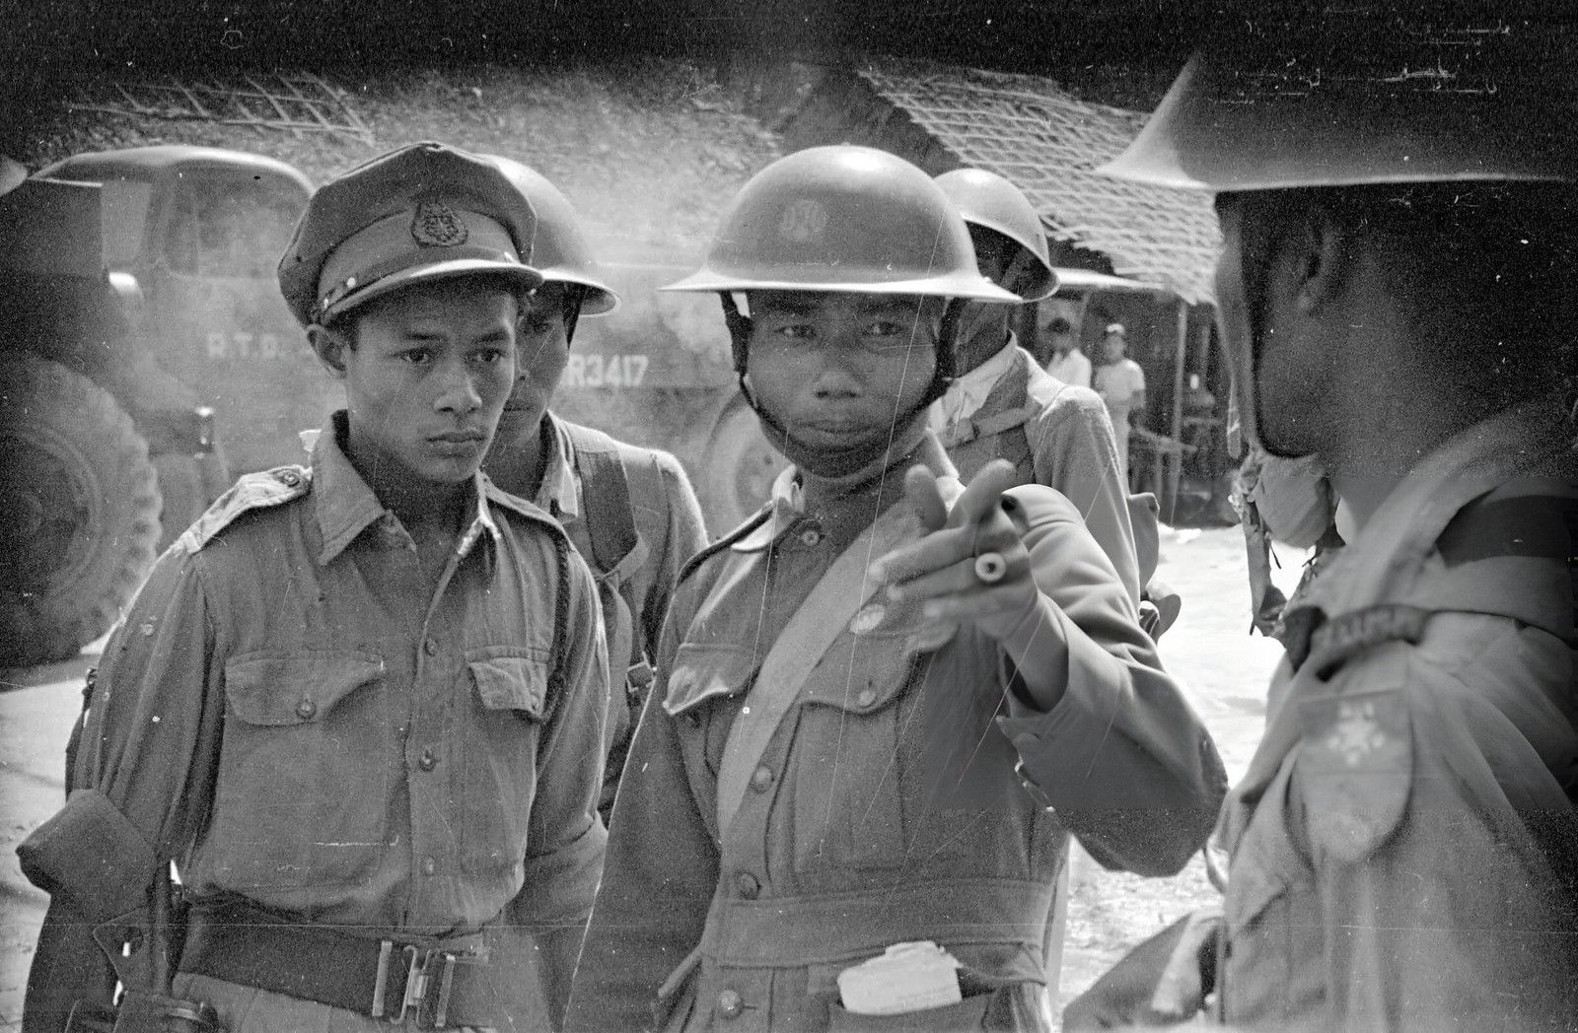
In 1951, the Central Committee of the CPB, seeking to repeat the success of the CPC during World War II, came up with the initiative of the “Government of Peace and Harmony.” The Communists offer the government a truce in order to fight against an external enemy - the Kuomintang soldiers - and, to demonstrate the firmness of their intentions, they begin to return the divided lands to their former owners. These efforts also failed: disillusioned peasants began to leave the People's Army, which had lost almost half of its members, and the government refused to negotiate with the communists.
Ultimately, the government took advantage of the CPB's slowness and lack of consensus among its opponents. By 1955, the AFPFL and forces loyal to it suppressed the volunteer movement, as well as national uprisings, and pushed the communists into remote areas, but the civil war did not stop.
The defeats demoralized many communists and volunteers, and as a result, their forces were reduced. While the communists adhered to guerrilla tactics, new leftist forces emerged in the cities. These were often splits from the Socialist Party and the Anti-Fascist League. The Communist Party of Burma followed a sectarian line against them. Thus, the Burma Workers and Peasants Party was condemned by the communists as “right-wing deviationists” only on the basis that the BWPP was ready to participate in the elections.
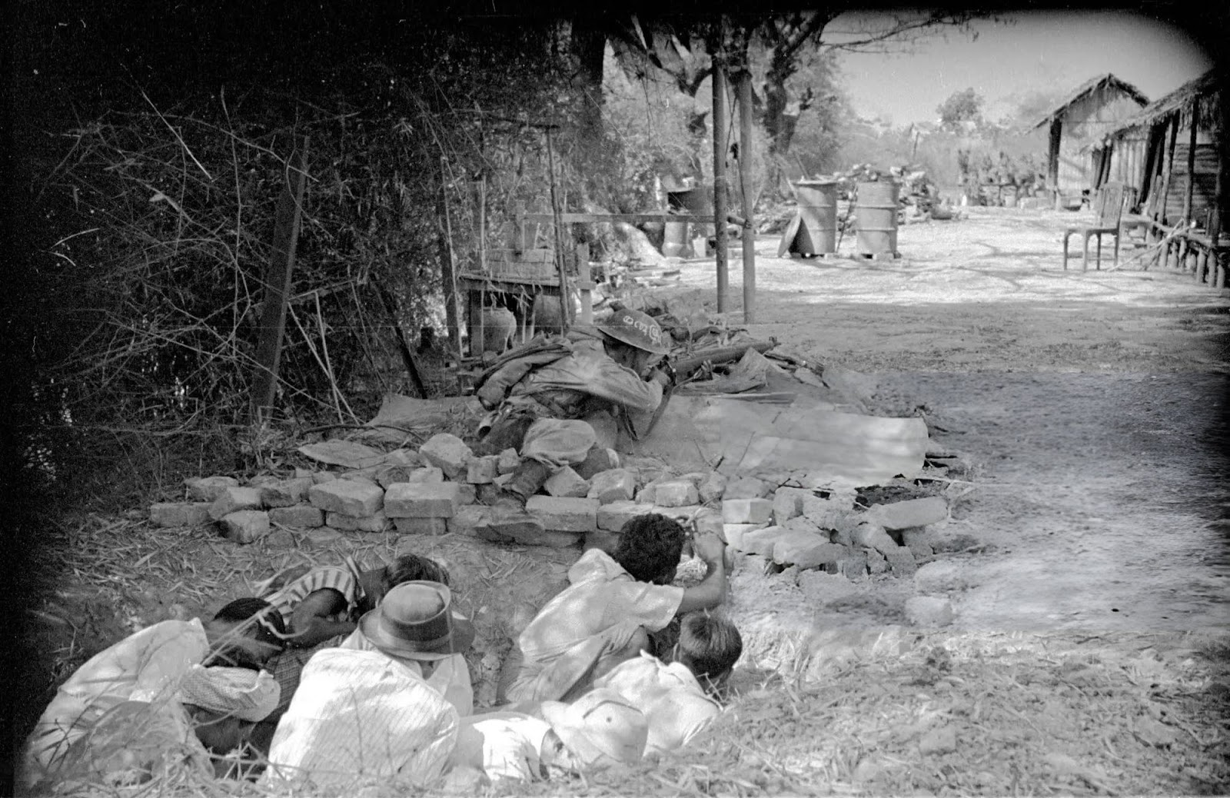
In the next 6 years, the communists will play the role of a bogeyman in domestic politics: the attitude towards them will determine which political force the army officers, who are strongly anti-communist, will support.

5. Military coup and creation of the “Revolutionary Council”
At the turn of the 1950s–1960s the country found itself in a political crisis. The Anti-Fascist League split into “pure” and “stable” groups, could not create a stable government. Using the support of the Kuomintang, hostile feudal lords continued to rebel.
In this situation, on the night of March 2, 1962, the military carried out a coup. All members of the government, leaders of the Union Party (the former “pure” AFPFL), and the leaders of the feudal separatists were arrested. Power in the country passed to the “Revolutionary Council” led by General Ne Win. The new government unexpectedly came up with the “Burma Road to Socialism” program and proclaimed a course towards building a socialist state.
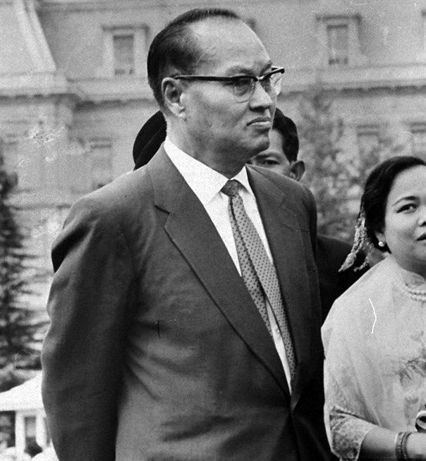
From the outside, it may seem that the struggle of the Burmese communists was still crowned with success. But the same military men who had participated in the fight against the communists in previous years were in power. Why did they declare themselves socialists?
Firstly, Aung San, who became the main leader of the anti-colonial struggle and the creator of the Burmese army, supported socialism. However, his ideas, like Sun Yat-sen’s “Three Principles of the People,” could be interpreted in a very broad sense: both the construction of socialism and the creation of a “socially oriented” bourgeois state. The officers saw the key to the country's salvation in a return to the “covenant” with the leader of the struggle for independence.
Secondly, many officers began their service during the years of the anti-Japanese struggle and fought alongside the communists or under their leadership. When the civil war began, not all of them understood what and against whom they were fighting: both the AFPFL and the CPB declared themselves heirs of Aung San, and both sides formally advocated socialism. The army saw itself as capable of establishing order and uniting all political forces.
Thirdly, the army was portrayed as an example of unity and a “real” fighter for the country, as opposed to corrupt politicians and their parties. The military coup was presented as the long-awaited unification of the country and its deliverance from bourgeois parliamentarianism. Just like the Socialist Party, the use of left-wing rhetoric was necessary for the military to intercept the agenda of the left and, above all, the communists.
History is replete with examples of anti-communist forces borrowing left-wing phrases, rhetoric and names to deceive the masses. Naturally, the ideology of the new government was not communism. The program document of the newly created “Burma Socialist Program Party” (BSPP), was entitled “Philosophy of the BSPP. The system of relationships between man and his environment,” in addition to some progressive aspects, stated a combination of Buddhism and Marxism.
"Burmese socialism" was presented as an alternative to capitalism and socialism. Although there were some progressive reforms (nationalization of enterprises and abolition of rent payments for peasants), socialism was not built in the country and Burma's economy remained weak.
Despite the proposed amnesty, the Communist Party, which by the 60s had taken the position of Maoism, was unable to come to an agreement with the “Revolutionary Council” and continued the partisan struggle. In 1963, despite the lack of a mass base, the CPB again continued to set as its goal an armed seizure of power. This gave rise to objections from a number of leaders who were dissatisfied with the absolute copying of the CPC course. In response, purges were launched as part of the adoption of the experience of the Chinese “Cultural Revolution”. The already small party lost its oldest leaders.
At the end of 1967, the chairman of the CPB, Thakin Than Tun, gave the order for the Communist Party to go on the offensive on all fronts. China provided the Burmese communists with modern weapons and supported their actions with detachments of “people's volunteers” - activists of the Cultural Revolution who wanted to prove themselves.
Despite its initial success, the CPB did not gain widespread support among the rural population. The offensive led to retaliatory military action by the government, to the defeat of the main forces of the communists, their abandonment of many bases, and the death of Thakin Than Tun himself, who was killed in September 1968 by a bodyguard during a retreat under pressure from government troops.
After another defeat and the death of the leaders of the CPB during the fighting in 1975, the remnants of the Maoist Communist Party of Burma retreated to the border with China, where they maintained control over the Kokan territory. After the death of Mao, a right-wing group came to power in the PRC and stopped supporting the CPB. In 1988, China finally stopped supporting the Burmese Maoists, and in 1989 the party, weakened by a series of uprisings, dissolved.
At the end of 1970, failure also befell the Red Flag Party, which had long ceased to play a role in Burmese politics and numbered only a few dozen adherents. In the Pakhouku region, government troops discovered and destroyed the Red Flag headquarters in the jungle, and then, with the help of peasants, staged a wide raid, during which the head of the Red Flag Party, Thakin So, was captured.
The communists of Burma fought a long and stubborn struggle, which, however, ended in their defeat. Why did it happen?
The party's inconsistent policies played a big role. As mentioned earlier, the party was formed in conditions of isolation from the labor movement, as a group of Thakins who were keen on Marxism, as a result of which there were almost no workers in it. It had no connections with the international communist movement. The actions of its leaders were sometimes contradictory and dictated by the interests of the moment, which led to strategic mistakes and miscalculations.
Finding itself in new conditions after the victory of the anti-colonial movement, the party was unable to move on to peaceful work. Tossing from side to side, the CPB made a number of mistakes that led to its isolation, the exclusion of communists from the Anti-Fascist League, which was created and developed with their direct participation, and turning the AFPFL against the CPB.
Ultimately, the party switched to Maoist positions. The leftist deviation, manifested in an almost exclusively focus on military action and the insufficient use of legal means of struggle in key periods, naturally led to a gradual loss of support among the population, the isolation of both the “White Flag” and the “Red Flag” and their extinction.

6. Burma at the present stage
In 1988, the country experienced another military coup and ceased to even call itself socialist.
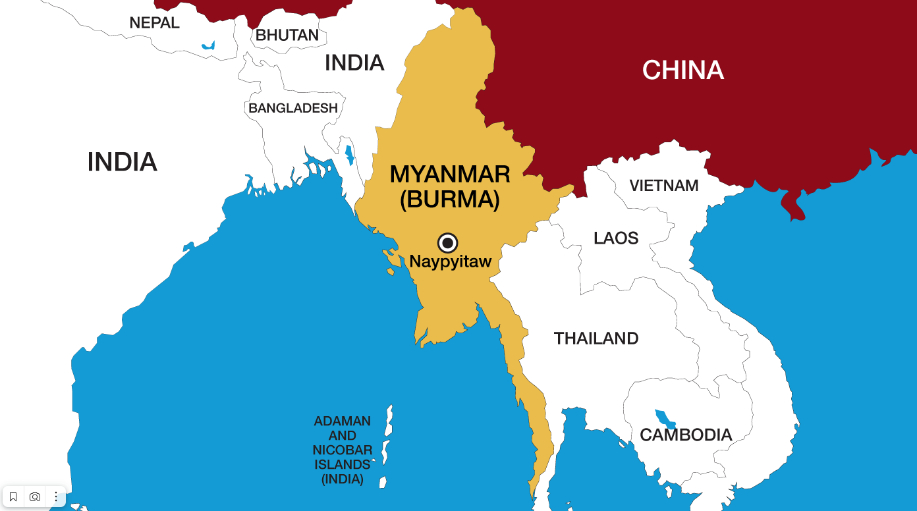
After the 1988 military coup and the abandonment of the one-party system, the military authorities initiated parliamentary elections. However, the military party lost this election. In 1990, the military again staged a coup and seized power.
Since the early 90s, Myanmar has been under sanctions from the United States and the European Union for repression of democratic forces. The pressure of sanctions began to weaken only in the 2010s, after major reforms.
In 2010, parliamentary elections were held. Sanctions were lifted and foreign capital poured into the country. Myanmar's economy began to develop rapidly. The share of industry in the economy has increased. Transport infrastructure was actively built, mainly through foreign investment.
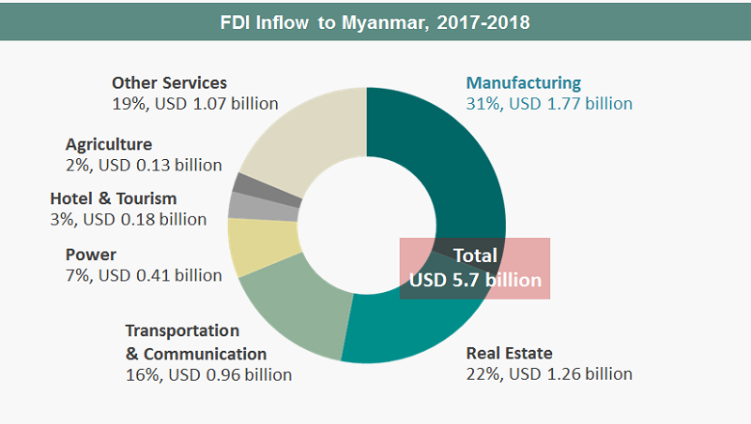
Foreign capital has flocked to Myanmar for several reasons: cheap labor, natural resources, Myanmar's favorable location, and a growing domestic market.
The accelerating urbanization of the population and rising consumption among the population have increased the domestic market of Myanmar and made it a tasty morsel for foreign companies. During this period, the service sector and light industry, including textiles and food, actively developed. Myanmar has become a major producer of clothing and agricultural products in the region.
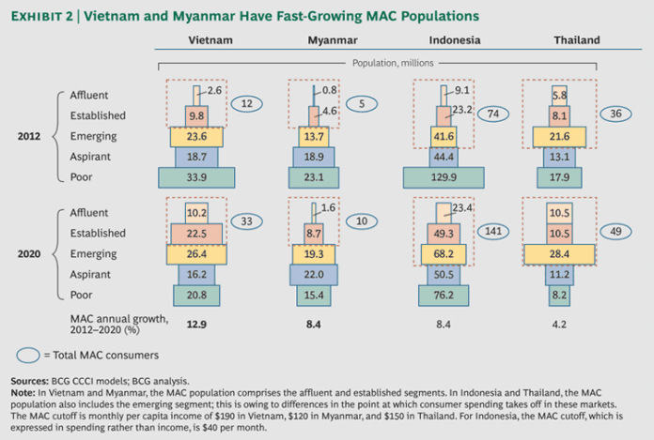
Foreign states have started to actively invest in their projects in Myanmar:
«...the volume of FDI in the Myanmar economy increased from $714.8 million to $7933.1 million over 2007–2016, or 11 times.”
The bulk of foreign direct investment (FDI) was invested in mining and transport infrastructure. For example, in 2017, these sectors accounted for 39 and 33% of all FDI, respectively.
However, capital inflows stopped in 2021 due to newly imposed sanctions. That same year, after losing the parliamentary elections, the military seized power again. The liberal democratic parties refused to submit to the demands of the junta and organized their own bloc, entering into an alliance with national groups. A civil war began in the country.
Why did the military again resort to an armed seizure of power, although a decade earlier they themselves initiated democratic reforms? To answer this question, we need to understand the opposing sides of the conflict.

II. Parties to the conflict

1. Military government
Until 2011, power in the country was entirely in the hands of the military. The military as a political force is known in the country as the Tatmadaw.
After the 1988 coup, the main means of production were concentrated in the hands of the Tatmadaw. Two monopolies were organized: the Union of Myanmar Economic Holding (UMEH) and the Myanmar Economic Corporation (MEC). These monopolies include companies in all sectors of production and services: engineering, natural resource extraction, transport, etc., down to breweries and tourism.
The shares in these companies are owned by the state and by high-ranking military officers. In other words, the Tatmadaws are really a group of capitalists. The only difference from more “traditional” images of capitalists is that they are much more militarized.
Immediately after the 1988 coup, the authorities announced a course of economic liberalization and privatization. The new economic conditions also gave rise to new political movements. A new political force emerged in the form of Aung San Suu Kyi, daughter of national hero Aung San, and her National League for Democracy (NLD) party.
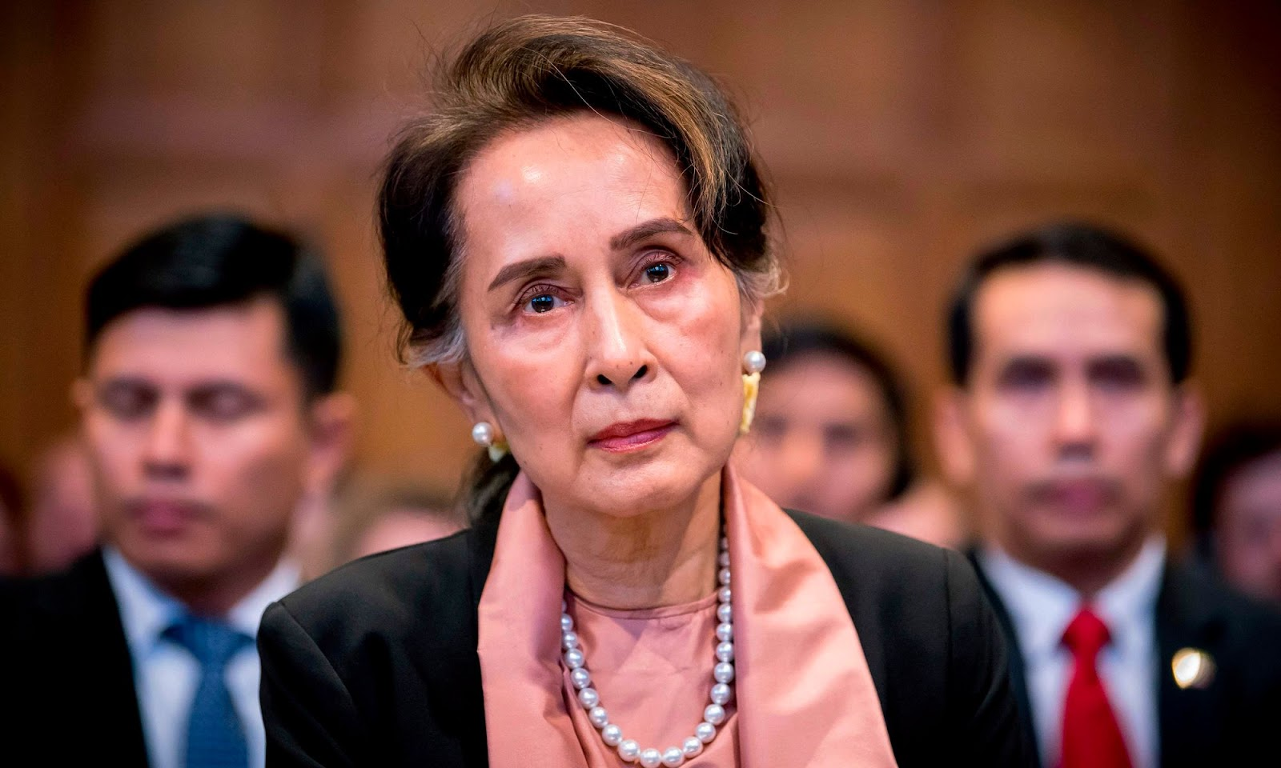
In 1990, elections were held for a constitutional committee to draft a new “democratic” constitution. The NLD party won, taking 392 out of 492 seats. The military did not recognize the results and detained Aung San Suu Kyi and other opposition politicians.
The military junta exercised open dictatorship until 2010 when it again decided to dress up its rule in democratic garb.
Following democratic reforms in the 2010s, the Tatmadaw now represents itself not directly but through the Union Solidarity and Development Party (USDP). Of course, the military did not forget its own interests when implementing the reforms.
The army has reserved 25 per cent of the seats in parliament, and 75 per cent of parliamentarians must vote in favor of amending the constitution. In other words, the military retained a veto over changes to the constitution, which it had drafted in advance in 2008.
When the military barred Aung San Suu Kyi and other leaders of the opposition NLD from standing in the 2010 elections, the NLD withdrew. After the 2010 elections, however, the restrictions on Aung San Suu Kyi were lifted and the NLD contested the 2012 by-elections. During this period, the liberal democratic NLD entered the wider political arena with the support of key Western countries.
In the next election in 2015, the military USDP party lost. The opposition NLD won 886 out of 1,146 (77 per cent) seats in both houses of parliament combined, while the former ruling USDP won only 112 (10 per cent) seats (excluding the reserved 25 per cent). In 2020, the NLD won an even bigger victory with 920 out of 1,117 seats (82 per cent), while the USDP won 71 seats (6 per cent) - a trend of declining popularity for the military.
Aung San Suu Kyi, through the parliament and President Win Myint, who is a member of the NLD, is gaining a lot of political influence.
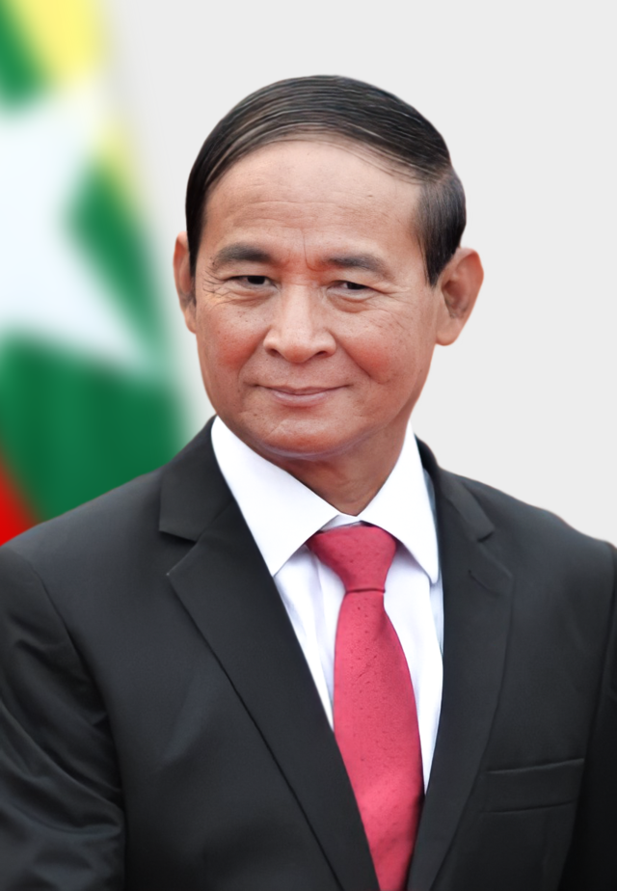
After failing for the second time, the military declared the last elections rigged. On February 1st, 2021, the day the new parliament was to meet, the Tatmadaw staged a coup d'état.
The date was not chosen by chance - the first session was to approve the composition of the government. The military took President Win Myint, Aung San Suu Kyi - the leader of the ruling party, and other officials into custody. The historic events of 1990 were repeated.
This time, the Tatmadaw are trying to dress themselves up in the garb of democratism to the last. The military is trying to emphasize the supposed legality of its actions. In their actions, they emphasized articles 417 and 418 of the constitution, which give them the right to declare a state of emergency and place all power in the hands of the commander-in-chief.
First Vice President Myint Sway, a retired general who led the military faction in parliament, formally became an acting president. The real ruler of the country is Commander-in-Chief Min Aung Hlaing.
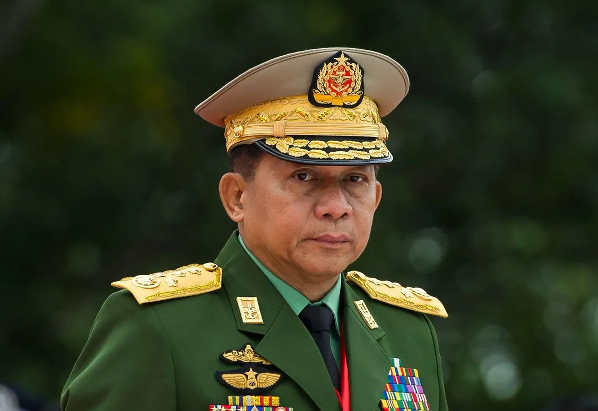
The military junta sought to mitigate the international backlash - mainly to keep capital flowing. In the new government, the military included many ministers who had served in the presidential cabinet between 2011 and 2016, when Myanmar was “democratizing”, as well as representatives of liberal democratic parties that had lost the elections but took advantage of the current situation to gain a seat in the government. Local media were banned from using the words “regime” or “junta” to describe the new military government. However, they did not succeed in saving their face.
The Tatmadaw actions speak for themselves: electoral fraud was just a formal excuse for a military coup. The military wants to play democracy in words, but in deeds, it is an open dictatorship. It couldn't be otherwise, because the Tatmadaw felt they were losing power, especially economic power. The dominance of the old monopolies was systematically undermined by the influx of foreign capital. Within the national capital, new groups emerged that did not want to be subordinated to the military bourgeoisie.
Aung San Suu Kyi was accused of corruption, violating the Export and Import Act, receiving foreign funding through a charitable foundation, and so on. The military was looking for any means to neutralize its main political opponent. Such charges carried long prison sentences and put an end to the possibility of running for office.
Although the originally announced duration of the state of emergency was set at one year, Min Aung Hlaing did not mention a new election date in his parade speech on 27 March 2021.
Such treacherous behavior by the military junta was met with an immediate response from their opposition.

2. Who opposes the military?
The main face of the opposition is Aung San Suu Kyi, daughter of Myanmar's national hero Aung San.
Before coming to power, the NLD leader was under house arrest (from 1989 to 2010). Supported by the UN, she received the Nobel Peace Prize in 1991, and a campaign was organized in her support with the participation of famous cultural figures: film director Luc Besson, musicians Bono, Bob Geldof, and others.
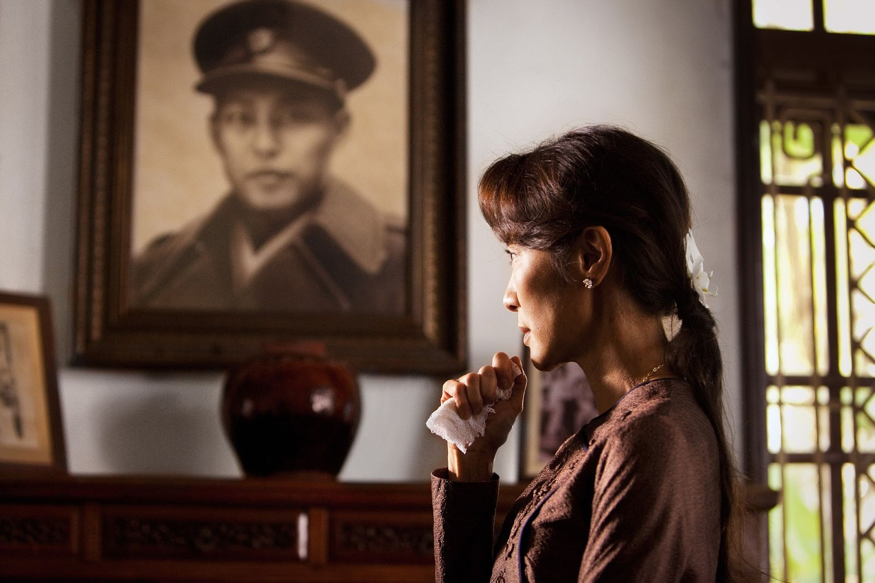
However, when the NLD came to power, Aung San Suu Kyi showed her real face in the so-called Rohingya crisis.
The Rohingya are a small people on the border of Bangladesh and Myanmar. The Rohingya mainly live in Rakhine state (formerly known as Arakan). Unlike the indigenous Burmese, who historically practised Buddhism, the Rohingya are descendants of Muslim migrants from Bengal who were brought in by the British to work on plantations during their colonial rule.
The Rohingya have limited rights and are not considered full citizens of Myanmar. On this ground of national oppression, Muslim terrorist organizations have grown. For example, militants from the Arakan Rohingya Salvation Army (ARSA) regularly attacked police stations and government buildings, killing police officers and seizing arms and ammunition.
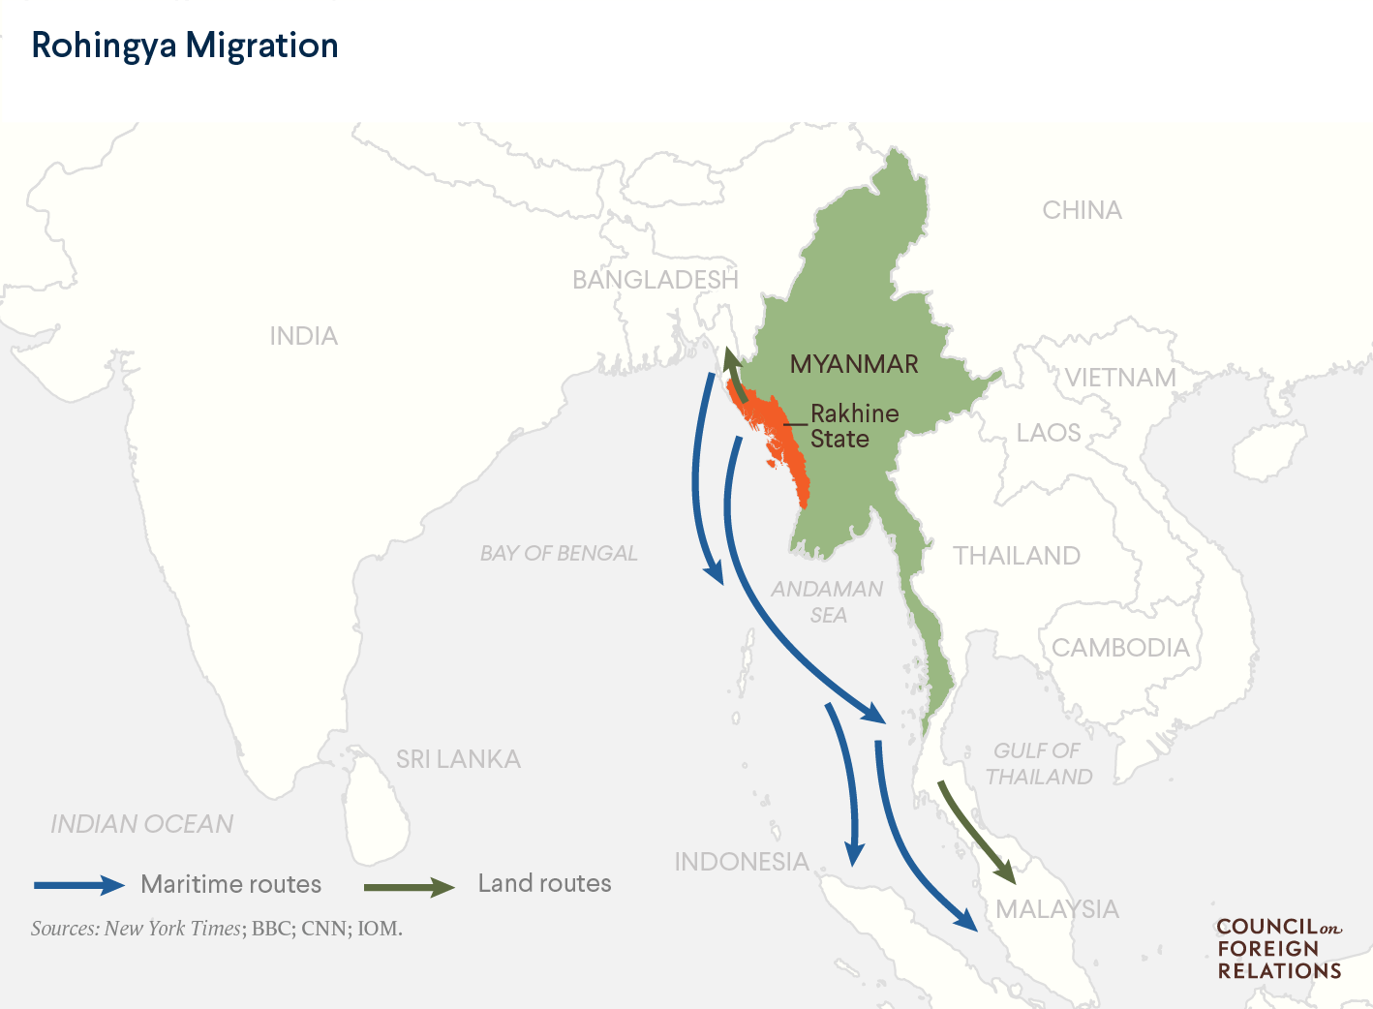
Aung San Suu Kyi's government had previously tried to resolve the issue with the Rohingya people, for which a special commission was drawn up in 2016. The commission came to obvious conclusions:
“Experts who worked on the Kofi Annan Commission believe that poverty is the root of all evil and must be tackled first and foremost. The poverty rate in the state is 78 per cent, twice the national rate of 37.54 per cent. Virtually all ethnic communities in the state suffer from poverty, lack of social services, unemployment and poor opportunities for development. While other states and regions of Myanmar have developed dynamically in recent years, Rakhine State has increasingly lagged behind.”.
However, the simmering conflict escalated in 2017 when ASRA fighters again attacked police stations. Thirty stations were attacked simultaneously.
The Myanmar army responded with a series of crackdowns that included massacres, torture, and the destruction of settlements. 700,000 Rohingya were forced to flee to neighboring Bangladesh, but the government there refused to accept such a mass of refugees and resettled them on a small island in the Bay of Bengal. The refugees, kept in camps, were left to face a humanitarian catastrophe.
The Myanmar government was accused of genocide. The “democratic” NLD government responded by standing in solidarity with the military's actions.
Aung San Suu Kyi led a group of country representatives and spoke at the trial in The Hague against the charges of genocide and the justification of military atrocities. The NLD has shown its acquiescence in practice.
Between 2016 and 2020, the NLD in power had no impact on the country's major problems: poverty, and national and religious discord. However, in her quest for popularity, Aung San Suu Kyi even spoke at the UN in defense of the military's actions, which she herself was previously a victim of. Significantly, there was no agreement between the NLD and the Tatmadaw - Aung San Suu Kyi acted on her own, and the military even refused to be represented in the defense team.
Aung San Suu Kyi returned to her country as a heroine who had supposedly defended national honor on the international stage. The price she paid was the resentment of the Western countries that had actively supported her for decades.
These are the two main political forces on the eve of the 2021 civil war, but of course, Myanmar's political field is not limited to two players. There are many national parties and armed militias in multi-ethnic Myanmar. However, these groups are more nationally based than politically aligned - although even this says a lot about their political color.

3. National forces
In addition to the official army (about 400,000 men), the country has national armed groups.
For example, the army of the Wa State which is an unrecognized state on the territory of Myanmar, whose armed forces include 30,000 people. The United Wa State Army (UWSA), has concluded a truce and even co-operates with the official armed forces of Myanmar. Besides this there are other formations:
- Guerrilla units of the unrecognized Shan state (Shan State Army, SSA).
- Kachin Independence Army (about 10,000 people)
- Karen National Liberation Army (KNLA)
There are many other national units. Such political forces exist in almost every state in Myanmar except the central states.
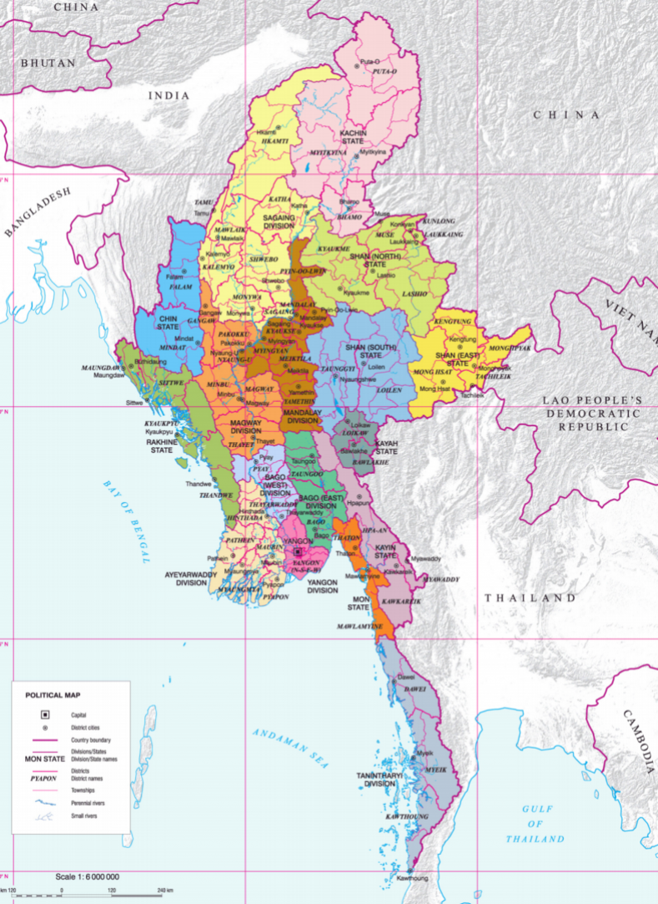
All these forces exist as autonomies within Myanmar, often unrecognized by the official government. Some of them cooperate with the government, some are allied against other groups (alliance with the Wa against the Shan), and even trade. Some ethnic groups have foreign support and trade with other countries (China, India, etc.).
The political demands of these groups vary widely: some want a federal restructuring of Myanmar, while others want to secede from Myanmar and form their own nation-state.

III. The Civil War in 2021
The coup of February 1st, 2021 set off a chain of rapid developments. On February 2nd, the military formed a new government. On February 5th, elected NLD MPs formed their own government. A period of dual power began.
The civil disobedience movement emerged. Mass strikes began. There was chaos in the economy and foreign trade as tens of thousands of workers and employees, including port workers, customs officers, and civil servants, went on strike. Imports through customs fell by 80 per cent and exports by 90 per cent.
Despite the civil war, Myanmar continues to export natural resources. In 2022, Myanmar's top export was oil and gas - 23% ($3.93 billion) of total exports.
The military authorities respond violently to strikes, arresting workers and businessmen, shutting down businesses, and closing shops.
In April 2021, the National Unity Government (NUG) and the Popular Defence Forces were finally formed and took up arms against the military junta. The political crisis revealed a multitude of national conflicts. Many national groups allied themselves with the NUG against the military. However, it is clear that the alliance of such diverse forces is a temporary phenomenon. The People's National Army has no unified command and many units act autonomously in their own interests.
At the same time, the revival of the old Burmese Communist Party, dissolved in 1989, and the activation of Maoist organizations have become known. However, these forces are small in number and politically and theoretically weak.
The military has reacted violently to the armed struggle. Punitive squads have carried out acts of intimidation in many towns and villages. On May 1st, for example, the military killed three people in a raid in the town of Sikain, one of whom was beheaded as a warning to others. On May 10th, 19 people, including 4 children, were killed in Nyaung Pin Thar village and their bodies burned along with their houses.
The military burns down settlements it cannot hold due to the lack of manpower. Between May 2021 and May 2023, for example, 53,000 houses were burned down.
The military junta has been known to use local militias. Popular defense units respond to the burning of villages by burning the homes of pro-junta militias, although on a much smaller scale than the military.
The military's brutality has been met with a strong response from the rebels, to which the military has responded with an even more brutal crackdown. Month by month, the level of atrocities committed by both sides increases. The junta has already developed "glorified" punitive units that have excelled in torture and murder.
The military is actively using high-tech weapons: artillery, aviation and missiles. The People's Defence Forces have no such arms.
Nevertheless, the military is gradually losing territory under its control, and if national groups start to coordinate their actions with the PNU, the military junta will be in trouble.
Joint operation “1027” in the autumn of 2023 carried out by several major national groups showed that the military was struggling to contain the combined opposition forces.
The joint intervention was highly successful, inflicting the worst defeat on the military junta of the entire war.
After suffering military losses in late 2023, the two sides agreed to a Chinese-brokered ceasefire in January 2024. It is likely that the junta's opponents will try to build on their success after a period of truce.
Does victory for one side mean peace for Myanmar?
No, and there are several reasons why:
1. Myanmar has experienced decades of national conflict. Post-war devastation, poverty, crime, and the flooding of the country with weapons will further exacerbate national discord.
Many nationalist organizations allied with the NUG for the sole purpose of waging war against the junta. After the defeat of the Tatmadaw, old conflicts will re-emerge and the national groups, having gained new territory, weapons, and influence, will try to build on their success.
2. The "democratic" forces of the NLD, which form the backbone of the NUG, have already shown their chauvinism and inability to solve Myanmar's long-standing problems when given the chance. Between 2016 and 2020, the NLD had every opportunity to do so: an overwhelming majority in parliament, even a one-party president. However, it was during this period that the Rohingya crisis occurred, resulting in a humanitarian catastrophe for hundreds of thousands of people. The NLD's victory does not mean peace and prosperity for Myanmar.
3. Myanmar is a delicacy for both Asian and Western imperialists. It is likely that China, the USA, India, and Japan will keep the fire of nationalist conflicts burning in Myanmar for their own interests.

IV. The Interests of major powers in the region
Which powers have interests in the region?

China
The Chinese Xinhua News Agency spoke out very softly regarding the coup:
«The Myanmar military has announced a major cabinet reshuffle.”
In addition, China did not support the UN draft resolution condemning the Myanmar military.
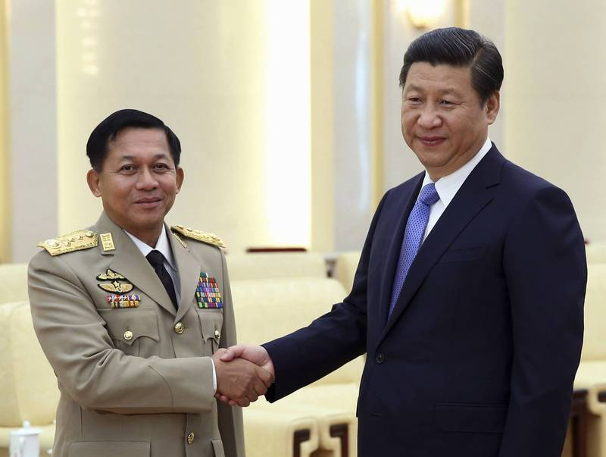
That said, one should not think that the Chinese authorities support the military junta exclusively. Active economic cooperation between China and Myanmar began in 2011 and received a new impetus with the NLD coming to power in 2016. Many Chinese economic projects were also laid down during the NLD rule.
In 2018, a memorandum was signed on the creation of the China-Myanmar economic corridor, and in 2019, Xi Jinping visited the capital of Myanmar.
From the speech of the head of the Chinese Ministry of Foreign Affairs, Wang Yi, dated March 7, 2021, we can conclude that China will cooperate with the opposition if it wins the civil war. He stated that the Chinese side has «long-term friendly exchanges with all political parties and movements, including the NLD".
Besides the Tatmadaw and NLD, China doesn't forget about national political forces:
“The current leader of Myanmar, Senior General Min Aung Hlaing, is known for his wary attitude towards China, which he has repeatedly accused of tacitly supporting Kachin and Shan separatists.”
It is also known about Chinese pressure on the nationalists and the junta in situations where military operations began to be carried out in close proximity to Chinese targets.
From this, we can conclude that the Chinese authorities will support the government that can ensure order on the border with China and can maintain sufficient stability in the country for the implementation of Chinese projects.
What are the main Chinese projects in Myanmar?
“Beijing strategists give Myanmar an important place in the implementation of the Belt and Road Initiative.” An oil and gas pipeline passes through its territory, connecting terminals in Chao Phyu (Rakhine National Region) with an oil refinery in Anning (Yunnan Province) and a gas distribution station in Guigang (Guangxi Zhuang Autonomous Region).
The Myanmar-China gas pipeline was officially put into operation in July 2013, and the oil pipeline in June 2017. As part of the economic corridor project, it is also planned to build a China-Myanmar railway and a main highway along existing pipelines.”
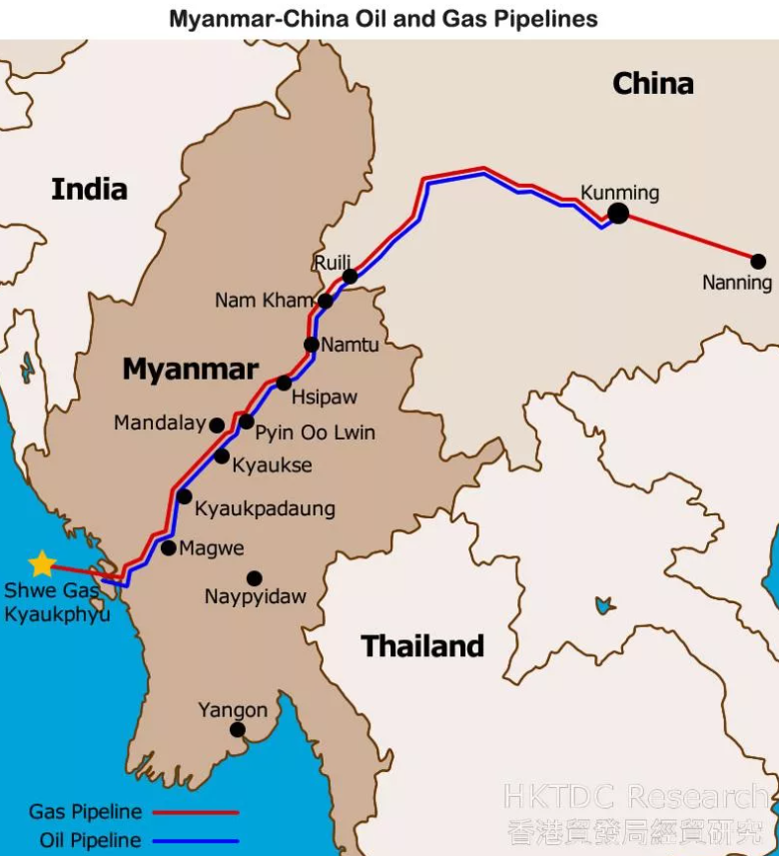
In addition to pumping out energy resources, China acts as the largest investor in Myanmar’s economy:
“China accounts for about a quarter of all foreign investment in Myanmar (over $14 billion) and about 40% ($4 billion) of the country’s external debt. In the 2019/2020 fiscal year, trade turnover between China and Myanmar reached $12 billion (a surplus of $1.3 billion in favor of China). According to official information, the volume of approved Chinese investments in Myanmar at the beginning of 2020 amounted to $21 billion.”
Since the beginning of the civil war, there have been constant attacks by nationalist organizations in Myanmar on Chinese targets:
“In February, a Chinese-owned oil and gas pipeline diversion station in Natoji township in the Mandalay region was damaged when a resistance group attacked regime forces guarding the facility. Following a January attack on power poles feeding a Chinese-backed nickel refinery in Sagaing's Tijayin township, China even reached out to Myanmar's parallel Government of National Unity and urged it to ensure that the resistance movement does not harm Chinese investments in Myanmar.
At a meeting on February 26, the military regime decided to strengthen security measures at Chinese special interest sites in Myanmar, including along oil and gas pipelines.”
In principle, for China, it does not matter which party will be in power in the neighboring country, only the uninterrupted operation of the pipeline and trade routes is important. Even if peace does not come to the country, China is quite capable of reaching an agreement with each side separately, including the national regions of Myanmar.
Behind all the red flags of China and the words about eternal friendship lies ordinary selfish interest. Whichever side wins the civil war, the expansion of Chinese capital will not stop.

India
India too has large infrastructure investments in Myanmar. Among them are the Indian–Myanmar–Thailand Highway, which will subsequently be extended to Laos, Cambodia, and Vietnam, as well as the construction of the Kaladan transport corridor between the Indian city of Aijal and the port city of Sitway in Myanmar.
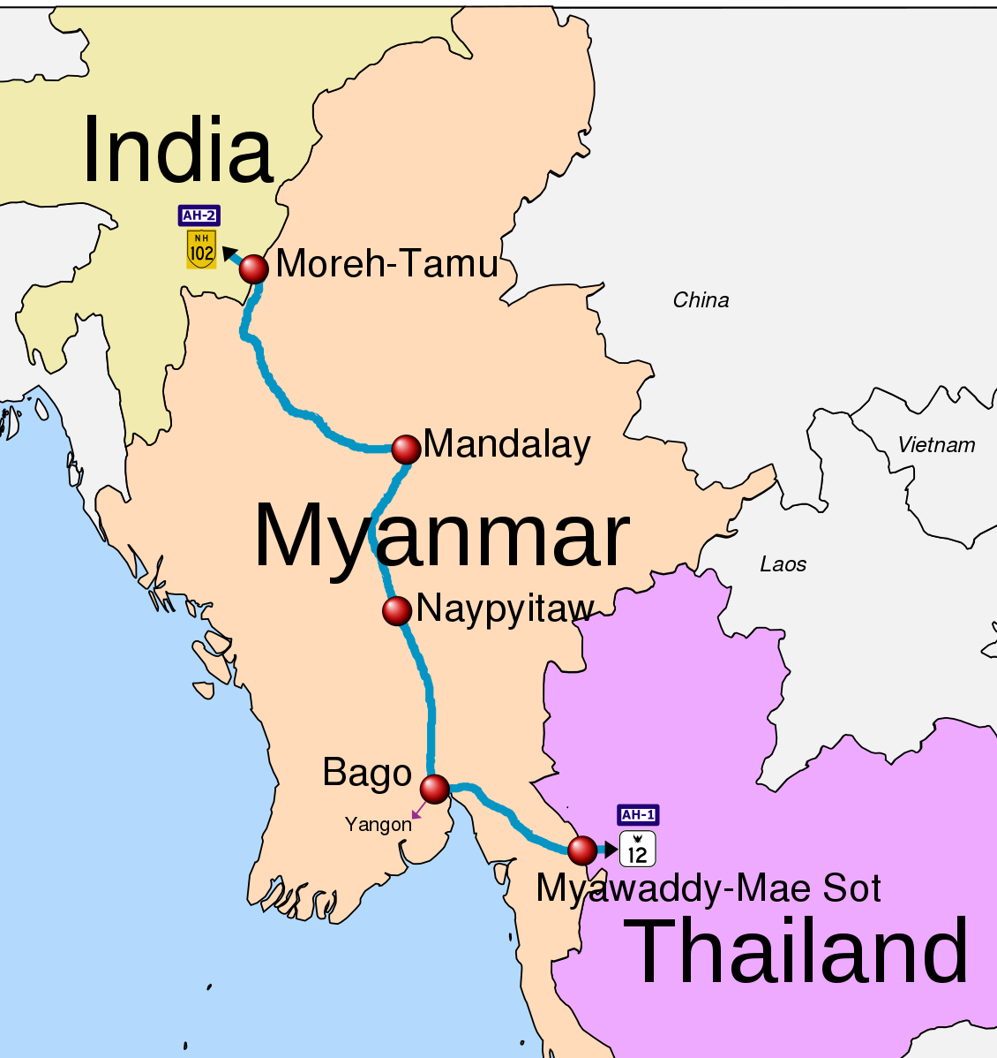
But the timing of the construction of this corridor was constantly shifted due to attacks by national troops on the territory of Myanmar in the 2010s, during construction. One such nationalist organization, the Arakan Army, who's weapons were supplied by China. Thus, by supporting armed nationalist groups, China seeks to disrupt the expansion of Indian capital and ensure its monopoly in Myanmar.
The same approach is obviously used against China - after all, some of the parties benefited from the destruction of Chinese property on the territory of Myanmar.
Among other things, India is also interested in gas supplies from Myanmar. Indian companies are investing in gas development in the Bay of Bengal, trying to catch up with competitors from China.
India, like China, has taken a "wait-and-see" approach to the civil war, neither supporting nor condemning either side. It is quite obvious that Indian capital is only interested in the opportunity to continue economic expansion. The ideological coloring of the Myanmar government is unimportant to India.

Japan
“Japan is one of the key investors in the Myanmar economy, with FDI volumes amounting to $1.7 billion from 2011 to 2020. In addition, it is the third import partner and sixth in exports."
The main areas of investment in Japan, like those of China and India, are transport infrastructure:
“It aims to improve connectivity in the context of the East-West Economic Corridor and the ASEAN Southern Economic Corridor. The East-West Corridor is a project to create an economic development zone along a 1,700-kilometer route connecting Vietnam with Myanmar through Laos and Thailand and through them the South China Sea to the Bay of Bengal with potential access to the Indian Ocean.”
Japan's strategy is to develop Myanmar's connections with other ASEAN countries. This undermines the monopoly of Chinese capital in this region, opening the way for capital from other countries, including Western ones. Japan interacts with India in the same vein.
Japan condemned the coup in Myanmar. However, it did this in much softer formulations than Western countries. Japanese capital does not want to lose funds invested in Myanmar, therefore, even while moving in the general direction of condemning the coup, Japanese politicians don't tear connections with the military junta:
“Unlike a number of other world leaders, Japanese Prime Minister Suga Yoshihide did not make any statements regarding Myanmar for a long time, and on March 8, the Japanese Ambassador to Myanmar met with the Minister of Foreign Affairs of the new military government. In addition, after the meeting, the Japanese government announced an $11 million grant for Rohingya refugees through international organizations. Such actions are related to Japan’s desire to maintain a channel of dialogue with the Myanmar government, regardless of who heads it.”

USA
The government and financial circles of the United States had a sharply negative reaction to the 2021 coup.
Economic sanctions didn't take long to arrive:
“The US has frozen $1 billion in assets belonging to Myanmar individuals and companies. In addition to individuals, the US sanctions list includes two Myanmar security agencies - the Ministry of Defense and the Ministry of Internal Affairs, as well as two military-controlled economic corporations - Myanmar Economic Holding Ltd (MEHL) and Myanmar Economic Corporation (MEC), involved in all sectors of the economy - from mining and light industry to telecommunications, hotel and banking businesses. Some international financial organizations, in particular the Asian Development Bank, have already announced the suspension of cooperation.”
Facebook and Instagram have officially banned the use of their platforms for the departments of the military government. The ban also applies to the advertising of commercial companies associated with the military.
In 2023, the US Senate accepted the “Burma Law,” the essence of which boils down to supporting the NUG in its fight against the military junta. The main points of this law are aimed at expanding sanctions against the military and their companies, as well as financial assistance to resistance forces.
In addition, the “Burma Law” contains a clause on holding Russia and China accountable for supporting the Burmese armed forces.
The US and other Western countries have sided with the opposition, despite condemnation of the NLD and Aung San Suu Kyi after the Rohingya crisis in 2017. It is clear that the US is betting on the opposition in order to have more influence in the region and undermine China if it wins. Countries of the European Union adhere to similar tactics.

Other countries
In general, Myanmar has turned from a world-supported “democratizing” country into a rogue country in just a few years. Even Myanmar’s main investor, China, does not directly support the military junta.
The current “friendly” relations with Russia, Serbia, Belarus, Cambodia, and the DPRK are not supported by practically anything other than words.
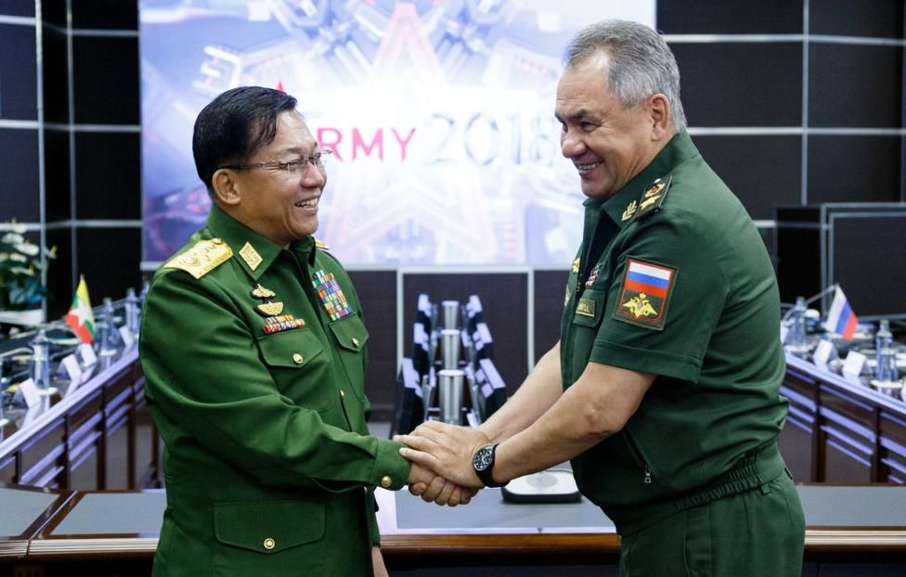
Myanmar's economic interaction with these countries is meager. In relation to Russia, Belarus, Serbia, and the DPRK, all ties were limited only to the supply of military equipment to Myanmar. In relation to Cambodia, the desire of Cambodian political leaders to play on the image of the main negotiator, “conciliator” of Myanmar and other countries in the region.
It is also interesting that the military government of Myanmar supported the start of Russia's ‘Special Military Operation’ on the territory of Ukraine. The junta blamed the start of hostilities on the United States and the Ukrainian people, who chose Zelensky. However, despite all the current accusations, this did not stop Myanmar from purchasing military equipment from Ukraine in 2016–17.

V. Important Lessons
The example of Myanmar provides several valuable lessons.

1. Without a mass communist organization, any military conflict becomes a “horror without end.”
No power in Myanmar meets the goals of progress. The military junta wants to keep its place and its property. The NLD wants to take the place of the junta and does not hesitate to use the help of other states. Nationalist groups wander from fighting for their narrowly focused national interests to selling themselves as mercenaries carrying out attacks against industrial facilities.
The people of Myanmar, ordinary workers and peasants, who truly create all the country's wealth, are torn to pieces by warring factions. They are disorganized, have no representatives of their own, and have no force that would defend their interests.
Only the Communist Party can be such a political leader of the broad masses. However, the tactics of the “revived” CPB are not qualitatively different from the tactics that led to its extinction and defeat in the 20th century.
A small party standing on the platform of Maoism, which, as in the last century, focuses exclusively on military action and guerrilla warfare, is a deliberately hopeless position for a small organization in the fight against the regular army of the state.

2. The imperialist stage of capitalism does not know the division of countries into “important” and “unimportant”.
The USA, China, India, and other imperialist players are fighting for any piece of land, for any piece of the market - as long as it does not go to a competitor. The imperialist powers are ready for anything, including attacks on the industrial facilities of their rivals.
In the struggle for the world market, there are no “small”, or “unimportant” countries that would not be of interest to certain capitals. All countries in the world are part of the global economic system of imperialism, occupy a certain niche, and represent one or another economic, logistical, and political value. Even in such a seemingly small country as Myanmar, the largest “great powers” ​​can come together in a desperate struggle.

3. There are no “non-imperialist” powers.
There is no basis for the claim that Myanmar is merely a victim of imperialism. Any country where private property relations dominate is included in the system of imperialism since imperialism is the state of the entire world system of capitalism.
As in any other country, in small Myanmar, all the main means of production are organized in monopolies. Different groups of capital—internal national groups of capitalists—are fighting for these means of production. They were not brought into Myanmar from the outside: the Tatmadaw and the NLD, who unleashed a civil war, are a product of the internal objective development of Myanmar.
Even in small and diverse Myanmar, ethnic oppression is rampant. National minorities are literally second-class citizens (for example, the Rohingya).
All this destroys the theoretical constructs according to which only a large and “evil” state, like the USA or EU countries, can be imperialist.

4. China pursues typical imperialist policies
This applies equally to India, the US and any other country mentioned above. The example of Myanmar only once again confirms this conclusion. But we single out China separately because it is the power that is trying to create the image of a “socialist state” around itself.
In practice, the whole flair of the theory of “socialism with Chinese characteristics” is shattered by the real affairs of Chinese capital: the seizure of markets, the expulsion of competitors, and the exploitation of the local population and natural resources.
China does not want peace in Myanmar, it only wants its industrial facilities to continue operating and generating profits. The sides can bleed each other as much as they want, but do not let them touch the gas and oil pipelines - this is the actual position of China.

VI. How can Myanmar exit the conflict?
At this stage - there is no quick way. Sooner or later the parties will either come to a ceasefire on their own or will transfer the conflict to a sluggish, more passive, stage – but only after resources are depleted. This is provided that a third party in the form of another state does not intervene, which will drag the warring parties away from their production facilities.
Neither side will even think about the fate of the local residents, who are rapidly sliding into even more appalling poverty.
Myanmar has been independent since 1948. And since 1948, not a single government has been able to lead the country to a peaceful life. A series of coups and civil wars over and over again bring only troubles to the inhabitants of this country. The reason for all this is rooted in the very essence of the social order, which is based on private ownership of the means of production.
But could it have been otherwise?
History gives us examples of different social development in the USSR.
Within two decades after its birth, the Soviet Union was able to radically change the face of the country: from an agricultural state to an industrial and scientific giant. Neither wars, economic isolation, nor the ideological opposition of other states could prevent this. The reason for this was the actual building of socialism.
This path is known, and it has shown its effectiveness in practice.
Sources:
1. Investment regulation in Myanmar - Kostyunina G.M., Baronov V.I. Southeast Asia: current development issues volume II, no. 3 (40), 2018 accessed: 01/10/2024
2. Mass exodus of Bengali-Rohingya from Myanmar: who is to blame and what to do? – Simonia A.A. Southeast Asia: current development issues issue XXXVI (No. 36, 2017) accessed: 01/10/2024
3. Events in Myanmar in the context of relations between major powers in the region (round table of the Center for Comprehensive Chinese Studies and Regional Projects and the ASEAN Center MGIMO) / Ed. HELL. Voskresensky // Comparative Politics. 2021. No. 4. pp. 143-156. Accessed: 01/10/2024
4. Simonia A.A. Myanmar a year after the military coup // Southeast Asia: Current Development Issues, 2022, Vol. 2, No. 2 (55). pp. 136–150. Accessed: 01/10/2024
5. Simonia A.A. The Hague Trial: Aung San Suu Kyi denies genocide in Myanmar // Southeast Asia: Current Development Issues 2020, Vol. I, No. 1 (46). pp. 115-126. Accessed: 01/10/2024
6. Simonia A.A. Myanmar 2021: military coup as a tragic repetition of the old scenario // Southeast Asia: current problems of development, 2021, Volume II, No. 2 (51). pp. 155–165. Accessed: 01/10/2024
7. Reuters – Statement from Myanmar military on state of emergency – 21.02.2021
8. The Times of India – China supplying weapons to Arakan Army armed group to weaken India, Myanmar: Report – 21.07.2020
9. IISS Myanmar Conflict Map – Myanmar’s conflict intensifies as use of firepower expands – 05.2023
10. IISS Myanmar Conflict Map – Junta tactics shift in Myanmar’s war-torn Dry Zone – 07.2023
11. Myanmar Now – 10 more found dead in wake of Ogre Column raid in Myinmu Township – 16.03.2023
12. Kommersant - China announces ceasefire in Myanmar – 14.01.2024
13. Kommersant – Facebook bans Myanmar military from using its platforms – 25.02.2021
14. Xinhua News – Urgent: Myanmar military announces major cabinet reshuffle – 01.02.2021
15. Arguments and facts – Psaki commented on the events in Myanmar – 01.02.2021
16. TrendEconomy – Myanmar. Import and Export… – 26.12.2023
17. RBC – Burma Knot: What's Happening to the Rohingya Muslims – 05.09.2017
18. The Diplomat – US Burma Act Uplifts the Resistance Movement in Myanmar – 01.02.2023
19. Bertil Lintner – The rise and fall of the Communist party of Burma (CPB)/ Cornell University, Ithaca, New York 1990
20. Win, Kyaw Z – A history of the Burma Socialist Party (1930-1964), PhD thesis, School of History and Politics, University of Wollongong, 2008.
21. I. V. Mozheiko, A. N. Uzyanov - History of Burma (brief sketch). Publishing house "Science", main editorial office of oriental literature, Moscow 1973

Original article

