What is Happening in Kosovo?
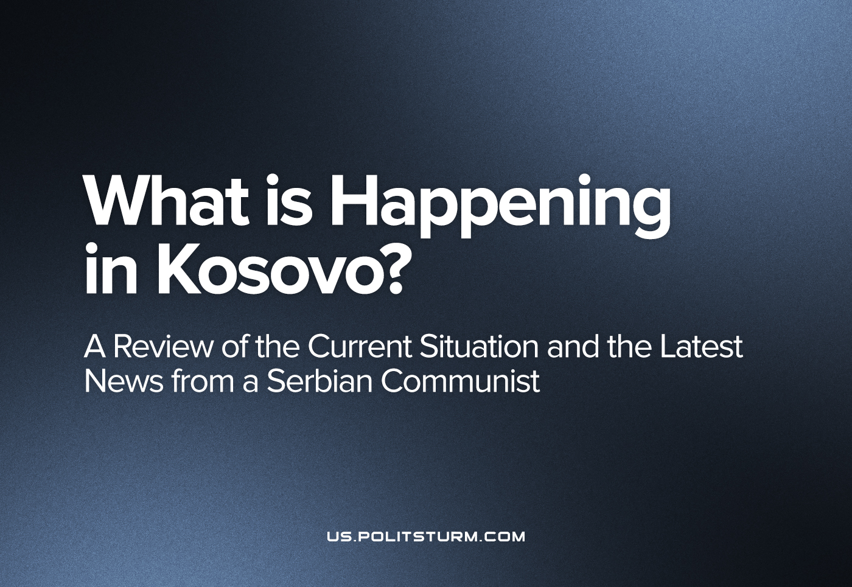

Original article
2022-11-09
8 min read

In a previous article on Serbia, our comrade from Serbia identified the importance of the Kosovo issue in Serbian socio-political life. Over the past few months, new problems arose in Kosovo in the field of ethnic conflicts between Serbs and Albanians. This article examines the problem of Kosovo and the events related to it in recent months.
These events are interpreted in completely different ways depending on who is reporting on them.
Specifically, a new conflict between Serbs and Albanians occurred due to the enforcement of the decision in Kosovo to invalidate Serbian documents and re-registration of cars with Serbian license plates.
The Kosovo Government wants to implement this measure in response to Serbia’s non-recognition of Kosovan official documents. These decisions are being implemented after a temporary measure was taken, according to which white stickers were pasted over state symbols on Serbian cars in Kosovo and also on Kosovan cars in Serbia.
As already mentioned in the previous text regarding Serbia, the Serbian bourgeoisie is practically powerless to change anything in Kosovo and the issue of recognition of Kosovo is merely a formality within the framework of international law as Kosovo is already de-facto independent. It is this fact, with the support of groups of countries opposed to NATO, that gives the Serbian bourgeoisie the opportunity to maintain the “status quo” regarding the recognition of Kosovo and use the Kosovo issue for domestic political purposes, while maintaining the hope that in the event of a change in spheres of influence based on a new redivision of the world, then perhaps it will be able to gain something more from this “status quo”. The events in Ukraine have seriously complicated the world situation, and these events give hope to the Serbian bourgeoisie that they will be able to use the current preservation of the “status quo” by not recognising the actual independence of Kosovo for territorial expansion in the future.
While no solution has been found for Kosovo (and the Serbian Government itself doubts the possibility of a long-term compromise), the Kosovo issue plays an important role at the domestic political level in Serbia.
Because of the aforementioned actual powerlessness, the Serbian bourgeoisie resorted to the tactics of organizing through the ruling political party. The Serbian Progressive Party (SPP) has a strong base compared to other Serbian parties in Kosovo. In addition to membership, an extremely important role is played by armed groups who, for the privileges granted to them, do the “dirty work” for the Serbian government in Kosovo. A clear example of this is the situation when, during the detention of five Albanians, one Serb and one Bosnian, the police in Kosovo were attacked by Serbs, after which clashes similar to the events of July-August of this year broke out.
These conflicts openly served to combat the detection of crimes of Vucic’s people. Organized groups of Serbs used their usual method of blocking roads and clashing with the police. Aleksandar Vucic has simply created a situation in which there are enough organized members of his party in the north of Kosovo to be able to organize riots “according to the directive” in several Serbian municipalities at any time. As a rule, these performances, which they make periodically, are followed by scenes of preparation for the war in Serbia, in which Alexander Vucic himself plays the main role. He fans a rising wave of hysteria to popularize his persona. However, these periodic scenes have become so frequent that they have lost their propaganda significance: they are less and less noticed by ordinary people, and they serve primarily to raise morale among SPP members in Serbia and in Kosovo.
A few months ago, this new problem began with the registration of cars with Serbian license plates. The Serbian government actually announced the conflicts the day before. A few hours before the clashes, Aleksandar Vucic addressed the Serbs in one of his classic speeches on live national television. He pointed to the “extreme complexity” of the newly created situation for Serbia, which represents “the mood in the world in which Albanians think they can play the card ‘big Putin ordered little Putin,’ so the new Zelensky in the person of Albin Kurti will save someone and fight against the hegemony of Great Serbia.”. He is insinuating that Albanians are attempting to identify themselves with Ukraine and Serbia with Russia in order to win the support of Western capital.
Vucic took this opportunity to draw attention to himself and, in his own style, accused the previous government of signing poorly negotiated agreements with the Albanians that allow them to do what they are doing today, but still later explained that the Albanians were to blame for misinterpreting the agreement on freedom of movement since 2011. Vucic went on to say that the peace had been called into question by remarking: “We are asking for peace and seeking peace, but let me tell you right now, there will be no surrender and Serbia will win. If they dare to persecute the Serbs, mistreat the Serbs, kill the Serbs, Serbia will win.”
A day later, the first news about the conflict between the Serbian army and the Albanian police appeared. Serbian media also actively exaggerated the topic with a post on Twitter, which says that in the event of armed clashes, a NATO reaction will follow: https://twitter.com/noclador/status/1554014173318856704
Error loading image
An announcement appeared on the social networks of the Ministry of Defense and the Army of Serbia with the following content: “Due to the large amount of misinformation that the administration of Pristina deliberately releases on the air and which is distributed through fake accounts on social networks and on some websites, which claim that some kind of conflict between the Armed Forces of Serbia and the so-called Kosovan Police allegedly occurred, the Ministry of Defense states that the Serbian Army has not crossed the administrative line at the moment and has not penetrated into the territory of Kosovo and Metohija in any way.”
The general situation led to the fact that the Albanians postponed the implementation of the new measures for a month at the request of the United States. This decision was welcomed by both the US and the EU.
Tensions are rising again in the Kosovo region today. Most recently, the Serbian army shot down a commercial drone in southern Serbia. Vucic said that NATO drones are allegedly moving along the border between Serbia and Kosovo. Regarding Serbian documents, the Kosovo authorities have started issuing warnings for the use of Serbian license plates, and it seems that a scenario similar to the previous one is brewing. Vucic has already talked about additional weapons and the production of weapons. The last step of the Serbian side is the exit of the Serbs from the Kosovo institutions, within which Serbs demonstratively tore the police uniforms.
Germany and France said they “have a plan to resolve the conflict between Serbia and Kosovo.” It is hard to believe that this plan will benefit the Serbian bourgeoisie, and we should expect that in the future Serbia will get even closer to the Eastern imperialist groups, although the West is actually trying to bribe the Balkan countries by announcing investments of 30 billion euros. The Serbian bourgeoisie’s interest in Kosovo is simply too great for these investments to reduce its ambitions.
The question of the nation’s right to self-determination is not actually raised in Serbia, but it is claimed that “Kosovo is Serbian.” International relations have been reduced to pure chauvinism, ignoring the rights of nations to self-determination and an emphasis on the struggle for territories.
Today, the Serbian people in Kosovo and Metohija are hostage to the expansionist policy of the Serbian bourgeoisie. The Serbian bourgeoisie needs the quality of life for people in Kosovo to remain poor to justify its expansionist motives. In Serbia itself, people who have left Kosovo and sold their property are looked down upon, so the term “Kosovars” has a negative connotation in Serbia. The motive for this, of course, is that such behaviour of the Serbs deprives the Serbian bourgeoisie of arguments in favour of its policy towards Kosovo. Especially destructive is the fact that this motive is extremely strong among the people of Serbia itself, which means that the Great Serbian expansionist ideas currently dominate and are in extremely strong positions. This situation allows the bourgeoisie in the Balkans to rule sovereignly, playing the nationalism card.

Original article

