What Is Happening in Italy: New Government and Neo-Fascists
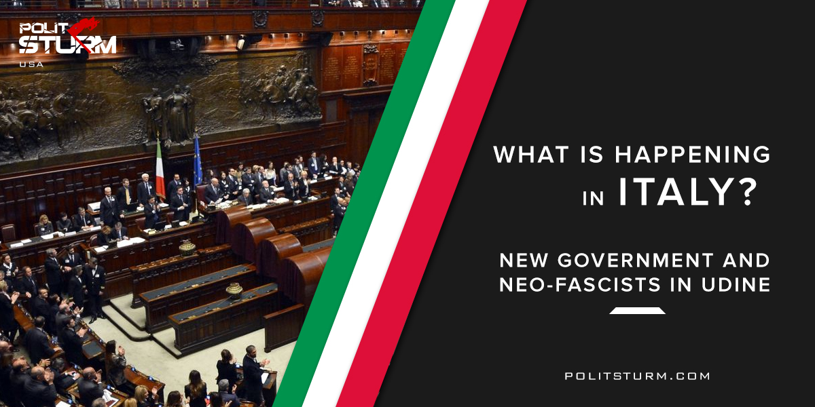

Original article
2018-05-27
3 min read

A New Government in Italy
A new government will probably soon be formed: in the last few days Luigi Di Maio and Matteo Salvini met multiple times to discuss the creation of an alliance that would lead to a conjoint government.
These men are the leaders of the two main Italian political parties: Matteo Salvini is the secretary of “The League”, a right wing party that is very popular in the north, while Di Maio leads the “Five Star Movement”, a big tent group that received most of its votes from southern citizens. If everything goes according to plans, Di Maio will become the new Foreign Minister and Salvini the new Interior Minister, while a third person (someone who doesn’t belong to either of the two parties) will be the Prime Minister.
The left is nowhere to be found: Italian leftist parties are so small and divided that they don’t even matter anymore on the political scene. During the electoral campaign that preceded the national elections both Salvini and Di Maio based their respective programs on populism and demagogy and because of this many argue that they won’t be able to fulfill their promises.
This new government will probably focus on protecting the environment, but immigrants and minorities will most likely be left behind. Will it help the working people? Of course not. As all the capitalist governments, it can make promises, but will never make them real. Italy, Greece, Russia, USA… Every government tells it will make the life better, but in reality they depend on oligarchs’ will. The only way we can make our life better is to struggle for it.
Neo-Fascists in Udine
On Sunday the 29th of April the citizens of Udine (a provincial capital in Friuli Venezia Giulia, Italy) were asked to choose their new mayor. Since no one received enough votes to be directly elected, a second ballot was held two weeks later, where voters could only choose between the two candidates who had received more votes: Enzo Martines (centre-left) and Pietro Fontanini (right wing). Martines, a member of the Italian Democratic Party, had been the vice mayor during the previous administration, while Fontanini was a high school teacher. While Martines focused his program on building dialogue with the citizens, Fontanini mainly focused on security and local traditions.
The winner was Fontanini, the first right-winger to become mayor of Udine after ten years, who received 280 more votes than Martines. Among the many promises made by Fontanini during the electoral campaign, one in particular stands out: the professor said he wanted to put all the refugees and the asylum seekers together in one place, an old barrack. The project aims to “hide” these people (mainly balcks) from the eyes of the citizens of Udine (mainly whites), but putting all these people in a single place is going to cause a lot of trouble, both for the immigrants and the humanitarian workers. Many argue that the newly elected mayor actually did this on purpose, so that when they start having problems, the right wing parties will have a chance to blame those blacks saying:”See? These people can’t stay here with us, they’re uncivilized!”.
Fontanini also received help and support from Casapound, a far right neo fascist organization, and when he found out he had won the elections, he invited his supporters to the city hall, where Ugo Falcone, the local secretary of “Brothers of Italy” (a right wing party) and future municipal councilor, proceeded to perform the fascist salute (luckily, he was filmed and he’s now facing charges).What’s for sure is that dark days are ahead in the city of Udine.
Where there are no communists – fascists start to rise their heads. The problem is really important. Alt-rights, neo-fascists, neo-nazists, nationalists and all kinds of reactionaries all over the world try to stop the progress. We all know what fascism and nazism ended with. And we remember, that communists were those who made the biggest contribution in this ending.
When fascists slowly try to bring their power back, it means communists need to reunite, renew their theory and continue their struggle.
Sources:
1) elezioni.repubblica.it/2018/elezioni-comunali/friuli-venezia-giulia/udine
2) www.ilfattoquotidiano.it/2018/05/14/udine-alla-lega-fontanini-e-il-nuovo-sindaco-il-centrosinistra-perde-lultima-roccaforte-friulana/4353481/amp
3) www.fanpage.it/udine-passa-al-centrodestra-il-candidato-fdi-ugo-falcone-festeggia-facendo-il-saluto-romano/amp/

Original article

