What is Freedom and Does It Exist?


Original article
2023-10-23
19 min read

Throughout the history of social thought there have been fierce debates concerning the problem of freedom. In one way or another they have boiled down to the central question of whether man's intentions and actions are conditioned by external circumstances, i.e. do people have the freedom to choose their actions or are they predetermined? This question is very important because it defines the recognition of one's responsibility for one's actions.
Many politicians, scientists, philosophers, priests, artists, and intellectuals talk about some kind of inner "freedom" inherent in man, intuitively understood by everyone, and urge they to follow it; or they say that man has no freedom of choice, that everything is predetermined in advance. There are also those who take a pluralistic stance on the subject, speaking of a plurality of equally valid opinions on the subject, thus further confusing the matter by failing to provide clear and precise answers.
In reality, the concept of freedom has a specific scientific definition, based on facts and historical experience, i.e. a materialist definition. On the other hand, there are many conjectures, myths, distortions and mere speculations, which are disguised as being scientific, but which, in one way or another, lead to an idealistic, distorted understanding of nature and society. Our new material is about the concept of "freedom" and its problems.

I. Myths about freedom.
Two main idealist points of view emerged from the debates on the question of freedom dating back to the time of ancient philosophy:
- Mechanistic Determinism claims that all human actions and deeds are always and in all cases determined by external conditions independent of them (the laws of nature, the universe or divine forces), i.e. it completely denies free will.
- Indeterminism: an opposite view to determinism, which denies causality and the objective connection of phenomena, and advocates an unconstrained, unconditioned free will or self-determination of the spirit.
There are also mixed, eclectic theories in the history of philosophy which combine determinism and indeterminism: e.g. Agnosticism (Kant, Hume).
In its modern meaning, the concept of 'freedom' has been around for a long time.
The historical struggle of people for the elimination of social restrictions in the 19th century took place under the slogan of "freedom" and led society towards progress. However, these slogans were expressed in different ways, depending on which class certain ideologists belonged to.
The famous slogan "Liberty, Equality, Fraternity!" was proclaimed by the French revolutionary bourgeoisie. It was under this slogan that the progressive bourgeois class of that time fought against feudalism and its remnants in Europe and around the world.
Jean-Jacques Rousseau, a man who could well be considered the forerunner of the ideas of the bourgeois revolutions, began his book “The Social Contract” with the following words: "Man is born free".
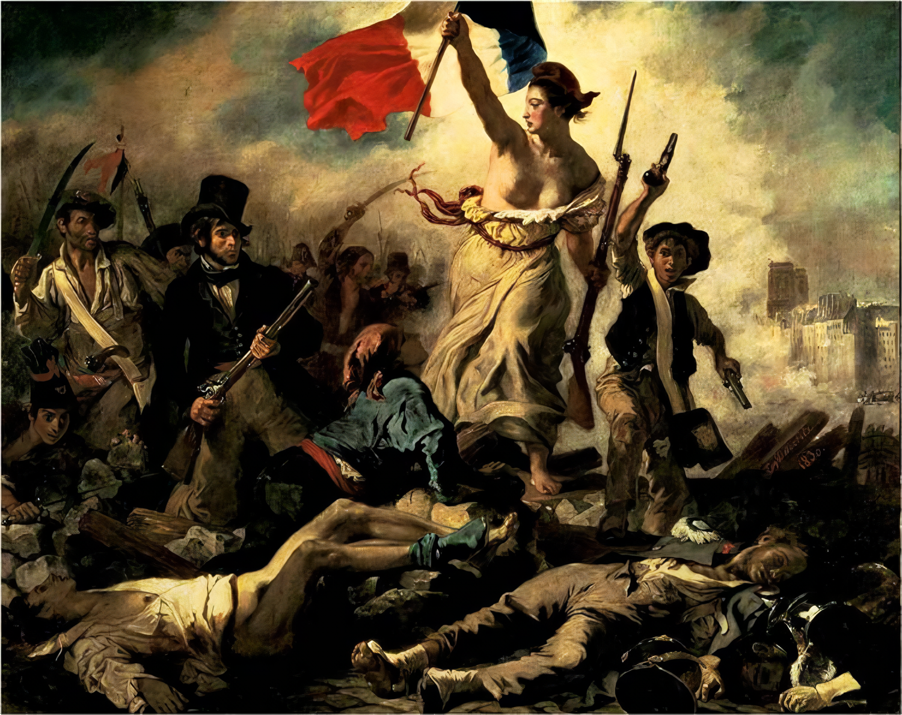
"Liberty Leading the People", or "Freedom on the Barricades" - Eugène Delacroix (1830).
Rousseau argued that the cause of inequality and unfreedom was private property, but at the same time he considered small property based on personal labor as the inviolable foundation of society, as inviolable as freedom. An independent freedom in society belongs only to the state, which emerged on the basis of a voluntary agreement between people, who enjoy freedom only by right of members of the state. Rousseau's condition for freedom is political and property equality, which is controlled and protected by the state that does not allow poverty and division of society into rich and poor.
Also, Rousseau advocated the idea of popular sovereignty and direct democracy, where laws are passed in an assembly directly by all citizens. All these ideas were and still are largely utopian, contrary to the objective course of historical development, which at that time expressed the experiences of the masses (especially farmers) and the needs of the emerging bourgeoisie.
Engels wrote that, according to Rousseau,” this kingdom of reason was nothing more than the idealised kingdom of the bourgeoisie; that this eternal Right found its realisation in bourgeois justice; that this equality reduced itself to bourgeois equality before the law; that bourgeois property was proclaimed as one of the essential rights of man; and that the government of reason came into being, and only could come into being, as a democratic bourgeois republic.”(Engels. “Anti-Duhring”)
The natural scientists and philosophers of the 17th through the 19th centuries, who espoused progressive ideas of materialism and atheism, made a major contribution to society.
Bacon, Hobbes, Spinoza, Holbach - their activities were in line with the rise of capitalism in Europe. However, in those conditions of limited science, the scientists' concepts were just as limited and mechanistic. The concepts of freedom and necessity were metaphysically opposed to each other.
Later, at the beginning of the 20th century, an irrational trend in philosophy emerged - existentialism, which grew out of the voluntaristic, subjective-idealistic ideas of philosophers such as Pascal, Kierkegaard and Nietzsche.
For the representatives of existentialism Sartre, Heidegger, Camus and others, being is the very "existence" of the individual, their personal experience, which cannot be cognised either by science or philosophy itself; "existence" (existentialism) is detached from essence, understood not as objective reality, but is equated with the transcendent (the unknowable, the otherworldly). Depending on how transcendence is interpreted, existentialist forms of reflection differ.
Sartre said: "man's essence does not precede his existence, he projects himself and is condemned to freedom and responsibility, which he can no longer pass on to God".
For Sartre, to be free means "to be oneself"; freedom is an absolute given once and for all ("man is condemned to be free"); the world, nature, society are chaos without meaning; the individual is not predetermined or limited by anything, only their "I" is responsible for their freedom and bears the burden of metaphysical "responsibility"; communication between individuals is false and shows only the solitude of each.
Nowadays statements along the lines of "being oneself" or "self-determining one's life" are quite popular among the everyday people, as are the writings of existentialist philosophers. The pessimistic nature of this philosophy reflects the deep crisis and problem of alienation in modern society, but provides no real way out of this situation.
In the economic sphere, ideas about "free market" and "freedom of entrepreneurship" are popular. Relatively modern and well-known representatives of such "theories" in the twentieth century are economists belonging to the new Austrian school of economics: Mises and Hayek.
In their opinion it is necessary to study not public economic relations, but the phenomena of economic life from the subjective point of view of the individual entrepreneur. An example of their practical application can be seen in the social and financial policy of Great Britain in 1979-1990, led by Thatcher, who was influenced by the works of Friedrich von Hayek.
«Without economic freedom there can be no other freedom» — Margaret Thatcher.
Its policy that proclaimed freedom of competition, reduction of the role of the state in the economy and stimulation of free enterprise development, individual initiative and individual responsibility led to reductions in social programmes, cuts in education and healthcare costs, suppression and restriction of trade union activity, growth of unemployment and poverty. These are the results of reforms based on an idealistic subjective-psychological method concerning the economic development of society.
Several popular worldviews related to mechanistic determinism and fatalism can also be briefly described.
Religious worldviews (Christianity, Judaism, Islam) and related notions of "fate" or "divine predestination".
Astrology is an anti-scientific, false doctrine in which the arrangement of planets and stars can supposedly predict the future outcome of human actions, and even entire nations.
Freudianism in psychology, formed on the basis of Freud's method of psychoanalysis. Despite his introduction of a number of important concepts about the human psyche into science, Freud transferred them mechanistically to the social realm and viewed the individual as completely conditioned by his own past.
So we have described the common myths, utopias, delusions and anti-scientific theories that attempt to answer the question of freedom.
In fact, the opposing mechanistic determinism and indeterminism, and their mixed variants, cannot provide a complete, coherent scientific answer to the question of "freedom".
“The point is that this is one of the favourite hobby-horses of the subjective philosopher—the idea of the conflict between determinism and morality, between historical necessity and the significance of the individual. Actually, there is no conflict here at all; The idea of determinism, which postulates that human acts are necessitated and rejects the absurd tale about free will, in no way destroys mans reason or conscience, or appraisal of his actions. Quite the contrary, only the determinist view makes a strict and correct appraisal possible instead of attributing everything you please to free will. Similarly, the idea of historical necessity does not in the least undermine the role of the individual in history: all history is made up of the actions of individuals, who are undoubtedly active figures. The real question that arises in appraising the social activity of an individual is: what conditions ensure the success of his actions, what guarantee is there that these actions will not remain an isolated act lost in a welter of contrary acts?” (Lenin, selected works, v.1. “What the friends of people are”, pp158-159)

II. The Marxist Understanding of Freedom
The struggle for freedom lifted mankind to a new stage of progress: the obsolete feudal order was abolished and a new capitalist society was created. It soon became clear, however, that the slogans of liberation and freedom proclaimed by the revolutionary bourgeoisie could not be fully realized under capitalism.
A hindrance to this is the capitalist order in itself, or, to be more precise, the basic contradiction of capitalism - between labor and capital. The exploitation that remains at the core of capitalism formalizes any slogan of freedom, equality and fraternity.
Only Marxism, which includes the method of dialectical and historical materialism, the explanation of the economic laws of the movement of capitalist society (political economy), the theory of the class conflict and the theory of scientific communism, helps to understand how society thinks and the reasons for changes in ideas and forms of social thought.
"Just as an individual man cannot be judged on the basis of what he himself thinks of himself, in the same way one cannot judge such an epoch of upheaval by its consciousness. On the contrary, this consciousness must be explained from the contradictions of material life, from the existing conflict between the social productive forces and the relations of production" (K. Marx. Towards a Critique of Political Economy).
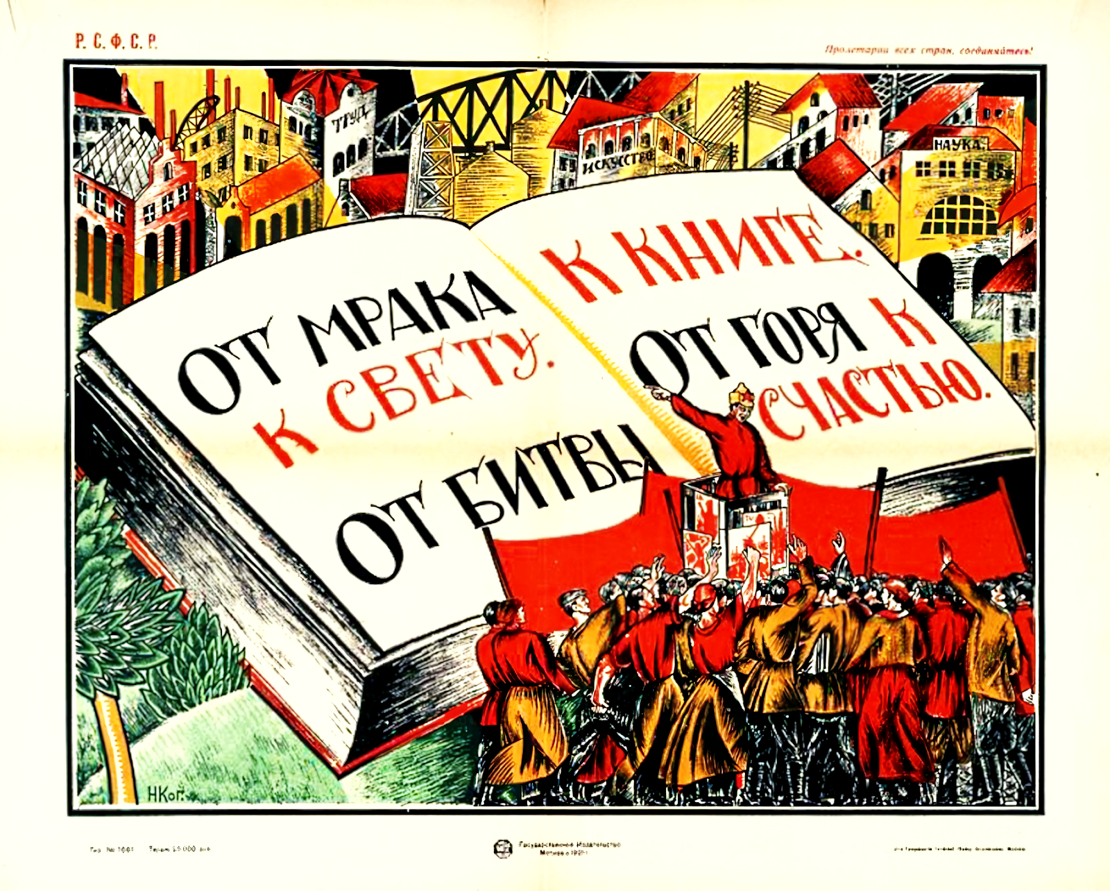
From darkness to light. From battle to book. From sorrow to happiness." - Nikolai Nikolaevich Kogot (1921).
A scientifically coherent analysis of the specific material, historical conditions of modern capitalist society is given by Marx, Engels and Lenin.
Capitalism is a socio-economic formation based on private property of the means of production and the exploitation of wage labor by capital.
The main contradiction of capitalism is expressed in the contradiction between the social nature of production and the private-capitalist form of appropriation of its results.
This contradiction gives rise to anarchy of production, unemployment, economic crises, wars and an irreconcilable conflict between the main classes of capitalist society - the proletariat and the bourgeoisie.
This is the economic basis of capitalist society, over which the ideological superstructure corresponding to it is built in the form of various forms of social consciousness in general and theories about freedom in particular.
Capitalism develops, gradually passing through stages of emergence, formation and decline.
In the days of young capitalism, the proponents of bourgeois ideology promoted scientific progressive ideas and believed that by defending the interests of the bourgeoisie, they were defending the interests of all people. This was partly true, as all society, except the feudal lords, was interested in destroying feudal exploitation.
However, we live in a time of "dying capitalism", i.e. imperialism - its highest and final stage. Capitalism is no longer able to meet the needs of society and can no longer develop the productive forces it has created, and is no longer able to do so in the framework of capitalist relations of production.
Capitalism is now a reactionary force, a brake on progress in all areas of social life: in politics, economy, ideology and philosophy.
The mistake of many freedom talkers is denial or ignoring the class form of society, attempting to blindly defend and justify capitalism. The consequence of this is that they talk about abstract freedom that does not exist in reality.
In real life people are not confronted with abstract freedom, but with its concrete embodiment in the form of material means to achieve their ends and in the form of real, historically established social and economic relations.
Society is not free to choose objective conditions of its existence and its activity, but at the same time society is quite free in the choice of goals and in the choice of means to achieve them, because usually there is not one, but several possibilities, with different probabilities. Even when there are no other options, it is possible to slow down or speed up the occurrence of desirable or undesirable phenomena.
There is no such thing as abstract or absolute freedom; freedom is always specific and relative.
Freedom is realized through the choice of a certain plan of action. The scope of freedom becomes wider when people are more aware of their real possibilities, when they have more means to achieve their goals, and when their interests coincide to a greater extent with those of the masses, the social classes and the objective course of social progress.
Freedom does not equal arbitrariness, as many "critics" of Marxism and materialism perceive it. Relative historically, but real practically, the freedom of the individual to choose a line of conduct according to one or another circumstance imposes moral and social responsibility for one's actions.
“Freedom does not consist in any dreamt-of independence from natural laws, but in the knowledge of these laws, and in the possibility this gives of systematically making them work towards definite ends. This holds good in relation both to the laws of external nature and to those which govern the bodily and mental existence of men themselves — two classes of laws which we can separate from each other at most only in thought but not in reality. Freedom of the will therefore means nothing but the capacity to make decisions with knowledge of the subject. Therefore, the freer a man’s judgment is in relation to a definite question, the greater is the necessity with which the content of this judgment will be determined; while the uncertainty, founded on ignorance, which seems to make an arbitrary choice among many different and conflicting possible decisions, shows precisely by this that it is not free, that it is controlled by the very object it should itself control. Freedom therefore consists in the control over ourselves and over external nature, a control founded on knowledge of natural necessity; it is therefore necessarily a product of historical development.” (Engels, “Anti-Duhring”)
Thus, in summary, the Marxist definition of freedom is as follows:
Freedom is the capacity of man to make decisions in accordance with their interests and goals, relying on the knowledge of objective necessity: the natural, historical, social and economic conditions of material life.
That is, freedom does not consist in an illusory 'independence' from the objective laws of nature and society (or society itself), but in the ability to choose, 'to make decisions with knowledge', as Engels writes.
Contrary to the idealist definition, the Marxist definition of freedom speaks of the dialectical interaction of freedom and necessity, of their organic connection. The mere awareness of freedom without the practical possibility of its realization in reality is an illusion of freedom.
Marxism is often referred to as a kind of "economic determinism", as if the development of society and the individual were entirely determined by the economy. In fact, Marxism has never denied the role of the individual in history. In a letter to Moehring Engels writes:
“We all laid, and were bound to lay, the main emphasis, in the first place, on the derivation of political, juridical and other ideological notions, and of actions arising through the medium of these notions, from basic economic facts. But in so doing we neglected the formal side – the ways and means by which these notions, etc., come about – for the sake of the content. we all laid, and were bound to lay, the main emphasis, in the first place, on the derivation of political, juridical and other ideological notions, and of actions arising through the medium of these notions, from basic economic facts. But in so doing we neglected the formal side – the ways and means by which these notions, etc., come about – for the sake of the content. “ (Engels, Letter to Moehring. 1893).
Marxism not only explains the concept of freedom theoretically but also provides a concrete plan of action for its realization under certain historical conditions.
The conditions for implementing true freedom only emerge after the abolition of capitalist production relations, specifically private property, which generates hostile relations between groups of people (classes).
The historical aim of liberating society from outmoded economic relations falls on the working class. This task derives from its specific material conditions of life.
On the one hand, the proletariat is the majority of modern society and its main productive, driving force. On the other hand, this class is deprived of the means of production created by its own labor, the class most exploited, living only by the sale of its labor power. In addition, every worker is a commodity in itself, its ability to work is sold and bought on the labor market.
Because of this, within the framework of capitalism the proletariat has no possibility of following its own interests, no possibility of reconciliation with the capitalist class.
Only by uniting on the basis of the scientific revolutionary Marxist-Leninist theory, by recognizing their common class interests, will the working class be able to abolish capitalism and build socialism - the first stage of a classless communist society, in which public property of the means of production, the planned management of the entire economy and the elimination of exploitation of man by man will be established.
Only when the spontaneous processes based on the exploitation of the labor of the majority of the people, the alienation of man from the results of their labor and themselves, are replaced by a systematic and conscious development carried out by the whole society, excluding the phenomena outlined above, the social activity of man becomes truly free and creative.
No matter how much is said about freedom by the apologists of the bourgeois order, only an association of workers free from exploitation is capable of giving the individual and society true freedom in its materialist understanding. Freedom in relation to the forces of nature, social production and management, existence as such; in short, one's own destiny.

Conclusion
Marxist analysis destroys all myths about "freedom". It clearly shows that the amount of freedom that individuals and society as a whole have is determined by the level of development of the productive forces, as well as by the level of people's own awareness of the objective laws of nature and society, and finally by the social and political system.
Individual freedom, on which bourgeois thinkers are so keen, largely mythologising it, is only part of the freedom that society has at a given historical moment. Lenin wrote succinctly and correctly on this point: "One cannot live in society and be free from society".
Individual freedom under capitalism is determined by the size of private property in the hands of a minority, which enables them to enjoy more goods at the expense of exploitation, impoverishment and the restriction of the freedoms of millions. As long as there is private property, exploitation and division of labor and warring classes, phrases about "real freedom" are a sham.
When hearing the calls of the bourgeois media for unity in the struggle for "freedom", one must always ask the question: freedom for which class?
Only a transition to socialism, which frees the labor of the majority from exploitation, creates the objective conditions for the real realization of true freedom. Having abolished the relations of exploitation, domination and subordination, human society can dispose of the results of its labor as well as independently choose the purpose of its application.
Finally, every single human being would no longer be a commodity-the labor force-would be able to control his own destiny, no longer belonging to the commodity-owner. Then, and only then, can we speak of real freedom, both for the individual and for society as a whole.

Original article

