Western Imperialists Plan Reshaping of Palestinian Rule
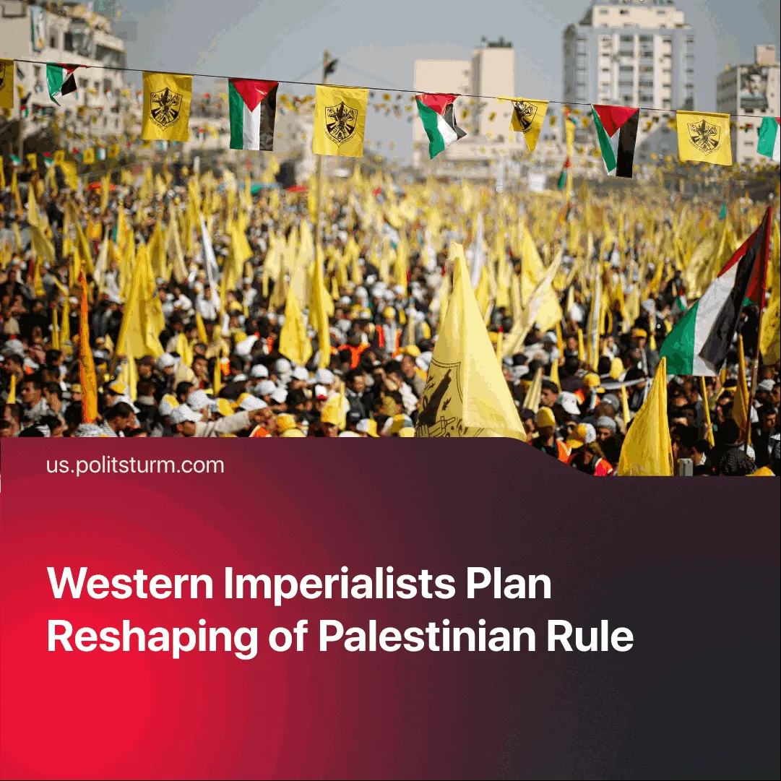

Original article
2025-08-08
2 min read

After the US proposed a peace plan and the EU’s renewed push for recognising Palestine, PA leader Mahmoud Abbas has moved to call elections—excluding rival factions.
Details. The US proposed a plan to end the Israel-Hamas conflict, which includes a 60-day ceasefire, a gradual exchange of hostages, and the delivery of humanitarian aid under international supervision. Israel accepted the terms of the ceasefire and added that Hamas has to disarm fully. US-aligned Arab states — notably Qatar, Saudi Arabia and Egypt — also called jointly for Hamas to disarm.
► Hamas, backed by Iran and Turkey, refused to disarm unless an "independent, fully sovereign Palestinian state with Jerusalem as its capital" was established. Another condition was the complete withdrawal of Israeli troops.
► The Palestinian Authority (PA) President Mahmoud Abbas, who governs Fatah-controlled territories, publicly announced plans to hold Palestinian National Council elections. However, only members of the Palestine Liberation Organisation — a multi-party alliance that excludes Hamas — would be eligible to participate.
Context. Several Western powers — including France, Canada, and the United Kingdom — have stated they may recognise a Palestinian state and continue aid to the PA. However, Canada has said such recognition depends on substantial reforms within the PA, the holding of elections, and progress toward demilitarisation.
► Earlier this year, Hamas and Fatah met in Beijing and signed a reconciliation agreement. The agreement outlines the formation of an “interim national reconciliation government” that would administer the Palestinian territories, including Gaza, after the current conflict with Israel ends. Hamas was expected to participate in this government.
► A section of the Iranian capitalists is pushing for improved relations with the US, under mounting imperialist pressure following the “12-day war”. Its regional proxies have also been weakened: the Lebanese and Israeli governments are threatening to disarm Hezbollah, which has lost senior commanders and thousands of fighters during Israel’s offensive in southern Lebanon. Assad’s regime, which enabled logistics for these proxies through Syria, has fallen.
► Former Israeli officials appealed to Trump to end the conflict, arguing that the objective of "defeating Hamas" has been achieved. Whilst Netanyahu has announced plans for the full occupation of Gaza.
Important to Know. The split between Fatah and Hamas reflects their subordination to rival imperialist blocs. Fatah serves US and Israeli interests, while Hamas represents the interests of the Islamic regional imperialists, primarily Iran, Turkey and Saudi Arabia.
► Hamas, though postured as a resistance force, advances Iran’s regional aims — and has at times been opportunistically supported by Israel to divide the Palestinian movement. Neither represents the interests of the working class.

Original article

