Western Democracy From The Inside
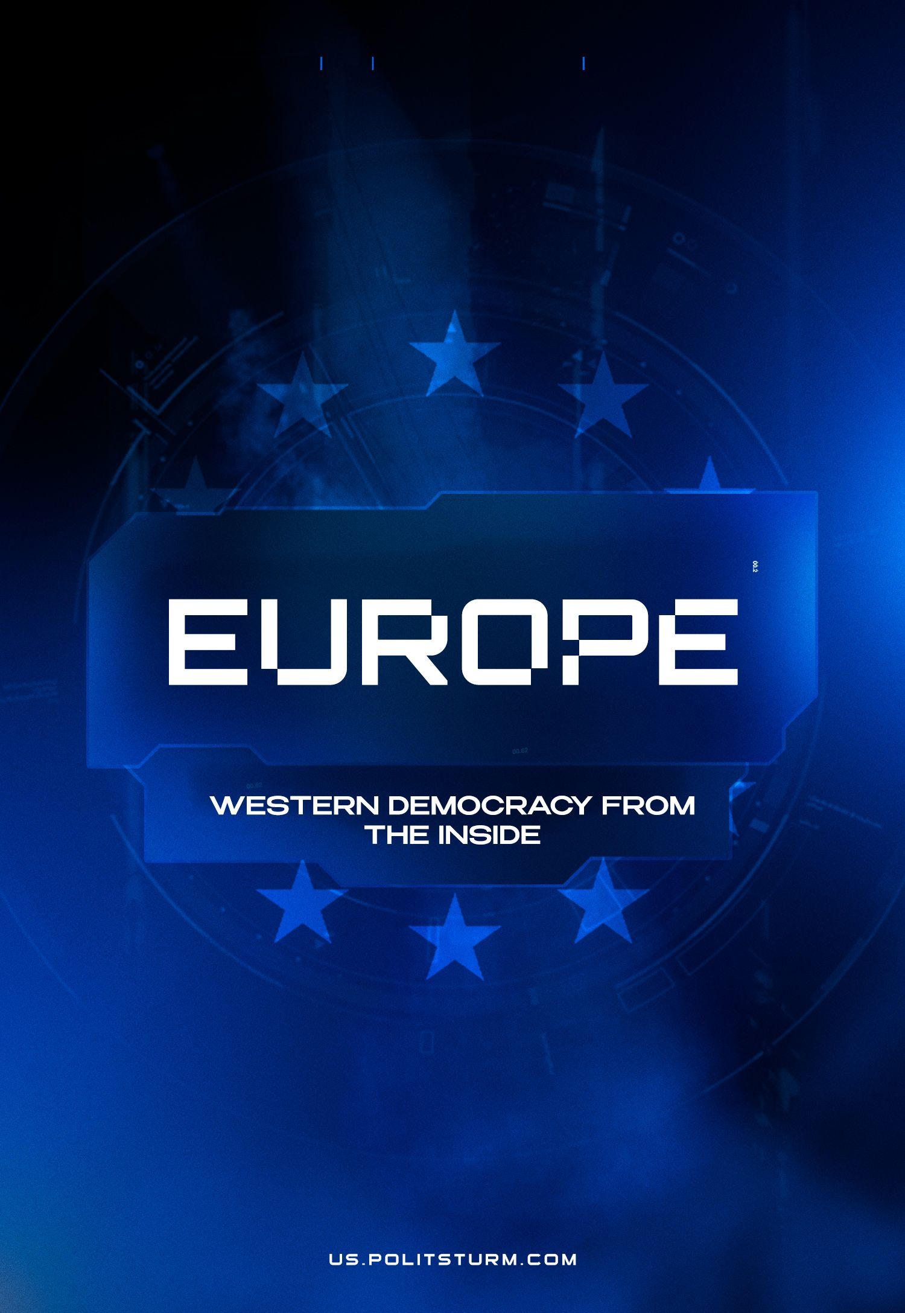

Original article
2024-04-06
24 min read

Introduction
In 1992, a book published by Francis Fukuyama "The End of History and the Last Man", made the claim that liberal democracy represents the end point of humanity's ideological evolution and the final form of government that can satisfy the basic human desire for freedom and prosperity. In line with Fukuyama’s claims, the formal statistics he puts forth support that.
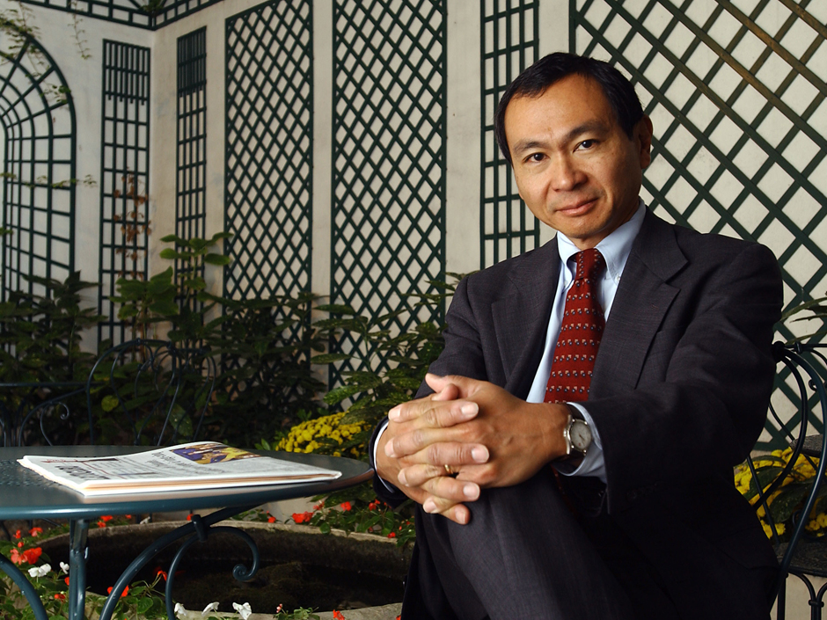
Francis Fukuyama
However, how do things go in reality? The author of this material spent several years in the Netherlands and was able to see the real objective image of European democracy, which has way more details than the dry numbers of state-sponsored statistics services.
Upon dissecting the foundation of democracy under capitalism, and observing the major aspects of citizen participation, a different and more objective picture is painted in contrast to Fukuyama’s surface-level analysis.

Representative Democracy
Western democracies are often praised for their representative bodies, housing a range of parties "to suit one needs". This is particularly true of the Netherlands.
Taking the Netherlands as a case study, we can see that the country is consistently rated very highly on the parameters of Freedom House and Democracy Matrix. The Freedom House rates the Netherlands with a total score of 97/100 deeming it a free state, this is based on a high rating of political rights 39/40 and civil liberties 58/60. The Democracy Matrix gives the Netherlands a rank of 7 in “Countries by Quality of Democracy” classifying it as a “working democracy”. This is based on a range of different parameters.
Yet what is representative democracy and what do all these parties embody?
Representative democracy is a form of government in which citizens elect representatives to make decisions on their behalf. Under this system, citizens do not directly make decisions on specific policies or laws but instead select representatives who will uphold their interests and views in the decision-making process. Representatives may be elected at various levels of government, such as national, state, or local. Now, while this gives a good idea of what they mean, in practice, it is quite different.

Trust
Firstly, arises the question of trust. Politicians and parties in the past years have had relatively low levels of trust. As of 2022, 63% of all Dutch people reported that they tend not to trust political parties, while 67% do not have confidence in Dutch politics. Undoubtedly there is a source for this, and one of the biggest contributors was the childcare benefits payment scandal in the Netherlands.
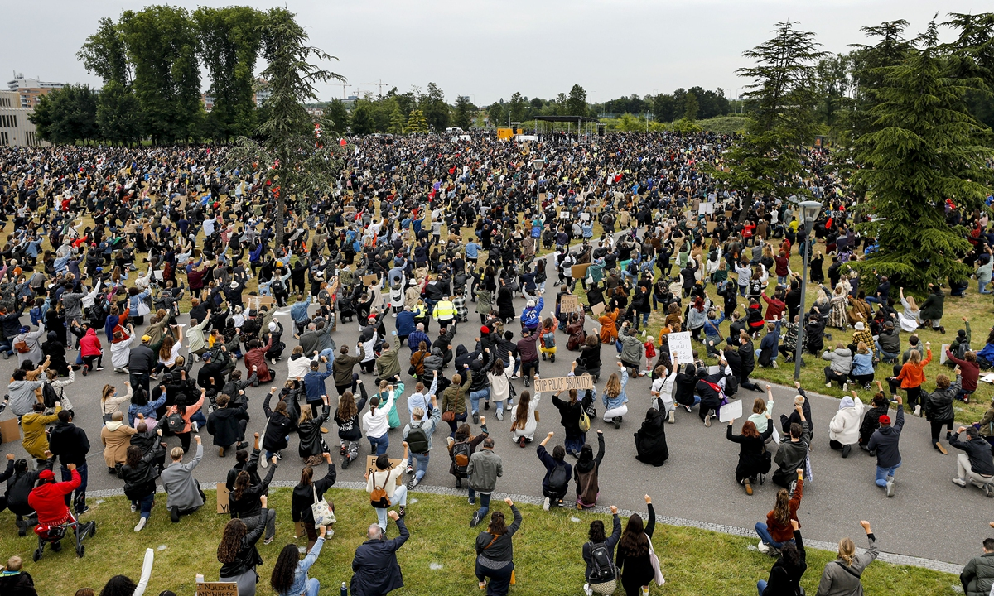
The racial discrimination that occurred in connection to the childcare benefits scandal played a part in sparking protests against Racism at Nelson Mandela Park Amsterdam in 2020.
In short, the childcare benefits payment scandal resulted in the state requesting a return in benefits in full (of each year they were provided) to people for whom aid was given. While it only affected around 26 thousand people, it fed a significant wave of distrust in authorities around the country and showed a major gap in Western democracies. This gap is the economic foundation that it stands on, as many party programmes do not deal with the main issue of the population - lack of income.
And this scandal alone is only a mere drop in the ocean, as statistics by the OECD show that low income is the biggest problem for most people in the Netherlands. Now why is the income problem not being solved then? If by the logic of representative democracy, there are representatives of the people who should actively focus on this?
The answer points us in the direction of class nature politics, where the fundamental basis of the capitalist (bourgeois) system results in the necessity to exploit people, charging extortionate prices for housing, and real wages dropping, with striking being the only chance for people to secure their wages. Yet even union work does not solve the roots of the issue. To quote Lenin:
“Not a single fundamental democratic demand can be achieved to any considerable extent, or any degree of permanency, in the advanced imperialist states, except by revolutionary battles under the banner of socialism.” (The Peace Programme)
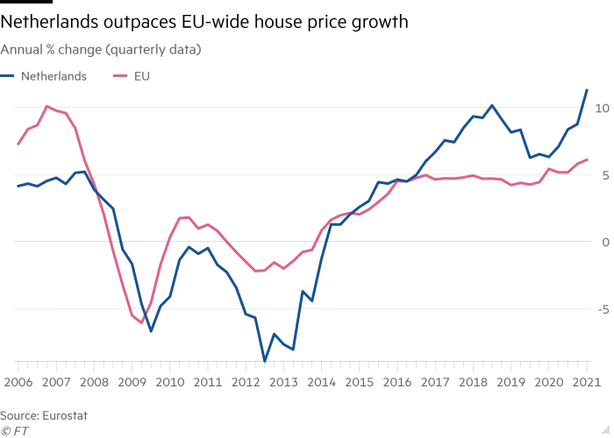

Representation
Then if they do not solve the issues facing the people, what do the representatives of the people who speak of equality and freedom really represent? The ones who claim that they protect everyone's interests? These candidates during elections go through a difficult and expensive procedure (campaigning), that creates a financial barrier to entry. Businesses utilise their property in the form of media to advertise the candidates that best represent their interests.
What about the representations of the interests of the working class? The People's Party for Freedom and Democracy (VVD) and the Christian Democratic Appeal (CDA) have both proposed labour market and tax reforms. The tax reforms would reduce the tax on high-income earners, and increase it for the middle and low-income strata. The labour reforms made it easier for employers to hire and fire workers.
Other parties such as the Labour Party (PvdA) and the Socialist Party (SP) have proposed minor reforms that held no permanency, either being eaten up by inflation or cancelled by future reforms of opposing parties. Lenin in 1917 successfully described this process:
“Once every few years to decide which member of the ruling class will suppress, crush the people in parliament – this is the real essence of bourgeois parliamentarism, not only in parliamentary-constitutional monarchies, but also in the most democratic republics”. (The State and Revolution)
The notion of a sombre reality is evoked with regard to the relationship between candidates of the general public and their affiliation with the labour force. Despite claims by contemporary authorities of implementing policies aimed at benefiting the working class, such actions can be likened to applying a mere band-aid to a terminally ill patient. In truth, the capitalist elite possesses the most significant influence and secures it through financial contributions, or "lobbying," in the political process.

Lobbying
Lobbying is the apotheosis of “democracy” under capitalism and is the guiding force to political implementation. Lobbying is the act of attempting to influence decisions made by government officials, legislators, or other public officials on behalf of a particular organisation, group, or individual.
It’s one of the brightest examples of the class origins of the modern state when this or that person is financed and aided by a certain group of capitalists in order to secure their interests on a large scale. It is the heart of all politics under capitalism, as many politicians forget their vows and promises to the electorate, once their plans affect the profits of monopolies. One never has to go far to see these processes.
Perhaps one of the most apparent and broadcasted examples of this in the Netherlands is the breaking of the climate promise to end the public financing for international fossil fuel projects. The fossil fuel industry is an extraordinarily influential actor in the Netherlands, and they vigorously lobby in Dutch politics. In 2020, Shell and ExxonMobil hired lobbyists to influence the Dutch government's climate policy. The lobbyists provided arguments against a proposed carbon tax and argued for more lenient emissions regulations.
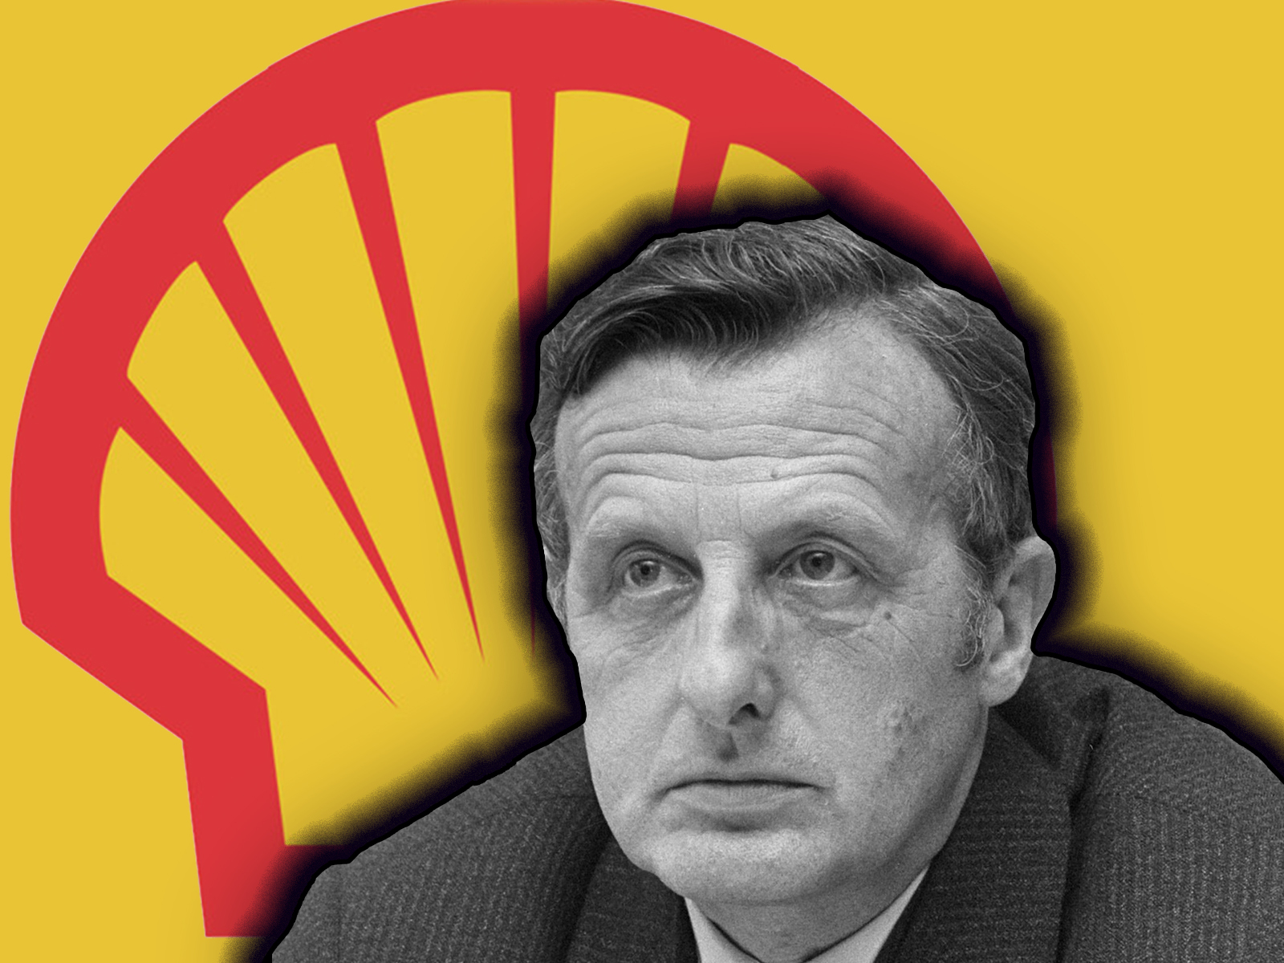
Shell Backed Dutch ‘Coordinator’ of Climate Science Denial For Decades
Additionally, in the Netherlands, political parties and candidates are openly allowed to receive donations from businesses and individuals. In the 2017 Dutch general election, several large Dutch corporations donated significant amounts of money to political parties, including Philips, Heineken, and Rabobank. Even in 2023, we can see this, where a range of groups of capitalists and smallholders donated to their parties (parties that best represent their interest, and due to donations, uphold and prevail the donors' interests) to help further their interests.
Corporate interests, however, do not end in mere lobbying; sometimes representatives of companies take up high positions in politics to continue to further their class interests. For example, former Dutch Prime Minister from 2002 to 2010, Jan Peter Balkenende after leaving politics, joined Ernst & Young, where he worked as a partner in the advisory division.
The Current president of the Netherlands, Mark Rutte, worked for several years in the private sector, including as a human resources manager for Unilever, a large Dutch multinational consumer goods company. He entered politics in 2002 and has served as the Prime Minister of the Netherlands since 2010. As Prime Minister, he has implemented policies to support the private sector, such as the reduction of corporate taxes.
Yet, these same people claim that there is equality and freedom in this system of representation but what equality and freedom can a worker and the capitalist; the poor and rich; the hungry and full have with one another? And thus representative democracy once again is revealed to be a tool for the ruling classes, that allows them to influence politics in the way they like, while for the working masses, it is a mere illusion.

The Myth of “Direct Democracy”
While Western bourgeois democracy is most known for its representative bodies, it is also made up of some means of people directly participating like in municipalities and NGOs. Could they be the key to helping the working class achieve their ends?
Direct democracy is a form of government in which citizens directly participate in the decision-making process rather than electing representatives to do so on their behalf. In a direct democracy, citizens have the ability to propose, develop, and vote on policies and laws, either through town hall meetings, referendums, or other forms of public forums. In the Netherlands, these mechanisms are claimed to be a direct democracy, however, most of them are simply more interactive forms of representative democracy. The political bodies that distribute this form of democracy are provinces, water authorities, and municipalities.

Municipalities
Municipalities, in essence, embody the clearest template as to how "direct democracy" functions and who it foremost benefits. The municipalities in the Netherlands are treated as “the tier of government closest to the people”.Based on this, they serve as a source of aid in the form of both representation and financial help. Despite these claims, the core capabilities of municipalities are limited and stumble into the same hurdles as the higher representative bodies.
Starting from the limits of representation, the leadership of the municipalities of different districts are represented based on local elections of people present in the same mentioned parties. Nevertheless, everything is entangled in creating an image during elections, that while less than parliamentary elections, still requires funding. From this, several other groups can gain representation.
More often than not, these are smallholder (petty bourgeois) parties that represent small businesses and/or farmers. Most recently, in 2023 the Farmer–Citizen Movement, or BoerBurgerBeweging (BBB), has, against expectations, won the provincial elections and utilised this power to further their small-holder interest, with current aims of offsetting fertiliser regulations. This showed that indeed newly emerging parties can actively combat the rink of politics with established parties, anyhow, all of these parties do not represent the working class, and instead act as a means for the small-holders to have their say in politics, leaving the remaining majority unable to get much out of participating.
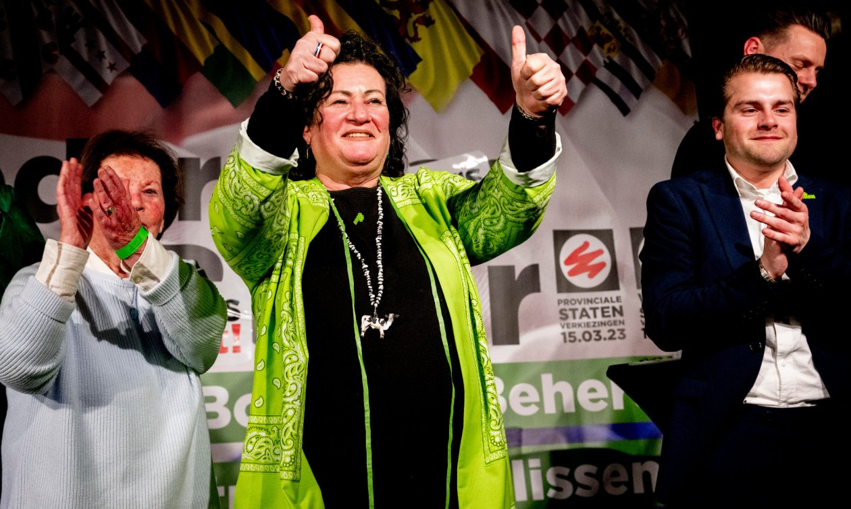
BBB leader Caroline van der Plas during the provincial elections
This is unsurprising at most, as we can see that these bodies lay a great emphasis in allowing smallholders to gain an additional grasp on their representation. This is exemplified in a wide range of programmes targeted at small businesses:
- ‘Business incubators’ and accelerators that provide support and resources to small businesses, such as office space, mentoring, and access to funding.
- Tax incentives to small businesses, such as lower property taxes or reduced rates for certain business activities.
- Business development grants or other forms of financial support to small businesses that are looking to expand or invest in new projects.
- Networking opportunities organised by municipalities such as events and workshops that allow small business owners to network with each other and connect with potential customers and partners.
- Regulatory support to small businesses, such as assistance with permits and licences, and help with navigating local regulations and zoning laws.
The programmes do not only provide financial incentives but also grant platforms for people to express their experiences and voice their problems. One of the more unique approaches taken by municipalities was working with the creative directors of the NoWhere art exhibition programme. Even with providing outlets to express their issues creatively, the working class people are left behind, let alone in terms of basic aid.
Municipalities in their provision of help to the working class are limited to giving consultation on their debt and issues of poverty, alongside providing minor material and financial assistance. Nonetheless, this does not amount to much and with active cuts in funding, this reduces each year. In addition, municipalities and other smaller bodies do not influence policy decisions on a national level, meaning that even the most progressive party winning in municipal elections, will not result in anything significant.

Unions
Statistics show the low trust and participation of lower-income workers in unions. As the ‘flourishing’ capitalist democracy results in more people struggling to make ends meet and pushes more people into poverty, one might wonder: what happened to the unions that claim to fight for workers' rights?
Dutch unions, like many of their international counterparts, face the century-old issue of being stuck in the economic struggle. In reference to Lenin’s works about his fight against Trade-Unionist politics:
“the pompous phrase about “lending the economic struggle itself a political character”, which sounds so “terrifically” profound and revolutionary, serves as a screen to conceal what is in fact the traditional striving to degrade Social-Democratic [future Communist] politics to the level of trade union politics.” (What is to be Done?)
Even then, for the past few years, union membership in the Netherlands has been regressing, with the youth being the least unionised. And so, the working-class person is left unheard in this system, with no proper ability to participate in the politics the capitalists had created for themselves.
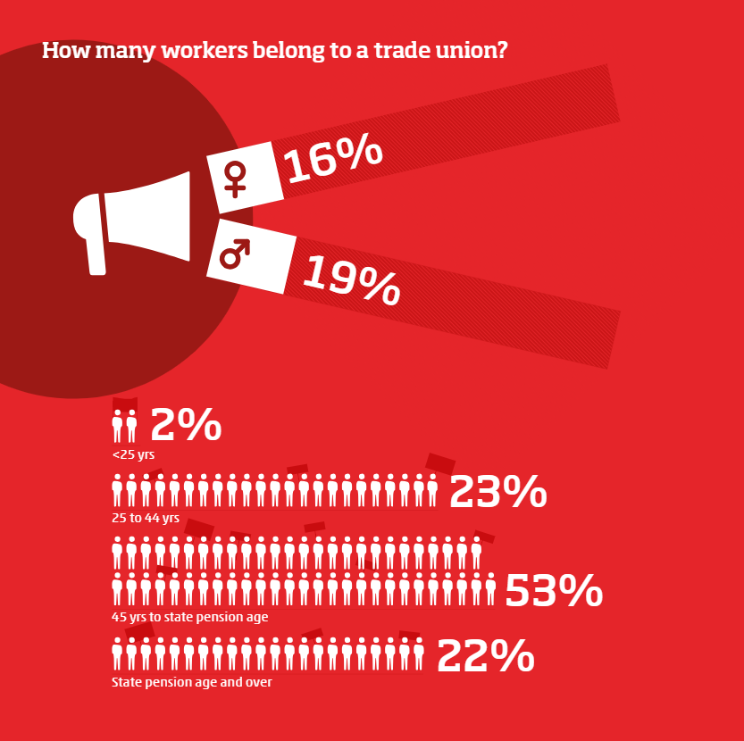
The mechanism of lower-level governance is very limited and is a tool for the property-owning classes to have political power and compete with one another for it, rather than the worker. Thus it should come as no surprise why working-class people, feel increasingly indifferent towards representative democracy and their optimism in politics, as Lenin put it:
“Owing to the conditions of capitalist exploitation, the modern wage slaves are so crushed by want and poverty that "they cannot be bothered with democracy", and "cannot be bothered with politics"; in the ordinary, peaceful course of events, the majority of the population is debarred from participation in public and political life.” (State and Revolution)

NGOs
Another element of governance in Western democracies are the Non-Government Organisations (NGOs). They act as "good-willed" elements of society that aim to bring welfare and as some argue they act as an intermediary between the state and people that gives empowerment tools for the masses. The Dutch state defines NGOs as:
“NGOs do not aim to make a profit and are often committed to the environment, poverty, and human rights… An NGO is not a government or commercial organisation. NGOs usually work with volunteers and money from donors.
NGOs can also be conversation partners for governments. For example, for advice or mediation in matters like child labour or human rights. Some NGOs focus specifically on developing countries, development cooperation, or development aid.” (Business.gov.nl)
While the wording is indeed noble, and there are strong examples of charitable NGOs such as FairWork, there are certain limits that overshadow the efforts of even the most well-meaning organisation. First and foremost there is the obstacle of the market, which inevitably penetrates every crevice of society under capitalism. NGOs ultimately face the issue of racing against time, where either they are turned into a tool of monopolies, are crushed by them, or are stuck remaining a small organisation working in the same manner as the aforementioned unions.

Co-optation
One of the aforementioned examples is that NGOs can be turned into tools for monopolies. In such a case companies may use NGOs to create the impression that they are environmentally responsible while continuing to engage in environmentally harmful activities. Companies may seek to directly overtake NGOs by providing them with funding or other resources, to influence their agenda or limit their ability to criticise company practices. Additionally, much like lobbying with representative bodies, companies seek to influence government policy or regulations by working through NGOs.
Instances of such occurrences are not scarce, and substantial cases have emerged in the past years.
In 2019, Shell was accused of greenwashing (conveying a false impression or misleading information about how a company’s products are environmentally sound) by several NGOs, including Greenpeace and Friends of the Earth International (FoEI). The company had made a $300,000 donation to the Climate Cleanup Foundation, an NGO that promotes carbon capture technology while continuing to extract and sell fossil fuels. The NGOs accused Shell of using the donation as a PR stunt to distract from the company's role in contributing to climate change.
In 2018, Dutch NGO Milieudefensie (Friends of the Earth Netherlands) was found accepting funding from the Dutch government and the National Postcode Lottery, both of which had investments in Royal Dutch Shell. As a consequence, they had skewed their efforts in criticising Shell.
In 2019, the Dutch NGO Stichting Natuur & Milieu (Nature & Environment Foundation) was criticised for its involvement in negotiations over a proposed CO2 tax. The NGO was accused of being too close to the energy industry, as it had received funding from companies such as Eneco and Vattenfall. The NGO was watering down its demands for a higher CO2 tax, in order to gain the support of these companies.
All of these examples embody the issue that no matter the case, each NGO requires funding, as without it they will cease to operate. As a consequence, since property owners own and manage capital, the largest funders will inevitably be Capitalists, and they will donate money to help maximise their profits, be it by helping themselves with marketing, opening new markets or gaining a competitive advantage over others.
The previously mentioned FairWork gains EU funding, so no matter their intentions, it is difficult to imagine that the European Commission would not cease their funding if the NGO began helping organise workers.

Strategic-Litigation
The second obstacle is litigation, as capitalists, especially larger ones, have enough money to spend on difficult and expensive legal processes as a means to protect their interests. And thus companies use the legal system to silence or intimidate NGOs that are critical of their activities.
In 2011, Dutch dairy company FrieslandCampina filed a lawsuit against animal welfare organisation Wakker Dier for defamation, after Wakker Dier accused the company of violating animal welfare standards. FrieslandCampina won the lawsuit, and Wakker Dier was ordered to pay damages.
In the same year, Amnesty International & FoEI filed a lawsuit against Royal Dutch Shell alleging it had breached human rights and environmental provisions at its oil operations in Nigeria. The NGOs had retracted from their case and thus it was withdrawn.
In 2014, the Dutch bank Rabobank filed a lawsuit against Milieudefensie for defamation, after the organisation accused the bank of financing companies that were involved in deforestation. Rabobank won the lawsuit, and Milieudefensie was ordered to retract its statements
All of the lawsuits were attempts to silence the NGOs and limit public debate on those issues. At the end of it all, NGOs face the same debate as charities once had, while some can help people, they ultimately do not solve structural issues and are insignificant on a large scale level. NGOs end up inheriting the same troubles as mentioned before in prior sections, with additions to them being co-opted even easier by the capitalist system. They cannot be considered "objective" structures in sufficiently dealing with issues of structural origin. Generated by the capitalist society and almost always sponsored by the capitalists, they are ready to point out one or more "gaps" of bourgeois democracy as long as it does not affect their sponsors.

Recent Elections
In the 2023 general Dutch election the far-right PVV (Partij voor de Vrijheid/Party of Freedom) led by Geert Wilders had won 37 seats in the exit polls, making it the biggest party in the Dutch Parliament.
In 2023 Geert Wilders is not a unique candidate at all, his political framing for which he is most known was anti-Islam, and anti-immigration, most of his rhetoric is almost identical to any other “populist” leader. The outcome of his coming to power further escalates the positions of the right in the Netherlands and in Europe, partnering him with Meloni’s Italy and Orbán’s Hungary.
While it is very improbable that a single party in the Dutch ‘democracy’ can take complete power, it will again shake the positions of the Western social democrats and the wider left. Regardless of what coalition government will end up forming such a party will establish new harsh policies that attack the working rights of foreigners working in the Netherlands, and hide the growing socio-economic contradictions with anti-refugee and anti-muslim rhetoric.
Referencing the earlier chapters, what has been described here, is a mere development of the same policies that had already been initiated by the Dutch state in recent times, and with the lack of a coherent party to defend the rights of all workers, business and their lackeys will use all of the means necessary to trample their freedoms and safety, starting with the most vulnerable groups.

Conclusion
From the collection of data on various institutions, can the Netherlands be called a pure democracy? No, for it is a bourgeois state, that serves the capitalists, parasitic strata and to an extent the petty bourgeois. The working class in capitalism is excluded and ultimately gets excluded from real political decision-making, and regardless of what is being voted on, no bourgeois party will ever replace the system of exploitation of man by man.
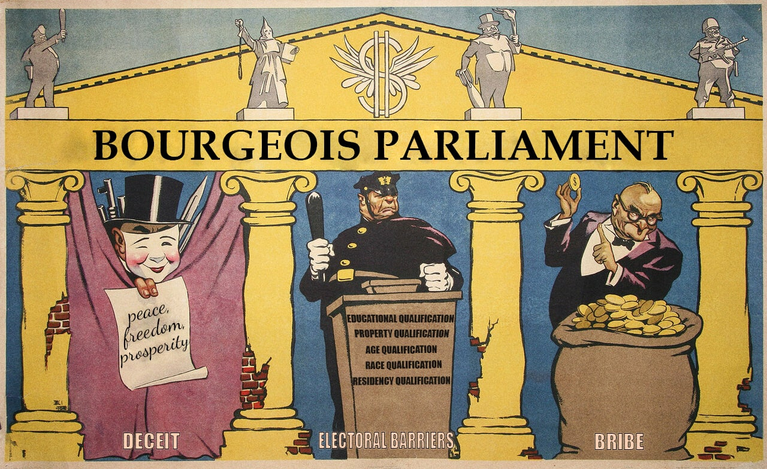
“Bourgeois Parliament”, a Soviet poster by Briskin and Ivanov, 1954. (translated)
Can it be changed? Undoubtedly these points illustrate that the flaws of this system run so deep that it cannot be reformed or patched. As a result the only alternative that is posed, is for the working class to let go of capitalist promises. As Lenin put it:
“Marx grasped this essence of capitalist democracy splendidly when, in analysing the experience of the Commune, he said that the oppressed are allowed once every few years to decide which particular representatives of the oppressing class shall represent and repress them in parliament!
But from this capitalist democracy – that is inevitably narrow and stealthily pushes aside the poor, and is therefore hypocritical and false through and through – forward development does not proceed simply, directly and smoothly, towards "greater and greater democracy", as the liberal professors and petty-bourgeois opportunists would have us believe. No, forward development, i.e., development towards communism, proceeds through the dictatorship of the proletariat, and cannot do otherwise, for the resistance of the capitalist exploiters cannot be broken by anyone else or in any other way.
And the dictatorship of the proletariat, i.e., the organization of the vanguard of the oppressed as the ruling class for the purpose of suppressing the oppressors, cannot result merely in an expansion of democracy. Simultaneously with an immense expansion of democracy, which for the first time becomes democracy for the poor, democracy for the people, and not democracy for the money-bags, the dictatorship of the proletariat imposes a series of restrictions on the freedom of the oppressors, the exploiters, the capitalists. We must suppress them in order to free humanity from wage slavery, their resistance must be crushed by force; it is clear that there is no freedom and no democracy where there is suppression and where there is violence.” (State and Revolution)
Even after a century, Lenin’s analysis of the political arrangement of the world proves its worth in innumerable ways. No matter what the many Fukuyamas claim, the world is objective, and through analysing the material roots of social structures, we are able to unearth the class nature of society and clearly observe the struggle of the working class - which has existed and will continue to exist for as long as capital does.
And so this reveals the only alternative - a proletariat state. A state that is led by the most progressive and class-continuous strata of the proletariat, that will act to democratise society and utilise the learned tools from capitalism, the struggle against it and large-scale social production. Only socialism can improve access to democracy, and give a voice to the silent majority, and for this, they must be consciously guided by a Communist party towards this goal.

Original article

