West Virginia Steelworkers Strike Over Contract
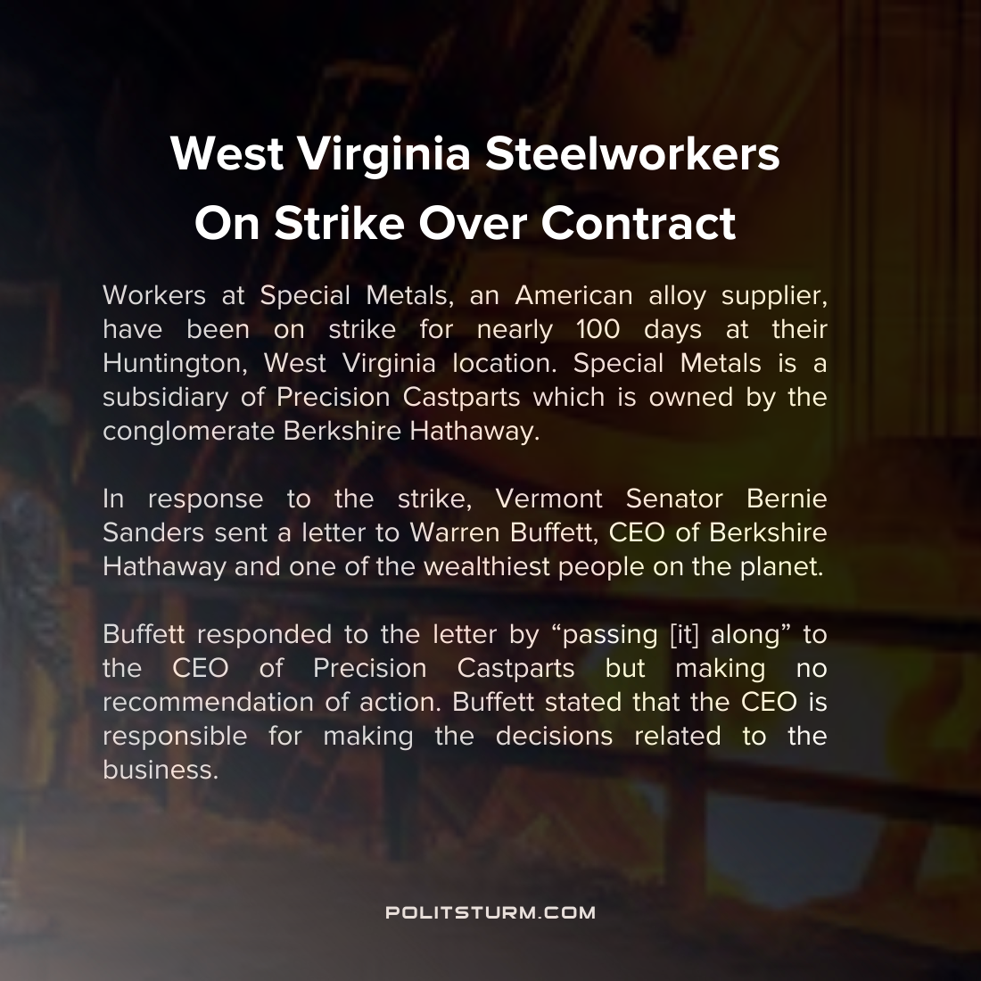

Original article
2021-12-30
1 min read

Workers at Special Metals, an American supplier, have been on strike for nearly 100 days at their Huntington, West Virginia location. Special Metals is a subsidiary of Precision Castparts which is owned by the conglomerate Berkshire Hathaway. In response to the strike, Vermont Senator Bernie Sanders sent a letter to Warren Buffet, CEO of Berkshire Hathaway and one of the wealthiest people on the planet.
“At a time when this company and Berkshire Hathaway are both doing very well, there is no reason why workers employed by you should be worrying about whether they will be able to feed their children or have health care. There is no reason why the standard of living of these hard working Americans should decline. I know that you and Berkshire Hathaway can do better than that.”, Said Sanders in the letter.
Buffet responded to the letter by “passing [it] along” to the CEO of Precision Castparts but making no recommendation of action. Buffet stated that the CEO is responsible for making the decisions related to the business.
It is obvious why Buffet would not make any recommendation on the course of action and defer to another CEO. The capitalist class is concerned with the maximization of profits for shareholders and not the well-being or interests of the workers. While Sanders implies that pay cuts and benefit reductions are happening despite record profits, it is patently clear that they contribute to the record profits for the capitalists.
Source: 1

Original article

