Welcome to Londongrad: Russian Capitalists and How They Managed to Get to UK and London
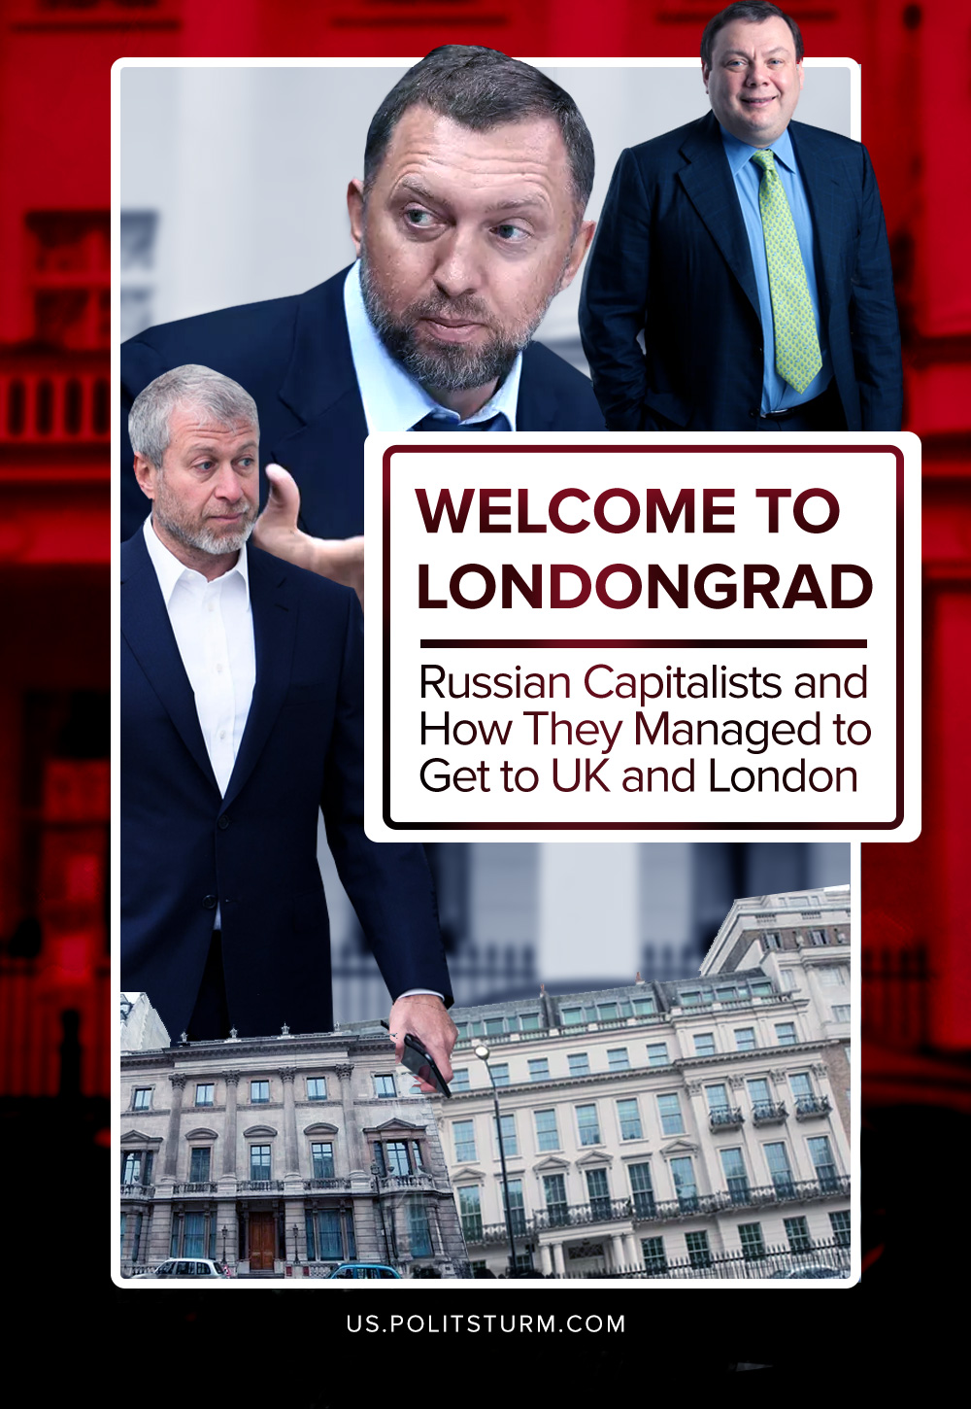

Original article
2022-04-10
11 min read

Recently, part of the Russian bourgeoisie has found itself under Western sanctions. Westminster hastened to freeze the assets of Russian oligarchs.
For example, Mikhail Fridman, one of the leaders of Russian “Alfa-Bank” and co-owner of the financial and investment consortium “Alfa Group”, the richest resident of London in 2019, complains that he has almost no cash and cannot leave London due to sanctions. “Maybe I should clean the house myself? It’s fine, when I was a student, when I lived in a small dorm room with four other people, but after 35 years, this was unexpected,” – says Fridman.
His “colleague” Pyotr Aven, the chairman of the board of directors of Alfa-Bank, found himself in a similar position. “Our business is completely destroyed. Everything that we have been building for 30 years is completely destroyed… We do not understand how to survive,” – says Aven.
How did the Russian oligarchy end up in the UK, and why are they so unhappy?
London is well-known for being one of the largest and most diverse cities in the world. Its history from a small port on the Thames, to an industrial center of the British Empire, to a financial nerve-point of the world economy, highlights its centuries of importance.
Recent events in Ukraine have brought concerns of British ties with Russian oligarchs to the forefront of political discourse once again. But this time Westminster has rushed to disavow and freeze the assets of Russian oligarchs lest its reputation be further ruined among the western allies who have formed a united front of sanctions directed at Moscow.
Some context, however, is necessary. It has been an open secret for decades that London is the primary location for the laundering of the money of the super-rich. Gulf oil sheikhs, Central Asian tyrants, Eastern European oligarchs and Latin American comparators. All see London as the place where their ill-gotten wealth stripped from their nations’ proletarians can be safely rinsed in the London laundromat of the stain of corruption, exploitation, and misery.
They are by no means the only ones to launder money in Britain; every nation’s bourgeoisie has laundered money via the City of London. Indeed, Russian capitalists are outclassed by European, American and even Finnish investment, but these groups of kleptocrats are simply the most notorious.
None so are as notorious as the Russian oligarchs; their patronage of both the City and Westminster has alarmed the British people and pundits since the late 90’s, when this phenomenon intensified. The truth is, that the real scale of the amount of Russian money laundered and invested in the UK cannot be ascertained; according to the Office of National Statistics, in 2016 Russian investments stood at £25.5bn. But this is a drop in the ocean.
Error loading image
Due to the many tax havens that the Russian bourgeoisie uses to offshore, it is hard to distinguish where it comes from, compounding that the money is held by opaque companies, further obfuscating who owns what, but a rough estimate according to a Deutsche Bank report, would be a further £67.5bn.
The banks were more than happy to aid their fellow capitalists in squireling away their ill-gotten wealth, with the previously mentioned Deutsche Bank being found to have been complicit in aiding Russian clients to secretly move £7.5bn ($10bn) by illegally exploiting the stock market two years after that report was published. As a result, the bank had to pay fines of £317m ($425m) in the US and £163m in the UK.
These oligarchs were even legally welcomed by the British state! The United Kingdom in 2008 created a Tier 1 (Investor) visa scheme which was quickly, mockingly, nicknamed “the golden visa”. This scheme offered residency to those rich enough to invest £2 million or more in the UK. Holders of the golden visa were able to apply for permanent residency in the UK, along with their families. This was happening whilst millions of Russian workers were hungry, working in dangerous and unsanitary conditions and worried about losing their homes. How quickly they could apply depended on the size of their investment:
- Two years with a £10m investment
- Three years with a £5m investment
- Five years with a £2m investment
The Home Office has issued 2,581 of these golden visas to Russian citizens, since the scheme began. Undoubtedly, thousands more have been given to Ukrainian oligarchs, Saudi princes and other bourgeois from around the world. The scheme was only scrapped on the 17th of February 2022 amid criticism of British links to Russia.
Compare this fast-track scheme to residency for the ultra-rich to the British policy on refugees and migrants. Escaping wars, started or aggravated by the imperialists in Britain, America and France, they are left to drown or freeze to death in the English Channel. Those that are lucky enough to make it to land alive, are kept in ad-hoc detention centers in army barracks with next to no basic sanitation or amenities and no respect for their human rights.
Error loading image
Even immigrants that were invited by the British government and have lived here for decades, are not safe from deportation. Caribbean immigrants, the ’Windrush Generation’ which settled in Britain after being invited to fill in demand for labor in the 50s and 60s, have been targeted by the British state over their supposed “lack of documentation”. Some of these people, most of whom are now in their 60s and 70s, have been “repatriated” to a land they have never even visited. It is clear from the bourgeoisie’s behavior towards their fellow exploiters from Russia and their behavior to the proletariat of their countries just how sanctimonious and inhumane these imperialists are.
Russian money has helped the finance sector of Britain (which dominates the UK’s economy) reap record profits. It has allowed the city to become one of the most expensive in the world, and all of that while squeezing the proletariat ever more as rent and mortgage was driven ever higher by Russian investment for landlords and capitalists to profit ever more. Such a situation went on for decades and due to other factors of capitalism has driven some proletarians in London to live in conditions that can only be described as Dickensian, while Russian capitalists buy mansions in London’s most expensive boroughs and neighborhoods just to leave them empty throughout most of the year.
Even the petty-bourgeoisie and labor aristocracy are finding it increasingly difficult to live as they used to, as even their high salaries and wages cannot cover the expenses that come with living and working in London anymore. If one considers the cost-of-living crisis that is unfolding in the UK and rising inflation, London will increasingly and rapidly begin to resemble its Victorian past.
Error loading image
Where there is money, political influence is sure to swiftly follow. It was not long before Russian oligarchs started funding political parties in Britain, most notably the Conservatives. Their leader, the current Prime Minister Boris Johnson, has financial ties to Alexander Temerko – a Russian arms-dealer and a major donor to the Conservative Party. The Tories duly returned the favor and turned a blind eye to further Russian investments on the London Stock Exchange.
The housing market, where at least £1.5 billion worth of UK property is owned by Russian oligarchs, was accused of financial crimes or ties with the Kremlin. One of England’s most famous football clubs, Chelsea FC, was bought by Roman Abramovich (one of the wealthiest oligarchs) which last year brought in a turnover of £434.9 million and many other sectors which were similarly infiltrated by Russian capital.
It seemed as if the gravy train would never end for Britain’s bourgeoisie who grew fat off the wealth being poured into the City. But as Lenin predicted, capitalist nations become increasingly hostile over time as they seek to gain larger and larger shares of the world-market to the detriment of other capitalist countries:
“The epoch of the latest stage of capitalism shows us that certain relations between capitalist associations grow up, based on the economic division of the world; while parallel to and in connection with it, certain relations grow up between political alliances, between states, on the basis of the territorial division of the world, of the struggle for colonies, of the “struggle for spheres of influence.”
As the 2010s went on and Russia became increasingly more confident, it began to diverge from the Western imperialists and started to chafe under what the Kremlin considers to be “Western dictate”. As the Russian bourgeoisie started to become more expansionist, it started to become more antagonistic to its counterparts in the West who, they believed, were infiltrating their traditional sphere of influence. This erupted into the open when following the pro-West coup in Ukraine, Russia incorporated Crimea and began supporting the puppet governments in Donetsk and Luhansk.
Sanctions quickly followed, and Russia was kicked from the G8. Successive governments in the UK offered little beyond words and petty sanctions; Russian money stolen from the proletarians of Russia continued to pour into London.
When the Russian “special military operation” in Ukraine commenced, Westminster and the financial elite in London scrambled to salvage the situation and jettison any monetary and economic links they had with Russia and its capitalists. However, in one last act of class solidarity with their counterparts in Russia, the government dragged its feet when it came to seizing the assets of Russian oligarchs allowing them to flee with most of their movable capital intact. This is despite the huge criticism of the Tories coming from the opposition in the House of Commons and the bourgeois media.
This thing is another proof of how corrupt and parasitic the British imperialists are. On the one hand, they were more than happy to do business with Russian capitalists. Aiding them in protecting their wealth, despite the hostile diplomatic relations between the two nations. On the other hand, the bourgeoisie in the UK behaved in the most reprehensible manner: child hunger in the United Kingdom reached 15% January-July of 2021, while Russian capitalists bought up mansions and flats. The British state gave out permanent residency to Russian millionaires and billionaires while simultaneously deporting British workers that have lived in the country for decades and letting refugees perish in their waters.
The current UK government is barely clinging to power as one corruption scandal, after another, has rocked the country over the past two years. Another is unfolding, as people are questioning how the British state sanctioned the laundering of such money. This, and the simultaneous events in Ukraine which the British government vocally opposes, is awakening the masses to the vile hypocrisy of their bourgeoisie. It was them who were handing out permanent residencies to the moneybags.
It is imperative that we, the communists, demonstrate just how little the bourgeoisie cares for the proletariat in reality, and that private property and capital are the source of this misery. The situation in Britain once again reveals the pressing need for proletarians of all countries to unite, for we have nothing to gain by supporting either the British or the Russian bourgeoisie.

Original article

