Wealthy Donors Backing Major Tea Party Organization
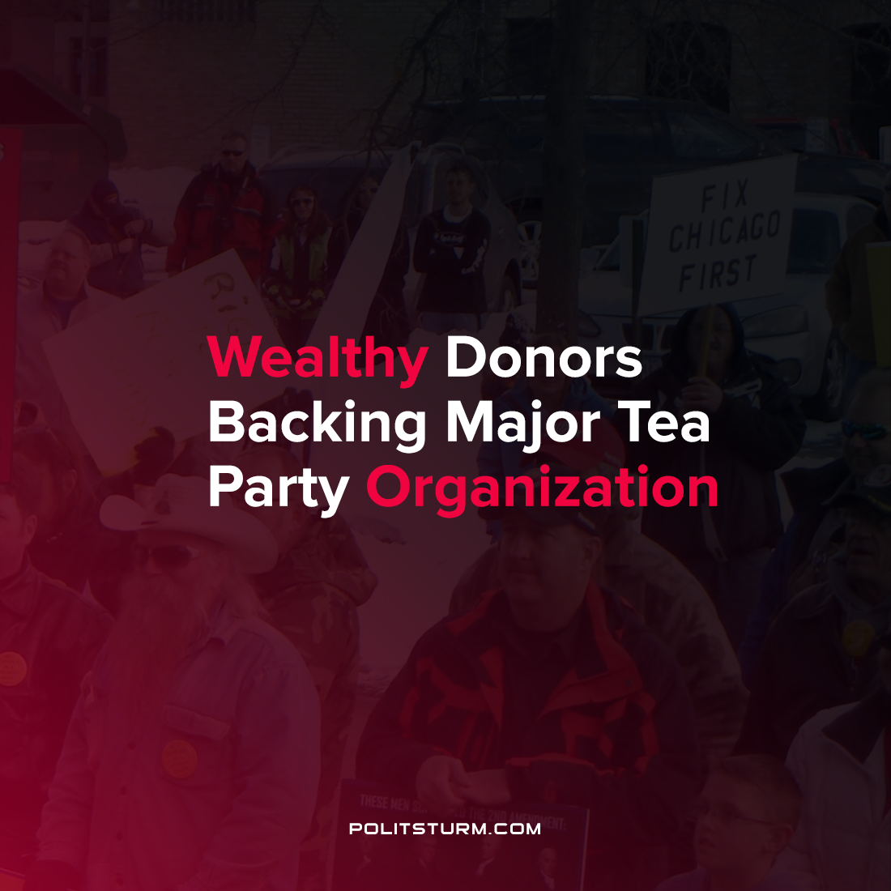

Original article
2021-08-05
1 min read

According to data obtained by The Intercept, the majority of the funding for the conservative group Tea Party Patriots (TPP) came from just three wealthy individuals. One of the donors, Christopher Goldsbury, who made a fortune selling Pace salsa to Campbell soup donated $1 million of the organizations $1.2 million in revenue in 2019. In addition to funding from ultra-wealthy individuals, the organization has received funding from interest groups and corporations. In total, the groups super-PAC contributed $2.9 million to the Trump 2020 election campaign.
The data also suggests that while the group claims to represent the views of “3 million patriots”, the number of active users is much smaller according to the leaked data.
The TPP was founded in 2009 and their platform is centered around personal freedom, lowering tax rates and government spending and the “rule of law”. Despite the typical flowery language surrounding liberty and freedom, the group supports the freedom of the capitalists to exploit labor and to amass massive private fortunes. This data leak is just another example of the capitalist class using their immense wealth to create fictitious grassroots campaigns which campaign for their personal class interests.
Source: 1

Original article

