"Wealth is Difficult to Measure in Money" - Minister of the National Economy of Kazakhstan Alibek Kuantyrov
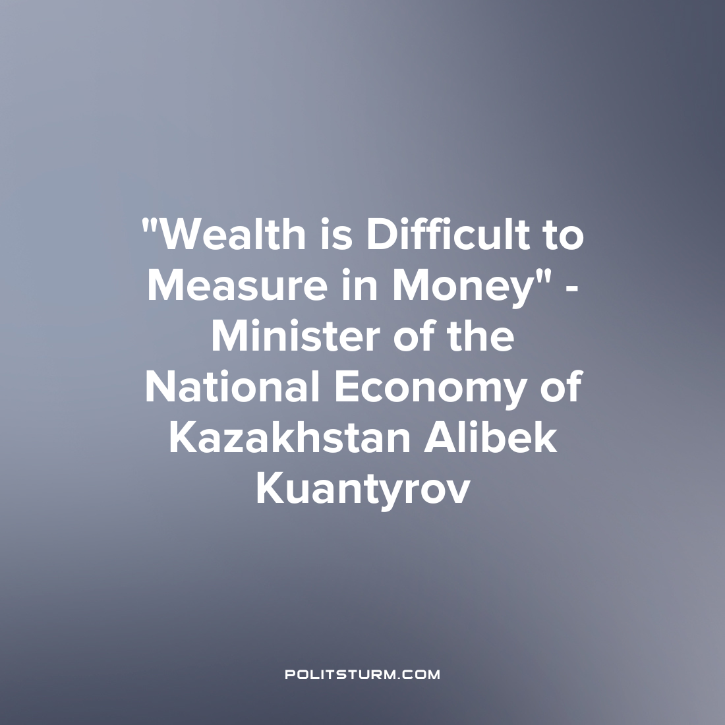

Original article
2023-06-08
1 min read

At the request of journalists, the minister tried to define the concept of a “rich person” who will be taxed on luxury.
"The concept of a "rich man" is very diverse. Ybyray Altynsarin said: "The wealth of Kazakhs is in work and contentment." Wealth is difficult to measure in money. We're not talking about rich people, we're talking about a luxury tax. It probably won't be called a luxury tax. It implies a tax on expensive goods. It is popularly called the luxury tax, so that it is clear. This is a tax on expensive cars, an air fleet, yachts, expensive fur products, jewelry, antiques," Alibek Kuantyrov said.
Earlier, he spoke about the active work of the relevant state agencies on the development of a new Tax Code, which will also include norms, and the luxury tax. The tax itself will be introduced in 2024.
In order to avoid drowning in their own gold, the unfortunate are “forced” to buy expensive cars, planes, yachts and so on, while their compatriots barely make ends meet. A sluggish attempt to gloss over this contradiction by talking about different interpretations of the concept of “wealth”, about great ancestors, glorious history, and spiritual unity. The latter is felt especially strongly when, after going to the store, the wallet loses a lot of weight, and the “unfortunate” owner of life passes by on a golden limousine. But in order not to cause unnecessary seething and discontent, such luxury taxes are introduced to divert the eyes. Whether the proceeds will be used to improve the living conditions of workers is a rhetorical question.
Source: zakon.kz - "Minister Kuantyrov about the luxury tax: Wealth is difficult to measure in money" from April 26, 2023

Original article

