Wealth Inequality Worsens During Pandemic
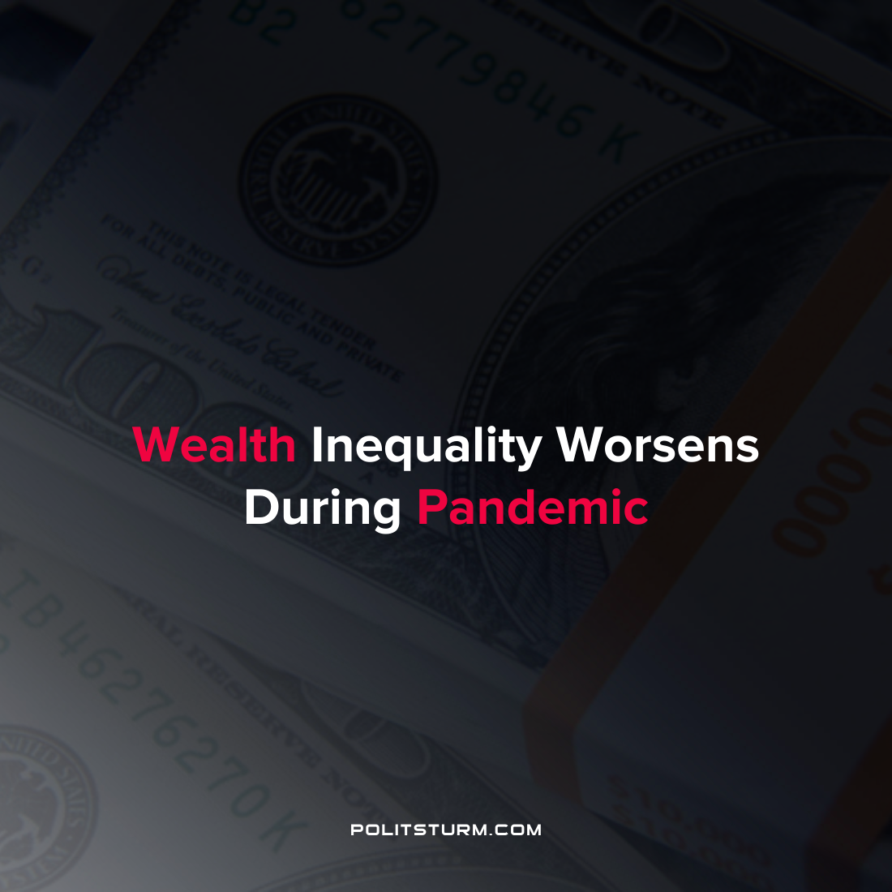

Original article
2021-12-08
1 min read

A new report issued by the World Inequality Database showed that wealth inequality has accelerated widening the gap between rich and poor. The research was conducted over four years by more than 100 researchers with the goal of compiling and analyzing data related to wealth inequality. The report claims that the top 1% have accumulated 38% of all global wealth created since the mid-1990s.
“The COVID crisis has exacerbated inequalities between the very wealthy and the rest of the population. Yet, in rich countries, government intervention prevented a massive rise in poverty, this was not the case in poor countries. This shows the importance of social states in the fight against poverty”, said the lead author of the report Lucas Chancel.
The report quantifies how over the past several decades the rich have benefitted from a reduction in taxes and tax evasion. It is suggested that wealth be redistributed within nations and from the imperialist core to combat the negative outcomes of wealth inequality.
The phenomenon of wealth inequality and the ability of the 1% to derive massive wealth is rooted in the private ownership of the means of production. Through this ownership relation oligarchs are able to extract profits and enlarge their private wealth at the expense of billions of exploited workers around the world.
Source: 1

Original article

