Wayfair Lays Off Nearly 900 Employees
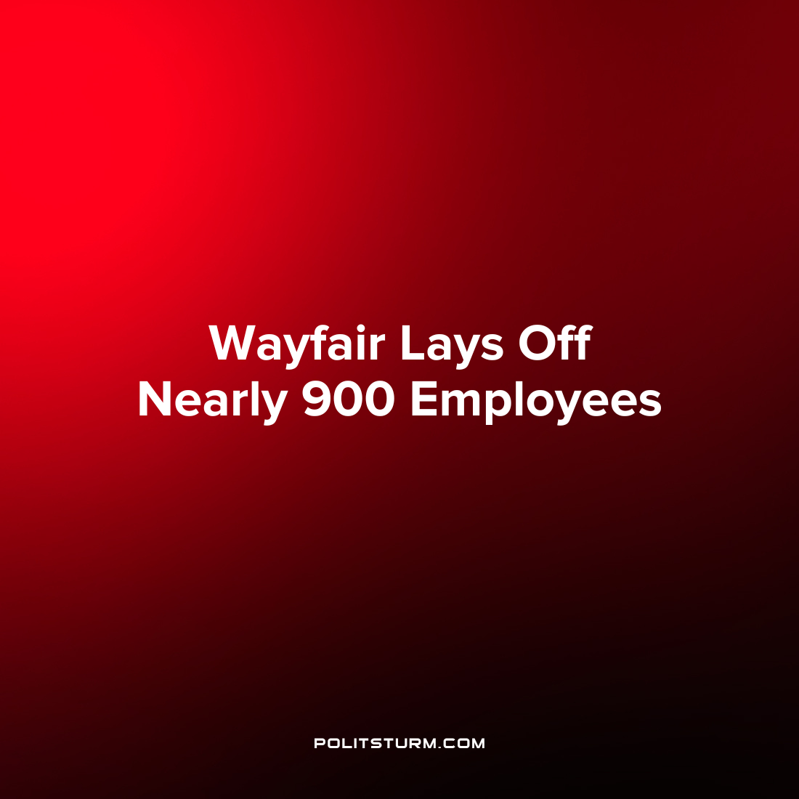

Original article
2022-08-19
1 min read

Boston-based retailer Wayfair announced that it would be laying off 870 workers, or about 5% of its global workforce. CEO and co-founder Niraj Shah released a letter to employees informing them of the layoffs and claiming to “take responsibility for the impact that this decision will have on the nearly 900 Wayfairians who will be told today they are no longer a part of building our company’s future”.
Shah stated that the company had grown significantly to keep pace with the growth of e-commerce however it has grown “too large for the environment we are now in”.
The company recently released its financial records for the second quarter and they posted a $372 million loss in the second quarter.
Under the capitalist economic system the livelihoods of the working class are precarious and workers can be thrown out of employment due to conditions beyond their control. While the CEO claims to “take responsibility” for the impact of the layoffs, the capitalists do not experience any inconvenience from the layoffs and these are simply empty worlds and platitudes. As long as capitalism exists, the existence of the workers will be precarious and subject to being upended by the periodic crises which are endemic to this mode of production.

Source: 1

Original article

