Washington Orchard Owners Settle Lawsuit and Pay $500,000 in Back Wages
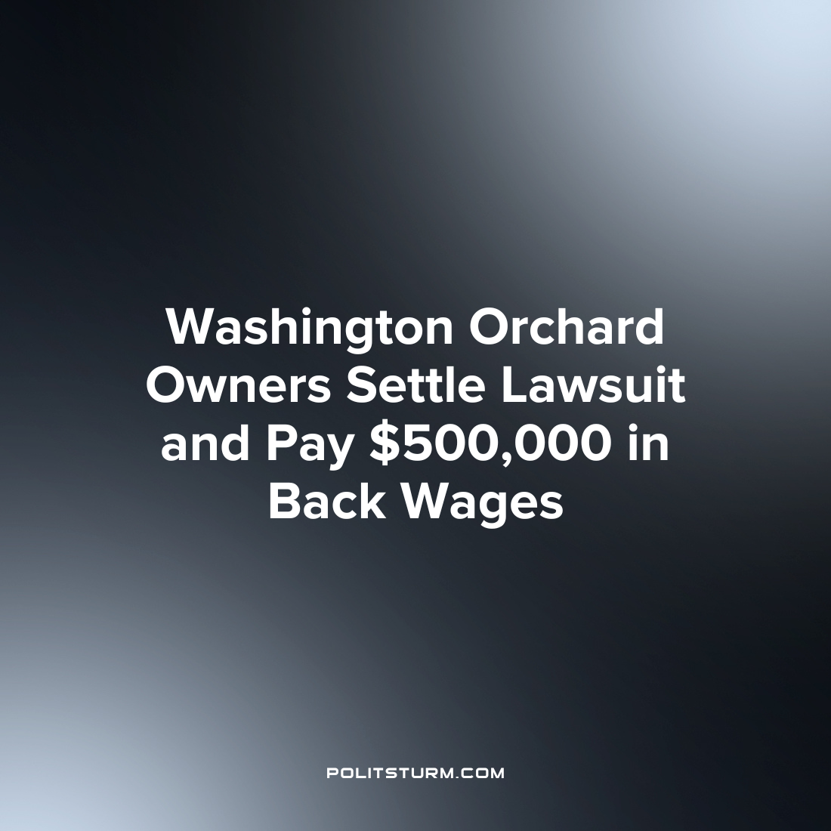

Original article
2023-07-17
1 min read

Rene and Carmen Garcia, owners of G&G Orchards Inc. and RC Orchards LLC, have settled a lawsuit brought forward by the Washington state Attorney General's Office for underpaying farmworkers. The business owners were found to have not paid workers properly for harvested fruit between 2018 and 2021 and have agreed to pay half-million dollars in back wages. The investigation by the state's Department of Labor & Industries (L&I) discovered that the farm owners owed workers either the piece rate for fruit harvested or an hourly rate, as stated in the employment contract. The workers were also owed wages for time spent waiting for machines to be repaired.
Under the settlement, the Garcias must inform their other employees about the payment and are prohibited from retaliating against or intimidating any current or former employees. L&I has additional requirements for the couple, including providing payroll reports and time sheets for workers, conducting self-audits every six months until 2024, and changing their record-keeping practices to accurately reflect all hours worked by employees.
A separate lawsuit filed by the Northwest Justice Project on behalf of seven H-2A workers against the Garcias was also settled in 2020, resulting in the workers receiving $240,000 in back wages and damages.
For every instance of reported wage theft and enforcement, there are likely many such instances that go unreported. Indeed, this is not even the first time that these specific capitalists have been accused and have settled claims of wage theft. Even when workers are paid the value of their wages, the capitalist still earns a profit which represents value created by the worker in production for which they are not paid. As long as capitalism exists, the workers will be exploited by the capitalist class and the oligarchs will continue to profit off the backs of the workers.
Source: 1

Original article

