Warren Buffett on Working Until You Die Under Capitalism
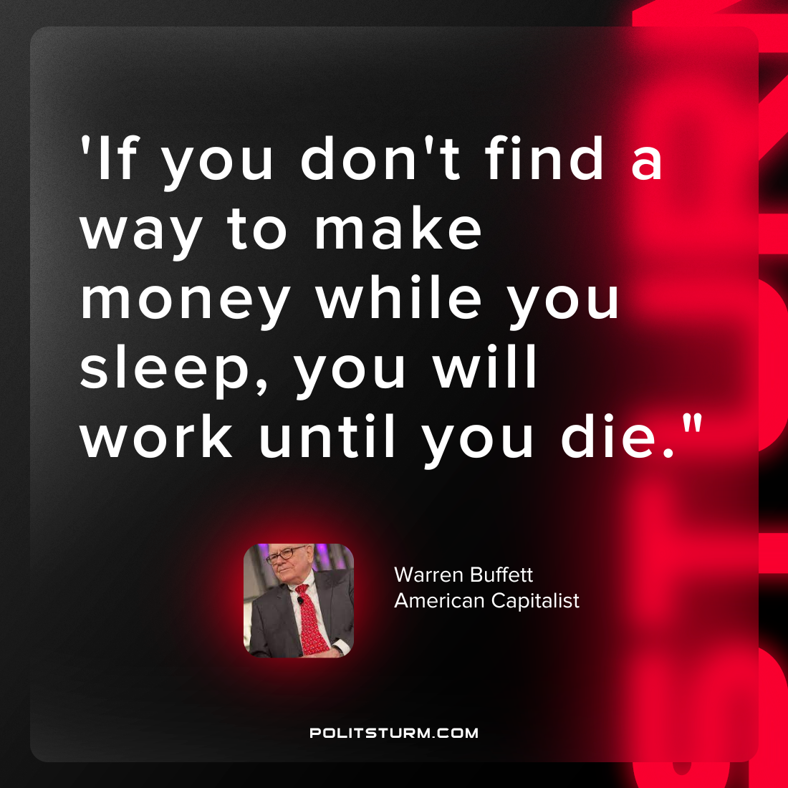

Original article
2022-10-02

“If you don’t find a way to make money while you sleep, you will work until you die”
Warren Buffett
American Capitalist

Original article

