War Threat and the Plight of Iranian Workers
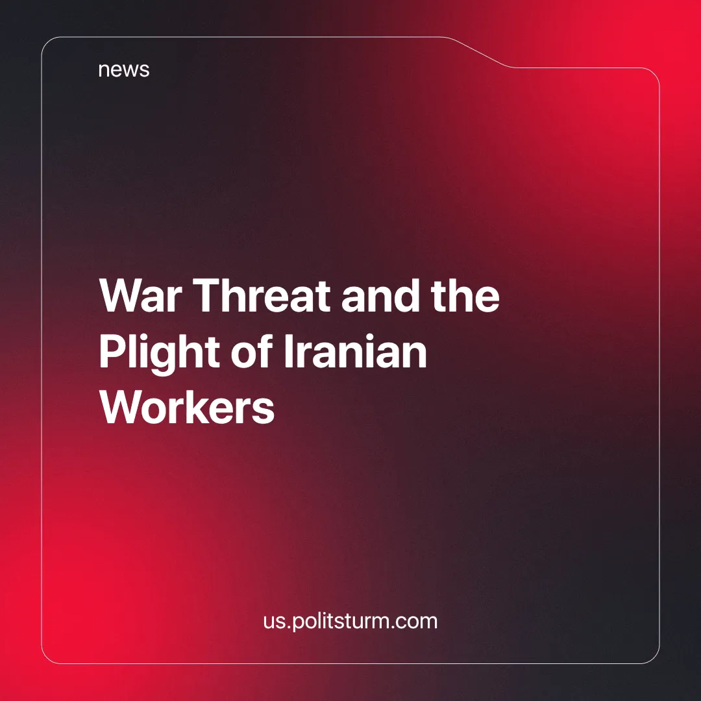

Original article
2024-10-15
2 min read

The growing tensions between Iran and Israel have dramatically increased the threats of plunging the Middle East into even further chaos. Recent reports have underlined just how precarious the Iranian economy already is, buckling under the weight of American sanctions and internal corruption. But the plight of the Iranian working class and its wider implications for regional stability have fallen by the wayside as both Tehran and Tel Aviv continue in militaristic posturing.
Both the Iranian and Israeli Governments display remarkable hypocrisy for supposedly ideologically different regimes. While the Iranian regime declares its leadership in the "The Axis of Resistance" and of regional sovereignty, it systematically refuses to put up with the power of workers and acts to facilitate the exploitation of Iranian workers, including 3 million child laborers and Afghan refugee children, being the country's major employer [1].
Meanwhile, under the rubric of "national security," Israel continues its machinery of occupation and disfranchisement, determining the fate of multitudes of people. As the most obtrusive outpost of U.S. imperialism, Israel has wasted no time in its duty to fabricate a terrorist state through mass civilian deaths — many among them children [2].
Under such regimes, chauvinistic rhetoric has been used to turn people against their neighbors and to garner mass support, but such rhetoric is only a tool to cling to state power and obscure bourgeois exploitation.
That is to say, something more general: the ruling classes in both countries are more concerned about their imperialist ambitions than the well-being of the working class.
The Iranian workers who toil to create the social wealth, struggling to survive, deserve not only to have the minimum of life, but also to thrive as the hegemon of a new society — not ridiculous talk about defending "their" homeland.
As one Iranian worker, who wished to remain anonymous, said: [3]
"We, the employees of the Khark Oil Company on Khark Island, have labored hard for years to make this terminal operational and be able to export the country's oil.
Considering the repeated threats by Israel to attack the oil facilities, these officials and the head of management do not consider the lives of these workers worth anything, and they do not even have a plan in case of an attack on the agenda.
They want to leave us here, hire us only for working, pay us little, and shut our mouths.
Food for thought."
As Marxists, we have to say that our stand is not with one reactionary camp against the other; our allegiance is with the working class. The road to liberation depends upon refuting both the Iranian and Israeli states, since the state is an organ of class rule, an organ for the oppression of one class by another.
Instead, we have to fight for an organized proletariat, led by its vanguard party, toward a future wherein the interest of the many will outbalance the interests of monopolies. In the face of a looming conflict, let us, with firmness, take a stand for class struggle and proceed to join Politsturm!
Sources:
[1] The Economist — Special Report [on Iran]: Stunted and Distorted — January 18, 2003.
[2] The Guardian — ‘Not a normal war’: doctors say children have been targeted by Israeli snipers in Gaza — April 2, 2024.
[3] Afkarneft (unofficial think tank of Iranian oil workers) — Anonymous Message from an Oil Worker — October 4, 2024.

Original article

