Wagner: Echo of Mutiny
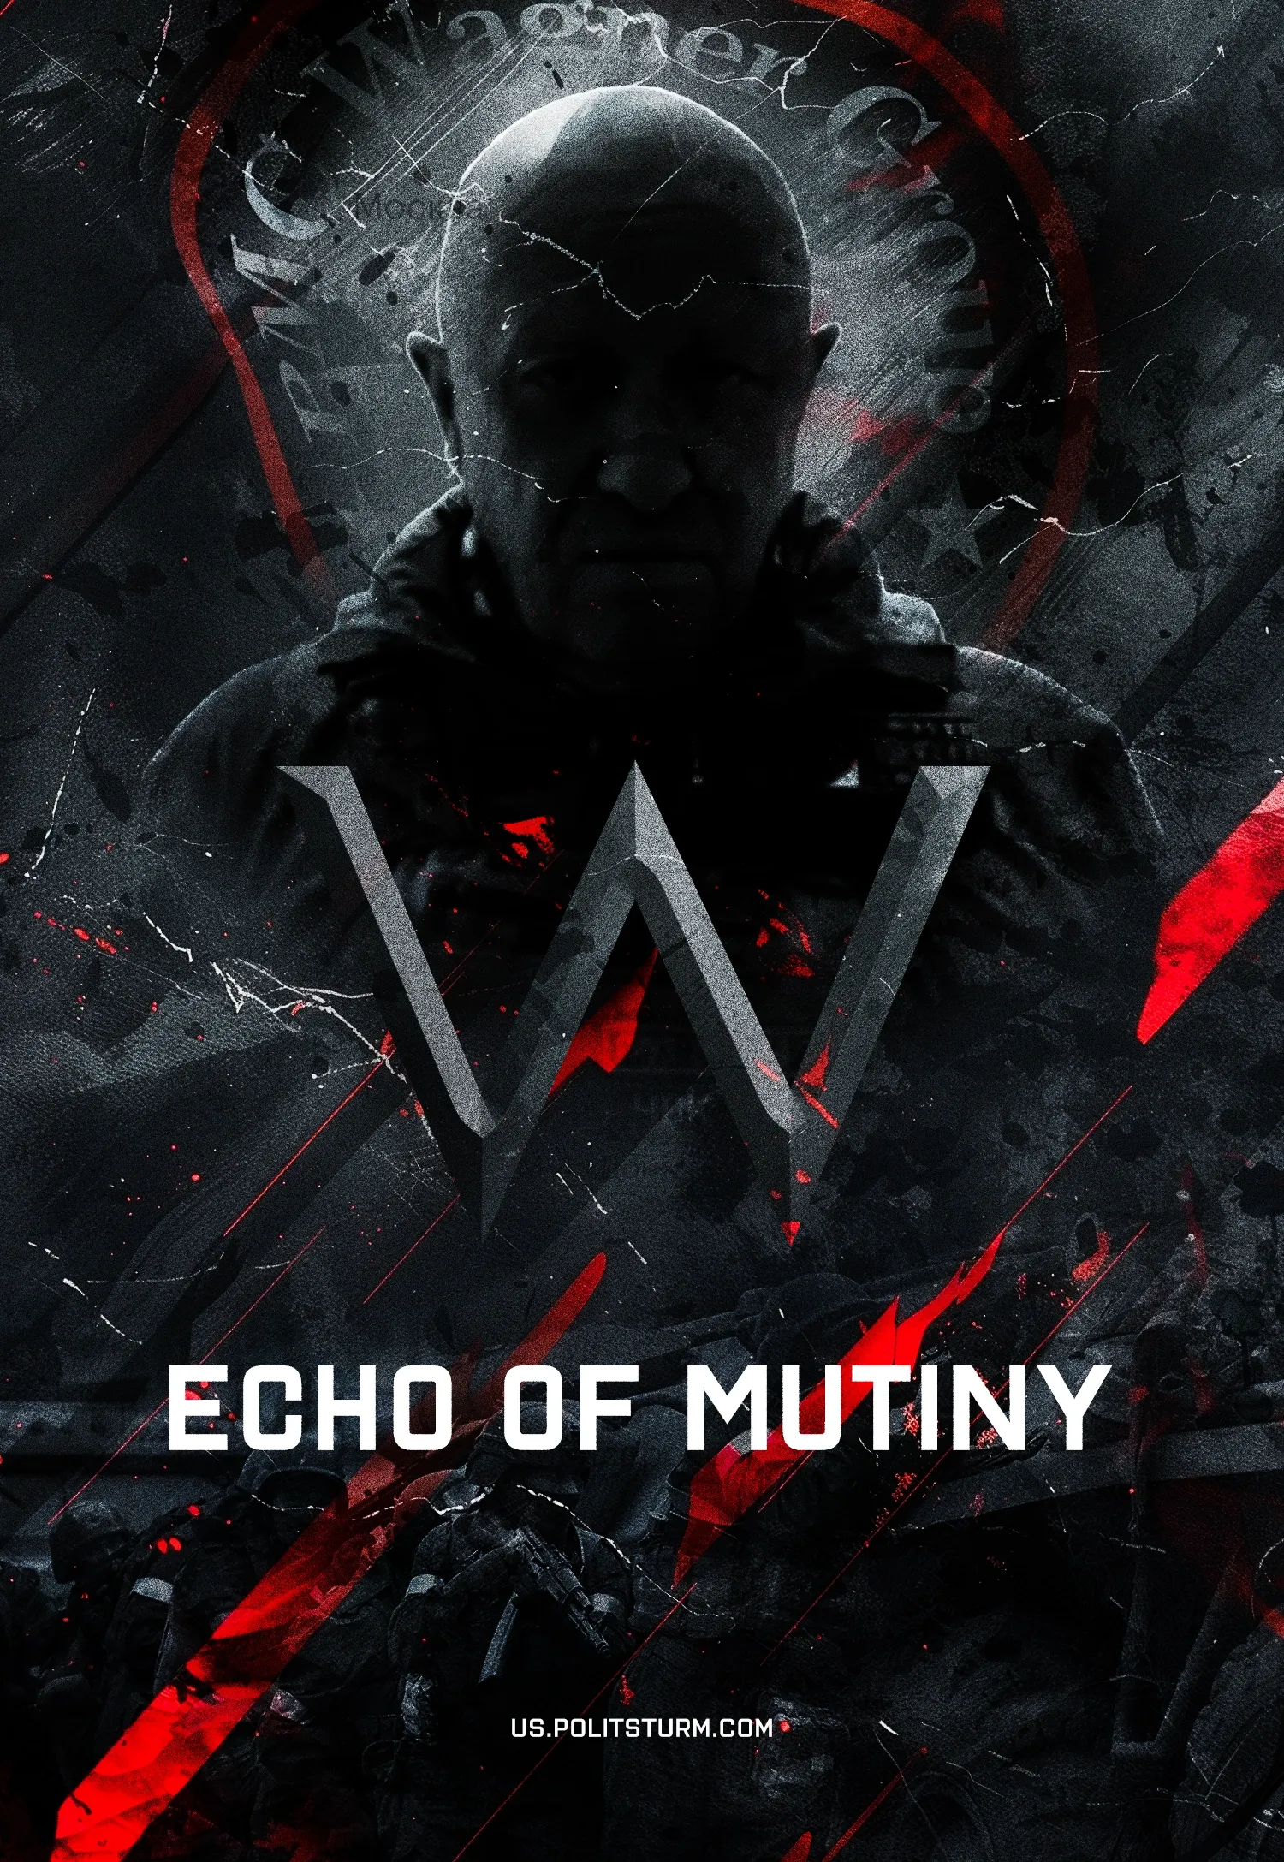

Original article
2024-06-23
27 min read

A year ago there was an attempted armed insurrection in Russia. Yevgeny Prigozhin and the Wagner PMC he controlled sent columns of armed mercenaries to Moscow, occupying Rostov-on-Don as they marched.
- Founded in 2013 under the leadership of Yevgeny Prigozhin and Dmitry "Wagner" Utkin, the Wagner Group acted as a military tool of the Russian ruling class, which it used in conflicts in Syria, Africa, and later in the ‘Special Military Operation’ in Ukraine.
- Gradually, Prigozhin began to increase his influence: from a simple businessman and “Putin's chef”, he became a powerful oligarch who controlled media resources and had his own private army.
- As the conflict in Ukraine continued and Prigozhin's resources grew, he began to clash with other representatives of the power clans: in particular, former Defense Minister Sergei Shoigu and Chief of the General Staff Valery Gerasimov. He accused the Defense Ministry of creating an artificial shortage of ammunition and putting pressure on Wagner.
- In June 2023, accusing the Russian Armed Forces of shelling PMC positions, Prigozhin attempted an armed rebellion and sent columns of mercenaries to Moscow. The Russian authorities were at a loss: the oligarchs fled from the capital, the president disappeared from the information space, and the propagandists remained silent. The conflict was averted thanks to behind-the-scenes negotiations after the intervention of Belarusian President Alexander Lukashenko. Wagner retired to Belarus, and Prigozhin presumably received some kind of security guarantees.
- However, the August plane crash claimed the lives of the Wagner elite; some of the mercenaries joined the Russian Armed Forces, some continued military campaigns in Africa, thus ending the intra-elite conflict.
- Prigozhin's rebellion was a manifestation of a deep political crisis, as the internal political struggle at the top of Russia's political elite intensified during the armed conflict in Ukraine.

I. Where did PMC Wagner come from?
Contrary to its name, this group was only formally a private military company. In reality, like all large PMCs, the Wagnerites were just a military tool in the hands of the Russian ruling class. Such "military companies" are used by the ruling circles of various countries where the use of official armed forces is difficult for political or other reasons. In this case, PMCs act as a convenient intermediary, a formally independent "private" company.
Since 2013, Russian capital has been actively using the Wagner Group in areas of its political and economic interests. The first commander of the group was a former GRU officer, Dmitry Utkin, with the callsign Wagner. This PMC was named after him. However, the head and main media person was Yevgeny Prigozhin.
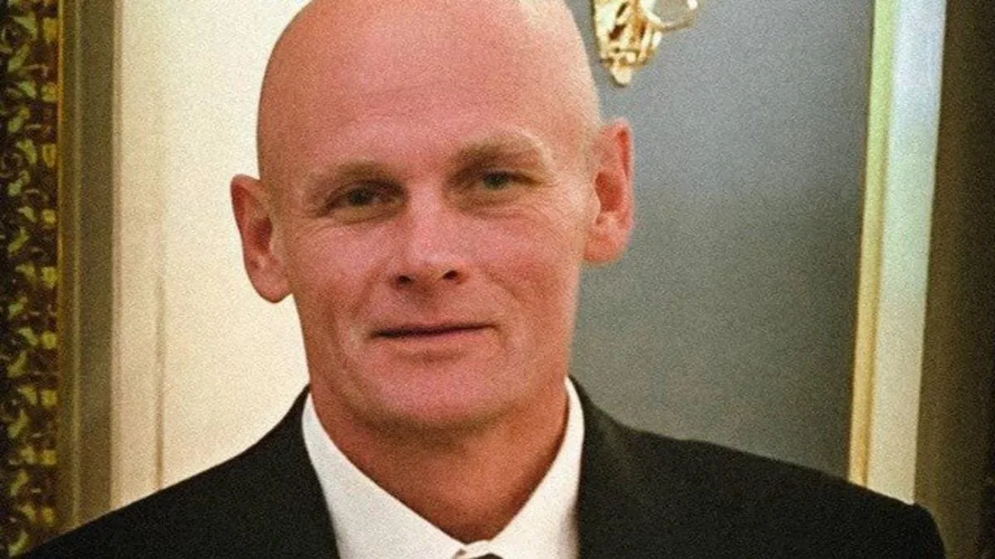
Dmitry "Wagner" Utkin
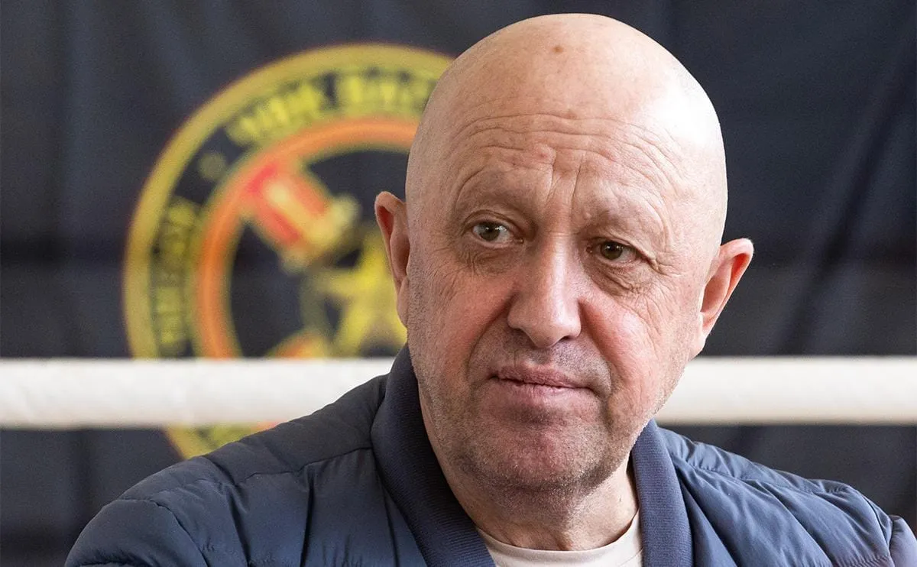
Yevgeny Prigozhin
Prigozhin is a man with a criminal past. In the 1980s, he served time in a colony for fraud, theft, and robbery. After his release in 1990, Prigozhin went into business in the food industry. By the 2000s, he owned several high-end restaurants and fast-food chains. At the same time, the future head of PMC began to get involved in construction and real estate. Even then, Prigozhin had connections with the country's top leadership: his restaurants were personally visited by Putin, Medvedev, as well as their guests: high-ranking foreign officials and politicians, in particular US President George W. Bush [1].
Since the beginning of the 2010s. Prigozhin's business has become increasingly intertwined with the state. Networks of public catering establishments served as the basis for a network of food factories that supplied food to government agencies. During this period, Prigozhin was called nothing less than "Putin's chef".
At the same time, Prigozhin's construction companies receive large contracts to build facilities for the Defense Ministry. His structures were turning into private military enterprises in the broadest sense. Prigozhin's companies provided services to the Russian army: cleaning barracks and training facilities of the Defense Ministry, supplying the army with food, and building military facilities. At the same time, Prigozhin worked on the creation of the Wagner PMC.
The first use of mercenaries as a military force was in Syria in 2013. Mercenaries were used to seize and protect industrial facilities, oil fields, and also to support the troops of the Syrian government of Bashar al-Assad. At that time, the PMC was called the "Slavic Corps" and consisted of only two detachments, one of which was led by Dmitry Utkin.
The first deployment of the "Slavic Corps" was unsuccessful, as a result of which it was disbanded. However, already in 2014 the mercenaries were gathered in the Wagner group under the leadership of Prigozhin. In the following years, mercenaries were actively used under this name in the Syrian conflict.
In 2014, the PMC took part in the conflict in Donbass, and after the completion of the main actions, the Russian leadership redirected the Wagnerites to a higher priority direction – to African countries. Wagner mercenaries operate in the Central African Republic, Mali, Niger, Chad, Mozambique, Sudan and other areas of expansion of Russian capital. The tasks of the PMCs in these countries were limited to supporting local governments and seizing sources of mineral resources in which the Russian capital expressed interest. Wagner still has a presence in many of these countries.
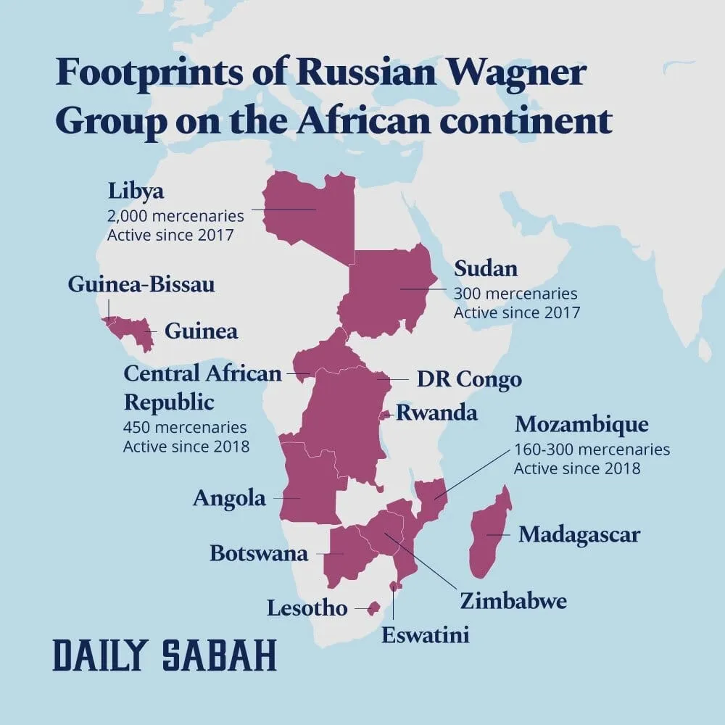
The map of the Wagner Group activities in Africa
At the same time, Prigozhin's mercenaries were exceptionally well armed. The Russian government provided them almost entirely with equipment, heavy weapons and ammunition. Until 2023, the Ministry of Defense provided the Wagner Group with a military training area in the Krasnodar region.
In the future, Putin personally confirmed the state funding of the Wagnerites:
"The maintenance of the Wagner PMC was fully provided by the state". [2]
Thus, Wagner as an armed force grew and developed not only with the tacit approval of the Russian political leadership, but also with its direct participation and financing.

II. Prigozhin on the rise
As the PMC grew, so did the income, wealth, and political influence of Prigozhin himself. He owned a number of companies.
“The Concord Holding” combined construction companies, companies that supplied food to the Russian army, and a number of other companies. The “Europolis” and “Mercury” companies, owned by Prigozhin, had contracts with the Syrian government to develop oil and gas fields. And the company "M Invest" was involved in gold mining in Sudan [3].
Thanks to the role that Prigozhin played for the Russian ruling class, as the performer of the most "dirty work", masking the openly predatory expansion of Russian capital, the former "chef" gained access to colossal resources and funds. By force of circumstances, from a simple mediator and executor, he became a noticeable force – he took the position of a great oligarch, whose economic interests objectively gave rise to his political aspirations.
For this purpose, Prigozhin created an entire media network of controlled resources. He owned a number of media outlets united in the “Patriot” holding company, as well as a network of telegram channels. It is known that a number of bloggers and war correspondents received money from Prigozhin's companies.
After the start of the Russian ‘Special Military Operation” on the territory of Ukraine, the Wagner Group received even more funds and opportunities. At the same time, the influence of Prigozhin himself continued to grow.
In March 2022, the Wagnerites occupied a sector of the front near the city of Bakhmut (Artemovsk) and fought fierce battles. During this period, the number of fighters increased significantly, and extensive advertising campaigns were conducted to recruit volunteers. The requirements for recruits were significantly lowered: anyone could join the ranks of the mercenaries.
In the summer of 2022, a radical change in the position of PMC took place: the authorities unofficially allowed Prigozhin to recruit volunteers in prisons. Prigozhin conducts a "tour" of Russian prisons and colonies, talking to prisoners and luring them to Wagner with promises of large sums and the prospect of pardon.
As a result: in 2022-2023 the Wagner Group got several tens of thousands of soldiers, its own artillery, air defense, attack aircraft and other equipment. The flow of money from the budget of the Russian Federation to the private army exceeded the annual budget of several cities with more than a million inhabitants.
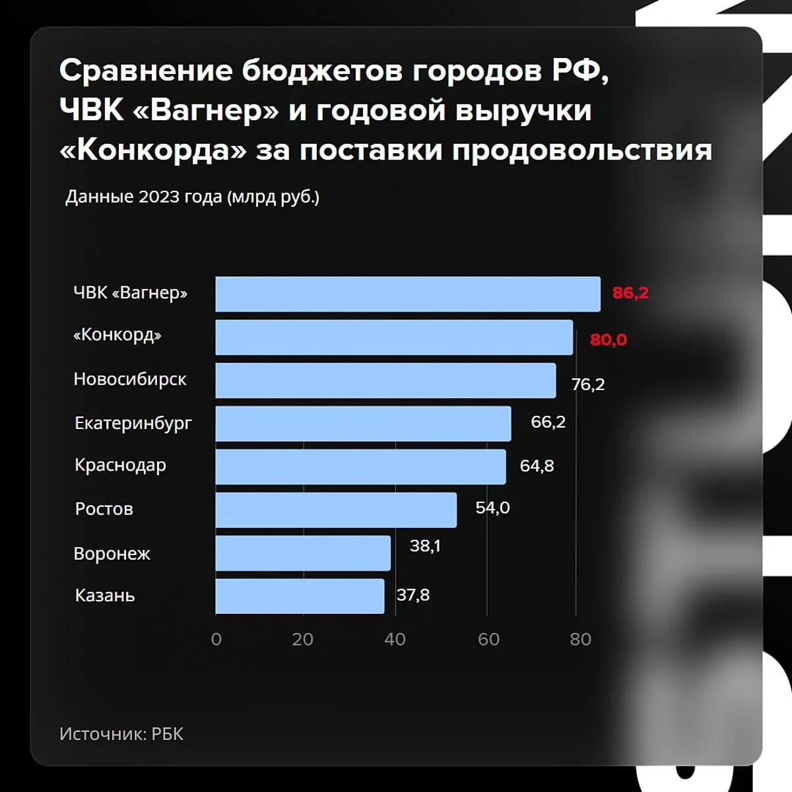
Comparison of the budgets of Russian cities, PMC "Wagner" and the annual revenue of "Concord Group" for food supplies. Data for 2023 (billion rubles).
From May 2022 to May 2023 Wagner received 86 billion rubles from the budget. In addition, Concord received another 80 billion from government contracts. Taking this into account, we can say that Prigozhin became an influential player with his own army.
Combined with the common distrust for the "official" oligarchs and the political elite, as well as Prigozhin's own claims to political influence, this could only lead to a clash against the backdrop of a general political crisis.

III. Conflict with the Ministry of Defense
No matter how rapid and dazzling Prigozhin's "rise" was, and no matter how his ambitions to take a "place of honor" among the Russian elites grew, most oligarchs and influential groups, especially in the "official" armed forces, did not accept him as an equal ‘partner’.
And then, from the second half of 2022, Prigozhin increased his political activity and launched a fight against his opponents in power.
Thus, he criticized Defense Minister Shoigu, Chief of the General Staff Gerasimov, and the Defense Ministry as a whole. Prigozhin accused the leadership of the Russian Armed Forces of ineffective management and of creating an artificial shortage of ammunition for the PMC. Prigozhin accused Shoigu and Gerasimov of inaction and of creating obstacles for Wagner. It is precisely for these reasons (and not for any particular combat tactics) that Prigozhin would go on to explain the heavy losses among the mercenaries.
In his speeches, Prigozhin drew a sharp contrast between Wagner and the Russian army, calling his PMC "the most effective fighting unit”. Prigozhin tried to create an image of his private army as the only successful and combat-ready Russian paramilitary structure. At the same time, he took on major politicians and officials: Dmitry Medvedev, Ramzan Kadyrov, and others.
At the same time, state propaganda continued to treat Prigozhin favorably. Soloviev, Russian TV propagandist, encouraged [6] to join Wagner and wrote laudatory reports about PMC. Margarita Simonyan, the editor-in-chief of “Russia Today”, [7] took a similar position.
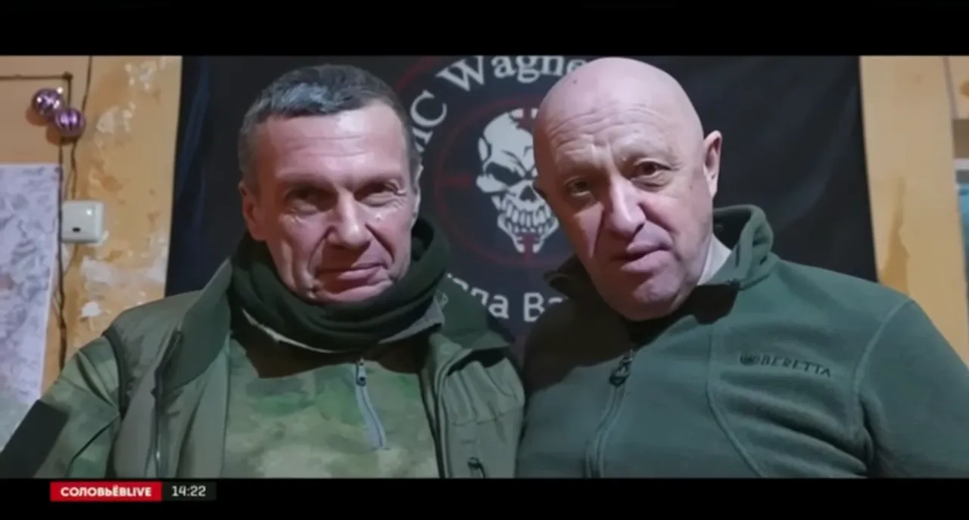
Solovyov and Prigozhin together
Pro-military bloggers spread Prigozhin's messages about the ammunition shortage and generally expressed sympathy for the head of the PMC in his conflict with the Defense Ministry. Among them were Boris Rozhin [8] and Yuri Podolyaka [9]. Both Crimean leader Aksenov and “A Just Russia” social-democratic party leader Mironov openly supported Prigozhin [10].
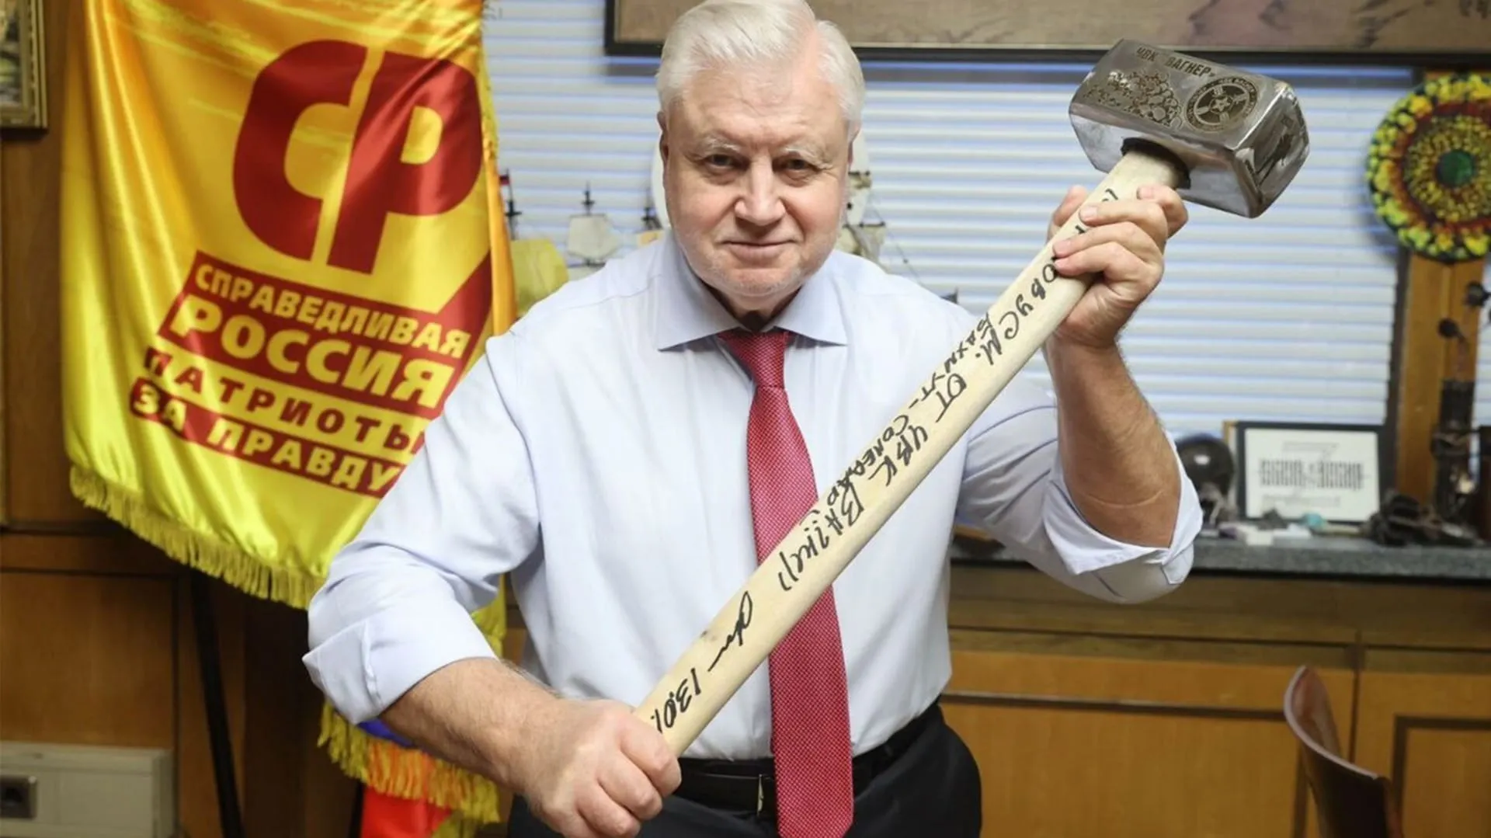
Mironov poses with the Wagner's hammer, which became popular after infamous video of execution of a Wagner soldier who deserted to Ukrainians
The Wagner group, though with heavy losses, achieved local military successes: it conquered the cities of Bakhmut, Soledar and a number of other settlements.
The successes of Wagner were extremely beneficial for the Russian authorities, and they highly appreciated Prigozhin's achievements. In turn, Prigozhin himself presented all these events as the only successes of the Russian side of the conflict in that period. On the wave of military successes, Prigozhin increased the pressure on the Ministry of Defense and the "official military" in power. During this period, he had significant media support due to his resources. The head of Wagner tried to create an image of an honest and uncompromising figure, devoted to the interests of Russia and the president personally.
But despite the general "patriotic" rhetoric, videos of Prigozhin's speeches and interviews criticizing the oligarchs, corruption, and the idle life of the Russian elite began to spread rapidly on the Internet.
As the conflict with the authorities escalated, his populist rhetoric became harsher. He talked about the theft of Donbass by the oligarchs and the Russian authorities, about corruption in the army, and about attributing the military successes of the PMC in Syria to the official armed forces. In the end, he arrived at criticism of the ‘SMO’, veiled attacks on the president, and even threats to expose the front and voluntarily retreat to the rear – if the conditions he presented to the Defense Ministry are not met [11, 12].
In response to Prigozhin's actions and his rapidly growing authority in military and paramilitary circles, the Defense Ministry tried to take the Wagnerites under its direct control.
In February 2023, the flow of prisoners to the Wagner PMC was blocked through the efforts of a behind-the-scenes struggle. And in May, the mercenaries were completely removed from the front and moved to the rear. During this period, final preparations were made to neutralize Prigozhin as an independent force. But Prigozhin himself was preparing for retaliation. The moment of direct clash was coming.

IV. Mutiny
On June 10, 2023, Defense Minister Shoigu issued an order requiring employees of all PMCs and volunteer formations to sign a contract with the Ministry of Defense [4]. All unofficial armed groups, according to the order, should come under the direct control of the Ministry of Defense. Obviously, the order was primarily directed against Wagner as the largest and most visible force.
However, Prigozhin refused to obey Shoigu's orders, and the confrontation between the mercenaries and the official authorities reached its climax.
On June 23, Prigozhin accused the Russian Armed Forces of carrying out an airstrike on the PMC’s camp on Shoigu's orders. It is worth noting that it is still not entirely clear what exactly happened that day: whether there really was a "planned" bombardment of the Wagner positions, or whether it was all staged.
However, there were enough reports of an attack on the mercenaries – the news was quickly spread by Prigozhin's media, the mercenaries accused the military leadership of trying to liquidate the formation by force and announced the start of a "march of justice" on Moscow.
A mutiny began in Russia.
Wagner's forces were split in several columns: Prigozhin entered Rostov-on-Don and took control of the headquarters of the Southern Military District without resistance. At the same time, a long column of several thousand PMC soldiers moved toward Moscow, meeting almost no resistance.
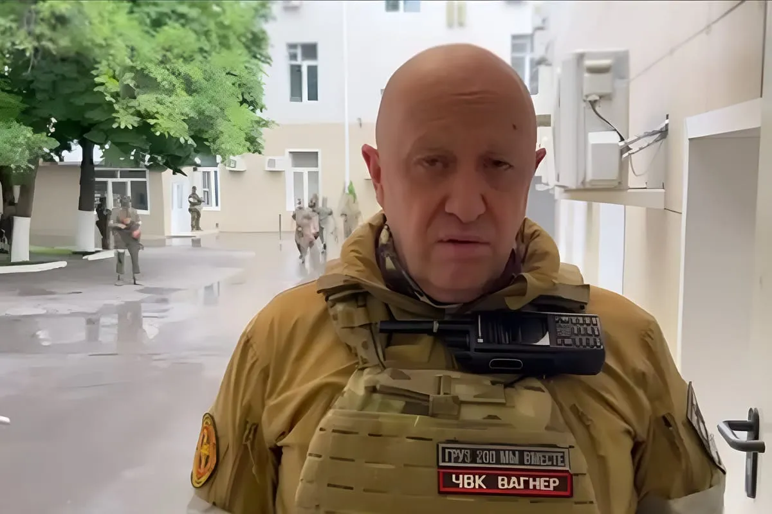
Prigozhin at the SMD headquarters on June 24, 2023.
On the way, the Wagnerites passed through the Voronezh and Lipetsk regions. There was information about the PMC shooting down one plane and 6 helicopters of the Russian army. On June 24, the mercenaries were about 400 kilometers away from the capital.
The authorities were completely confused. Top officials and oligarchs began to leave Moscow en masse. Generals Surovikin [13] and Alekseev [14] record appeals to PMC fighters, asking them to stop. At the same time, government propagandists remained silent until the president spoke. Putin himself virtually disappeared from the information space, and Telegram channels announced that the president's special flight had already left the capital for St. Petersburg. Just one day later, Putin appeared with a statement in which he called Prigozhin's speech "a stab in the back" and compared what was happening to the events of 1917.
Only after this presidential speech did the propagandists begin to speak cautiously: Soloviev, Dugin [15] and others.
An anti-terrorist operation was declared in the Moscow region. On the approaches to the capital, the preparation of defensive structures began, and the military began to gather in the city.
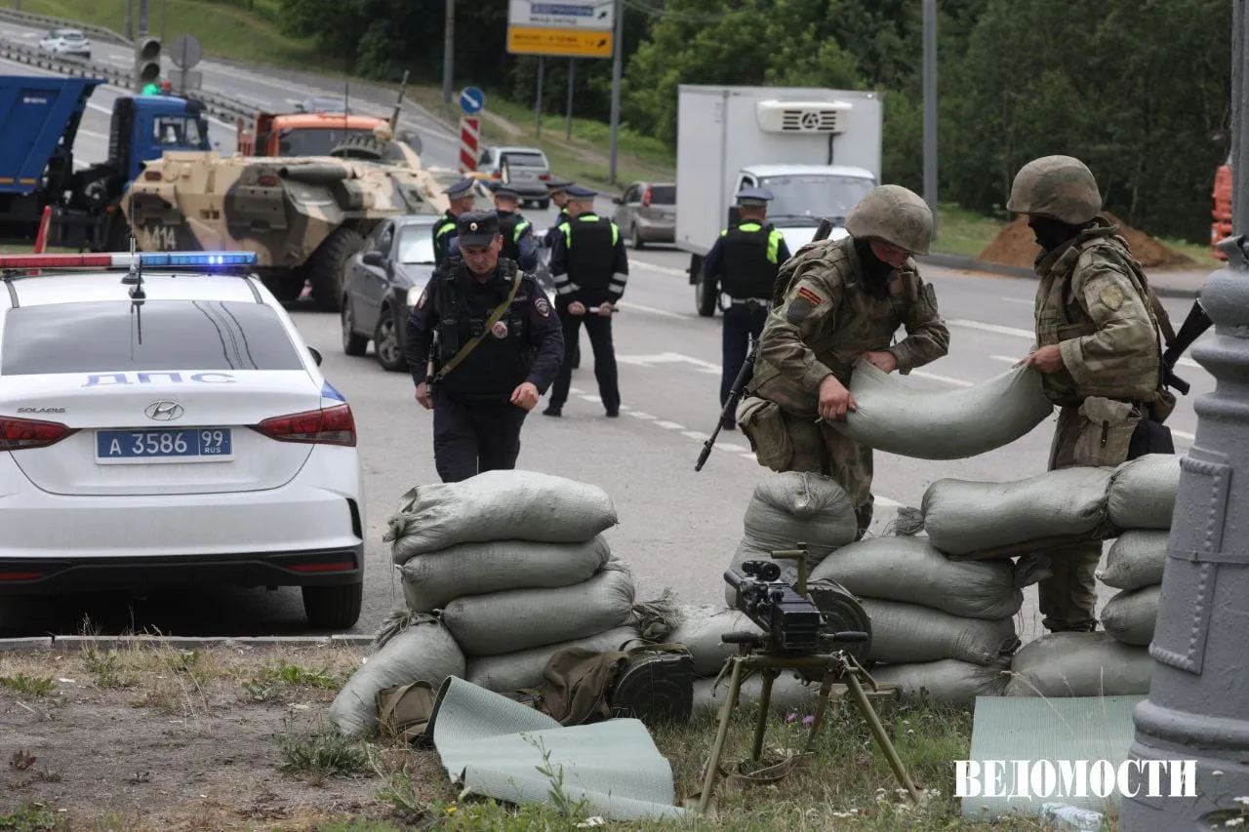
Defenses near Moscow on June 24, 2023
But the very next day, June 24, the Wagner column stopped. Prigozhin and the ruling circles of the Russian Federation, through Belarusian president Lukashenko's mediation, came to some kind of non-public agreement, the content of which is still unknown. According to the announced details, the Wagner PMC was transferred to Belarus, and the criminal case against Prigozhin for an armed coup, initiated the day before, was dropped. At the same time, the mercenaries were effectively absolved of any responsibility for the murder of Russian military personnel.

V. The fate of Wagner after the mutiny
Two months after the mutiny, on August 23, 2023, as a result of an explosion for unknown reasons on board a private plane flying from Moscow to St. Petersburg, the entire top leadership of Wagner was killed: Evgeny Prigozhin, PMC Commander Dmitry Utkin, Head of the PMC Supply Service Valery Chekalov [5].
The plane crash put an end to the confrontation between the largest Russian PMC and the Defense Ministry. Not everyone believed in the official version of Prigozhin's death: Telegram channels associated with Wagner, a number of military correspondents, right-wing figures and organizations still spread rumors that Prigozhin is allegedly alive in Africa. From time to time, low-quality photos and videos, allegedly of the former PMC chief, appear on the Internet.
After Prigozhin's death, however, Wagner came under the full control of the Defense Ministry. According to available information, the remnants of the Wagnerites in Russia are now one of the units of the Rosgvardiya (“National Guard of Russia”). Some of the mercenaries have moved to other PMCs controlled by the Russian Army. For example, mercenaries who broke away from Prigozhin during the rebellion, under the leadership of Andrei Troshev, moved to the Redut PMC. New detachments [16] are recruited from other former Wagner fighters and sent to the combat zone.
The part of the mercenaries that remained in Africa completely submitted to the official army. About a thousand mercenaries based in the Central African Republic signed a contract with the Ministry of Defense. At the same time, the former Wagner bases in Belarus were closed. The remaining mercenaries signed contracts with the Belarusian company “GardService”.

VI. What did the mutiny show?
Prigozhin's mutiny revealed many systemic features and tendencies of the current structure of political power in Russia that were previously hidden from the general population.

1. The struggle of the capitalists
First of all, the mutiny showed that, contrary to the statements of the state propaganda and officials who tried to create an image of cohesion and national unity throughout 2022 and the first half of 2023, a sharp and fierce struggle is taking place among the capitalists and ruling circles.
Before the ‘SMO’, flashes of internal struggle broke out only occasionally in the form of resignations or reappointments of certain politicians, or the imprisonment of not the most influential oligarchs; much less often: mysterious deaths of top managers and executives, large political rallies and protests. The ‘Special Military Operation’ has obviously exacerbated all the intra-elite contradictions and competition inherent in the ruling class's dominant groupings and their subordinate security and government structures.
What was completely new was that this struggle took on an open armed character. So far, as an excess – in the form of a mutiny, a rebellion of a single group. But this alone indicates the presence of accumulated, insoluble contradictions of Russian capitalism, which have reached extreme aggravation.
It is not yet completely clear with which of the biggest oligarchs Prigozhin was connected and if he was connected. Nor do we have all the information about which political forces supported the rebellion. However, it seems doubtful that Prigozhin and his PMC, being such a serious force, did not have contacts with other influential clans of Russian capitalists. And although we do not yet have complete information, it is quite likely that Prigozhin could be acting as an instrument of another, more influential force, competing with its current masters for power over the Kremlin.
The events of the mutiny clearly show that the tendency to a split and full-scale struggle between various groups of the ruling class in Russia is a real prospect for the development of the internal political situation in the event of another military or political coup.

2. Bourgeois law
The behavior of the law enforcement agencies during and after the Wagner uprising once again traversed the entire system of bourgeois law, showing the class nature of the existing legal system. Laws are applied when and in relation to those who are in favor of the ruling class. And when the situation changes, nothing prevents them from playing it all back.
For example, Prigozhin was initially charged with armed rebellion under Article 279 of the Criminal Code of the Russian Federation. But after Lukashenko's intervention and the resolution of the crisis, the criminal case was quickly dropped, the refusal to prosecute the mercenaries who participated in the rebellion and the removal of responsibility from them for actions during the rebellion were proclaimed. Obviously, this was done within the framework of the agreements reached with Prigozhin.
All this proves once again the hypocrisy of the bourgeois propagandists who talk about the rule of law. It is not the law that determines the rules of the game under capitalism, but personal agreements and informal rules that are made behind closed doors to which the media have no access. Laws apply only when the ruling class needs them.

3. The reaction of the people
The most important and significant consequence of Prigozhin's rebellion was the reaction of Russian citizens: there were no mass demonstrations, rallies, or actions in support of either the authorities or the mercenaries. Except for Rostov-on-Don, the inhabitants of not a single large city went out on the streets and did not express their position in any way.
On the contrary, the majority of the Russian people showed detachment from the unfolding events, preferring indifferent observation. This reaction, better than any "public opinion" poll, shows the true mood of Russians: passivity and indifference to both bourgeois politics and power. The main thing people were interested in during this period was the preservation of their usual everyday life, no matter what political background it took place against.
This behavior of Russians during the days of the rebellion shatters all the propaganda theories about popular support for the policies of the state and the system of power itself.

VII. One year after the mutiny
Summing up the results [17] of the rebellion in the summer of 2023, we predicted that it would certainly intensify the struggle within the ruling groups of Russia, lead to a significant tightening of the political system, and increase repression. One year after the mutiny, we can say that this prediction has come true.

1. Intensification of the struggle between the factions of the ruling class
We pointed out that Prigozhin's rebellion was the first chord of a future large-scale clash between various groups of capitalists. During the whole period of 2022-2023 there was an internal struggle. They didn't talk about it on federal television, they didn't write about it in the media, but its echoes broke through in every possible way.
A series of mysterious deaths of top managers and senior executives of large corporations. Resignations and arrests of small and medium managers of various departments. The flight of Anatoly Chubais from Russia and his creation of a "Center for the Study of Post-Putin Russia" in Israel. Pressure on billionaire Oleg Tinkov, who was forced to give up control of Tinkoff Bank (known as T-Bank now). All these events became echoes of the fierce behind-the-scenes struggle that took place during the first two years of the ‘Special Military Operation’.
But Prigozhin's rebellion significantly intensified this struggle. Although the second half of 2023 passed without any visible clashes, 2024 began with the high-profile arrest of Deputy Defense Minister Timur Ivanov. This was soon followed by the replacement of Shoigu as defense minister and the resignation of Patrushev, previously considered an influential security official, from the post of chairman of the Security Council. All of this was accompanied by the arrest of other high-ranking defense officials and generals.
The behind-the-scenes struggle between various influential figures in Russian politics has led to a noticeable change in the balance of power within the ruling group.
But the internal struggle is just beginning. The more the economic and political situation deteriorates, as well as the situation in the zone of special military operations, the more the struggle at the top will intensify.
The most important thing here is that Prigozhin's rebellion in this struggle creates a precedent that can overturn all the previously established "rules" of the internal struggle. Oligarchs and influential clans, who in the course of the years of the ‘SMO’ have acquired their own private armies [18], in the event of an acute political crisis, will have before them a clear example of how to act when the question of the fate of their property and position arises.
Therefore, we should expect that Prigozhin's rebellion is not an incident or an "excess" of the political life of Russia in the era of the special operation, but a prototype of the future struggle for power and capital.

2. Tightening the regime and intensifying repression
In addition to intensifying the internal struggle, we pointed out that the state authorities will certainly take advantage of the situation with the rebellion to further tighten the political system. To intensify repression against disloyal or potentially disloyal groups and to strengthen control over previously independent groups and organizations. And so it happened.
In Russia, after the mutiny, the total number of repressions and persecutions increased due to the expansion of the register of "foreign agents" and "extremists". Many famous and despicable figures found themselves behind bars.
But in addition to the arrest of important and well-known figures, the persecution of ordinary supporters and participants of opposition organizations and movements increased every week. It is important to note that the ruling class, while pursuing a policy of increasing repression, does not take into consideration the position and views of the persecuted. It doesn't matter whether these people defend right-wing or left-wing views, just as it doesn't matter whether they support the ‘SMO’ or not. Repression has also increased against organizations and movements that were originally non-political. Anyone whose loyalty can be doubted is subject to arrest. This is the logic of the excessive escalation of repression in conditions of fierce internal and external struggle.
In addition, the ostentatious cruelty of the actions of the security forces has noticeably increased.
But in addition to the usual repression, the entire political system in Russia has become harsher. The pressure exerted by the security forces on the opposition was accompanied by a further increase in restrictions on legal political activity. Opposition politicians were increasingly pushed out of local authorities and municipalities. And the State Duma is considering amending the law on foreign agents to ban them from participating in elections.
Thus, Russia's ruling class began to pursue a much more reactionary policy. All this is a natural result of the crisis that is gradually developing and deepening in Russia. In this sense, Wagner's rebellion was only one of the most striking manifestations of this crisis, which indicates a serious change in the entire socio-political system of Russia.
Prigozhin's mutiny was both a precondition and a consequence of this crisis. Since it was itself generated by the crisis processes and the aggravation of the contradictions of Russian imperialism, it deepened and widened the crisis, leading to an increase in reactionism and a further tightening of the political system.

Sources
- Prigoshin Yevgeny Viktorovich – Biography on the RBC site, accessed on June 16, 2024.
- RBC – ”Putin named budget spendings on the Wagner PMC”, accessed on June 27, 2023.
- “Novye Izvestiya on-line” – “Won’t die from hunger: what Yevgeny Prigozhin owns”, July 27, 2023.
- Известия – Shoigu signed an order on the procedure for organizing the activities of volunteer organizations, June 10, 2024.
- RBC – A plane with Yevgeny Prigozhin on board crashed, August 27, 2023.
- Solovyov Telegram Channel – publication on May 2, 2023.
- Simonyan Telegram channel – publication on January 11, 2023.
- “Colonelcassad” Telegram channel – publication on February 16, 2023.
- “World Today with Yuri Podolyaka” Telegram channel – publication on February 20, 2023.
- “Aksyonov Z 82” Telegram channel – publication on February 20, 2023.
- “Dolgov Says (18+)” Telegram channel – publication on May 23, 2023.
- “Prigozhin’s Cap” Telegram channel – Prigozhin speech on May 9, 2023.
- Politsturm Telegram channel – publication on June 24, 2023.
- Politsturm Telegram channel – publication on June 24, 2023.
- “Tsargrad TV” VKontakte group – publication on June 24, 2023.
- “Nizhny Novgorod Online” – ”New Nizhegorodian squad “Guardians of the Motherland” went on the ‘SMO’. It consists of former PMC Wagner fighters. November 1, 2023.
- Politsturm – The Wagner Rebellion: Aftermath. June 30, 2023.
- Politsturm – Russian Mercenaries: How Many, and What They Do? October 28, 2023.

Original article

