Victory Day — 2020
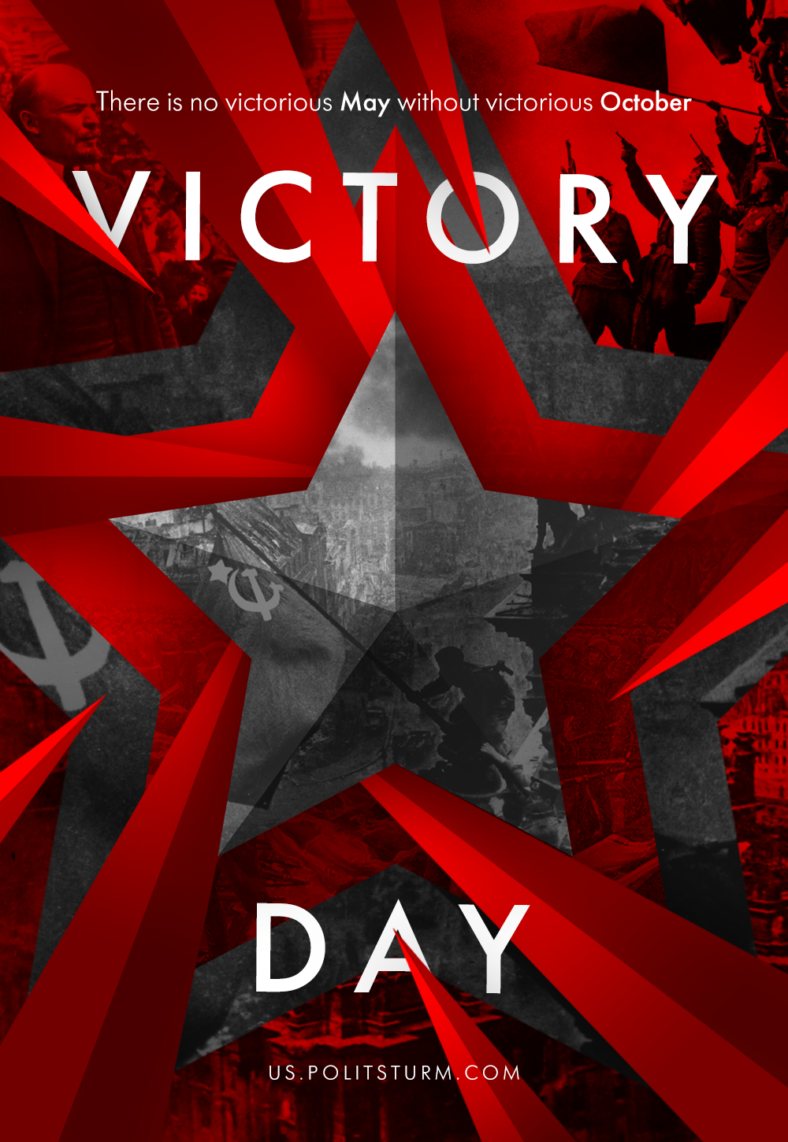

Original article
2020-05-09
1 min read

Could the Red Army soldiers know that their grandchildren would build not a bright future, but palaces for capitalists? Could they know that their struggle would be used to maintain the power of capital?
No, they didn’t fight for that. Soviet soldiers fought for the future, where there would be no exploitation of a human by a human, where there would be neither class, nor social, nor any other oppression. For the future, where there will be no hypocritical lies.
The path of the victorious Red Banner was founded with the assault on the Winter Palace in 1917.
There is no victorious May without victorious October.

Original article

