Venezuela's Workers Remain Exploited Under the New US-Backed Order
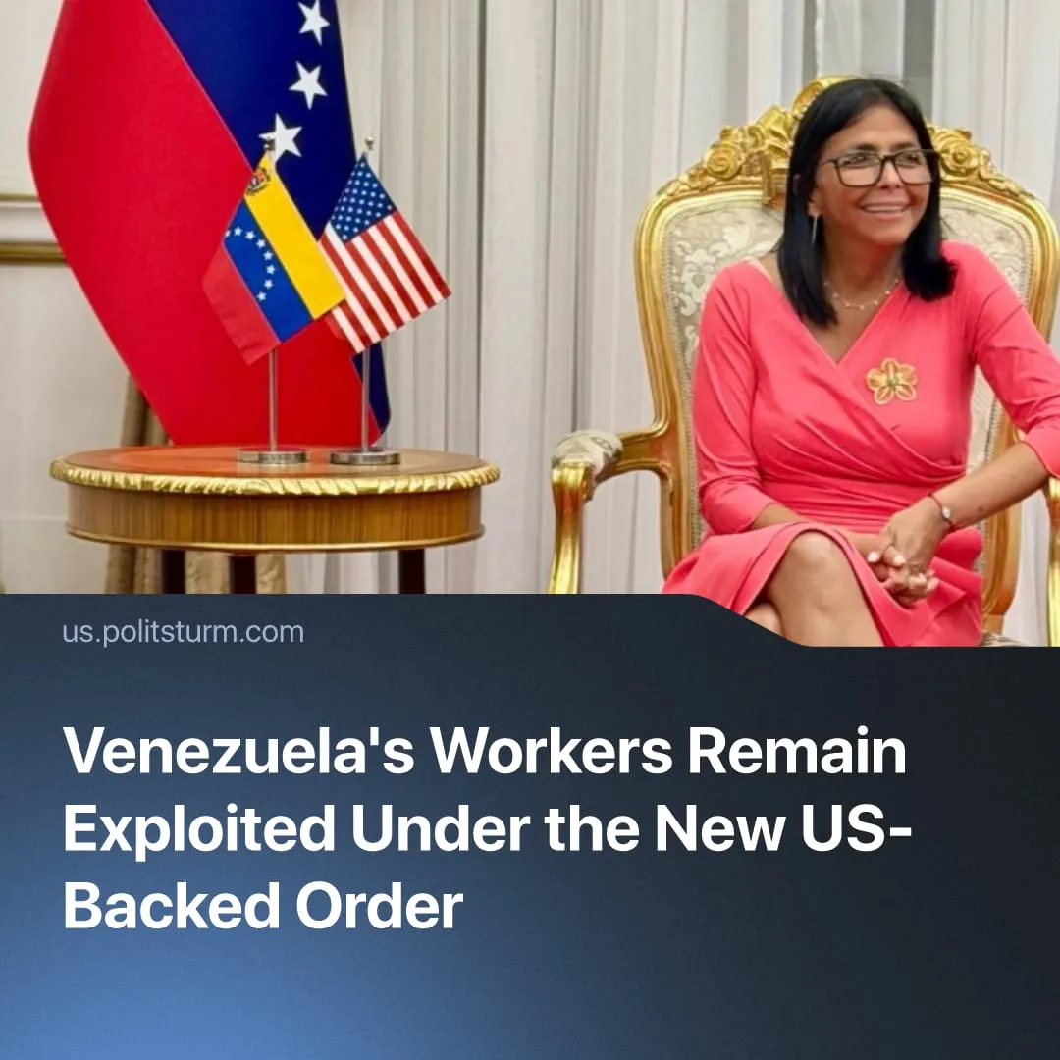

Original article
2026-07-08
2 min read

US has preserved Maduro’s “socialist party” regime for six months, which continues to exploit workers. Social-chauvinist “solidarity with Venezuela" essentially defended the capitalists that now continue to rule.
Details. Since the coup in Venezuela, US and Chinese competition for control of the oil sector has intensified. As oil production increases, American companies like Chevron hold a 25% share of daily production of 1 million barrels. US interests extend beyond oil to gold, rare earth elements, and other minerals. Planned investments run into the billions, with US companies earning growing profits while squeezing out Chinese competitors.
► Delcy Rodríguez, having assured her collaboration prior to Maduro's capture, rose to power after him. Instead of triggering an immediate vote, Venezuela's Supreme Tribunal appointed her interim president. The new administration has since conducted a purge of Maduro's allies, replacing them with US and Rodríguez loyalists.
▶ Venezuela's economy has not recovered rapidly. Public services are weak, infrastructure fragile, and living standards poor. Because of this, polls also show declining confidence in the interim government and in Trump's Venezuela policy, with support for him falling from 92% to 45% in three months.
Context. The removal of Maduro marked a significant advance in the US campaign to consolidate imperialist dominance in Latin America, in opposition to Chinese imperialism, which had established a strong economic presence there.
► It was also a major example of a shift towards direct "decapitation" operations, in which rival capitalist leaders are forcibly removed. This reflects a broader pattern of inter-imperialist rivalry, in which states resort to the forced redistribution of political control in strategically important regions.
Important to Know. Social-chauvinist parties such as the Communist Party of the Russian Federation (CPRF) and the German Communist Party (GCP) were among the first to declare solidarity with Venezuela. In practice this meant solidarity with a national bourgeoisie manoeuvring between competing imperialist blocs, not with the Venezuelan working class.
► Despite the removal of Maduro and some of his allies, the state apparatus remained under the control of the United Socialist Party of Venezuela (PSUV). The same regime that exploited workers under Maduro, with ties to Chinese capital, now exploits them under Rodríguez, closely linked to US capital. This is a tactic that Trump has tried to replicate in Iran and Cuba.
► The hollow rhetoric of solidarity with the Maduro regime under the guise of "the Venezuelan people" and "Venezuelan sovereignty” – also expressed by social-chauvinists towards Iran and Cuba – exposes itself when considering the initial popular support for the new government. The subsequent decline in support confirms that neither the Maduro regime nor its US-backed replacement governs in the interests of the working class.
For a deeper analysis of Maduro's removal and the class character of Bolivarianism, read the Marxist position on the US intervention in Venezuela.

Original article

