USA Warns Europe to Embrace Far-Right or Risk Losing NATO Support
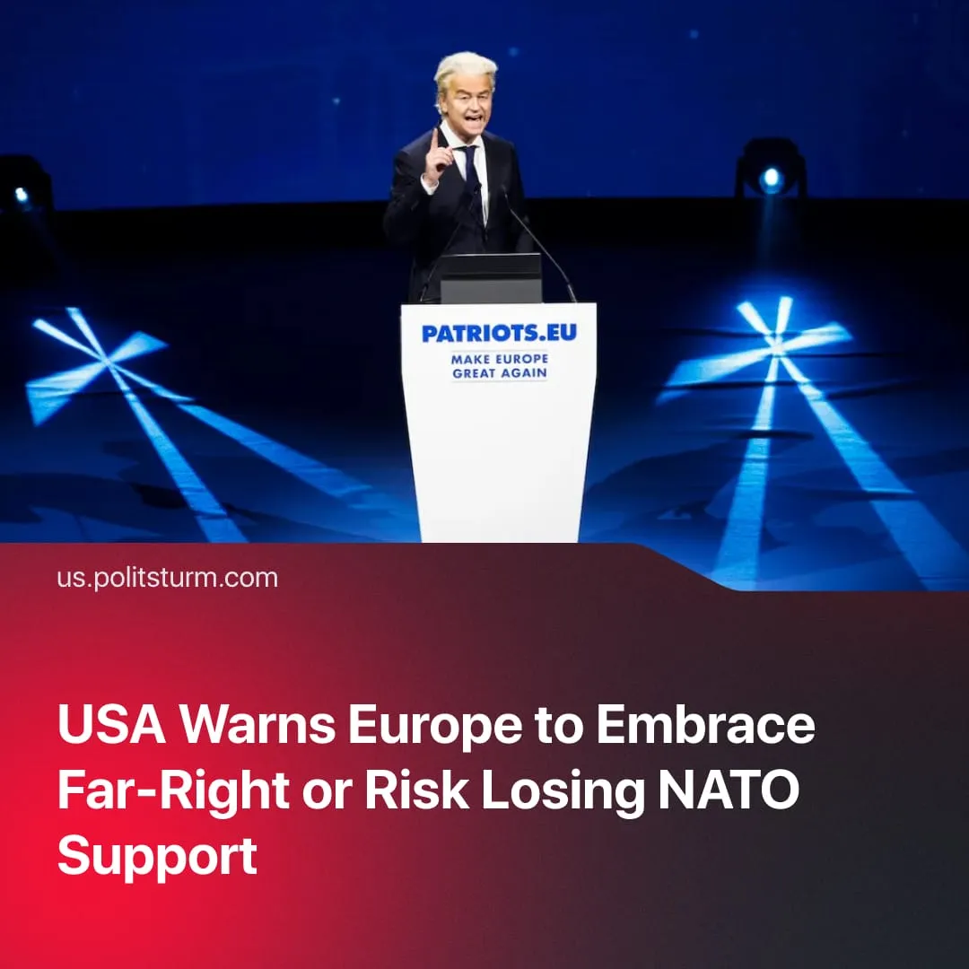

Original article
2025-12-15
2 min read

USA warns Europe to embrace the far-right or risk losing American NATO support, in its latest Security Strategy
Details. President Trump’s National Security Strategy 2025 outlines how the US will remain the “strongest, richest, most powerful, and most successful country.” Essentially, America will defend its position as world hegemon and “prevent the emergence of dominant adversaries.”
► In this new document, Europe is accused of facing “civilizational erasure” due to mass migration. Furthermore, the US casts doubt on whether “European countries will have economies and militaries strong enough to remain reliable allies.”
► The document includes ideological attacks against the EU’s “elite-driven, anti-democratic restrictions on core liberties” that are claimed to “undermine political liberty and sovereignty.” This is contrasted with American “freedom” and Trump’s “pro-worker” agenda, where supposedly “prosperity is broadly based and widely shared.”
► The US stated goal is to “help Europe correct its current trajectory” and Trump expresses support for the growing "patriotic European parties." These far-right movements more closely align with US interests and broadly oppose EU policies.
► European leaders criticised the American document, but have not yet mustered the confidence to openly attack Trump. Germany’s Foreign Minister stated that ideological questions shouldn’t be brought up in the transatlantic alliance’s strategic deliberations, only security issues.
► Polish President Tusk pleaded to the Americans that "Europe is your closest ally, not your problem" and noted their "common enemies,” calling for NATO to focus on its traditional opponent. In contrast to European concerns, the US strategy document no longer labels Russia a “security threat,” and instead calls for the speedy conclusion of a peace deal.
Context. The continued straining of US–EU relations is mainly caused by diverging imperialist interests regarding Russia’s “Special Military Operation”. Europe seeks escalation in the conflict, driven by militarism and predatory superexploitation of Ukraine. Conversely, the US is attempting to placate Russia, hoping to distance it from China. Moscow reacted favourably to the new National Security Strategy, amid ongoing ceasefire negotiations with the West.
► The new document anchors American strategy in the Pacific Ocean, not in the Atlantic. Tensions between China and the US continue to slowly boil, with the US needing to focus its economic and military forces on future confrontations there. Isolating Russia from China fits into US strategic sequencing, as Washington wants to confront each imperialist rival one by one.
► European capitalists have been increasingly asserting their independence from American domination, for example, by weakening American companies’ position in the EU market through issuing billions of dollars in fines. Elon Musk – the most recent American capitalist victim of this rivalry, having been fined $140 million – angrily called for the dissolution of the EU. Following the publication of the US strategy document, the European Commission intensified its antitrust investigation against Google, threatening to seize up to 10% of the company’s global revenue.
► Earlier in 2025, European powers had already begun pushing back against American influence. Clashes over mineral-rich Greenland, Dutch and Danish intelligence labelling the US and Israel as potential threats, and performative recognition of Palestine all signalled Europe asserting greater independence from Washington.

Original article

