U.S. Workers Real Weekly Earnings Declines 3.1%
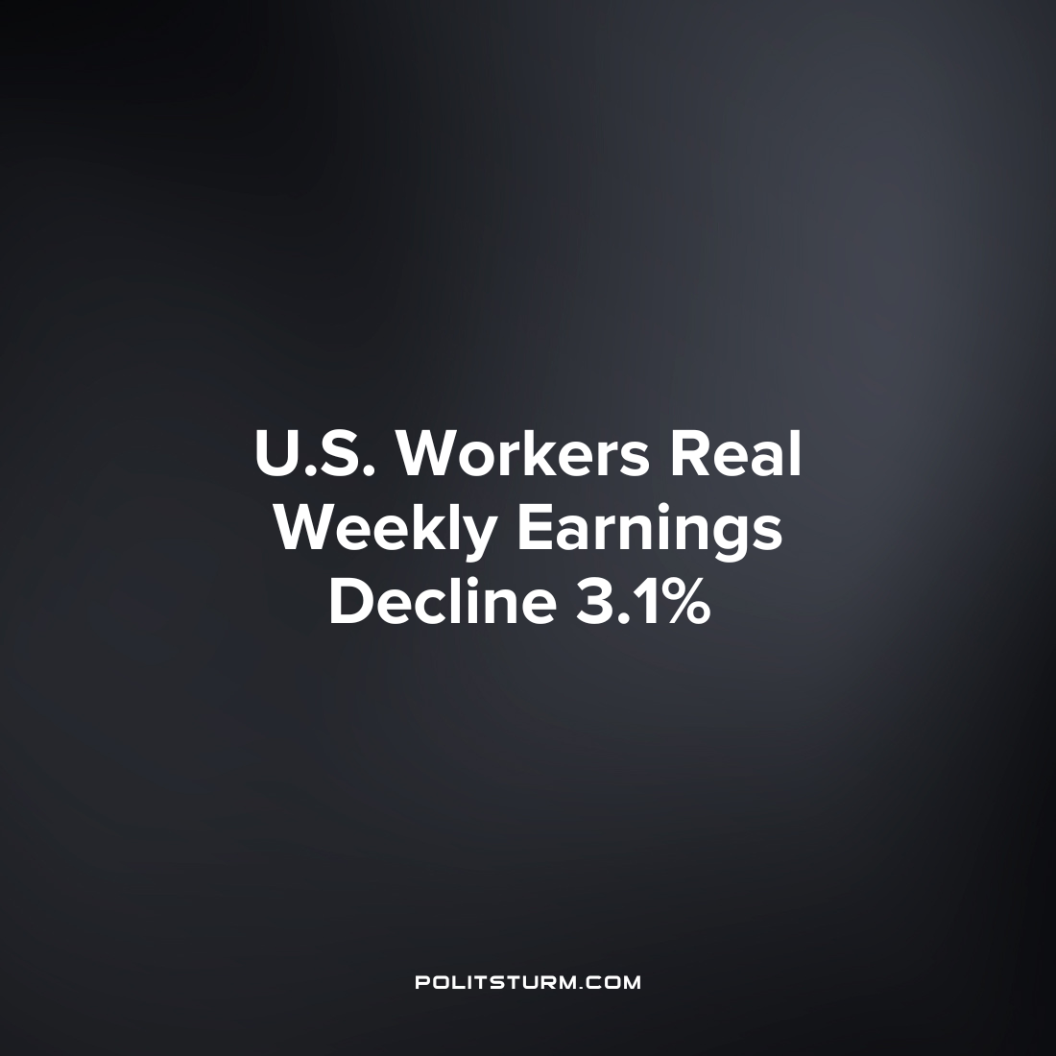

Original article
2023-02-08
1 min read

A release by the U.S. Bureau of Labor Statistics announced the real average hourly earnings of all U.S. employees. The release indicated that real average hourly earnings have decreased for workers by 1.7% in seasonally-adjusted terms from December 2021 to December 2022. Over the same time period the average workweek decreased by 1.4% which in turn led to a 3.1% decrease in real average weekly earnings over the period.
While the income of wage workers has declined as a result of high inflation and weaker wage growth, the capitalist class amasses fortunes. As of November 2022, the 728 U.S. billionaires had a combined wealth of $4.48 trillion.
In capitalist society wage workers are forced to sell their ability to work for the capitalists for a wage. Over the past year the earnings of U.S. wage workers has declined in real terms leaving them worse off. By contrast, the capitalists are the beneficiaries and will continue to reap massive profits at the expense of the larger society. It is necessary for workers to understand and practice Marxist-Leninist theory in order to improve their situation and ultimately end the exploitation of man by man which occurs under capitalism.
Sources: 1 2

Original article

